**Dog Rape Fantasies - 1**

**Preparation for your "Rape-Breeding"**

[***https://www.beastforum.com/showtopic-51055.html***](https://www.beastforum.com/showtopic-51055.html)

Dogs aren't like men even though all the erotic stories you read give them human characteristics. In the stories, you stimulate them by hand or orally to get them erect and then achieve penetration. Then the stories have the dog perform intercourse for a while, eventually getting the **knot** inside somehow. Then the stories say the dog ejaculates and withdraws. All are stories written by men who have no idea how the process actually occurs.

Actually, the dog does get interested and excited . But it does not become "erect" until after penetration. The dog has a bone called the os penis, so technically it is hard all the time. Most of the time, it is concealed in the furry sheath that you see under his belly. It mostly pops out when he becomes interested and in the early stages of excitement. It is pink, smooth, and about the size of a man's forefinger. It will come out of the furry sheath about an inch, maybe two. At this stage of excitement, he will begin to attempt to mount.

He does this by approaching you from behind. You should be on your hands and knees at this point with your shoulders level with or slightly lower than your hips so that your pelvis is at the right angle. He will rear up and grasp your waist with his forelegs and bring his penis into contact with your now exposed genitals. He will probe firmly with the tip of his penis looking for your vagina.

At this point, you should reach quickly between your legs, grasp his penis gently with your fingers, and bring him quickly to your vagina. If you allow him to probe without helping him, it can be uncomfortable for you. It is a bone, after all. When he feels the tip slip in, he will thrust it into you all the way in one push.

Once it's in all the way, it will immediately begin to grow in length and thickness and the **knot** will begin to form. The entire penis reaches full size very quickly. At the same time, he will begin to **thrust** in-and-out in short sharp jabs. He also begins to ***ejaculate*** as soon as he gets inside you and will continue to do so until he pulls it out of you. He will ***ejaculate*** a large quantity of semen and it is quite hot. You will be able to feel the ***spurts*** of hot semen while he is inside you.

Depending on the size of the **knot** and the relative tightness of your vagina, he may or may not get stuck inside you. If you are fairly flexible and his **knot** is not large, he will pull it out of you. The vigorous **humping** will last from 1-to-3 minutes. Then he will simply stop and stand there with his penis still inserted in you. If his **knot** and your lack of tightness are such that he can, he will pull it out of you at this point. If the **knot** and your tightness are such that he can't get it out, however, it becomes known as a ***"tie".***

In that case, he will not be able to pull it out but will stand there quietly and ***ejaculate*** into you. This will last from 10-to-40 minutes until his penis shrinks enough to pull out. he time will vary depending on the individual dog, breed of dog, how long it's been since he's had sex, and other factors.

Also during the ***tie***, the dog will most likely swing his foreleg over your back and turn so that he's butt-to-butt with you with his penis still locked inside your vagina. This is a natural defensive maneuver on his part to allow him to defend against predators. If you can't hold him on your back in the doggy position, hold him by the back legs after he's turned around to keep him inside you. Or your partner can hold him for you. During this time, don't try to pull away because it might be painful for you and will be painful for him. You have to remain quiet and let Nature take its course.

For that reason, schedule your sessions when you know you won't be disturbed for a couple of hours. You should always put sweat socks on his front feet or wear a sturdy shirt to avoid scratches. You should also place a thick towel or something beneath you to catch the ***ejaculate***. (There will be a lot!) For the single ladies and those whose partner doesn't know about your activities, it is suggested that you try to have a helper for the first few times. Although the dog won't deliberately hurt you, he can be single-minded once he discovers that he's about to be allowed to have intercourse with you.

After he becomes familiar with intercourse with you, you can train him to do it "missionary" style as well. And remember, no matter what position you choose, your genitals have to be at the right height for him. If you feel him probing too low, spread your knees to lower yourself. If his probing is too high, bring your knees together to raise yourself. Or you may have to kneel on a small pillow if he is a large dog.

Some things to do if you are just starting out with a new dog. Play with him a lot, making him your friend. Do this until he is relaxed and comfortable. While doing this, begin to fondle him gently until he is comfortable with you handling his genitals. When he is comfortable, try masturbating him.

First, remove all your jewelry including rings. Grasp the furry sheath at the tip of his penis,with your fingers between the shaft and his belly. Pull gently but firmly back on the sheath all the way. When the sheath is behind the area where the knot will form, it will trigger the growth of the penis. It will lengthen and thicken and the **knot** will form. He will probably begin hunching his hips at this point as if he was having intercourse. He will begin ***ejaculating***.

Remember, his penis is very sensitive. So use plenty of lubricant and be gentle. Grasp his penis behind the knot and hold it. Rub the shaft gently with the other hand. You can do oral safely as soon as he quits hunching his hips. Hold the penis behind the knot and place the shaft in your mouth. Watch out for your teeth; his penis is very sensitive. He will ***ejaculate*** in your mouth while you are doing this.

If he does not ***tie*** with you during intercourse, he will pull it out of you as soon as he quits humping. This will happen if the **knot** isn't big enough or you aren't tight enough (as mentioned above). It will still be swollen at this point and is another opportunity to perform oral on him (following the information above).

Sometimes a dog will appear indifferent or uninterested. He won't lick much and won't mount. Don't give up. He is probably just confused about what it is you want him to do. Keep working with him, praising him when he takes a step in the right direction. Get on all fours and have your partner place his (or her) hand on his penis and gently masturbate him.

When the dog begins to become erect, have your partner lift him on your back and quickly place his penis in your vagina. He should **hump** at this point even if it's just a little before he dismounts. This is fine. Keep doing this over-and-over. Dogs learn by repetition. So don't give up. After all, you have spent a lot of time telling him *"Don't jump up. Get down".* Is it a wonder he's confused now that you're telling him that it is all right to jump on your back and even to breed with you?

A final note to remember. About 10 percent of all dogs will not do intercourse with a woman. Every now-and-then you will encounter one of these non-performers. N o matter what you do, you will not be able to teach one of these dogs to do what they're not inclined to do. So if you have one of these and he will not respond to the suggestions above, don't pursue the matter with him. T o do so would be abuse.

This is a guide that I came up with based on my experiences. It addresses a couple of issues that most people either don't have or they don't think to tell about. So hopefully you guys will find this helpful in your own endeavors.

**'How To' for Beast Beginners.**

This will cover alot of the basics of getting started and being successful. When I first got into this, someone had a similar one for me. Now that I am experienced, here is a good guide line for beginning.

The first thing to do when getting into this is to find a good unneutered dog. You want to find one that will not be too big or too small for you. Each person is different. Labs, pitts, and danes are the most popular choices. Consider carefully whether you want a short hair or long hair, a well hung, or moderately hung. Although telling their cock size can be more difficult as you can't just check when you buy a dog. Remember these dogs are pets. T hey are not just for sex. They are still going to need the love and attention that any other animal would get.

You have to let a dog get used to you. If you just jump into it, you will find that it will be harder because most dogs aren't used to being handled in this fashion. You want a dog that is friendly and likes to be petted. But don't get one that is too submissive. You will know if they are by how they act. If they constantly roll over on their back when you come over to them, that means they are less aggressive and less likely to let their instincts take over when it comes to mounting.

Once you have decided what kind of dog you want, get to know them. Let your dog get used to his new environment and you. If you give them time to settle in, they will be more receptive to attention and want to please you. Go into it slowly when training a dog. Touch their sheaths every so often as you pet and play with them so that they get used to this contact and learn that it is okay and isn't going to hurt them.

It has also been suggested that whenever you plan on sexual activity with a dog that you wear the same thing so that they know what is expected of them. You don't need to do this until you have gone from the stage of just rubbing them to trying to get them to respond to stimulation. Some dogs have no trouble responding and it doesn't take much to get them **pumping** and ready to mount. Others need more coaxing.

So the next things are mitts and muzzle. If you choose to use these, let them get used to them before expecting them to perform. They are both very irritating to the dog until they get used to them. I would not suggest a muzzle though as this keeps the dog from panting and that is their cooling system and prevents them from licking. The mitts can be a good idea, though. Dogs tend to have sharp claws even after they are clipped they can be. The mitts keep you from getting scratched. Let them wear them a few times a day for a while at a time until they no longer chew on them or walk funny. This means they have accustomed themselves with them and they will do what it is you want them to.

Be VERY careful once a dog is **hard**. Make sure you clip your nails and don't wear any jewelry that might rub on his cock. A fully hard dog is very easy to hurt. J ust the slightest scrape can cause a bleeding wound on his cock and is quite uncomfortable for a dog (think about razor burn or a yeast infection). If this happens, stop playing with him immediately and give him 2-or-3 days to heal. You can clean it with peroxide. But don't use very much that can make his skin dry out and be quite uncomfortable for him.

Another thing to look for is if a dog makes you itch. The itch is generally not fleas. But make sure. Check a dog for fleas before you start, bathe him, and make sure he is fully dry before you start. If you find that you suffer from any sort of itch or bumps that swell and turn red, use Benadryl or lotion. It Helps!!! Generally it is an irritation from his skin and there is nothing you can do about it except put lotion on before you start when you are done.

AND MOST OF ALL, DON'T SCRATCH!!!!!! I cannot stress that enough. I had this problem. Scratching makes the problem 10 times as bad as it has to be. When it itches, put lotion on it. Also after you done, take a shower. This will wash away the offending particles and irritants. So, Lotion before you start; Shower and Lotion when you are done; and DO NOT scratch.

If you find yourself with a dog that needs coaxing, it is fairly easy to get them to respond. But there are exceptions. There are dogs that no matter how hard you try never do respond to this. To get them **hard**, rub their sheath like you would stroke a man's cock. Back-and-forth along the length draw backward so that the sheath rubs over the tip and shows it. Once you feel the **knot** starting to form in his sheath, pull the sheath gently but firmly all the way back so that you can get behind the **knot**. Firmly wrap your fingers around his cock behind the **knot**. It needs to feel like it is almost banded. ( Kind of like what a cock ring does. While I haven't tried it, a cock-ring might work for a dog. But be very careful.)

To help him get fully **hard**, you can very very lightly rub the tip of your finger over the very tip of his cock. As he starts getting **hard**, he will start shooting ***cum***. He continues doing this until he is flaccid. But it stops and starts. Don't expect it to be nonstop. If you prefer, you can use your tongue instead of the tip of your finger on his tip to get him hard as well.

When you are going for a dog to mount and **knot**, just rub his cock in his sheath. When he starts **pumping** in your hand, get into position and his instinct will kick in and he will try to mount you. Let him do his own thing. Be gentle when you redirect. Remember that this is not a natural act for a dog so he has to learn it. A dog will only pump until he is **knotted**. Then he will stand still.

If you find that he mounts well but he has trouble **knotting**, have someone stand behind him and gently push his rear end towards you to help his **knot** penetrate. Once a dog is **knotted** to you, do not try to pull off of him. This can be a very ***painful*** experience. I have a dog that was too big for me to **knot** with and I didn't know it. So when we knotted, I had to pull off of him because of the ***pain*** and I wound up torn. I would highly suggest having someone there to help you for your first **knotting**. A dog ***cums*** A LOT! When he pulls out, **it will pour out of you.**

Despite all of this, do not expect your dog to perform perfectly the first few times. As I said before, they have to learn it as much as we do. It is as unnatural for them as it is for us. Love your dog. Don't just use him for a sex toy. Treat him as the treasured pet that he is and encourage him and treat him.

MOST OF ALL, ENJOY YOURSELF. There is no point in doing this if you aren't going to enjoy it. This can be one of the most sensual and sexually satisfying experiences if you let it. I f you don't, you will not have any fun.

**Frequently Asked Questions**

Q. Is it true that a dog is very clean and you don't have to worry about getting an STD or infection?

A. Yes, dogs' genitals are very clean. And there are no diseases that are common to both dogs and humans, so none can be transmitted. The only way you could get an STD is if your dog had intercourse with an infected human and then immediately had intercourse with you.

Solution: Don't share your dog and don't let him hang out in bars picking up strange women. :-)

Q. One big concern I have is I would not want him to perforate me or tear me. I would be sure to guide him in with my hand. Since it is bone, it has potential to do damage. So do you have any additional suggestions not mentioned in the how-to guide you forwarded to me?

A. Don't worry about the bone. It is well padded and he will simply probe firmly looking for your vagina. Since your vulva is quite tender, it may cause a little soreness if he is allowed to probe freely. As soon as he mounts and begins the probing motion, grasp his penis gently and quickly with your fingers and bring the tip to the opening of your vagina. He'll take it from there by **thrusting** into you.

Q. I have had 2 children so the **knot** should not be a problem as far as size is concerned. I have heard a black lab would be around 5-to-6 inches long. Is that right?

A. Dogs are like men. They come in all sizes. 6 inches in length is about average for a lab. That is measured from the front of the **knot** to the tip. So you may have to accommodate 8 or 9 inches altogether. For most women that is not a problem but is enjoyable. His **knot** will be about like a tennis ball if he is average in size. You should feel pleasantly stretched just inside the entrance of your vagina about where your g-spot is located. Many women say that **knots** and g-spots are made for each other.

Q. I should be prepared for a ***tie*** in case it happens. If it happens, he must ***ejaculate*** more semen in you because he is in you 10-to-20 minutes rather than 3-to-5 minutes. Right?

A. Yes. When he ***ties***, he will ejaculate more semen into you for the reasons you stated. Once in you, he will ejaculate until he withdraws. You will feel the hot spurts. Although he fills you up with it, it will leak out around his penis so there won't be any discomfort.

Q. The how-to mentions a "large quantity of ***semen*** and it is quite hot". Would this be like a half-a-cup or how much is usual? Is it uncomfortable at all because it is hot?

A. About a quarter-cup is normal. Sometimes more depending on the dog. It is noticeably hot to you because a dog's body temperature is higher than a human's. It's not uncomfortable. Just erotically noticeable.

Q. Will I feel pressure in me until he pulls out due to the large quantity?

A. You will feel the hot ***spurts***. Although he fills you up with it, it will leak out around his penis so there won't be any discomfort.

Q. Should I expect his ***semen*** to drain out quickly or generally how long does it take for it all to be absorbed and drained?

A. Since his ***semen*** is thinner than a man's, it will **gush** out when he withdraws. Although you will be wet afterwards, it should go away as fast as a man's. So just take a bath and it won't be noticeable at all. Because it leaks out during intercourse and then **gushes** out at withdrawal, you need a towel or other cloth to catch it and not wet the floor. Easier to clean up.

Q. Unfortunately for me, my husband would feel threatened if I asked for his help (maybe later I can convince him). And I have no girl friend interested (or said not and it is not something you can ask anyone). So I would have to do it alone. I am a housewife so time alone during the day is not a problem. Anything else you can add for doing it alone?

A. As far as your hubby, he may not be as threatened as you think. A lot of men have the secret desire to see their wife have intercourse with other men, dogs, etc. One suggestion is this: When hubby comes home one day and during pillow talk, tell him that the dog was sniffing around that day and put his nose in your crotch. That the dog was persistent about it and then tried to mount your leg while you were sitting down. You can judge by his reaction how to proceed. If he says that you should have taken off your panties for the dog, you'll know you're home free. If he says "yuck!", you can react that way. It's a way to judge his feelings without committing yourself.

As far as doing it alone, many many women do it alone because they don't have a hubby or are afraid to tell him and don't have any female friends that they can trust with this. It's just easier to get the dog to understand what he can do if there is a helper. But you can do it all alone without any danger. The main risk is getting panicked during intercourse and trying to pull the dog's penis out of you. As I said in the 'How-To' (above), that can be ***painful*** for both of you.

Often when the dog is finished **humping**, he'll get down off your back (or front) and stand with his back legs toward you. He will tug gently as if trying to pull out. If he has ***tied***, he won't be able to pull out. But it can be unnerving for the beginner lady. Just hold on to him by the collar, the back legs, or fur to control him until he shrinks and slips out naturally.

Solution: Just don't get panicked. Relax and let nature take its course.

Q. The 'How-To' says to schedule your sessions when you won't be disturbed for a couple of hours. It seems to me like about 1 hour might be right in allowing for a little foreplay and 20 minutes if in a ***tie*** plus some recovery and clean-up time. Right?

A. I suggested a couple of hours for beginners. After you and the dog become practiced at this, you can have a quickie in 30 minutes if you want. You'll be able to remove your panties, expose your vulva to him, and he'll be in you in a flash. But at first, go slow and careful. Take all the time you need.

Q. Should I expect the feeling to be so intense at the end (especially at first) that I will need more time to recover compared to my husband?

A. Since I don't know your reactions to sex, it would be hard to judge intensity or recovery time. Most of the ladies say that it is somewhat different than intercourse with a man but just as (or more) intense. Most report multiple orgasms during intercourse with their dog.

Q. How should I expect to feel mentally and physically after the first time? And do those feelings change after more times?

A. You may feel a little *kinky* after the first time. But that's okay. The *kink* adds to the mental excitement. Physically you should feel like you have just had wonderful sex. I don't know if the feelings change much. Most ladies are just as turned on after years of dog-sex as they were at first. And they still love it.

Q. Will my OB-GYN doctor know about this from examining me?

A. Your physician will not be able to tell anything about this from any examination. In fact, after a nice bath, even your hubby or your lover (if you have one) won't suspect a thing. Unless you tell them, of course.

Q. Is it suggested that lube be used. Or does Nature take care of this?

A. Your natural lubrication should be enough. And more. Besides, the dog will begin spurting ***pre-ejaculate fluid*** as soon as he begins to try to mount. I've never heard of a woman who got this far and needed artificial lubricant.

Q. What is the most dangerous thing for me in this case? And how should I guard against it?

A. The most dangerous thing is the panic as discussed above. Just relax and don't try to pull him out of you once he's in and swollen to full size. Enjoy. After all, that's what you wanted anyway.

Q. The 'How-To' is right when it says we tell our dog not to jump up and on people. If we do have a relationship. How do I handle things when other people are around and he shows unique interest in me?

A. Do it with your dog only in the same room (bedroom, for example) and under similar conditions every time. Example: Only let him have you when you're completely naked. Scold him if he approaches you under any other circumstances. Dogs are very intelligent. He will learn when it's all right to approach you. Another trigger is when you put the socks on his forelegs. That's a sure sign to him that he's about to get some wonderful sex.

Our first dog was so intelligent that he would go to the laundry hamper and get any old sock he could find and bring it to my wife (hoping that she would let him, I suppose). Of course, she did most of the time.

And most people will think he's just being a dog if he approaches you in their presence. Dogs do that, you know. J ust scold him gently and put him in another room. You'll do fine on this score.

**- - - - - - - - - - - - - - - - - - - - - - - - - - - - - - - - - - - - - - - - - - - - - - - - - - - - - - - - - - - - - - - - - - - - - - - -**

A dog's ***ejaculate*** consists of 3 distinct fluids.

1. The bitch's vagina does not self lubricate as a human female does when she's ready to be bred by the male. So as he begins to mount and his penis extends from the sheath, he is ejaculating a ***lubricant***. He continues to ***ejaculate*** this lubricating fluid until his penis is fully engorged inside of her and he is tied with the female.

At this point he stops **humping** and may try to turn into the traditional butt-to-butt position. It is for defensive purposes as a female dog in heat will draw males from long distances and all of them want to breed her. The breeding manual says that you must be ready to help the male turn if he tries to turn.

2. The bitch's vagina contracts and the combination of this contraction and the male's **knot** causes the ***"tie".*** At this point, the female's vagina begins rhythmically squeezing the male's penis and his ***ejaculate*** changes from lubrication to semen.

3. When he finishes ***ejaculating*** his semen, he then begins to ejaculate a ***thicker fluid***. Since a bitch in heat will allow as many males as are waiting to mate with her, this thicker fluid is meant to slow the movement of the swimming sperm from the next dogs ***ejaculate*** thereby ensuring the first dog's sperm reaches her eggs first.

Now you know why there is so much more ***ejaculate***.

**- - - - - - - - - - - - - - - - - - - - - - - - - - - - - - - - - - - - - - - - - - - - - - - - - - - - - - - - - - - - - - - - - - - - - - - -**

If you're a little afraid of taking your stud's **knot** for first time, you can wrap your thumb and index finger around his member just in front his **knot** and curl your other fingers to block it should you not desire or be afraid of a ***tie*** and want take it at your own pace and time.

**- - - - - - - - - - - - - - - - - - - - - - - - - - - - - - - - - - - - - - - - - - - - - - - - - - - - - - - - - - - - - - - - - - - - - - - -**

As for my dog, on average he lasts only 30 seconds after first penetrating into an orifice. Once on a second round of mating, he lasted 45 seconds.

As for ***tying*** with him, he has to be held most of the time. He'll wait a couple of minutes to turn. Then myself or the woman needs to hold one back leg up once he's turned. So ladies, clamp down with your vaginal opening and grab one of his back legs gently as the guide suggests and hold him.

Also, I find it helpful to do it near the bathroom cabinet or something. This way, he can only turn in one direction to turn off of your back. Then you can hold the front leg of his that is not near the cabinet, wall, etc. This may prevent him from turning. I would try doing it near a wall and holding his front leg after he is familiar with breeding you. He'll totally trust you then.

**- - - - - - - - - - - - - - - - - - - - - - - - - - - - - - - - - - - - - - - - - - - - - - - - - - - - - - - - - - - - - - - - - - - - - - - -**

I really can't remember whether it's been mentioned before. But for us "over here" that have mainly wooden floors, keep in mind that a dog will be more insecure of mounting if he feels that he is not "steady" on the ground. Dog claws don't "stick" well to hardwood floors. So put a **rug** under you. That way he will not slip and he will be more happy.

Frankly, I recommend a large beach towel or a particular blanket (something that you might be able to throw in the washing machine with ease as it will be collecting an awful LOT of doggy ***fluids***. An advantage to something particular for the occasion (and only used for that occasion) is that your dog will begin to associate that blanket or towel being brought out with the potential for some more 'illicit' activities.

**- - - - - - - - - - - - - - - - - - - - - - - - - - - - - - - - - - - - - - - - - - - - - - - - - - - - - - - - - - - - - - - - - - - - - - - -**

During the first few times that you and your dog get sexual, it would be a good idea to not be wearing perfumes, body deodorants, or even have freshly bathed. While this is not a necessity, dogs have a strong sense of smell and communicate with other dogs by sniffing genitals and bottoms. Letting yourself build up a little ***body odor*** would not hurt anything. You will smell more like the animal that you are (mammal) and less like an overpowering "different" thing. Not taking a bath for a day-or-two before letting him first smell your bottom might entice him to **lick** more.

This may even encourage a dog that does not lick enough to lick more. If anything, I have noticed that my dog likes the added taste and salt. You will smell more natural, animalistic, and inviting. Maybe only drip dry just after a pee before your first time with him. Also, get your own juices flowing soon in your play with him. I am sure that they already will be. But you want to stress your femaleness as much as possible.

That info all came from one of the guides written by a woman that I came across on the Net. She also stressed staying on all fours or in a lying position while he first gets used to seeing you **naked**. I work with horses a lot. And even they read body language such a being submissive and walking soft with the head down or aggressive and walking with the arms and head high.

Get down on his level and pet him and kiss him. Don't make too much eye contact. Rub his legs and ribs a lot before touching his genitals. Let him get used to you touching his belly and his whole body while he is seeing submissive, low, and naked for the first time. Then after he is relaxed and you are confident that you can rub his underside and sheath, turn your rear to him while on all fours.

Sometimes crawling away or crawling in a circle will cause him to want to hop up on your back. Do this if he has been licking for a long enough time and you are ready to have him in you if he hasn't been wanting to hop up on you. This may encourage him. Then you want need as much assistance from another human.

You may not always need to guide him into you. This is the right thing to do until he is familiar with the location of your vagina. Then after you are both experienced, he'll find it quickly on his own. You may feel a few **bony jabs** on your vulva and paritoneum 2to--5 times. But it feels like being poked with a wet finger gently but firmly.

**- - - - - - - - - - - - - - - - - - - - - - - - - - - - - - - - - - - - - - - - - - - - - - - - - - - - - - - - - - - - - - - - - - - - - - - -**

I feel one section is somewhat lacking in content. I know others have more experience and knowledge of this than I and I'm sure I'll hear it. I feel the section on knotting in the doggie position downplays (or should at least make the reader aware) that when the k9 is done, he won't always simply swing a leg over and calmly wait till he's able to slip out. Even if it's a rare occurrence, the possibility of **injury** dictates its mention.

Also if you read the ads, most want large dogs. I don't think many realize the **strength** and ***power*** that these dogs have. And especially if you're alone, to control them even if your standing is not easy let alone while he's behind you and **knotted**. I don't want to scare. Anyone. Just be aware so its memory is of pleasure and not pain.

**- - - - - - - - - - - - - - - - - - - - - - - - - - - - - - - - - - - - - - - - - - - - - - - - - - - - - - - - - - - - - - - - - - - - - - - -**

Not all CAN separate from the **knot** just like that. We are all very different build. So saying that it's just to let the dog pull out with every female is utterly BS! It can cause **severe** ***tearing*** for the female and also be VERY **painful** for the dog.

**- - - - - - - - - - - - - - - - - - - - - - - - - - - - - - - - - - - - - - - - - - - - - - - - - - - - - - - - - - - - - - - - - - - - - - - -**

I would like to add something that my Husband & I came up with to protect my tender parts (LOL!). We took an old pair of my Levis and cut a hole around my ass and pussy. Leaving the waist and legs to protect me from the dew claws. Works great!

**- - - - - - - - - - - - - - - - - - - - - - - - - - - - - - - - - - - - - - - - - - - - - - - - - - - - - - - - - - - - - - - - - - - - - - - -**

I can offer a bit of advice and it comes from a lot experience on my part. I am a male and have enjoyed my dog fucking me for quite a long time. I introduced a number of women to it. To my surprise, they were not only receptive but fell in total love with it. Perfect!!!

But I will tell you that even though the height from the floor to their vaginal opening is quite important, so is position. To be honest, from the rear is a little more difficult for the ladies for several reasons. The dog is harder to control since he is out of reach . And most of them wished for the erotic intimacy factor (i.e., the missionary position where they could really get into it).

It also allows the woman to wrap their ankles around his hips. While guiding his dick to their vaginas, they can quickly and easily pull him deeply into her. As he fucks her, she is able to control him as far as keeping him mounted to her. Seems to be better all the way around.

Being a male, I usually always let him fuck me from behind. But the control is more difficult. If a woman wants it from the rear, it would be advisable to place several pillows under her pelvis if she wants to lay on the floor. In this way, he will be able to enter her easily. Bending over the edge of the couch seems to place the vaginal opening a little high. It will work. But the depth of his penetration won't be as great. Bending or kneeling at the edge of a soft couch is okay. But it may be necessary to spread your knees wider thereby lowering your vaginal opening for the depth of penetration factor.

Just wanted to add my 2 cents worth. Great and helpful article. And he was right in that there are a WHOLE lot of guys that secretly would dearly love to watch and/or be a part of their better half being fucked by another man or especially their loved pet. The larger the better. I think it is a primal/erotic/fantasy thing or something.

**- - - - - - - - - - - - - - - - - - - - - - - - - - - - - - - - - - - - - - - - - - - - - - - - - - - - - - - - - - - - - - - - - - - - - - - -**

I wonder what she would have said if her partner had been my fully matured St Bernard and he buried all of his bone fully inside. From personal experience with my lover, his **knot** would grow to just under 6 inches across and just over 6 inches high plus it was almost 5 inches along the shaft. His shaft was over 10 inches in length and grew to 3 inches across the thickest part. I had let him use me as his bitch many times when he was growing up without any problems.

Then one night after I had been able to be alone with him for several months, I stripped down and was on my knees in the passage with my head on the floor and let him have his way. At first, he just licked me for a short while. Then he jumped up and **mounted** me like I was a bitch on heat.

At first he could not find my entrance. So I quickly guided his slippery dick to my aching body. He quickly buried all of hot growing sex organ deep inside with so much ***power*** that he lift my knees up off the floor and pushed me forward into the bedroom as he kept **thrusting** his dick deeper inside me.

After what seemed like minutes of his thrusting. I could feel that his dick was getting **bigger** than ever before. Then he stopped and stood there over me as I was being filled with more dick that I have ever had in my body before. After several minutes it felt like my body could not stretch any further. What had been pleasure now turned to ***pain*** as there was no way that his **knot** would ever fit out from between my hips. As I was a lot tighter that usual, he stayed fully inflated inside for over half-an-hour of ***agony***. I was lucky not to have sustained any permanent damage.

**- - - - - - - - - - - - - - - - - - - - - - - - - - - - - - - - - - - - - - - - - - - - - - - - - - - - - - - - - - - - - - - - - - - - - - - -**

One of my friends does regularly have **anal sex** with her dog being a fan of anal sex all round. But I'd have to say it's pretty rare in the rest of my experience. Although anal sex is more popular with couples these days, anal sex with a dog is a risky and potentially painful variation when vaginal sex is there for the taking.

A dog's penis has a bone in it. They thrust without care of their partner's pain and **knotting** is an uncomfortable and potentially dangerous activity. While any woman's vagina can take (and, more importantly, release) a **knot**, the anus is not designed for sexual penetration. Unless the woman is very experienced and well prepared, it risks an embarrassing trip to the doctor (if not the emergency ward).

Men on this site seem to take their pets anally quite often although I can't speak with any experience of that. So perhaps their advice on the subject would be more useful.

**- - - - - - - - - - - - - - - - - - - - - - - - - - - - - - - - - - - - - - - - - - - - - - - - - - - - - - - - - - - - - - - - - - - - - - - -**

One item left out was the fact that the anus and the tissues inside are very THIN and delicate.

So anyone who intends to try anal sex with ANY animal or human should seriously invest in a variety of **lubricants**. At least to make it pleasant for yourself and to protect both yourself and your dog from injury from friction.

**- - - - - - - - - - - - - - - - - - - - - - - - - - - - - - - - - - - - - - - - - - - - - - - - - - - - - - - - - - - - - - - - - - - - - - - -**

Thanks for the great information. It's too bad that my wife and I didn't have it a few years ago. She made a couple of videos for someone who had a trained dog who paid her and then sold them to a collector.

After she got the dog interested, his **knot** did enlarge. When he penetrated her, it hurt. But after reading your information, I think maybe it hurt her because she expected it to and she was nervous since it was her first time. Also I was at the first session and thought I could see his **knot** flashing in-and-out of her as he **humped** her. Is that possible or did I imagine it?

Finally, the first time they "mated", he slipped out of her after he ***ejaculated***. What a mess! But the second time, she actually held him with her vaginal muscles. She says it wasn't until then that she actually remembers having an orgasm and that seemed to go on and on.

I was concerned that they might be **knotted** and have to be separated physically. But the dog trainer said to be patient and they would separate after a while. But it did seem to take 15-to-20 minutes. She said when he pulled out of her finally, she was very sensitive. And while it didn't actually hurt, the feeling was intense.

**- - - - - - - - - - - - - - - - - - - - - - - - - - - - - - - - - - - - - - - - - - - - - - - - - - - - - - - - - - - - - - - - - - - - - - - -**

Especially notable was the poster (I apologize for forgetting the name) who commented that during a woman's menstrual cycle, the male dog is more reactive. This is something that I didn't know and wonder if other member's have experienced the same arousal factor for their pet?

Notable was the comment pointing out that dogs do carry STIs (Sexually Transmittable Infections). Mentioned was *Brucellosis cani* which I know has been implicated in being transmitted to humans and which is quite easily transmitted between dogs, often resulting in an infection with no noticeable symptoms. Though in dogs it can severely affect litter size and so is a problem with breeders. Its prevalence and concurrent lack of any significant number of human infections make me think that this bacterium doesn't do well in humans.

**- - - - - - - - - - - - - - - - - - - - - - - - - - - - - - - - - - - - - - - - - - - - - - - - - - - - - - - - - - - - - - - - - - - - - - - -**

I have never been comfortable with full insertion and **knotting** as the dog has been bouncing off my prostate as it was with one hand holding him by the **knot** tight to my ass. And that is a blast!

But I have seen ample evidence and know that full insertion and **knotting** is both possible and probable with any dog of mid-size or bigger.

The first **thrust** is an attempt to find the opening. There follows a rapid thrust attempting to bury the penis 'to the hilt'. This is when the **knot** is inserted and begins immediately to swell. (Just ask some of the ladies. This can be quite a stretch with a large dog). And then since everything is inside already, all the swelling and squirting is just fun.

But there is the matter of the **knot**. There is an inch-or-more of penis still behind the **knot** which makes for plenty of room for it to fit inside your anal sphincter. And the first time or two might be a bit uncomfortable as your anus feels quite stretched. These **knots** can be as large as an apple, maybe bigger. (When was the last time you passed a BM that size?)

Also be sure to control the dog as soon as he is in you. There will come a time when he will want to step over you, pop his dick in the other direction, and be attached to you but pointed the other way. I think they are caught and just stuck there while their testes make more ***sperm*** to flood you a few drops at a time (they don't have the large storage capacity we do).

If you don't watch it, after this point he may try to pry away resulting in a painfully dilated rectum and some possible bleeding. Tightening your anal sphincter (if you can) and holding on to his back legs will prevent any surprises of this type.

A few points about the start of insertion or penetration.

I find that a gentle stroking of the penis until he shows interest (that wet pink think protruding slightly and a small **knot** discernible within the sheath) is all it takes for him to be ready to penetrate you. Removing the whole penis from the sheath at this time is counter-productive.

Once the **knot** is out of the sheath, it will just continue to swell. You will probably need for the dog to "cool down" and his **knot** recede before you can proceed with sex.

I recommend you use the curled up fingers of one hand as a guide with the first stroke or you might have a painful poke or two before he finds it on his own. I suspect this might be uncomfortable for him as well. Then you have a split-second to decide whether or not to remove the hand and let him plunge fully into you and **knot** or whether to keep the hand there and expose his **knot** with his next thrust.

The latter technique will allow him to enter you up to the **knot**. You can hold him tightly to you with one hand on the far side of the **knot**. Really, you only lose a couple inches of penetration and a lot of anal dilatation this way.

Actually all parts of sex with a male dog (when precautions are taken and you have a towel at hand) are pretty amazing. You won't need KY lubricant. But you might like to put socks over his front paws and pants will prevent scratches from his hind legs to your lower ones.

***Semen*** (even mixed with his urine) is tasty, salty and warm. The doggy smell and warmth are rather intoxicating. The spurting, swelling, and rapid thrusting. Even the panting are really exciting and sexy.

Just be sure to be safe, don't force him to do anything he doesn't really want to and have a good time.

Oh, and don't forget to have some water and food nearby. He will become easily dehydrated by the exertion and the amount of "fluids" he loses in the process.

**- - - - - - - - - - - - - - - - - - - - - - - - - - - - - - - - - - - - - - - - - - - - - - - - - - - - - - - - - - - - - - - - - - - - - - - -**

Your **anus** may be small. But your rectum (the chamber just inside the anus) is HUGE. So when you think about it, actually anal penetration is perfect for a dog's penis since your anal sphincter is so small while your rectum is big enough to accommodate any dog. Likewise it's also long enough while sometimes your vagina isn't long enough to accommodate some dogs' penises which can exceed 9 inches! Meanwhile your rectum is even longer.

Also dogs don't **thrust** much beyond the first few seconds. Which is good for anal sex since it's less tolerant of friction\ and more sensitive to pressure.

Because of the smaller anal sphincter, it's much easier to ***"tie"*** with the dog anally since most women's vaginal spincters are much bigger than anal (mine really isn't since I've only been a dog-girl, so I guess it never got stretched to normal size). So while the **knot** is small when it goes in, it will swell up so BIB that there's no getting it out until he finishes and shrinks (which with my dogs takes over a good half-hour, each).

The problem with anal is the sensation of having to "go" which I've read is due to the pubo-rectal sling being stretched. But it goes away if you just relax. In fact, it's a very exciting sensation of being filled. I sometimes let my dogs take me anally. There's nothing like it. But I prefer vaginal most of the time.

Once a dog penetrates and stops dancing/**thrusting**, his orgasm is over and his ***ejaculation*** begins. After all, the purpose of the orgasm is to make him complete the act. And since he's locked in place, once the orgasm is over, then he's no longer "acting". He simply has no choice in the matter anymore and he knows it. So he just stands there and waits until he can go. (When ***tied***, my Mastiff pretty much just puts his head down and looks away head-down eyes-wide and ashamed and won't pay attention to anything I say or do to get his attention LOL).

So all the doggy-porn with women playing with a dog's erect penis have no idea what they're doing. Or it's just for the entertainment of same.) So don't go jacking or sucking etc. a dog's penis once he's hard. It won't do anything good for him.

Sometimes I'll just give my dogs handjobs until they begin ***ejaculating***. Then I'll keep the ***ejaculation*** going and just let them cum all over me until I'm literally bathing in it like a shower of ***hot*** ***dog sperm***. This is done by keeping pressure around the base of the **knot** using one or both hands. They'll go through the entire ***ejaculation***-cycle before going soft and they're out of cum.

But I make them ***ejaculate*** at least once every day and have done so since they were old enough to even dry-cum. So maybe they've developed the ability to produce a lot more ***cum*** than normal.

**- - - - - - - - - - - - - - - - - - - - - - - - - - - - - - - - - - - - - - - - - - - - - - - - - - - - - - - - - - - - - - - - - - - - - - - -**

You should get him ***cumming*** as soon as possible too and train him to mount and penetrate you as well. Do this by feeling out his penis-sheath and noticing the little bulge at the base of it. That's his **knot**. Put your fingers in a "ring" around the base of that closest to his body and begin working his sheath in your hand back-and-forth up his shaft and he'll immediately start **humping**.

His penis should begin ***ejaculating*** when he's old enough. But of course if he yelps and pulls away, he's not old enough. Try more gently or when he's older.

And once he starts **humping**, he'll want to mount you. So keep working his **knot** while you turn around and let him climb on your back. Put the tip of his exposed penis to your vaginal entrance and let him **thrust** in. Eventually he'll get the whole thing in, not at all (though you might want to wear a leather jacket or something so his claws won't scratch you).

**- - - - - - - - - - - - - - - - - - - - - - - - - - - - - - - - - - - - - - - - - - - - - - - - - - - - - - - - - - - - - - - - - - - - - - - -**

It took me almost 2 YEARS until I was able to take my dog's **knot** and I was being penetrated on pretty much a weekly basis. Every woman's anatomy is different. I know that some of it was my body and some of it was my dog. His **knot** is HUGE and his shaft is very long. It's so long that my body just could not accept all of that length. And it ***hurt*** when his **knot** would swell inside.

I can take him now. But I have to be very prepared, relaxed, and it doesn't always happen.

I've learned that if it's hurting, I need to ease him out before his **knot** swells to the size of a baseball (that's an estimate! LOL). Even now if I get him all the way and he finish and deflates, I feel like my chacha has been fisted and turned inside out. So it's straight to a hot bath. Sometimes I have to use **ice** because I'm swollen and tender.

Yeah, I think that people need to be aware that there can be consequences if you ignore your body's signals. It's a pain sometimes but SO worth it. It just took some getting used to.

**- - - - - - - - - - - - - - - - - - - - - - - - - - - - - - - - - - - - - - - - - - - - - - - - - - - - - - - - - - - - - - - - - - - - - - - -**

Body angle can help. Keeping your legs behind you and leaned forward ,hard for him to get the depth needed. Some have claimed clamping legs together tightly can keep him out. For me that creates an uncomfortable position.

It is definitely better to guide him in so you don't get stabbed with that pointy dick at speed in soft spots (actually feels like you been stabbed). Keep your hand around his dick and you can gain a lot of control how deep he goes.

Also because he is **humping** so fast and hard, your hand will push his sheath back over the **knot** making him feel tied and swelling up because of it till he too big to get it in. Then you can let go and brace yourself for a hell of a ride. I have had dogs hammer my ass so hard with the **knot** hitting the outside that I end up sore. Next day realize I got bruising. When he stops **pounding** you silly, you can grip tight behind the **knot** and fake a ***tie*** with him.

Dogs are often **overpowering**. The **strength** and ***power*** a really horny dog can hammer you with is amazing. No way to keep balanced and hold onto him unless you want face-planted. It is more comfortable on all fours than having an arm twisted back there.

No matter how much you enjoying it and mind blanks out, KEEP AWARE of where the **knot** is. I often end up having a dog snap the **knot** in-and-out several times. Before he is too big, snap yourself forward a good bit and pop him back out. Might end up doing it more than once. Stay slightly forward so he doesn't have enough reach to get it back in till he too big to get in then you can lean back and let him have at it.

If you do get the **knot**, DO NOT PANIC! Having it ripped out is beyond ***painful***. You must force yourself to remain calm, relax, RELAX, no matter how much it might hurt. Ripping it out will be MUCH worse. The more you relax, the easier it will be.

If the **knot** goes in, you often only have a-split second to pop him back out or it might not come back out. Many dogs truly explode in size the instant they get it slammed in. It's on purpose so they can't come back out as fast as possible and the bitch can't get away if she changes her mind

Even a relatively small dog, border collie, aus shep size, ect. will basically ***tie*** with you anally if it gets in. You're fucked even if you change your mind. You won't get lasting damage if he rips it out. But it still is a sharp serious ***pain***. A dog the size of a lab that rips out can feel like he ripped your asshole off. The extreme pain of a **knot** rip out for me never lasted but for a few moments ....

… except a large hound that had been chasing a bitch in heat for close to a week without getting any. YUP! I WAS STUPID! Couldn't help it. Truly felt wonderful. Hardest fastest **hammering** I ever had. He also got the **knot** in and I somehow never noticed till it was jerking me from the inside at fast speed. *OH FUCK! Too LATE!* He was hammering me so damned hard it felt like his feet were coming off the ground (they were!).

His back legs suddenly shot forward beside me and he literally flipped off my back backwards at the same time HEARING a LOUD POP as he ripped out of me. Was like a slow motion cartoon. Shock kept the ***pain*** away for a few seconds to think WTF. Then it suddenly felt like he literally ripped my asshole off. That ***pain*** lasted at least an hour. And yes, I walked real damn funny for days. I did tear. But only light blood spotting (thank goodness) and I healed.

I wish some more folks would post what works for them on this. Truly need to know information not often covered in guides. It works for both men and women and not simply anal.

**- - - - - - - - - - - - - - - - - - - - - - - - - - - - - - - - - - - - - - - - - - - - - - - - - - - - - - - - - - - - - - - - - - - - - - - -**

After many years and dozens of dogs, I learned my mistakes the HARD WAY before the internet. And had no clue what I was doing.

**Warnings that quickly come to mind I wish to add.**

**A really horny large dog has the strength to flat out feel like he is *raping* you in some cases. Once he gets going, it can be seriously overwhelming and hard (f not impossible) to stop.**

Once had a rott that had been chasing a bitch in heat for several days and not getting any. He was so damn sexy studdly, I could not resist when my lust kicked in. He flat out ***raped*** my stupid ass. t was not enjoyable. It was damned scary at the same time. He seemed lovable until he realized he was gonna get some. He never stopped growling at any movement I made. He determined that I was getting fucked and was not going to stop it. It was like he was actually trying to ***punish*** me as much as possible for his waiting so long to fuck something.

**It is stupid to too take a knot from any dog you do not truly know how he reacts to being stuck to you.** A dog that decides after he has finished humping is done or tries to turn can freak out when discovering he is stuck to you and not understand why. You can not stop a determined dog from ripping himself loose. A big **knot** will feel like he ripped part of you off with it!

**It is stupid to take the knot from a dog you have not checked out what he might be hiding.** Exactly like humans, dogs increase majorly in size after ***tieing*** (some might double in size). Some can be many many times bigger than you can believe possible. A mixed dog with a sheath smaller than most labs I have known. You don't think about it while in want. Love labs nice size. He kept trying to mount (why not?). He kept getting bigger-and-bigger after the **knot** was done in and no possible way to get it back out. It went from nice to uncomfortable, to painful, to feeling like had a shoved a cantaloupe up my ass! Never discover he hiding a grapefruit knot AFTER IT IS IN YOU! SURPRISE! You're FUCKED LITERALLY NOW! All you can do is wait to split apart or die. Even 5 minutes will feel like hours.

**That damned penis bone. It is SHARP!** A horny humping dog can jab hard enough in soft spots to feel like you been stabbed. And they somehow do not seem to feel it. They keep right on stabbing at you with it.

**Dew claws:** Ever wonder why-the-hell dogs have them? Get mounted and you learn fast. They work the same exact way as they do with a bitch. They are perfectly angled to grip into your sides. They are serious sharp. You WILL get scratched up. It hurts like a mother! A strong dog can feel like they are ripping into you. I can't really tell but it sure seems like I should have some major scars from a few.

**Oral** Truly love the taste of dogs. Do Not let a dog hump your face without experience. You can not truly control a sharp dick stabbing at you with force with amazing speed. The dog could do serious damage to the back of your throat (possibly actually punching thru it). Learned that lesson when I could not actually hold him back with both my hands around his dick. It only tapped the back of my throat. But it hurt like hell. Wait till he quits trying to shove it out the back of your head before you actually take him in your mouth.

**Dog Rape Fantasies**

<https://www.beastforum.com/showtopic-261360.html>

I want to be a high class escort for pet owners. Wealthy clients would call me into their homes to mate with their dogs. Some of my clients might be new to this and want to see a woman get knotted in person for the first time. Others might be regulars and enjoy watching their dog mate with the same woman over and over. Some of my clients might have multiple dogs and I would have to service all of them. I would be in very high demand so with ***doggie cum*** still in my pussy I'd have to get over to another client and get filled with another dog's ***cum***.

Maybe some of the clients would host parties and would want their guests to be entertained by watching a woman get mounted by a dog. After the dog gets to use me, he would just lose interest in me and go away. The owner would pay me and I'd walk out of the client's home with *doggie cum* dripping out of me.

Some of the clients would quietly watch me from the shadows, maybe masturbating to the live view of a woman getting knotted by a dog. Some might pay extra and have me service them as well as their pet. The owners would encourage their dogs by telling them that they are fucking a human **bitch**. Some might even pet me and praise me for doing such a good job as a dog prostitute.

**Fertile Valley Breeding Kennel**

**An exclusive kennel featuring special breeding services to our distinguished and well heeled clients. For those who want more for their furry friends than just a dog's life, we offer you top notch service and treatment.**

**We have many stud dogs on premises to supply high quality semen for implantation into your prized bitch. In order to avoid potential injury to your pampered pet as well as to provide superior service for the studs, we harvest the semen ourselves from our dedicated staff of human surrogate bitches. These girls pamper and take care of our boys day-and-night to ensure they are happy and healthy and will produce viable and organically collected *sperm*.**

**We also do *semen* collection services for your prized stud as well. Just bring him in and he will be pampered and well looked after by our girls. The *semen* will be collected while you wait. Our bitches will breed with him until he is fully satisfied. He will leave with a smile on his face!**

**We offer many other services from boarding to relief services and to bitch training. And we are adding new services all the time!**

**We also offer boarding services when you can't take him with you. Don't worry! Our girls will take extra special care of him for you!**

**Our newest offering is a nice training course for those young ladies in your life who need a little instruction.**

**Our girls just love their jobs! It is so fulfilling (in many ways!) as well as rewarding. And not just doggie biscuits!**

**We hire nubile young human girls to act as surrogates because we want to lessen the chances of an unintended pregnancy of a teaser bitch. But sometimes Mother Nature has a plan of her own...**

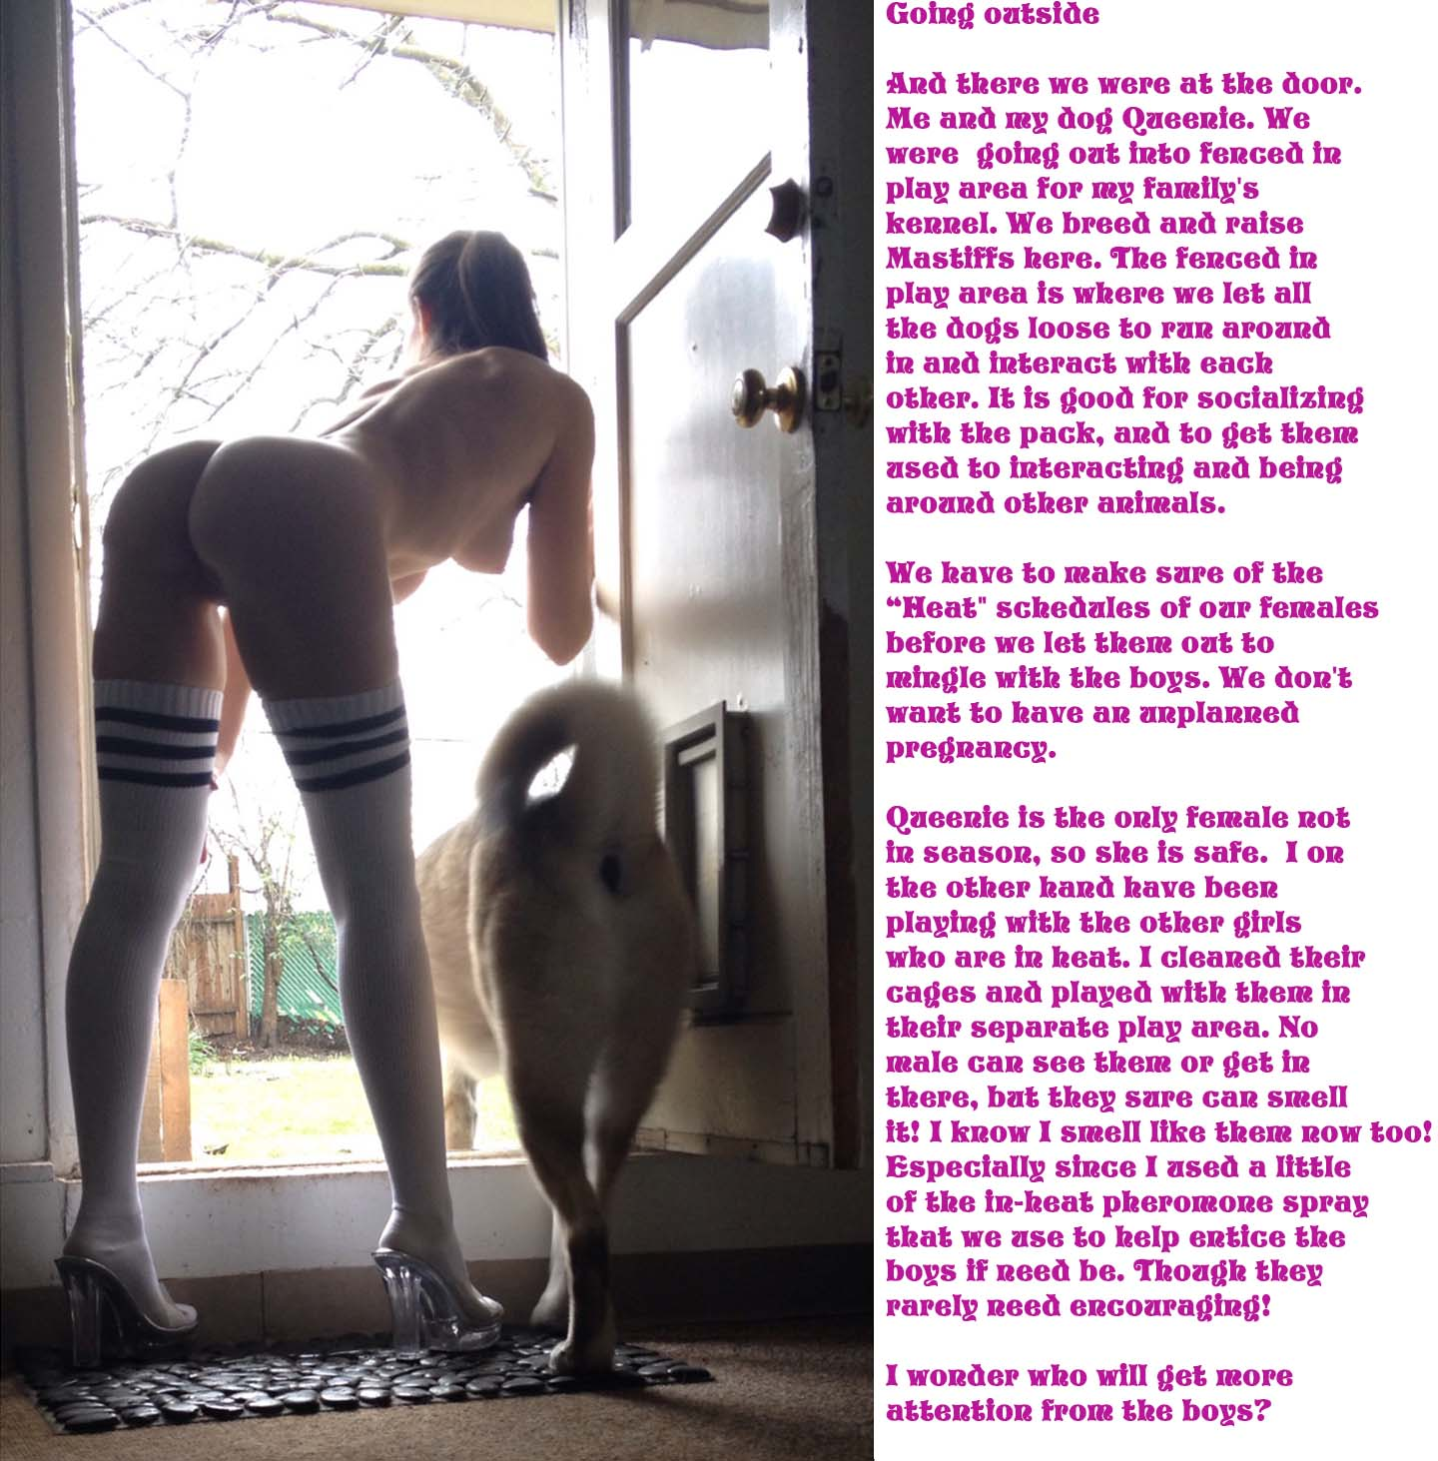**Going Outside …**

And there we were at the door. Me and my dog Qaeezle. We were going out into a fenced-in play area for my family's kennel. We breed and raised Mastiffs here. The fenced-in play area is where we let all the dogs loose to run around and interact with each other. It is good for socializing with the pack and to get them used to interacting and being around other animals.

We have to make sure that some of the "Heat" schedules of our females before we let them out to mingle with the boys. We don't want to have an unplanned pregnancy.

Qaeezle is the only female not in season. So she is safe. On the other hand, I have been playing with the other girls who are in heat. I cleaned their cages and played with those in their separate play area. No male can see them or get in there. But they can sure smell it!

I know that **I** smell like those female dogs now. Especially since I used a little of the lu-heat pheoromone spray that we use to help entice the boys if need be (though they rarely need encouraging.)

*I wonder who will get* ***immediate******attention*** *from those horny boys?*

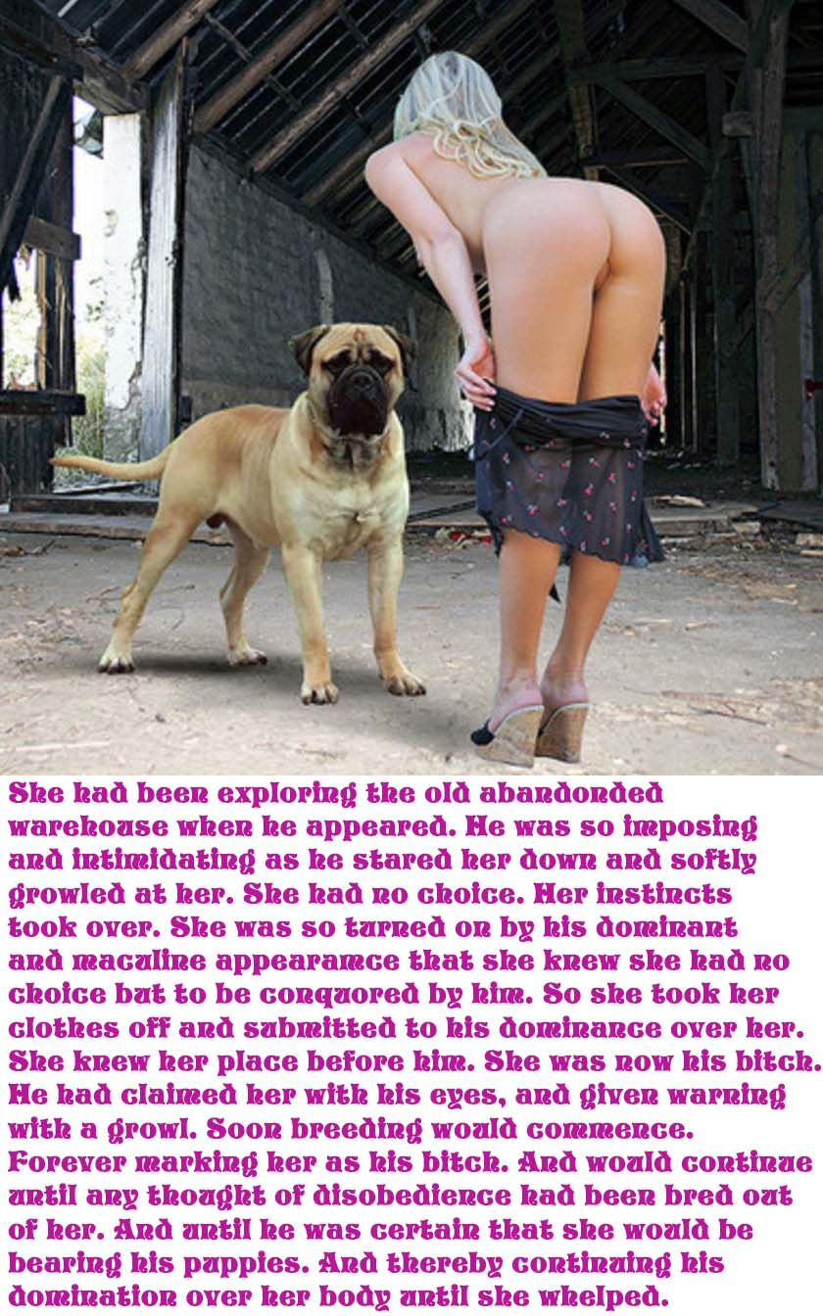

She had been exploring the old abandoned warehouse when he appeared. He was imposing and **intimidating** as he stared her down and softly growled at her.

She had no choice. Her instincts took over. She was so turned on by his **dominant** and masculine appearance that she knew that she had no choice but to be conquered by him.

So she took her clothes off and submitted to his **dominance** over her. She knew her place before him. She was now his **bitch**. He had claimed her with his eyes and given warning with a low ***growl***.

Soon ***raping/breeding*** would commence, forever marking her as his **bitch**. And it would continue until any thought of disobedience had been bred out of her. And until he was certain that she would be bearing his puppies, thereby continuing his **domination** over her body until she *whelped*.

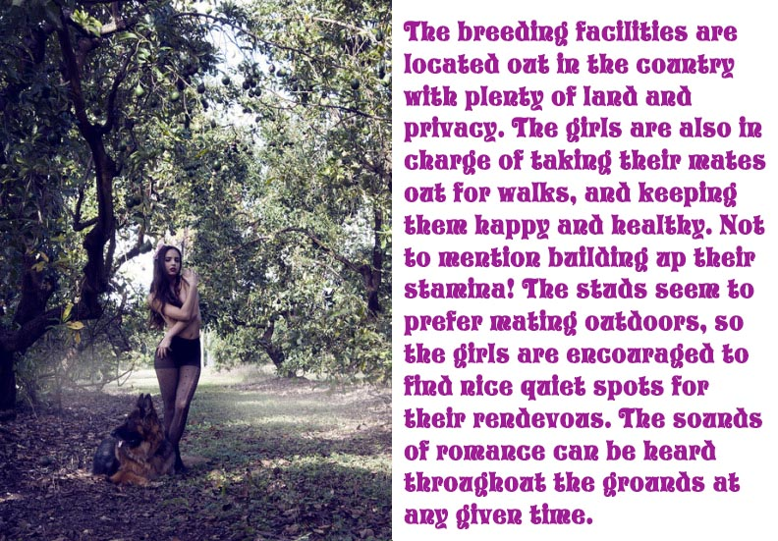

**Breeding** facilities are located out in the country with plenty of land and privacy.

The girls are also in charge of taking their mates out for walks and keeping them happy and healthy. (Not to mention building up their breeding stamina!)

The studs seem to prefer **mating** outdoors. So the girls are encouraged to find nice quiet spots for their rendezvous.

The sounds of ""romance can be heard throughout the grounds at any given time.



Another service provided by the Facility are **relief sessions** where clients bring their beloved pets in for some much needed ***sexual*** relief.

Dogs do not have many opportunities to breed. So they build up agonizing levels of ***sexual*** tension. These pent-up tensions can cause stress, pain, and behavior issues with these poor guys.

So our angels of mercy tend to their needs on a regular basis in order to ease their suffering and to give them outlets for all that pent-up ***sexual*** energy.

Our girls do alll they can in order to bring relief to their guests using whatever techniques are needed in order to ensure they leave here completely satisfied with a huge smile on their doggy faces.

(Special requests are accepted for those quests with "special interests".)

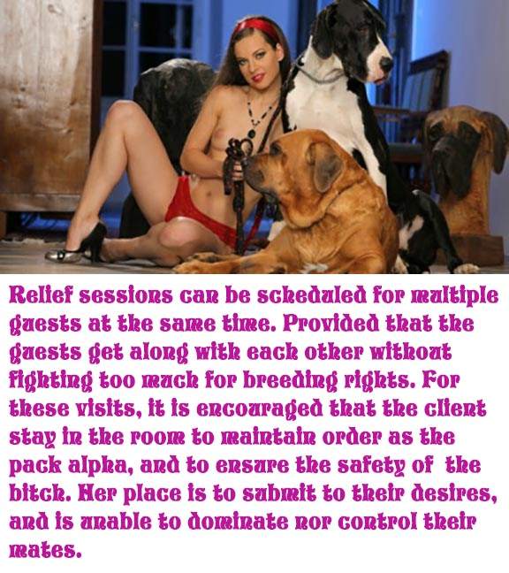

Relief sessions can be scheduled for **multiple guests** at the same time provided that the guests get along with each other without fighting too much for breeding rights.

For these visits, it is encouraged that the client stay in the room to maintain order as the pack alpha and to ensure the safety of the **bitch**.

Her place is to submit to their desires and is unable to dominate nor control their mates.



We can also provide boarding services for when you are going away and are unable to care for your furry friends.

We don't believe in keeping our guests in cages. He will be treated to a romantic getaway with whatever **girl-bitch** meets his fancy.

She will devote her entire time to being with him and will sleep with him at night.

During the day they will be free to frolic and enjoy the park-like atmosphere of our Facility while nightly "entertainment" will be provided by the **girl-bitch**.

For an additional fee, we can arrange for the guest to be accompanied by his bitch to a remote location for a relaxing vacation at the beach, in the mountains, in a church, in the big city in full public view, or wherever he desires.

Our newest service is our **Bitch Training** program. If you know of a girl who thinks that being a **dog-bitch** is fun or one who is arrogant and stuck-up and really needs to be put in her place, we can help. We can show her the true "joys" of being a **dog-bitch**.

Our studs instruct her on her place and her duties as a **bitch**. She will learn how to act and service her new Masters.

Our studs are very strict and will accept no less than total submission and an understanding of her new role. When she leaves here, she will know that she is forever a **dog-bitch**; what a **dog-bitch** truly is; and that she is expected to obey her canine Masters' orders explicitly.

Below is one **bitch** who is learned her lessons. She quickly went from feeling superior to others to not be allowed to move until her Master's cock allowed her to.

It doesn't take many ***painful*** lessons before **bitches** learn to shut up … stop crying … submit … get into position … and pull her goddamned panties down!



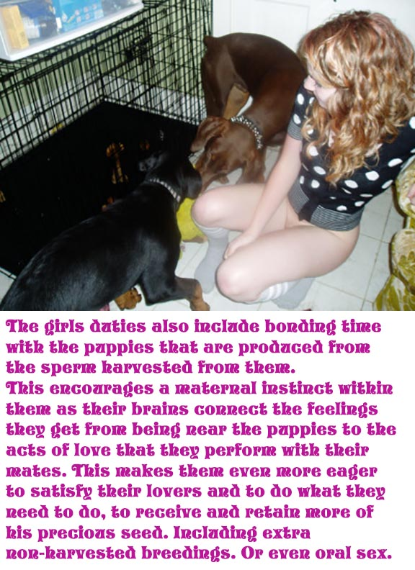

The girls' duties also include boarding time with any **puppies** that are produced from the sperm harvested from them.

This encourages a maternal instinct within them as their brains connect the feelings they get from being near the puppies to the acts of love that they perform with their Masrers.

This makes them even more eager to satisfy their 4-legged lovers and to do what they need to do in order to receive and retain more of the precious ***impregnating*** seed.

Including extra non-harvested breedings. Or even oral sex.

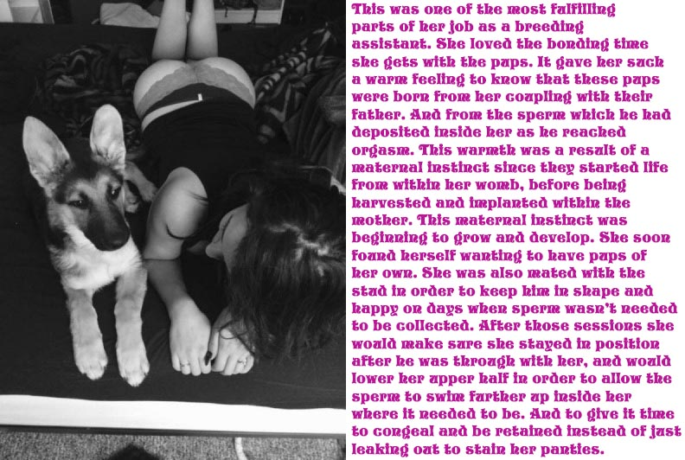This was one of the most fulfilling parts of a bitch's job as a breeding assistant.

She loved the bonding time that she gets with the pups. It gave her such a warm feeling to know that these pups were born from her copulating with their father. And from the thick sticky ***sperm*** which he had deposited deep inside her as he reached orgasm.

This warmth was a result of a maternal instinct since they started life from within her womb before being harvested and implanted within the mother.

This maternal instinct was beginning to grow and develop. She soon found herself wanting to have pups of her own.

She was also mated with the stud in order to keep him in shape and happy on days when ***sperm*** wasn't needed to be collect.

After those sessions, she would make sure that she stayed in position after he was through ***raping*** her and would lower her upper half in order to allow the ***sperm*** to swim farther up inside her where it needed to be.

And also to give ***it*** time to congeal and be retained instead of just staining her torn panties and running down her legs into her high heels.



Sometimes this job and lifestyle can take a bit of getting used to.

That's why after each training session, new **bitches** are encouraged to look at themselves in a mirror and remind themselves that they are beautiful (and not just filthy **dog whores**).

And to think of all the pleasures that she has just received in her ***rapings***. And also of all the pleasure she has just given to her instructor studs.

And how much happiness she will be spreading in the World.

And what a marvelo9us thing that is to do.

After which she is encouraged to thank her instructor with a nice slow passionate doggy **blow-job.**

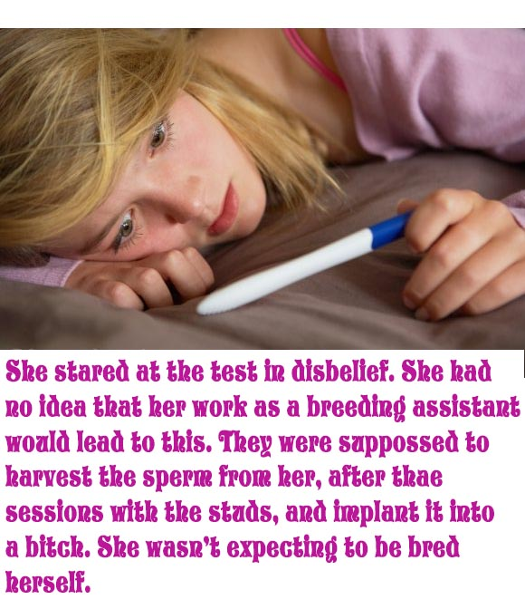

She stared at the pregnancy test in disbelief.

She had no idea that her work as a breeding assistant would lead to this.

They were supposed to harvest the ***sperm*** from her after the sessions with the studs and implant it into a bitch.

**She wasn't expecting to be bred herself!**



[](http://www.hotlegsinlove.com/ContactXXX.htm)

