Dog Rape Fantasies - 2

*** Owned By A Dog ***
https://www.beastforum.com/showtopic-122030-930.html

Demi Owned by a Dog

"Honey, I'm home. Where are you?"

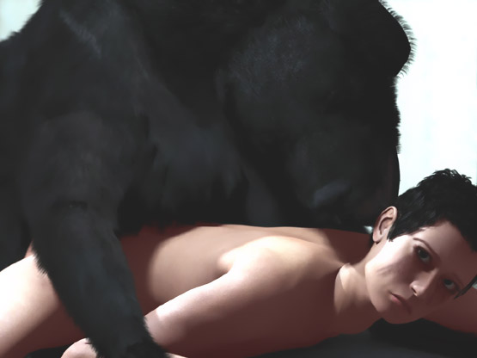

Sherilyn Owned by a Dog

"Honey, I'm home. Did you feed my brother's dog? ... What the..."

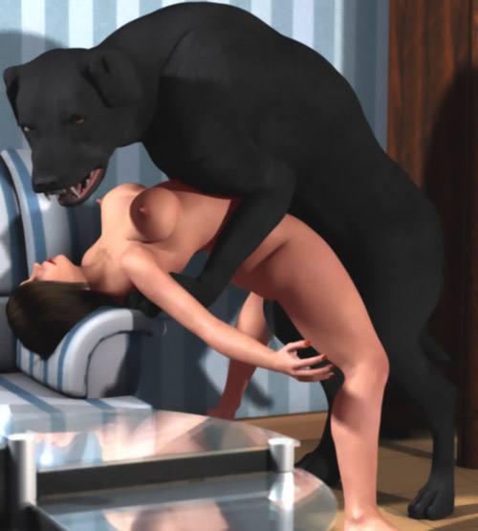

Kaoru Owned by a Dog

"Honey, I'm home.... Oh my!"

"King, I've told you a dozen times that she's not your bitch! She's my wife! You damn dog have filled her with your sperm again. Get off her!!"

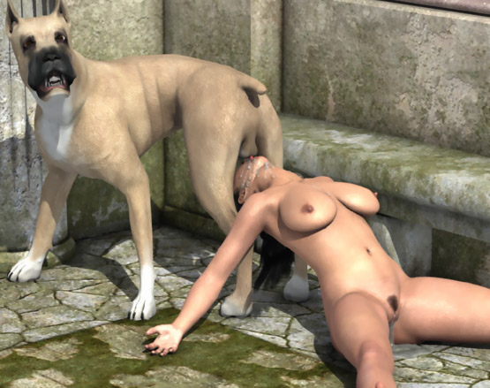

Marlena Owned by a Dog

Once again a husband can only watch as a dog breeds his helpless wife.

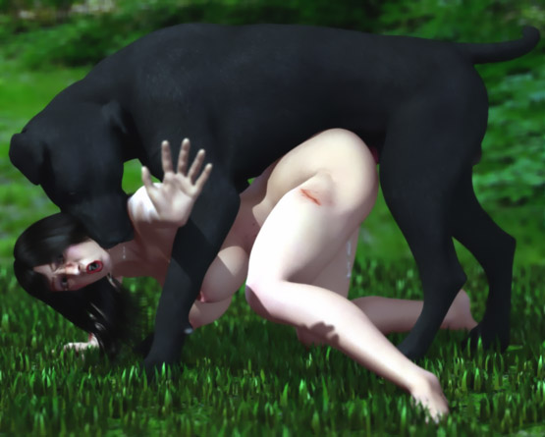

Emo Owned by a Great Dane

"Honey, I'm home. Saw Mike outside. He hasn't seen his dog since morning. Have you seen him?"

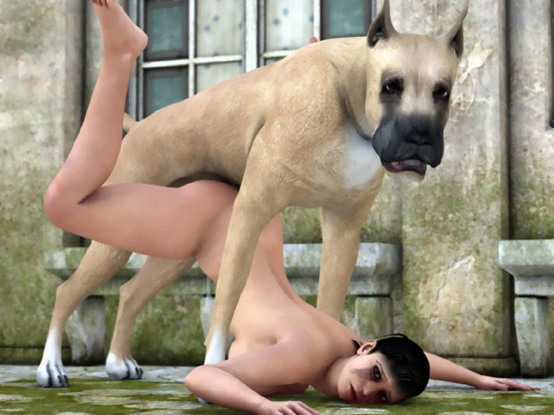

Samantha Owned by a Dog

"Honey, I'm home. Buster, I'm home. Come here, boy..."

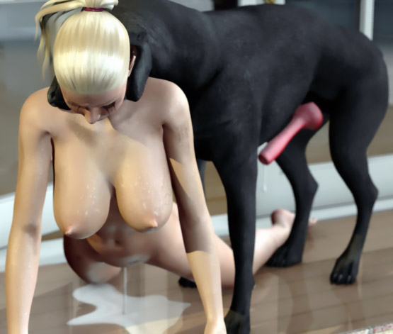

Owned by Rover

"Rover! What have you done? Let her go!"

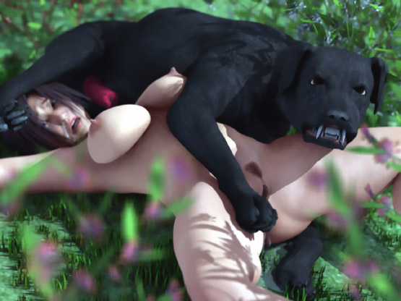

Chloe Owned by a Dog

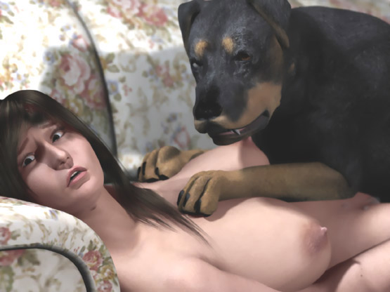

Stefany Owned by a Dog

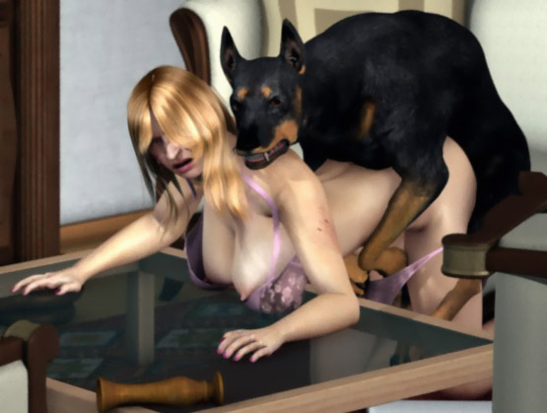

Jennifer Owned by Dogs

"Don't leave me alone!"

But he can only watch his helpless wife being savagely used by a pack of dogs.

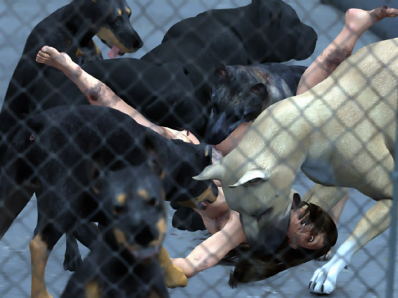

Jessica Owned by a Dog

"Honey, sorry it took so long. But now your lover is coming..."

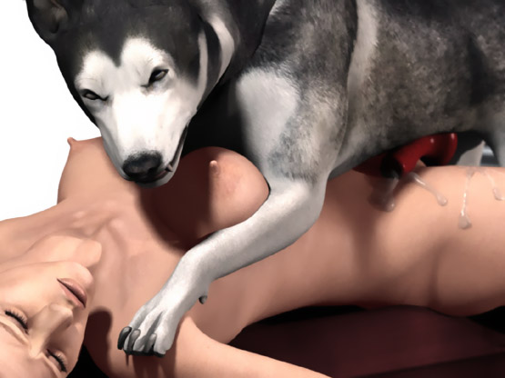

The dog was not finished with breeding his human bitch. He was not going to give her away.

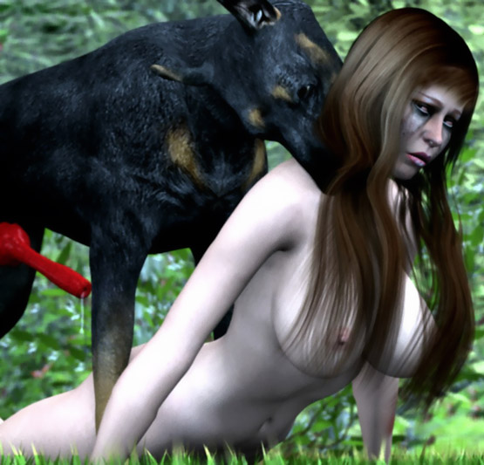

Christy Owned by a Dog

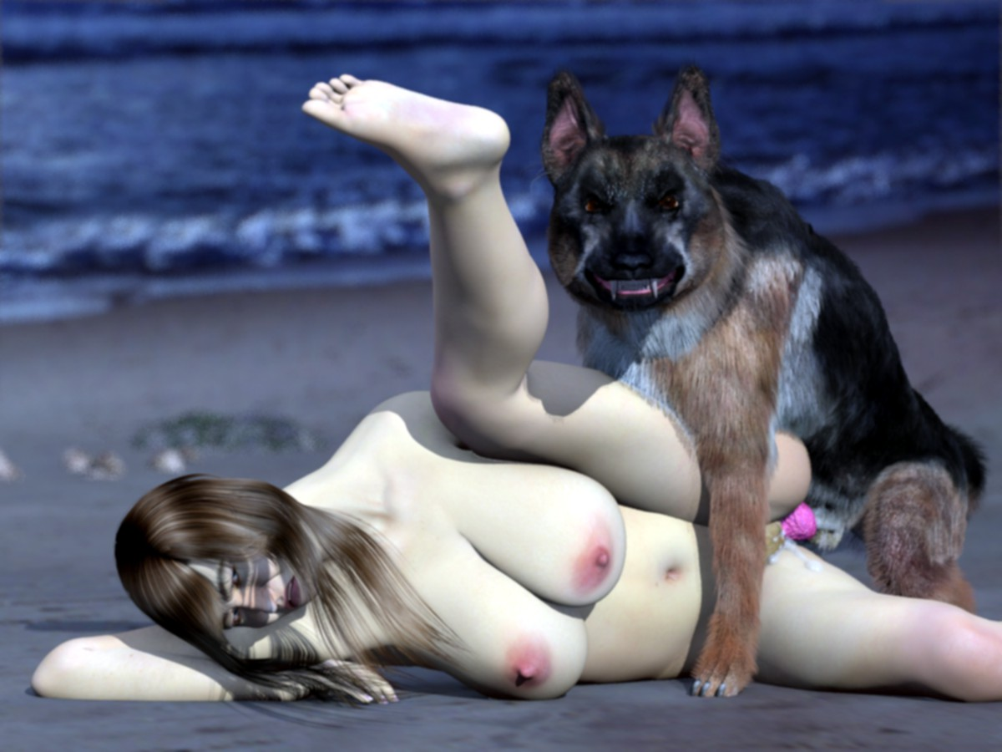

https://www.beastforum.com/showtopic-122030-1185.html

Wendy Owned by a Dog

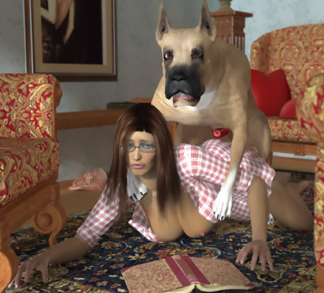

A (too) friendly stray dog



Felicity Owned by a Dog



- - - - - - - - - - - - - - - - - - - - - - - - - - - - - - - - - - - - - - - - - - - - - - - - - - - - - - - - - - - - - - - - - - - - - - - -

https://www.beastforum.com/showtopic-122030-1215.html

Working too late ...

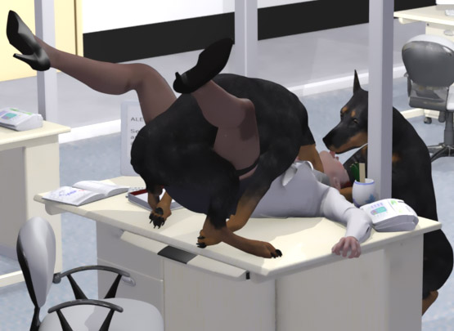

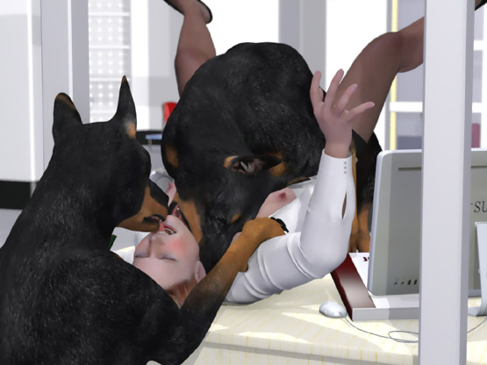

- - - - - - - - - - - - - - - - - - - - - - - - - - - - - - - - - - - - - - - - - - - - - - - - - - - - - - - - - - - - - - - - - - - - - - - -

https://www.beastforum.com/showtopic-122030-1215.html

*** Homeless Sleeping ***
She was homeless and slept in an abandoned building. She had to pay a rent, though. The local stray dogs used her as their bitch ...

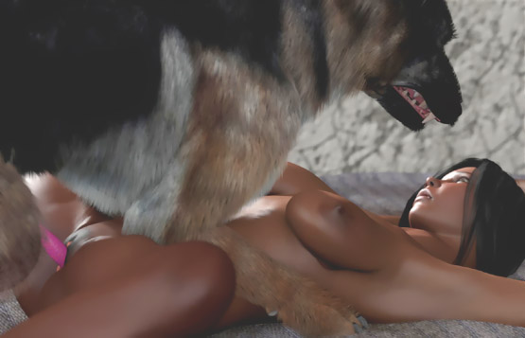

- - - - - - - - - - - - - - - - - - - - - - - - - - - - - - - - - - - - - - - - - - - - - - - - - - - - - - - - - - - - - - - - - - - - - - - -

https://www.beastforum.com/showtopic-122030-1230.html

*** Knotted and Suspended ***
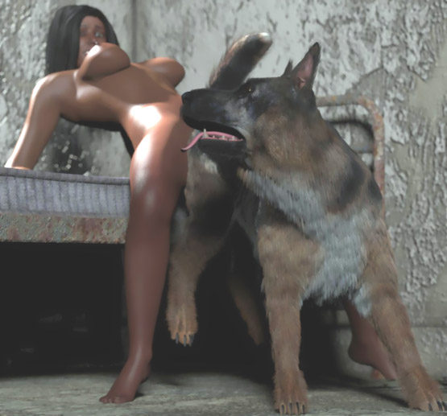

- - - - - - - - - - - - - - - - - - - - - - - - - - - - - - - - - - - - - - - - - - - - - - - - - - - - - - - - - - - - - - - - - - - - - - - -

https://www.beastforum.com/showtopic-122030-1230.html
*** Paying the Rent ***

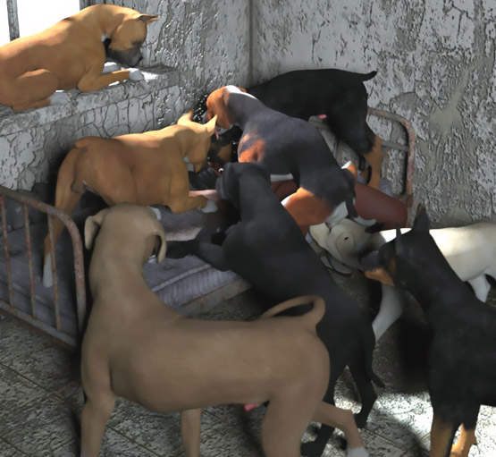

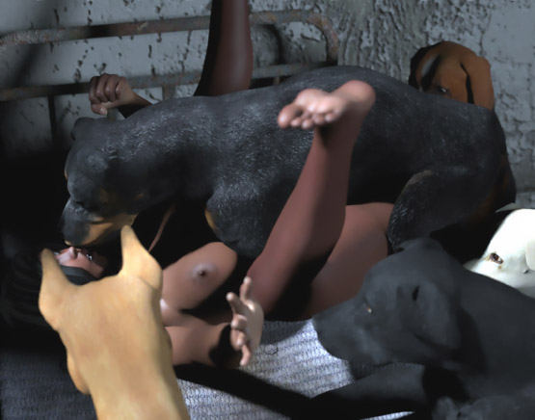

- - - - - - - - - - - - - - - - - - - - - - - - - - - - - - - - - - - - - - - - - - - - - - - - - - - - - - - - - - - - - - - - - - - - - - - -

https://www.beastforum.com/showtopic-122030-1260.html
*** Breeding over Husband's Face ***
Matt was lying on bed with his head over the edge when his wife sat on her chest, grabbed his head and made him lick her pussy.

Suddenly Giant -- their huge black dog -- jumped over her. Matt's face was being smothered by his wife's ass as the dog forced its huge cock into her pussy and filled her with its sperm.

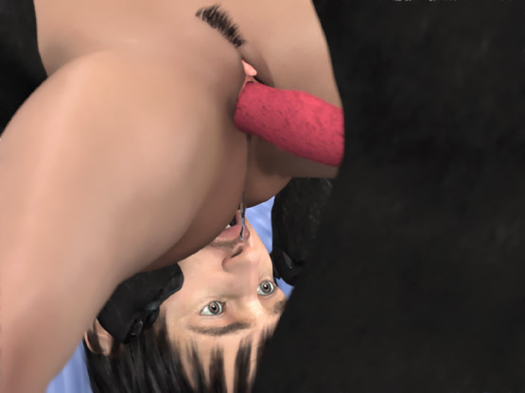

- - - - - - - - - - - - - - - - - - - - - - - - - - - - - - - - - - - - - - - - - - - - - - - - - - - - - - - - - - - - - - - - - - - - - - - -

https://www.beastforum.com/showtopic-122030-1275.html

Lucy tried doggy sex with Rex, her Great Dane. The huge dog knotted her painfully and dragged her by her pussy on the floor like a rag doll. She never wanted to try that again!

Rex, however, had other thoughts. Lucy was now his bitch and he would breed her whenever he wanted. He would not take "no" as an answer!

"Rex! Not again!
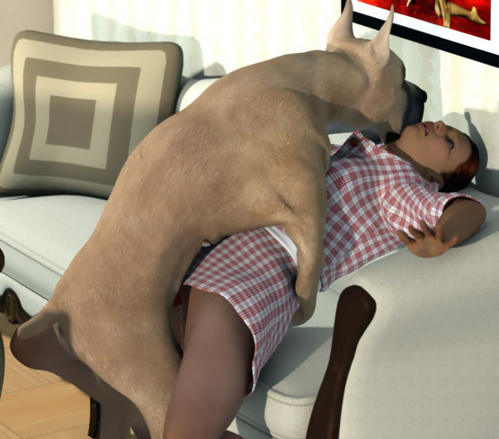

- - - - - - - - - - - - - - - - - - - - - - - - - - - - - - - - - - - - - - - - - - - - - - - - - - - - - - - - - - - - - - - - - - - - - - - -

https://www.beastforum.com/showtopic-122030-1335.html
***The Trash ***

Denise was taking out a bag of trash ...

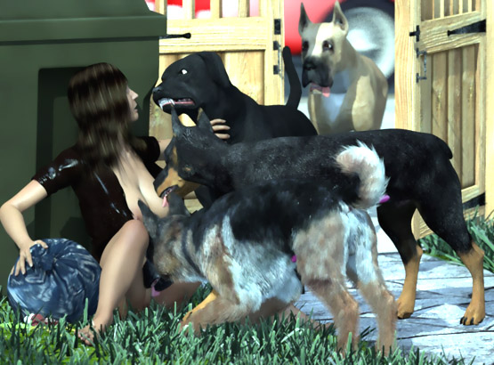

- - - - - - - - - - - - - - - - - - - - - - - - - - - - - - - - - - - - - - - - - - - - - - - - - - - - - - - - - - - - - - - - - - - - - - - -

https://www.beastforum.com/showtopic-122030-1380.html
*** Washing The School Floor ***

The head of the school wouldn't tolerate any complaints about his dog. And she couldn't risk losing her job.

Now the dog had chosen her as his bitch. Her - a married woman and a mother of two!

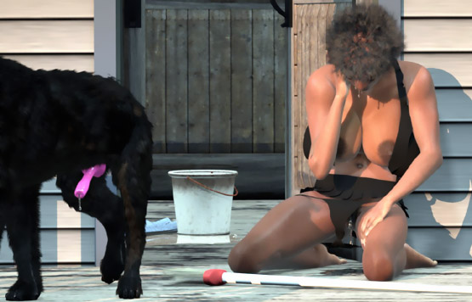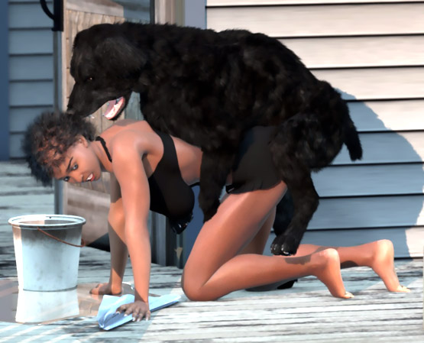

Her husband comes to see her working. First he thought she was washing the stairs. But when the huge dog started growling, he understood that something was wrong...

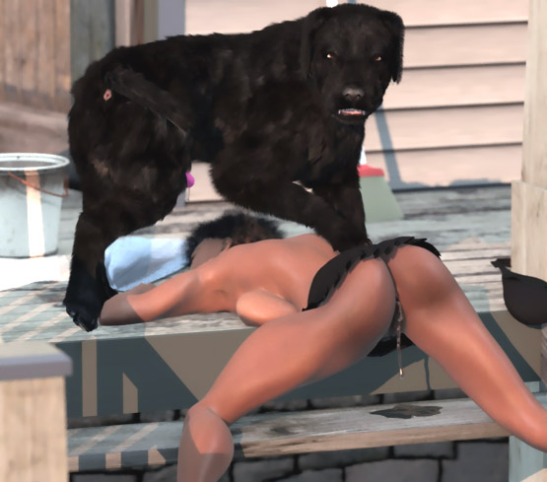

- - - - - - - - - - - - - - - - - - - - - - - - - - - - - - - - - - - - - - - - - - - - - - - - - - - - - - - - - - - - - - - - - - - - - - - -

https://www.beastforum.com/showtopic-122030-1395.html
*** Surprise on a Private Beach ***

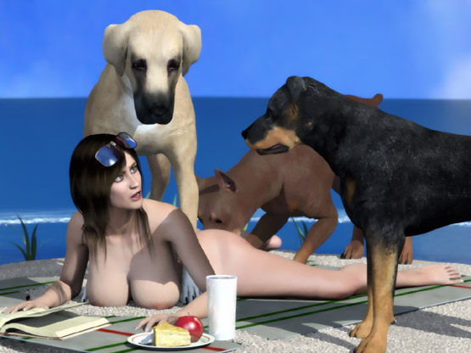

- - - - - - - - - - - - - - - - - - - - - - - - - - - - - - - - - - - - - - - - - - - - - - - - - - - - - - - - - - - - - - - - - - - - - - - -

https://www.beastforum.com/showtopic-122030-1395.html
*** Wendy Taken on a Chair ***

Wendy wakes up and remembers all the wet dreams she had in the night. She takes off her wet nightgown and walks to the living room.

She screams when she feels the paws of her Great Dane on her back. She falls on a chair and then feels the weight of the huge dog over her as his doggy cock penetrates her already-wet pussy.

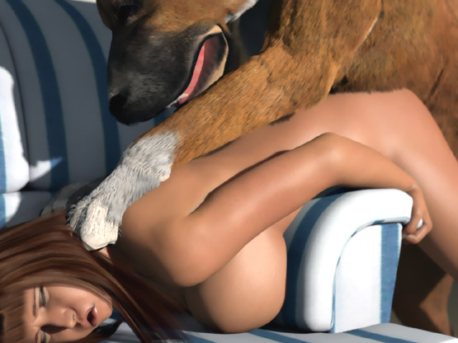

- - - - - - - - - - - - - - - - - - - - - - - - - - - - - - - - - - - - - - - - - - - - - - - - - - - - - - - - - - - - - - - - - - - - - - - -

https://www.beastforum.com/showtopic-122030-1395.html
*** Why? ***

Viviana was sitting on a chair with her hands behind her head and doggy semen leaking from her abused pussy.

"Why are you doing this to me?" she asked her huge dogs as they licked her clean and growled if she tried to move.

She didn't get an answer. She knew that she had to clean the doggy sperm from the floor and from the chair.

And while she was kneeling on the floor, the dogs would RAPE her again!

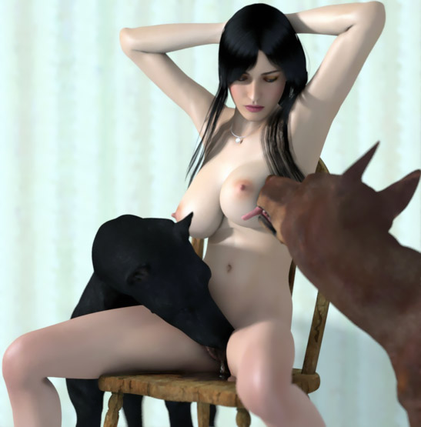

- - - - - - - - - - - - - - - - - - - - - - - - - - - - - - - - - - - - - - - - - - - - - - - - - - - - - - - - - - - - - - - - - - - - - - - -

https://www.beastforum.com/showtopic-122030-1740.html

A hooker for her pimp and his huge dog ...

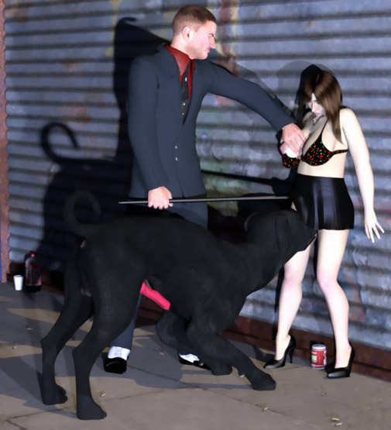

- - - - - - - - - - - - - - - - - - - - - - - - - - - - - - - - - - - - - - - - - - - - - - - - - - - - - - - - - - - - - - - - - - - - - - - -

https://www.beastforum.com/showtopic-122030-1770.html

The pack of dogs ...

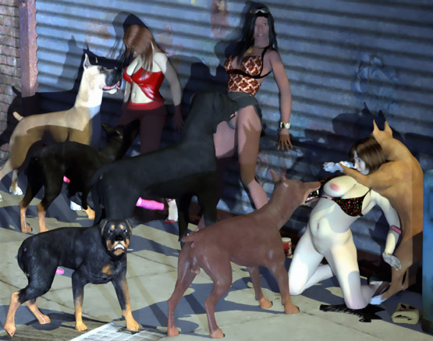

- - - - - - - - - - - - - - - - - - - - - - - - - - - - - - - - - - - - - - - - - - - - - - - - - - - - - - - - - - - - - - - - - - - - - - - -

https://www.beastforum.com/showtopic-122030-1950.html
*** Incident on a sidewalk***

"Grrrrr! Stay away!"
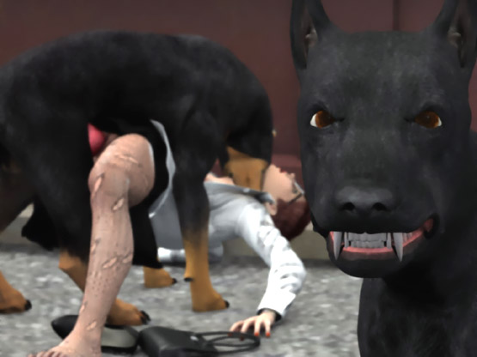

- - - - - - - - - - - - - - - - - - - - - - - - - - - - - - - - - - - - - - - - - - - - - - - - - - - - - - - - - - - - - - - - - - - - - - -

https://www.beastforum.com/showtopic-122030-1965.html
*** Doggy Gang-Bang on a Terrace ***

After chatting with his neighbor, he came back to the terrace where he had left her ...

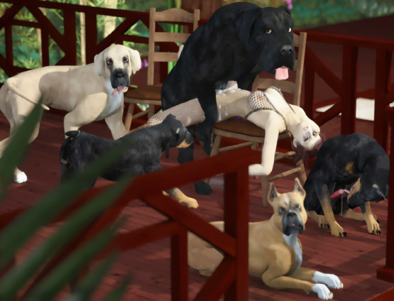

- - - - - - - - - - - - - - - - - - - - - - - - - - - - - - - - - - - - - - - - - - - - - - - - - - - - - - - - - - - - - - - - - - - - - - -

https://www.beastforum.com/showtopic-122030-2025.html
*** Mami the Maid ***

Mami promised to work for a week as a maid in secluded house. The master had briefly mentioned that he had a dog.

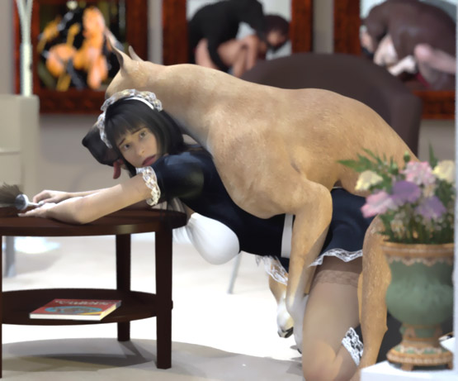

- - - - - - - - - - - - - - - - - - - - - - - - - - - - - - - - - - - - - - - - - - - - - - - - - - - - - - - - - - - - - - - - - - - - - - -

https://www.beastforum.com/showtopic-122030-2040.html

"Come on! What's taking you so long with the New Year's paper?"

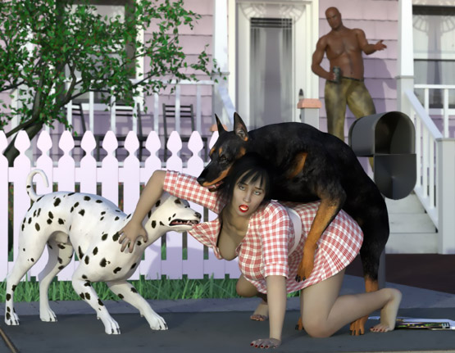

- - - - - - - - - - - - - - - - - - - - - - - - - - - - - - - - - - - - - - - - - - - - - - - - - - - - - - - - - - - - - - - - - - - - - - -

https://www.beastforum.com/showtopic-122030-2115.html
*** Sarah Trapped on the Stairs ***


- - - - - - - - - - - - - - - - - - - - - - - - - - - - - - - - - - - - - - - - - - - - - - - - - - - - - - - - - - - - - - - - - - - - - - -

https://www.beastforum.com/showtopic-122030-2130.html
*** Katie Jogging on a Beach ***

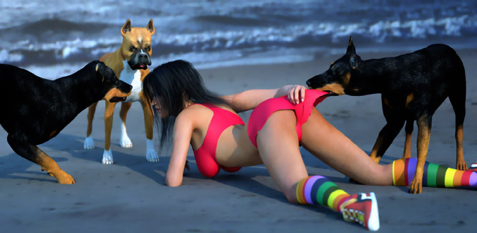

- - - - - - - - - - - - - - - - - - - - - - - - - - - - - - - - - - - - - - - - - - - - - - - - - - - - - - - - - - - - - - - - - - - - - - -

https://www.beastforum.com/showtopic-122030-2640.html
*** Breeding Time ***
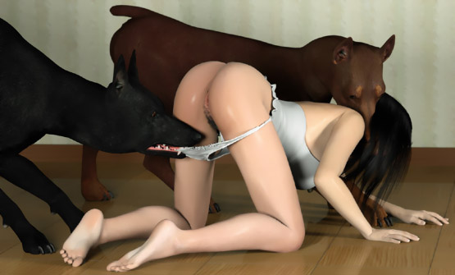

- - - - - - - - - - - - - - - - - - - - - - - - - - - - - - - - - - - - - - - - - - - - - - - - - - - - - - - - - - - - - - - - - - - - - - -

https://www.beastforum.com/showtopic-122030-2640.html



- - - - - - - - - - - - - - - - - - - - - - - - - - - - - - - - - - - - - - - - - - - - - - - - - - - - - - - - - - - - - - - - - - - - - - -

https://www.beastforum.com/showtopic-122030-2760.html

A public punishment for an unfaithful wife ...
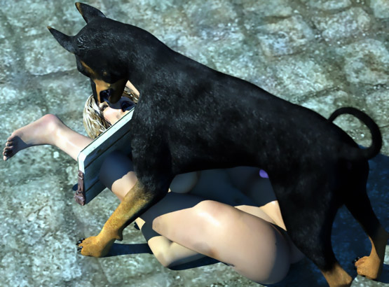

- - - - - - - - - - - - - - - - - - - - - - - - - - - - - - - - - - - - - - - - - - - - - - - - - - - - - - - - - - - - - - - - - - - - - - -

https://www.beastforum.com/showtopic-122030-2775.html

Katie's Dog: One of those days

Defeated with the tip of her dog's cock in her pussy, Katie knows that in a few seconds her dog will pin her harshly on the bed and painfully slam his huge hard cock all the way into her vagina and start breeding her.

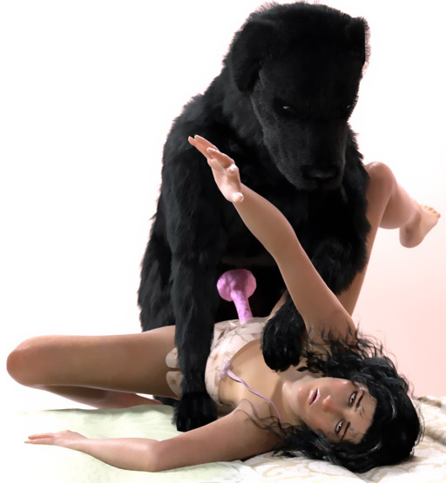

Katie's Dog: After Shower

Pinned on the chair, Katie feels a knot swelling in her vagina, locking her pussy around her dog's huge throbbing cock that fills her with warm doggy sperm.

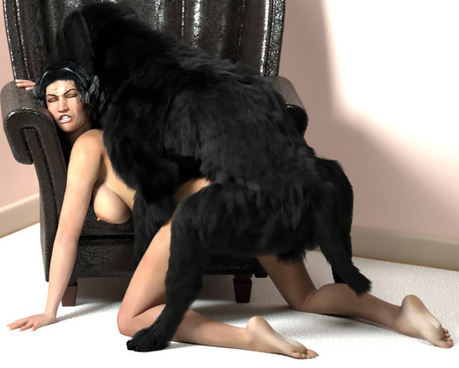

- - - - - - - - - - - - - - - - - - - - - - - - - - - - - - - - - - - - - - - - - - - - - - - - - - - - - - - - - - - - - - - - - - - - - - -

https://www.beastforum.com/showtopic-175296.html
*** Aria and the Dalmatian ***


- - - - - - - - - - - - - - - - - - - - - - - - - - - - - - - - - - - - - - - - - - - - - - - - - - - - - - - - - - - - - - - - - - - - - - -

https://www.beastforum.com/showtopic-175296.html

Jessica waited for her boyfriend to come from the shower when his dog took advantage of the situation ...



Finally he came from the shower...



- - - - - - - - - - - - - - - - - - - - - - - - - - - - - - - - - - - - - - - - - - - - - - - - - - - - - - - - - - - - - - - - - - - - - - -
https://www.beastforum.com/showtopic-175296.html
*** Jessica Dogsitting ***

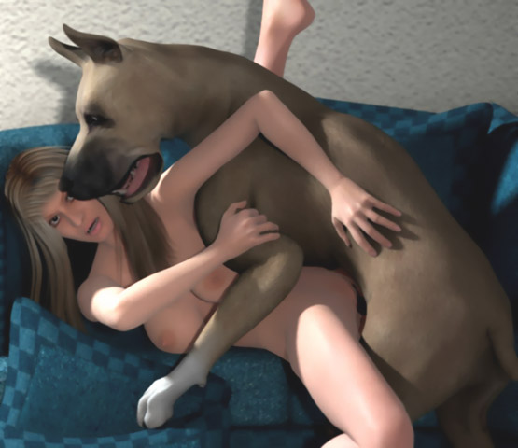

- - - - - - - - - - - - - - - - - - - - - - - - - - - - - - - - - - - - - - - - - - - - - - - - - - - - - - - - - - - - - - - - - - - - - - -
https://www.beastforum.com/showtopic-175296.html
*** Pamela Relaxing ***

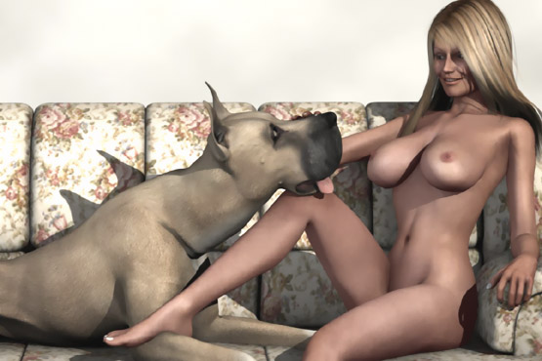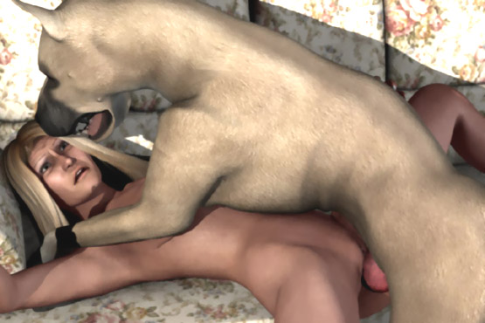

- - - - - - - - - - - - - - - - - - - - - - - - - - - - - - - - - - - - - - - - - - - - - - - - - - - - - - - - - - - - - - - - - - - - - - -

https://www.beastforum.com/showtopic-175296-15.html

In the evening, Lindsay's friends found her on the beach ...

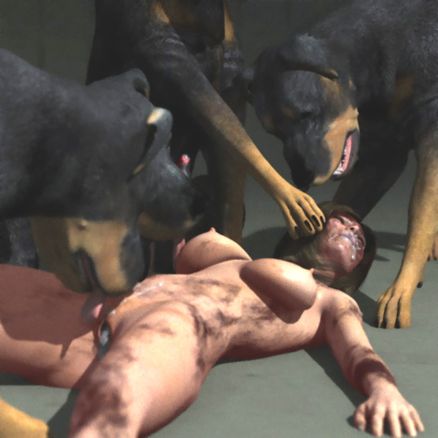

- - - - - - - - - - - - - - - - - - - - - - - - - - - - - - - - - - - - - - - - - - - - - - - - - - - - - - - - - - - - - - - - - - - - - - -

https://www.beastforum.com/showtopic-175296-30.html
*** Demi Helpless on the Bed ***

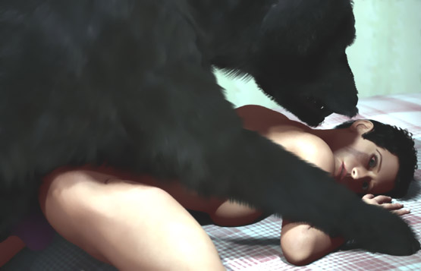

- - - - - - - - - - - - - - - - - - - - - - - - - - - - - - - - - - - - - - - - - - - - - - - - - - - - - - - - - - - - - - - - - - - - - - -

https://www.beastforum.com/showtopic-175296-30.html
*** Joslyn and Dog ***

When her lover went to play with his buddies, he used to leave his huge black dog at her home ...

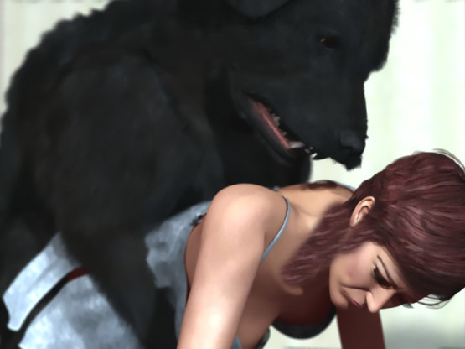

- - - - - - - - - - - - - - - - - - - - - - - - - - - - - - - - - - - - - - - - - - - - - - - - - - - - - - - - - - - - - - - - - - - - - - -

https://www.beastforum.com/showtopic-175296-30.html
*** Michelle, Lucy, and Susan - British Glamour Girls on the Beach ***

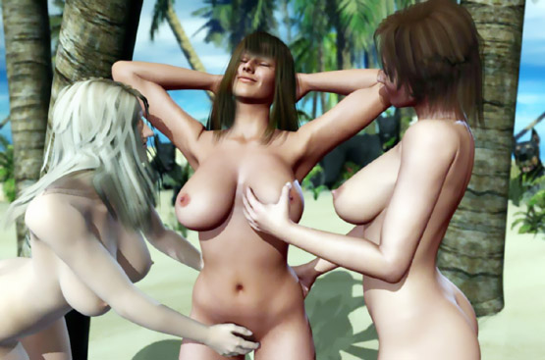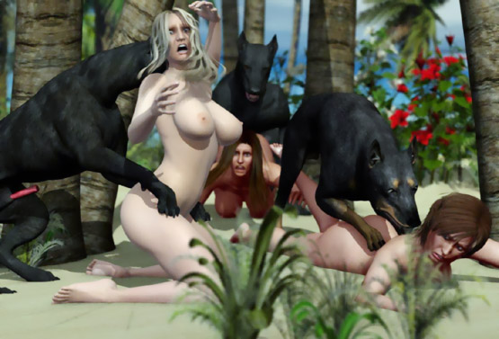

- - - - - - - - - - - - - - - - - - - - - - - - - - - - - - - - - - - - - - - - - - - - - - - - - - - - - - - - - - - - - - - - - - - - - - -

https://www.beastforum.com/showtopic-175296-30.html
*** Lucy and a Stud Dog ***

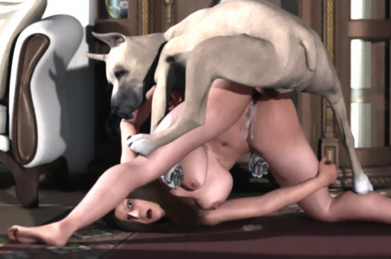

- - - - - - - - - - - - - - - - - - - - - - - - - - - - - - - - - - - - - - - - - - - - - - - - - - - - - - - - - - - - - - - - - - - - - - -

https://www.beastforum.com/showtopic-175296-30.html
*** Anna Nicole on the Couch ***

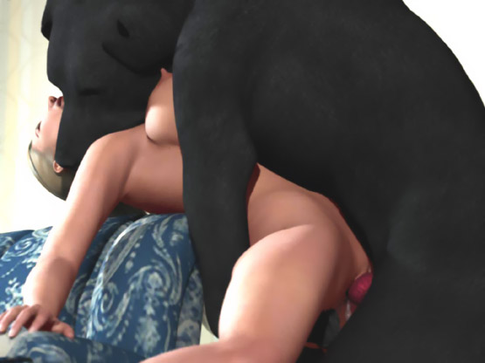

- - - - - - - - - - - - - - - - - - - - - - - - - - - - - - - - - - - - - - - - - - - - - - - - - - - - - - - - - - - - - - - - - - - - - - -

https://www.beastforum.com/showtopic-175296-75.html
*** Joslyn Owned by a Dog ***
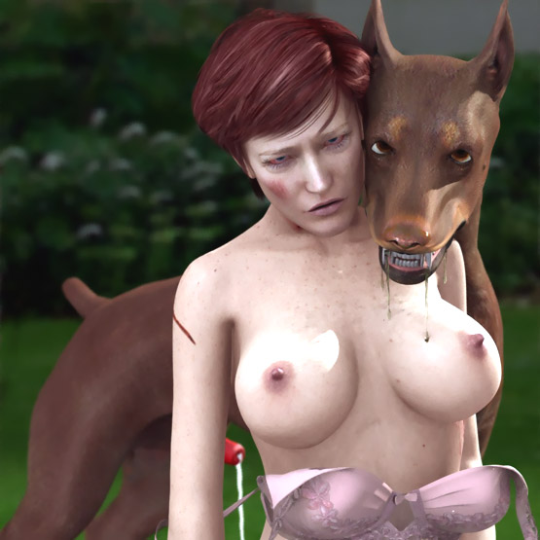

- - - - - - - - - - - - - - - - - - - - - - - - - - - - - - - - - - - - - - - - - - - - - - - - - - - - - - - - - - - - - - - - - - - - - - - -

https://www.beastforum.com/showtopic-156123-210.html
One would hope to be in the right place at the right time to get something like this ...

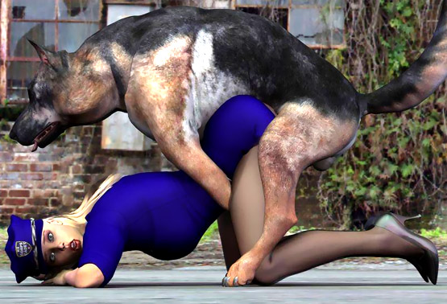

- - - - - - - - - - - - - - - - - - - - - - - - - - - - - - - - - - - - - - - - - - - - - - - - - - - - - - - - - - - - - - - - - - - - - - -

https://www.beastforum.com/showtopic-175296-75.html
*** Buffy and a Wolf ***

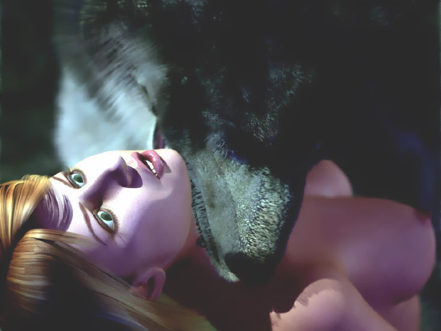

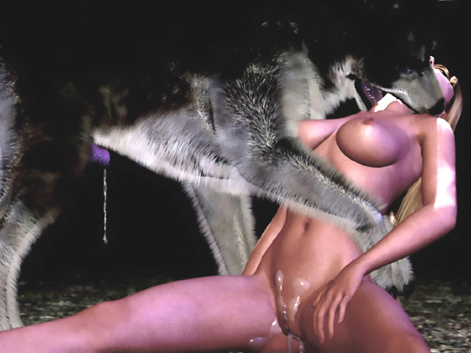

- - - - - - - - - - - - - - - - - - - - - - - - - - - - - - - - - - - - - - - - - - - - - - - - - - - - - - - - - - - - - - - - - - - - - - -

https://www.beastforum.com/showtopic-175296-90.html
*** Betty and a Monster Dog ***

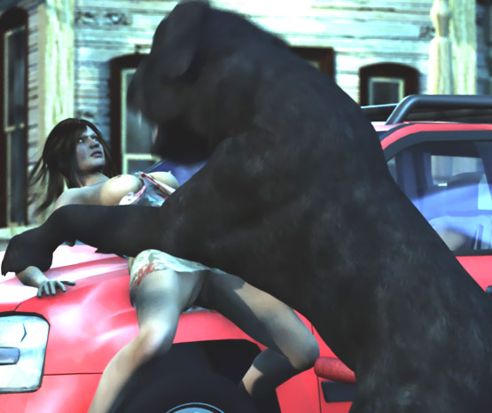

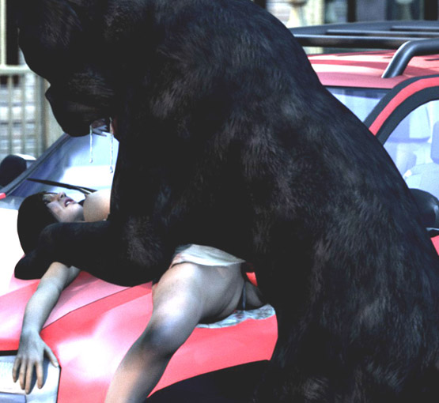

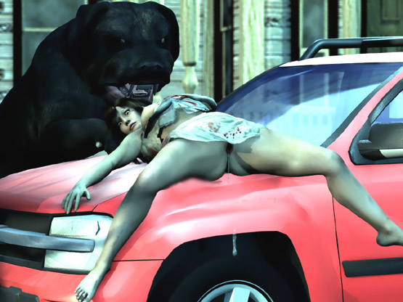

- - - - - - - - - - - - - - - - - - - - - - - - - - - - - - - - - - - - - - - - - - - - - - - - - - - - - - - - - - - - - - - - - - - - - - -

https://www.beastforum.com/showtopic-175296-120.html
*** Shookie Meets a Horny Wolf ***

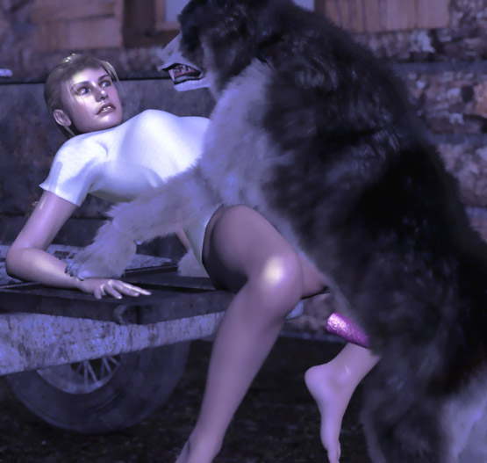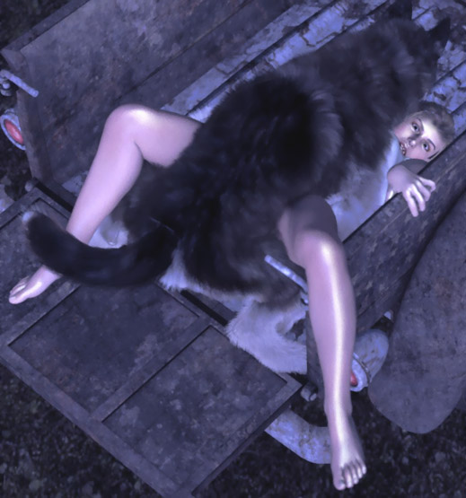

- - - - - - - - - - - - - - - - - - - - - - - - - - - - - - - - - - - - - - - - - - - - - - - - - - - - - - - - - - - - - - - - - - - - - - -

https://www.beastforum.com/showtopic-122037.html
*** In a Dungeon with Dogs ***

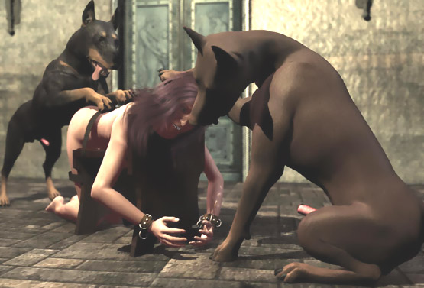

- - - - - - - - - - - - - - - - - - - - - - - - - - - - - - - - - - - - - - - - - - - - - - - - - - - - - - - - - - - - - - - - - - - - - - -

https://www.beastforum.com/showtopic-122037-60.html
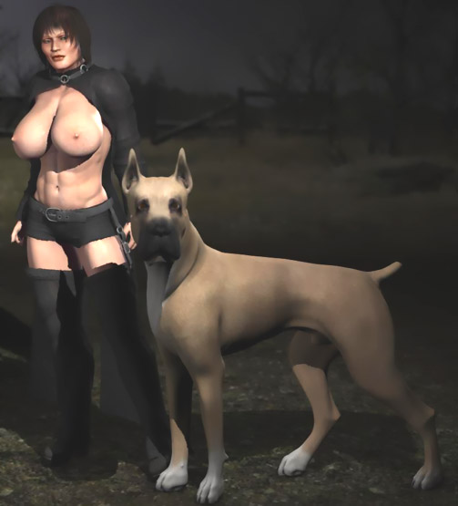

- - - - - - - - - - - - - - - - - - - - - - - - - - - - - - - - - - - - - - - - - - - - - - - - - - - - - - - - - - - - - - - - - - - - - - -

https://www.beastforum.com/showtopic-122037-75.html

She just wanted to spend a quiet evening on the beach. But a pack of horny stray dogs had other ideas ...

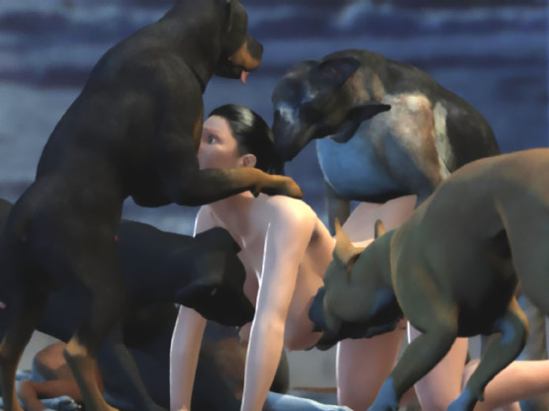

- - - - - - - - - - - - - - - - - - - - - - - - - - - - - - - - - - - - - - - - - - - - - - - - - - - - - - - - - - - - - - - - - - - - - - -

https://www.beastforum.com/showtopic-122037-90.html
*** On a Table ***

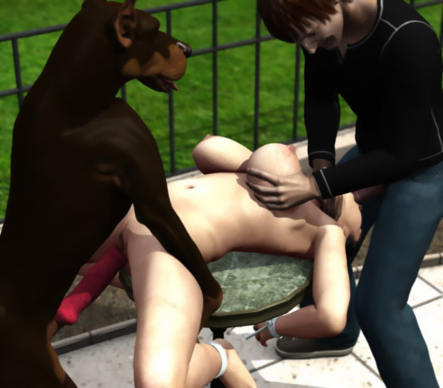

- - - - - - - - - - - - - - - - - - - - - - - - - - - - - - - - - - - - - - - - - - - - - - - - - - - - - - - - - - - - - - - - - - - - - - -

https://www.beastforum.com/showtopic-122037-135.html

One night Shione and Carl are sitting by a campfire when suddenly they are faced by 3 wolves. They force Carl to stay away while one-by-one they breed the girl ...

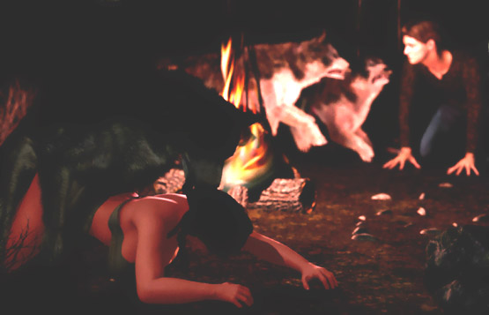

- - - - - - - - - - - - - - - - - - - - - - - - - - - - - - - - - - - - - - - - - - - - - - - - - - - - - - - - - - - - - - - - - - - - - - -

https://www.beastforum.com/showtopic-122037-150.html
*** Lost and found ***

Last year Mike, Arianna, and their 18-year old daughter Sara got lost in the wilderness. After 2 nights in the forest, Arianna and Sara were picking berries when they lost contact with Mike. For two days he tried to find them until he finally saw Arianna. He was shocked!

She was naked and dirty, filled with scratched and bruises. She was sitting on the ground with her legs spread wide and leaning on a wolf lying behind her. Another wolf was licking sperm leaking from her gaping pussy. Tears had dried on her dirty face.

Daughter Sara was weeping on her hands-and-knees as yet another wolf pounded her stretched once-virgin pussy with his huge cock.

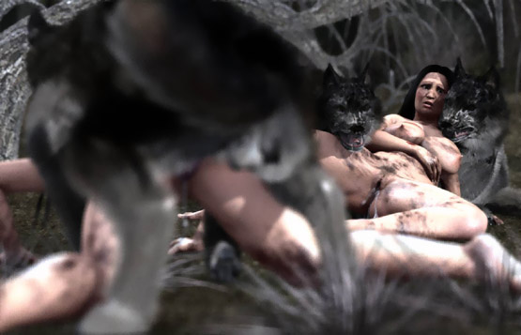

- - - - - - - - - - - - - - - - - - - - - - - - - - - - - - - - - - - - - - - - - - - - - - - - - - - - - - - - - - - - - - - - - - - - - - -

https://www.beastforum.com/showtopic-122037-165.html
*** Daphne and Velma and ScoobyDoo ***

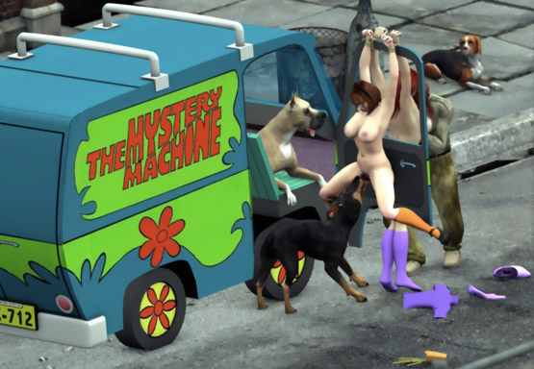

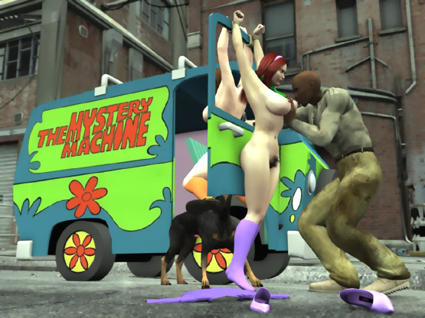

- - - - - - - - - - - - - - - - - - - - - - - - - - - - - - - - - - - - - - - - - - - - - - - - - - - - - - - - - - - - - - - - - - - - - - -

Esha is a 5 ft voluptous woman living with her Great Dane.

Her Great Dane had her pinned on the table and forced his bony slimy cock into her pussy. Esha felt the cock swell with each thrust. Soon the helpless woman wailed in agony waiting for her painful breeding to end.

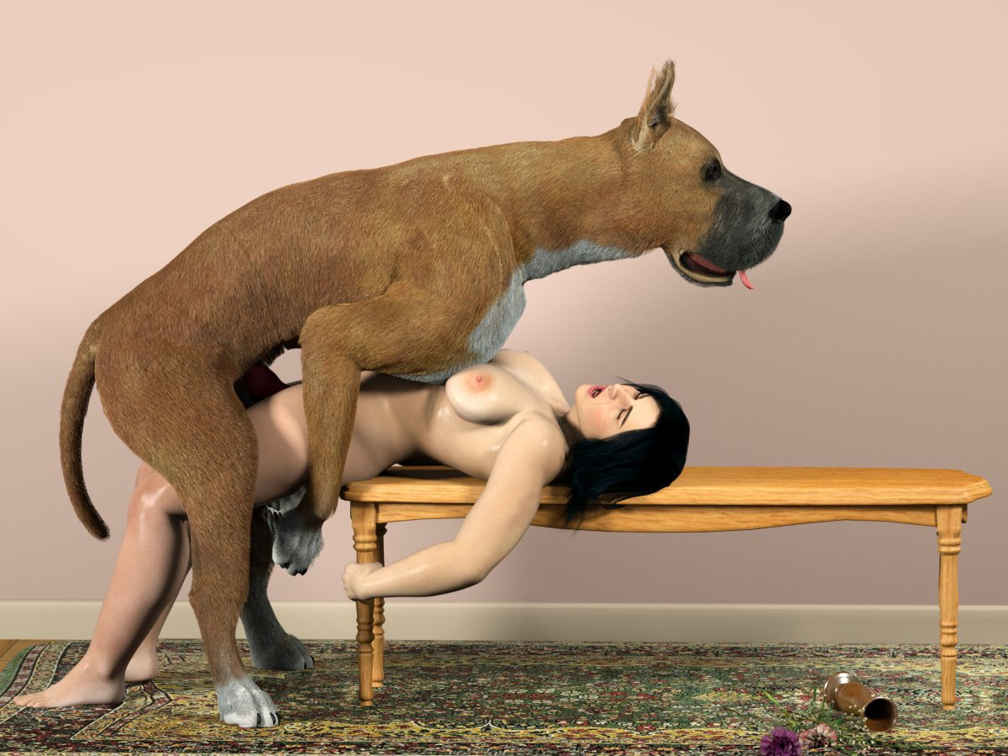

- - - - - - - - - - - - - - - - - - - - - - - - - - - - - - - - - - - - - - - - - - - - - - - - - - - - - - - - - - - - - - - - - - - - - - -

https://www.beastforum.com/showtopic-122030-2970.html

Yesterday I visited my neighbor to see if my two Great Danes had sneaked into her house.

They had!



- - - - - - - - - - - - - - - - - - - - - - - - - - - - - - - - - - - - - - - - - - - - - - - - - - - - - - - - - - - - - - - - - - - - - - -

https://www.beastforum.com/showtopic-122030-3045.html
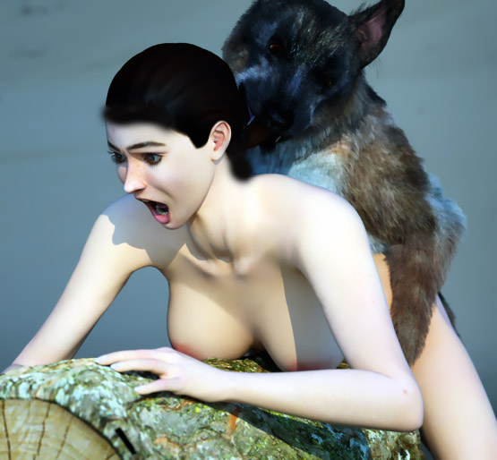

- - - - - - - - - - - - - - - - - - - - - - - - - - - - - - - - - - - - - - - - - - - - - - - - - - - - - - - - - - - - - - - - - - - - - - -

https://www.beastforum.com/showtopic-122030-3255.html

She didn't know why her dogs were fighting over her. She was soon to find out ...

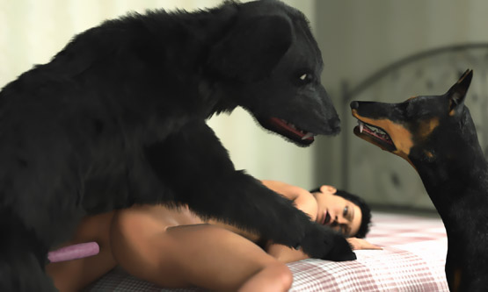

- - - - - - - - - - - - - - - - - - - - - - - - - - - - - - - - - - - - - - - - - - - - - - - - - - - - - - - - - - - - - - - - - - - - - - -

https://www.beastforum.com/showtopic-122030-3480.html

"Sorry I left you alone..."

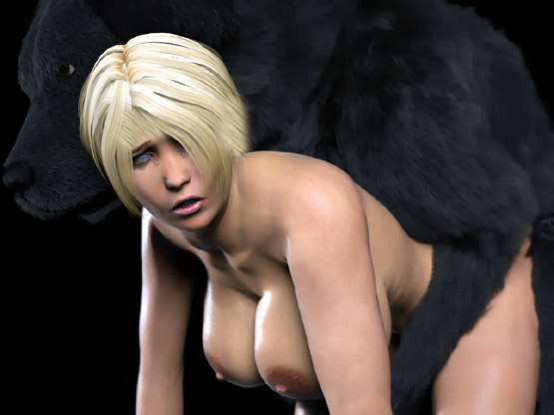

- - - - - - - - - - - - - - - - - - - - - - - - - - - - - - - - - - - - - - - - - - - - - - - - - - - - - - - - - - - - - - - - - - - - - - -

https://www.beastforum.com/showtopic-122030-15.html
*** Hands Cuffed behind Her Back ***



- - - - - - - - - - - - - - - - - - - - - - - - - - - - - - - - - - - - - - - - - - - - - - - - - - - - - - - - - - - - - - - - - - - - - - -

https://www.beastforum.com/showtopic-122030-15.html
*** In the Backyard ***

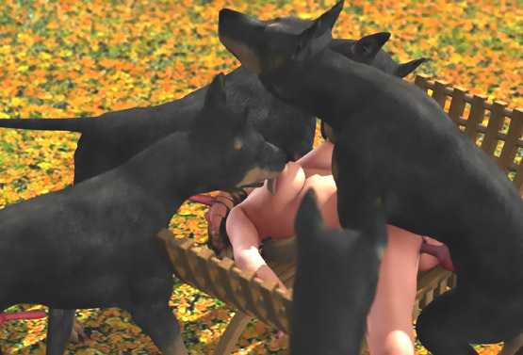

- - - - - - - - - - - - - - - - - - - - - - - - - - - - - - - - - - - - - - - - - - - - - - - - - - - - - - - - - - - - - - - - - - - - - - -

https://www.beastforum.com/showtopic-122030-75.html
*** Used by Dogs ***

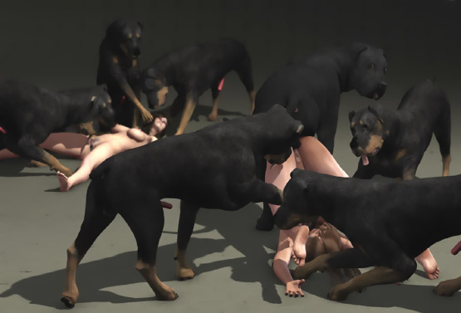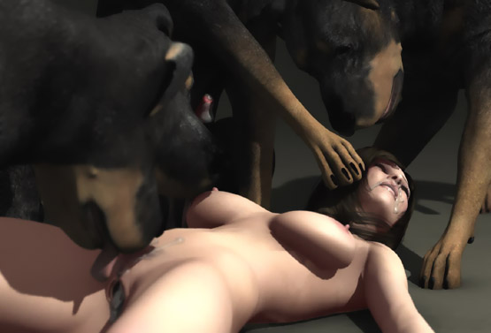

- - - - - - - - - - - - - - - - - - - - - - - - - - - - - - - - - - - - - - - - - - - - - - - - - - - - - - - - - - - - - - - - - - - - - - -

https://www.beastforum.com/showtopic-122030-180.html
*** The Harem of a Huge Dane ***

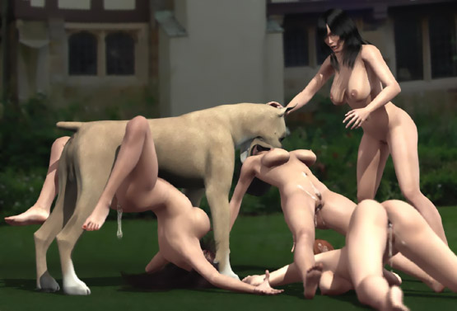

*** Just a Friendly Lick ***

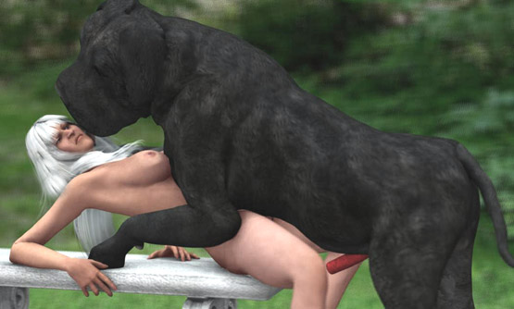

*** Tied on a Beach ***

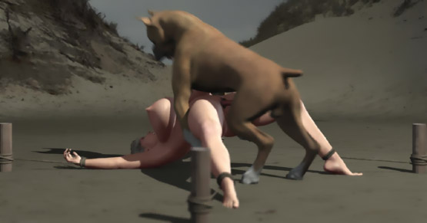

*** In the Backyard ***
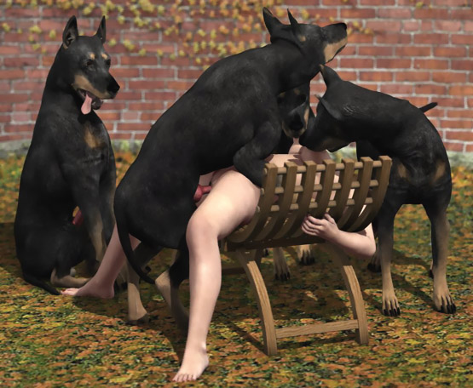

*** The Dog and His Prey ***

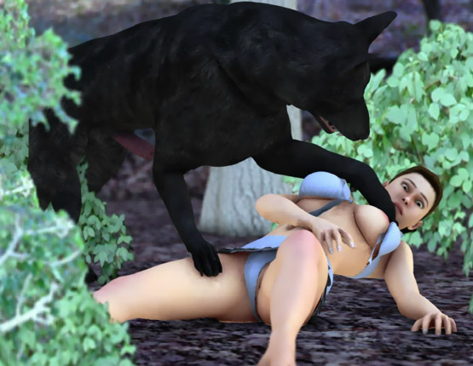

*** Taken by a Dog ***

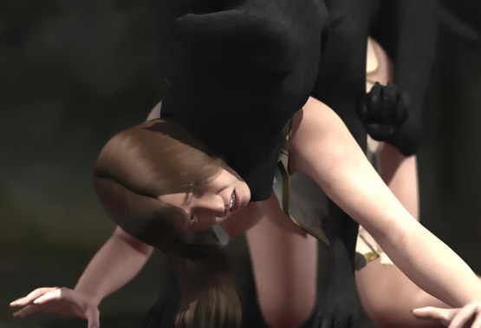

***The Howling ***

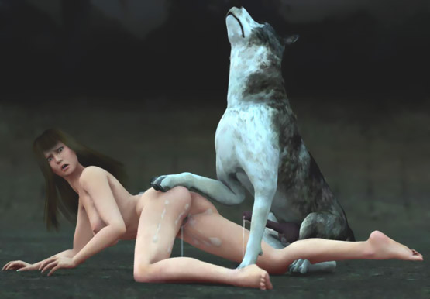

*** Dragged and Licked ***



*** Claimed by a Dog ***
"Stop!! Don't come closer! You can't help me now. It's too late ..."

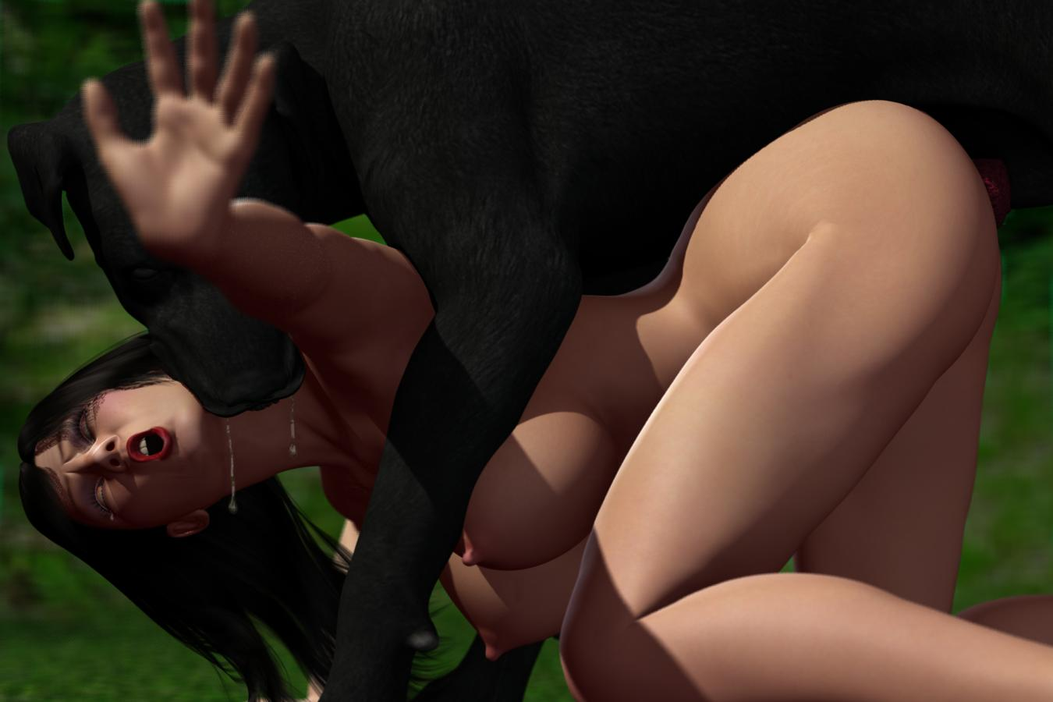

- - - - - - - - - - - - - - - - - - - - - - - - - - - - - - - - - - - - - - - - - - - - - - - - - - - - - - - - - - - - - - - - - - - - - - -

https://www.beastforum.com/showtopic-122030-735.html
Knocked down into the bathtub and bred ...

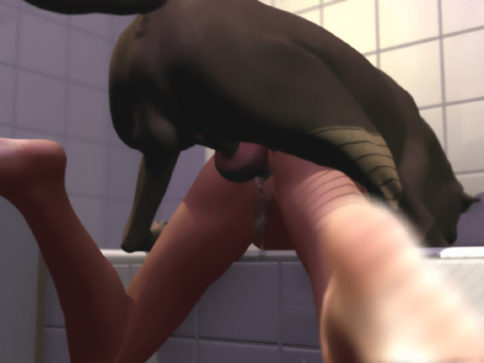

What these dogs want is not in the fridge. ...

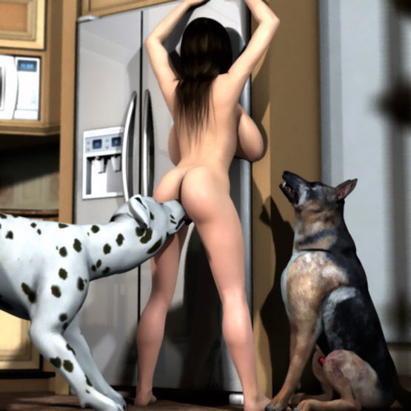

Lost and Found

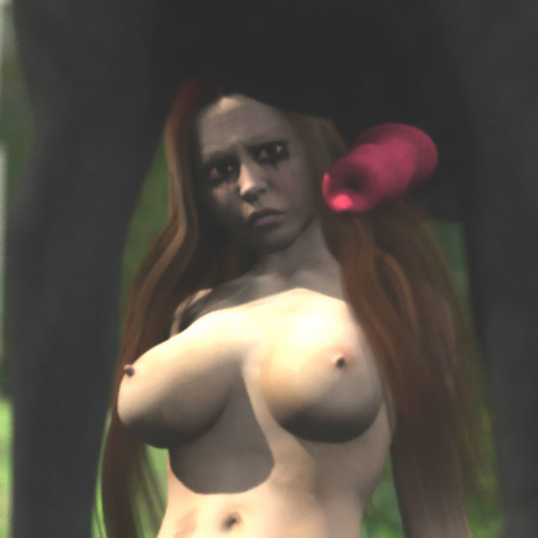

Knotted by Mouth

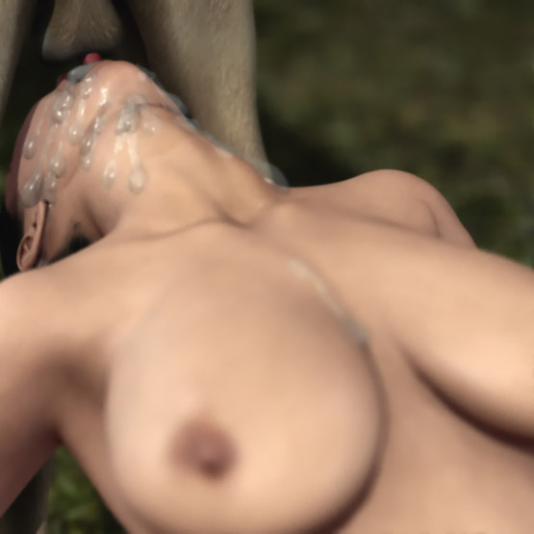

- - - - - - - - - - - - - - - - - - - - - - - - - - - - - - - - - - - - - - - - - - - - - - - - - - - - - - - - - - - - - - - - - - - - - - - -
=

https://www.beastforum.com/showtopic-122030-765.html
*** Molested in the Subway ***
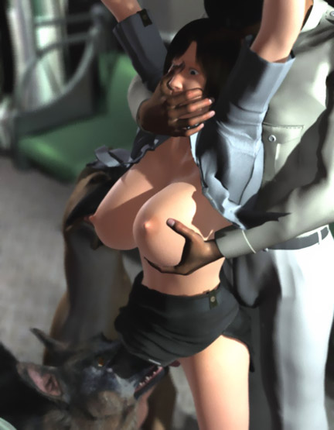

*** Campfire ***
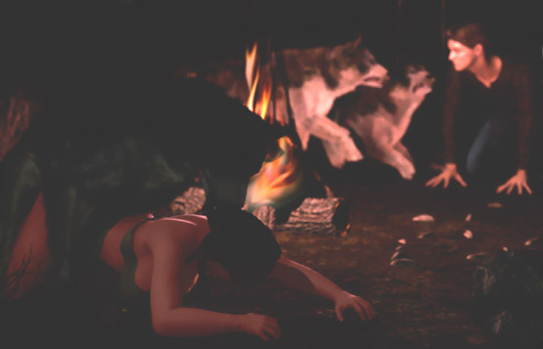

- - - - - - - - - - - - - - - - - - - - - - - - - - - - - - - - - - - - - - - - - - - - - - - - - - - - - - - - - - - - - - - - - - - - - - -

https://www.beastforum.com/showtopic-122030-840.html
*** Under the Hood ***

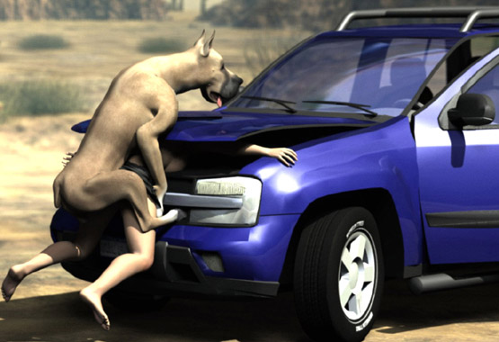

- - - - - - - - - - - - - - - - - - - - - - - - - - - - - - - - - - - - - - - - - - - - - - - - - - - - - - - - - - - - - - - - - - - - - - -

https://www.beastforum.com/showtopic-122030-870.html
4 Puppies
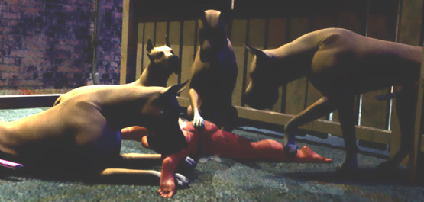

"Boys, where Are You?"
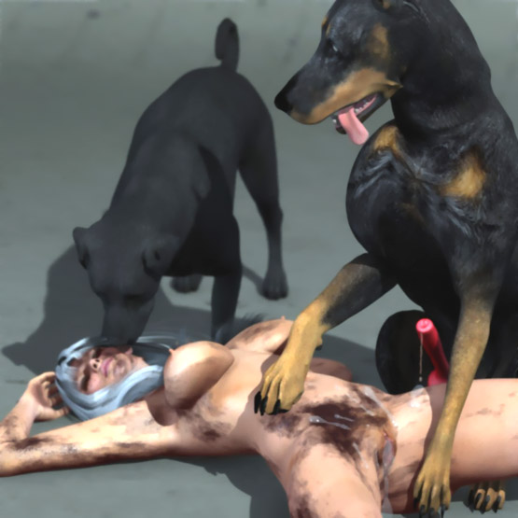

Husband comes home after a long day at work. Busty Owned by a Dog ...
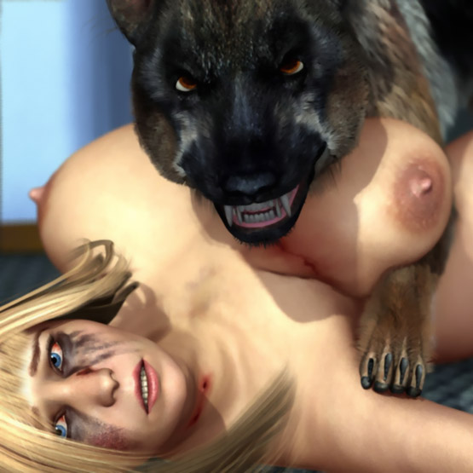

Denise Owned by a Dog
"Denise, why is Rusty growling?"
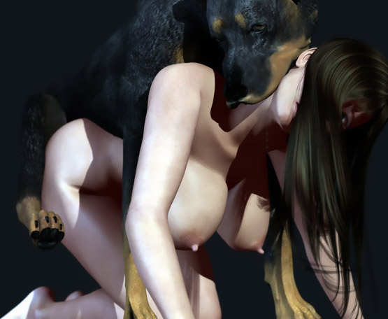

Lucy Owned by a Dane
"Honey, I'm home. The door was open. What the...!"
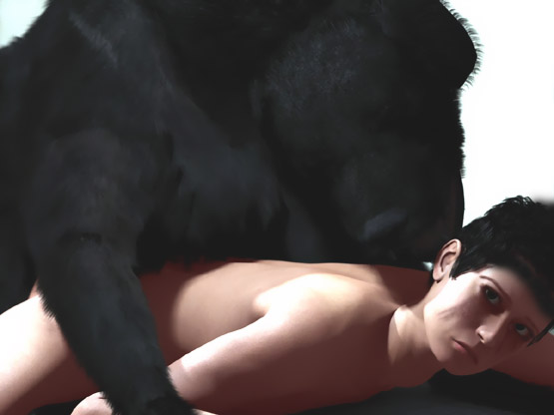

Kaoru Owned by a Dog

"Honey, I'm home. Oh my!

"King, I've told you a dozen times that she's not your bitch. She's my wife. You damn dog have filled her with your sperm again. Get off her!"

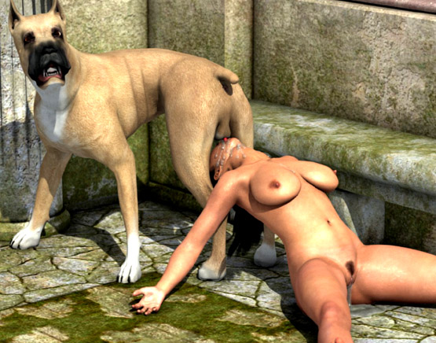

Hitomi Owned by a Dog
"Honey, I'm home. Do you like the new dog that I ..."
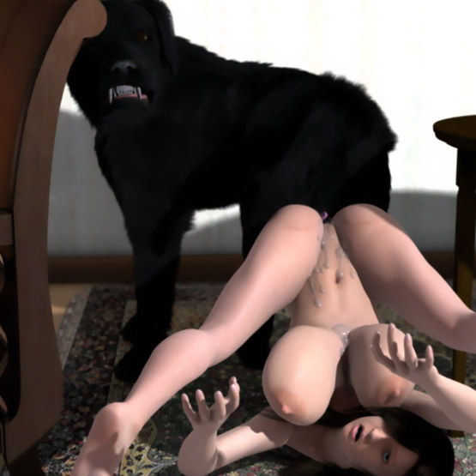

Jennifer Tamed and Ready for Gang Breeding
"Jen, I'm home. Do you know what's wrong with the neighbor's dogs?"


Marlena Owned by a Dog
Once again, the husband can only watch as a dog breeds his helpless wife.
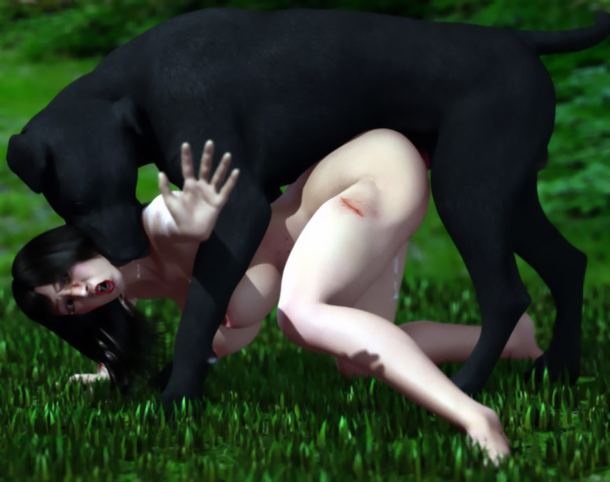

Emo Owned by a Great Dane
"Honey, I'm home. Saw Mike outside. He hasn't seen his dog since morning. Have you seen him?"
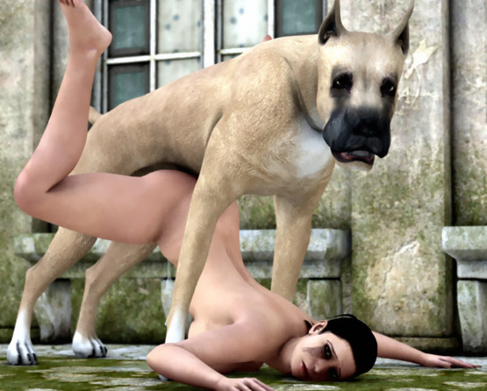

Samantha Owned by a Dog
"Honey, I'm home. Buster, I'm home. Come here, boy..."
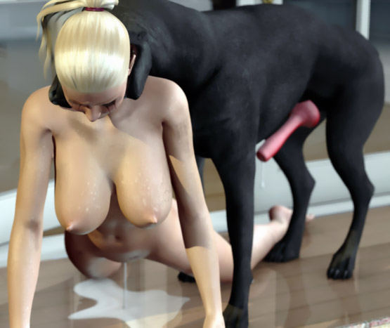

Owned by Rover
"Rover! What have you done? Let her go!"
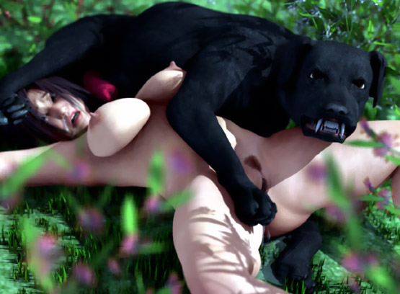

Chloe Owned by a Dog
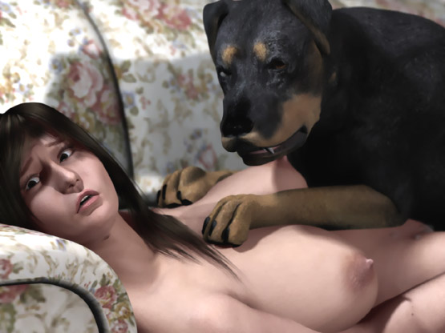

"Easy, boys. Easy. I'll step back. Go ahead and take her."


- - - - - - - - - - - - - - - - - - - - - - - - - - - - - - - - - - - - - - - - - - - - - - - - - - - - - - - - - - - - - - - - - - - - - - -
https://www.beastforum.com/showtopic-122030-1200.html
*** Arianna Tied on a Table ***

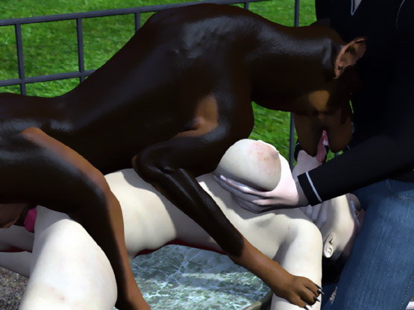

- - - - - - - - - - - - - - - - - - - - - - - - - - - - - - - - - - - - - - - - - - - - - - - - - - - - - - - - - - - - - - - - - - - - - - -

https://www.beastforum.com/showtopic-280294.html
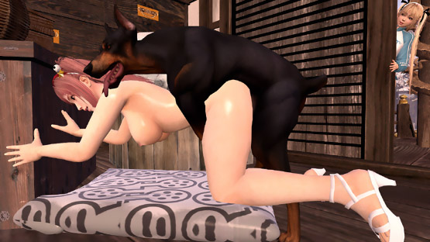

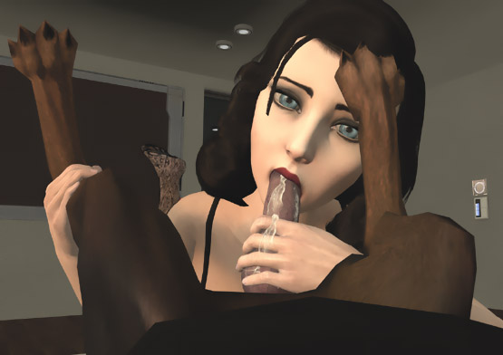

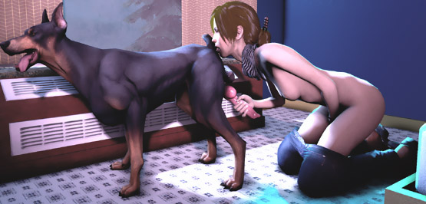

https://www.beastforum.com/showtopic-280294-30.html

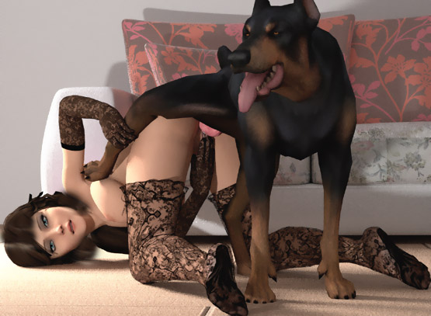

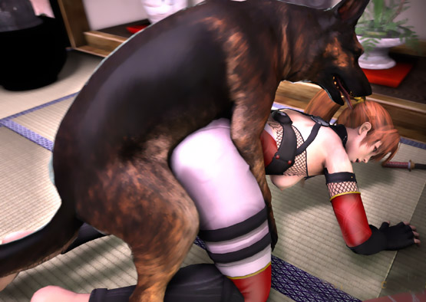

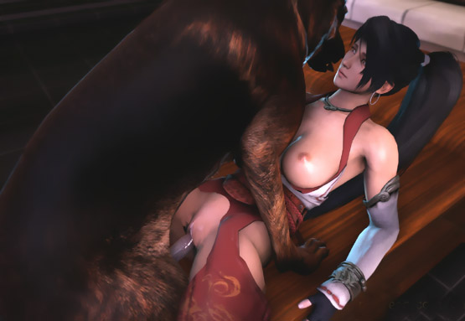

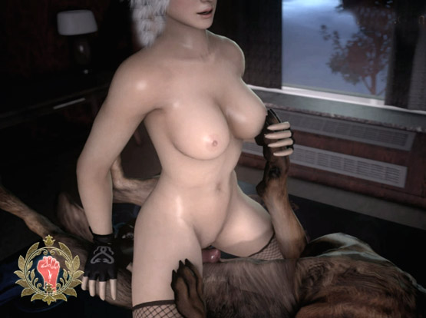

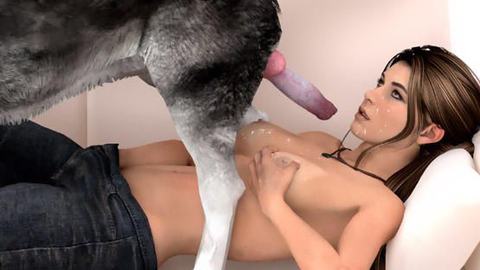

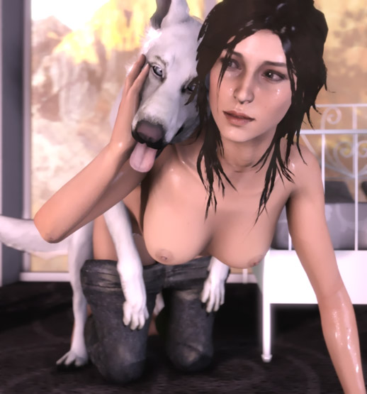

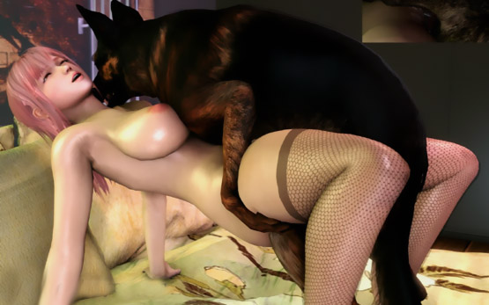

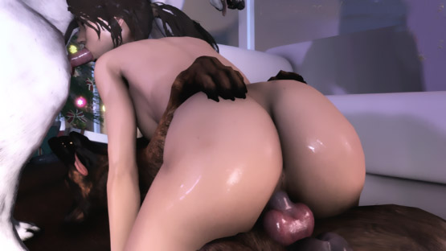



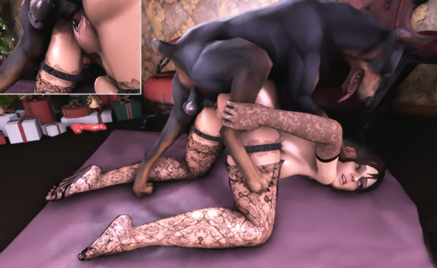

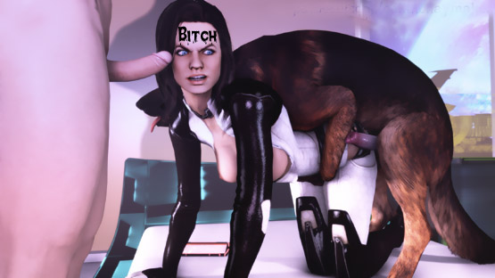

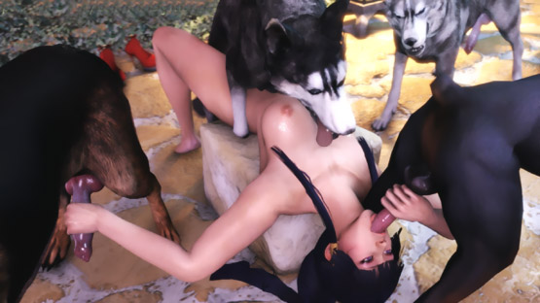

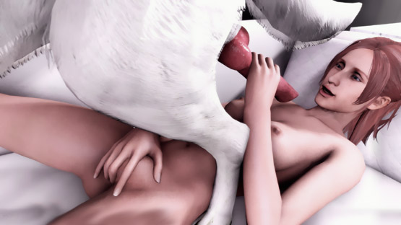

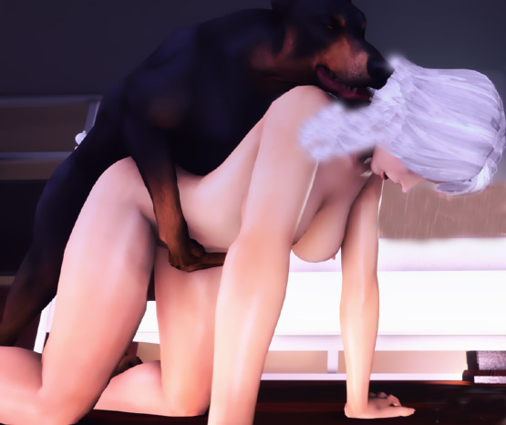

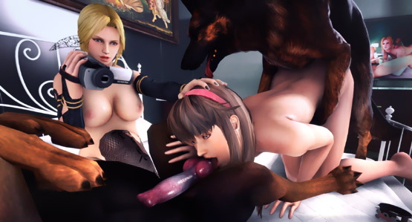



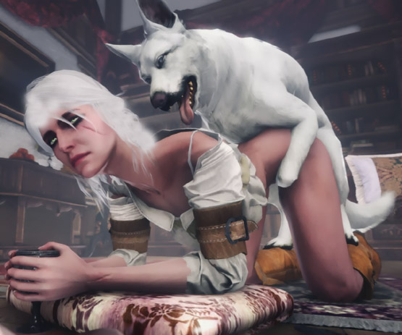

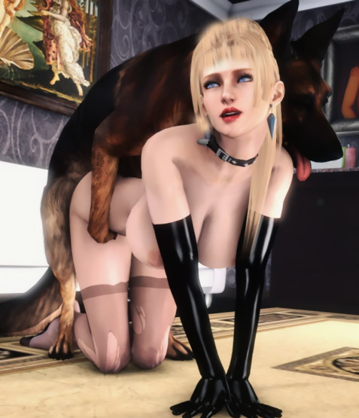

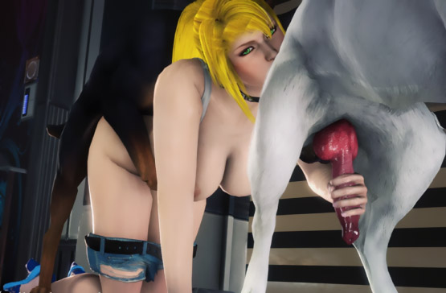

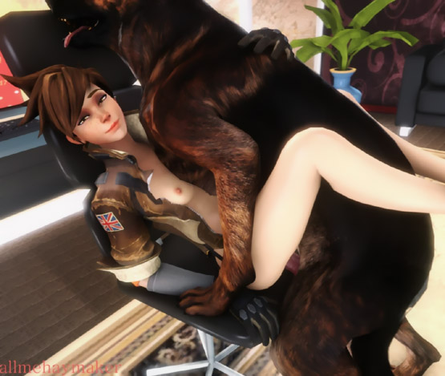

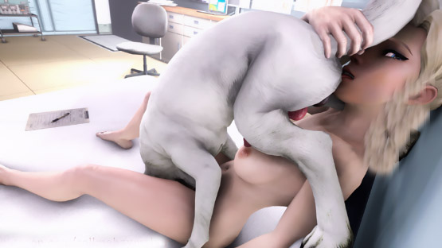

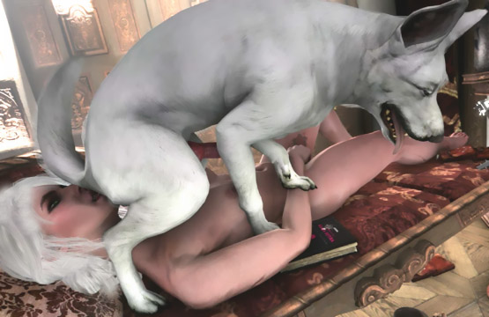



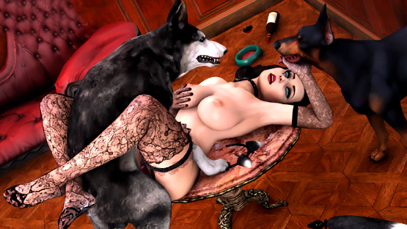

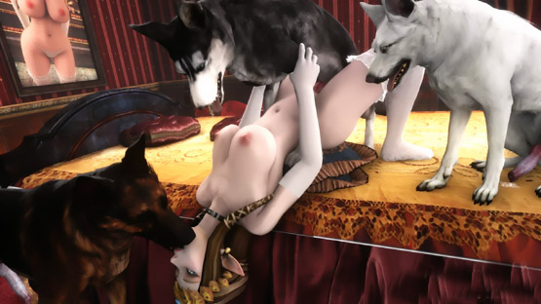

https://www.beastforum.com/showtopic-280294-195.html

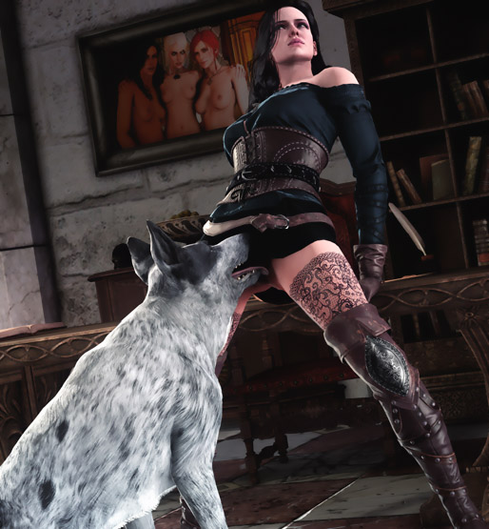

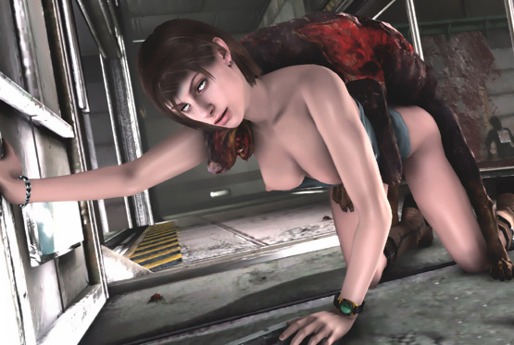

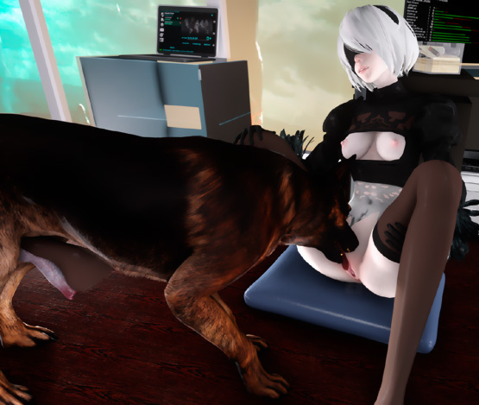

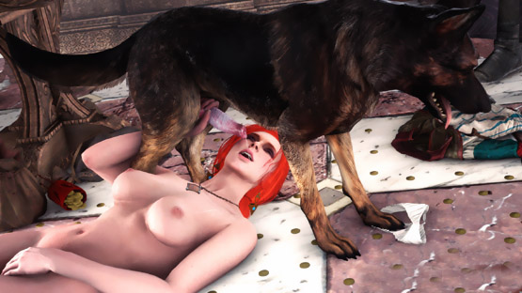

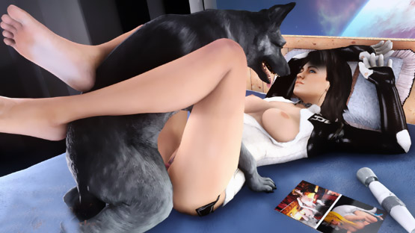

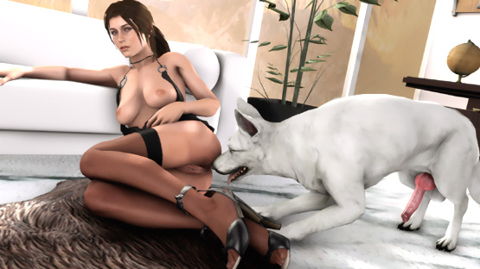

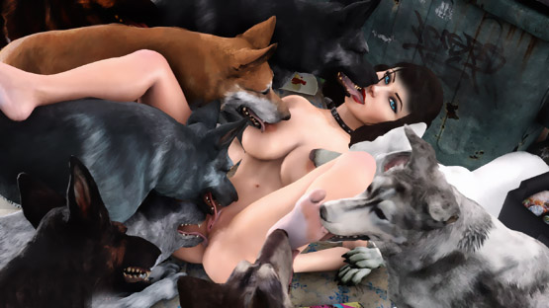

- - - - - - - - - - - - - - - - - - - - - - - - - - - - - - - - - - - - - - - - - - - - - - - - - - - - - - - - - - - - - - - - - - - - - - - -

https://www.beastforum.com/showtopic-85968.html

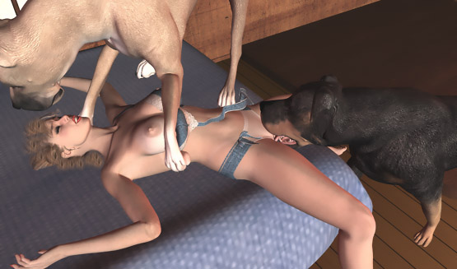

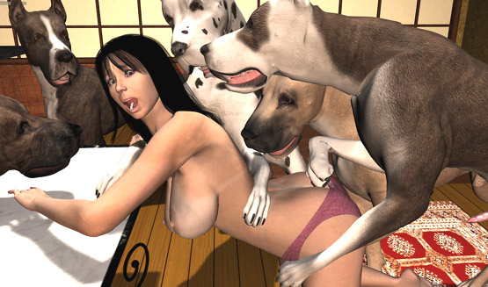

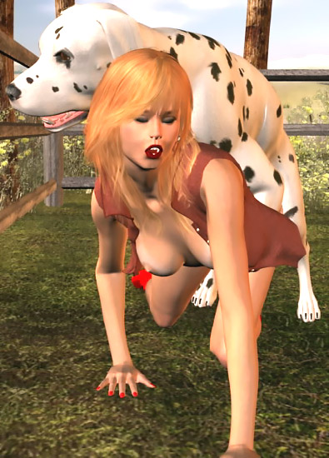

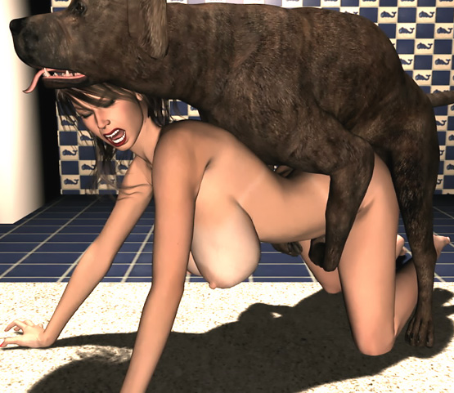

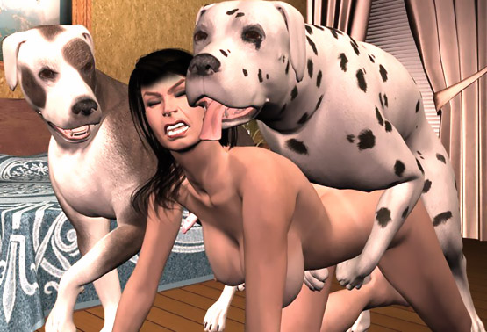

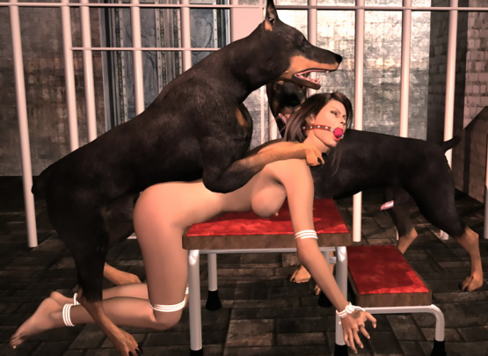

- - - - - - - - - - - - - - - - - - - - - - - - - - - - - - - - - - - - - - - - - - - - - - - - - - - - - - - - - - - - - - - - - - - - - - - -

https://www.beastforum.com/showtopic-256883.html

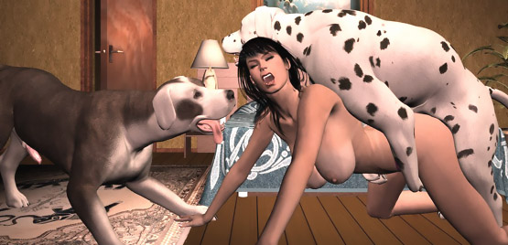

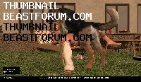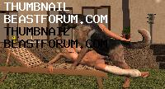

- - - - - - - - - - - - - - - - - - - - - - - - - - - - - - - - - - - - - - - - - - - - - - - - - - - - - - - - - - - - - - - - - - - - - - - -

https://www.beastforum.com/showtopic-292879.html

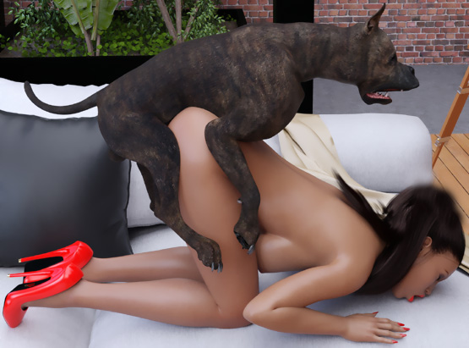

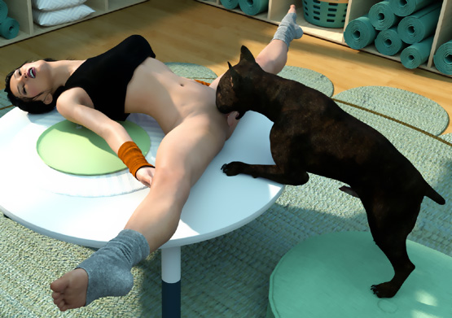

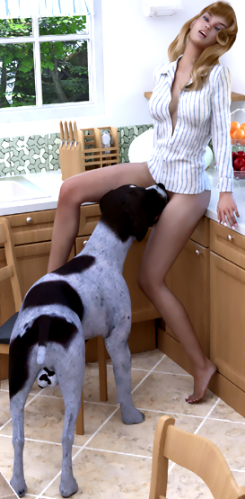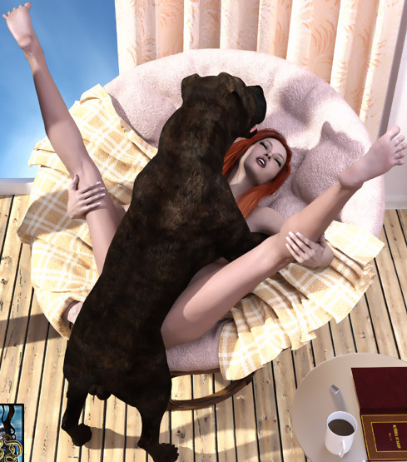

- - - - - - - - - - - - - - - - - - - - - - - - - - - - - - - - - - - - - - - - - - - - - - - - - - - - - - - - - - - - - - - - - - - - - - - -

https://www.beastforum.com/showtopic-245461.html

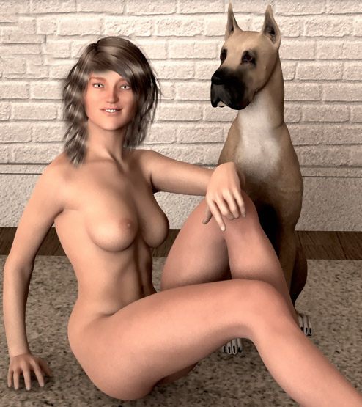

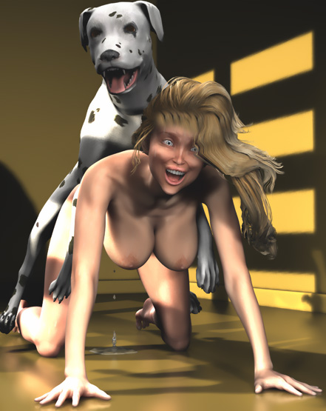

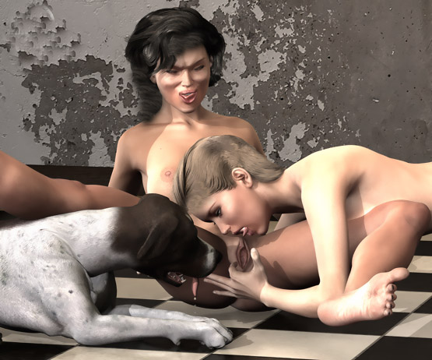

- - - - - - - - - - - - - - - - - - - - - - - - - - - - - - - - - - - - - - - - - - - - - - - - - - - - - - - - - - - - - - - - - - - - - - - -

https://www.beastforum.com/index.php?s=37396d4116c03faae513c4993bc3146f&showtopic=274612

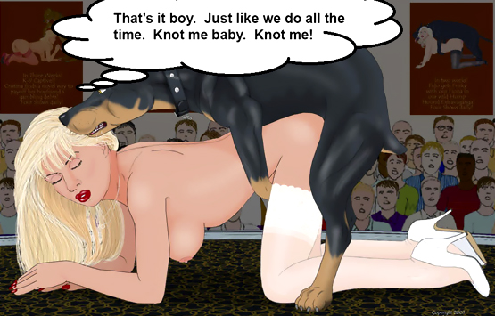



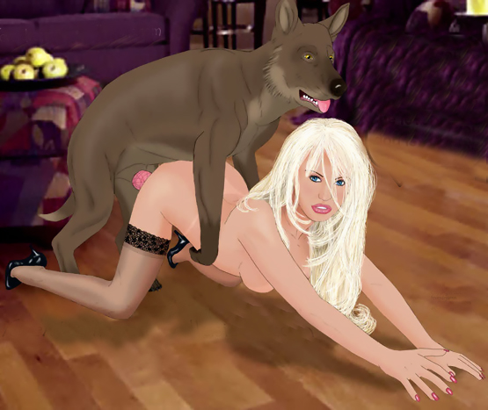

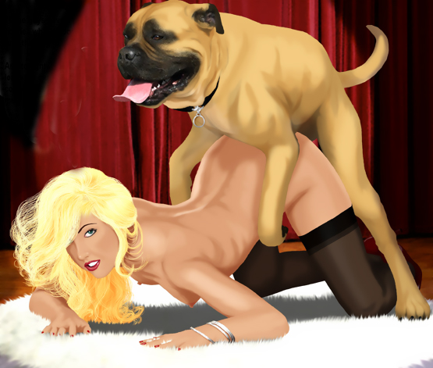

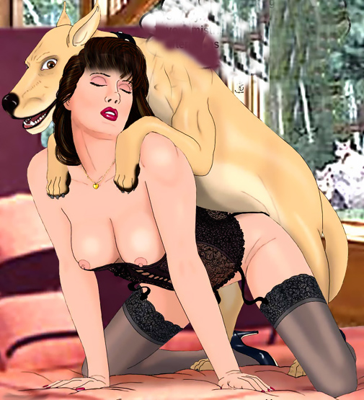

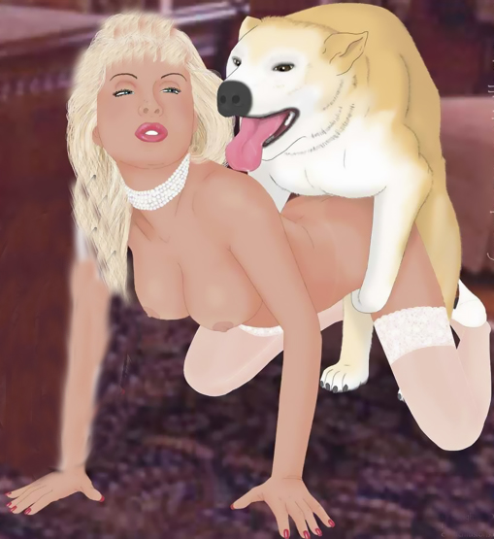

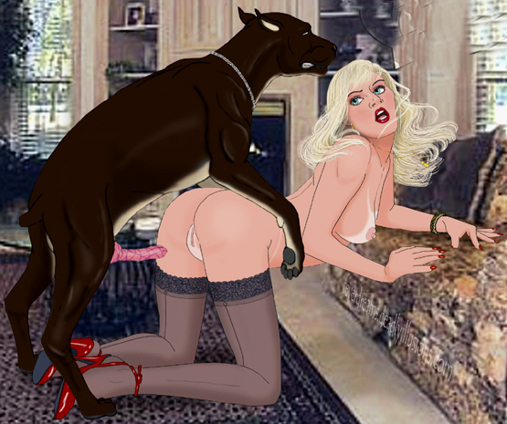

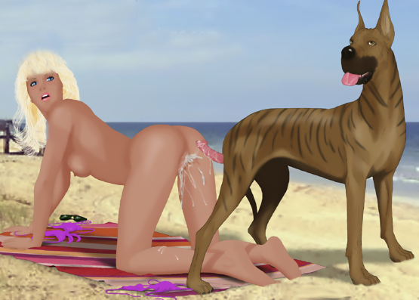



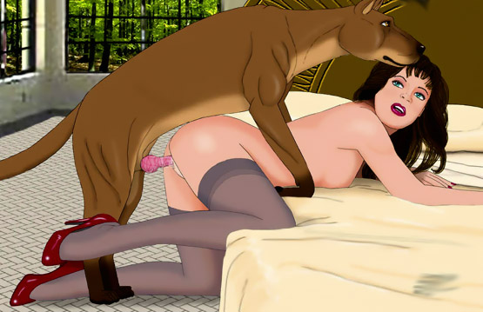

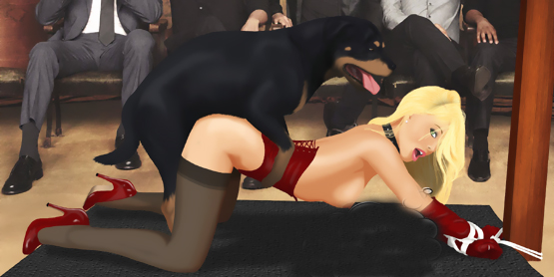

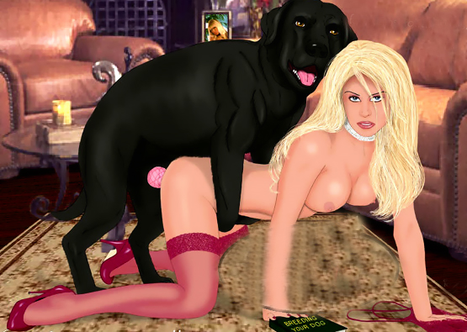

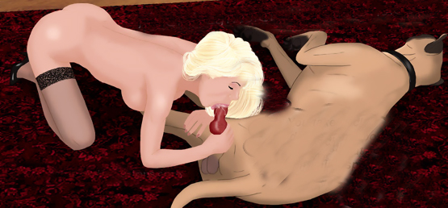

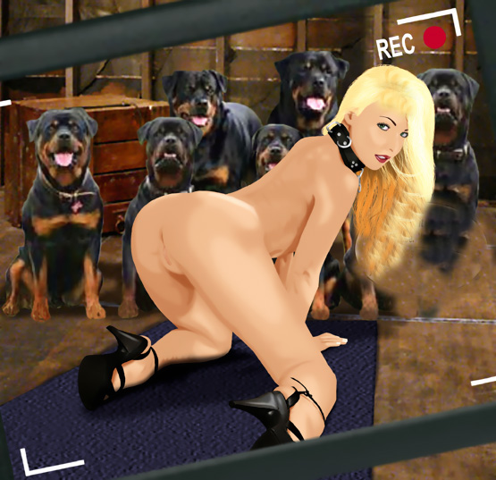



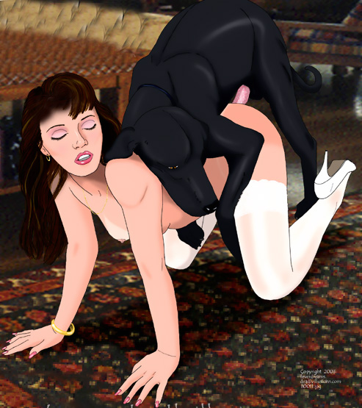

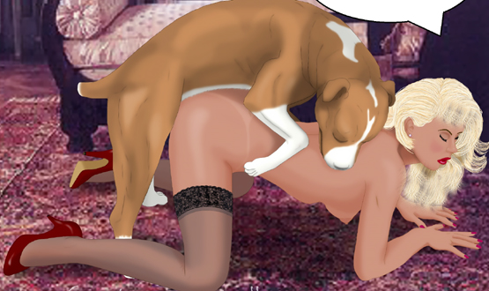



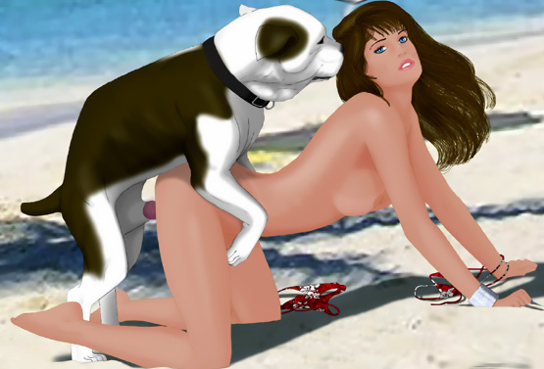

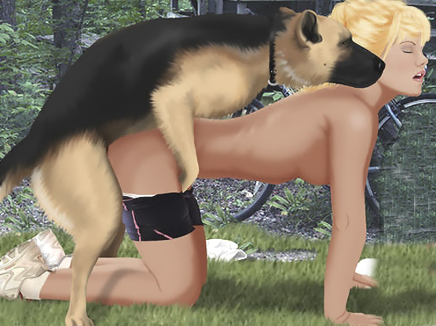

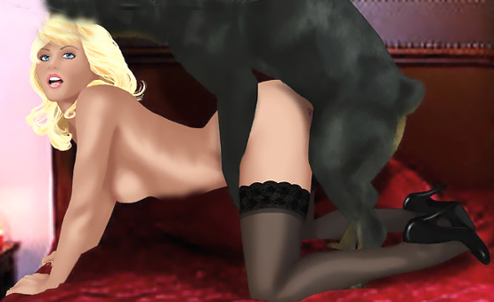

https://www.beastforum.com/showtopic-274612-45.html

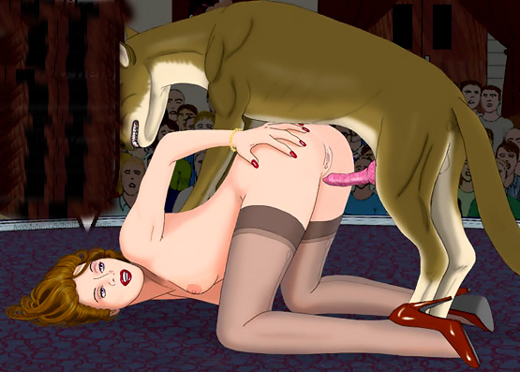

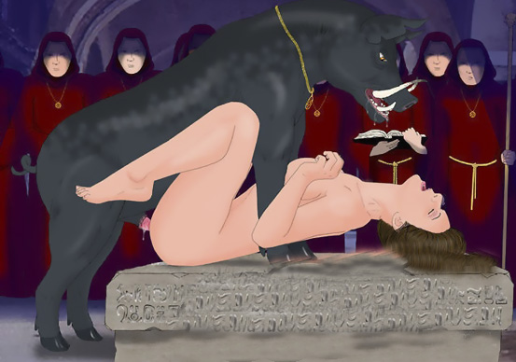

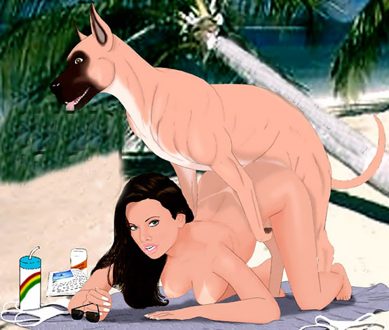

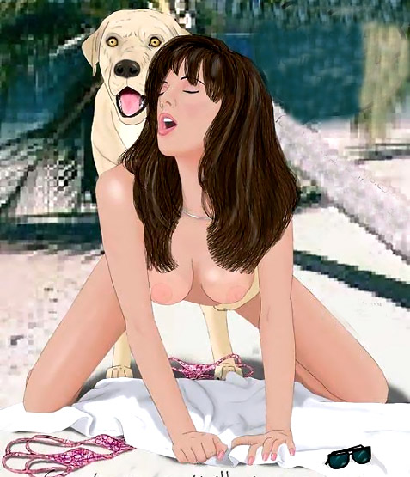



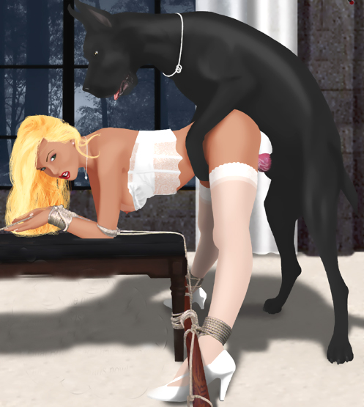

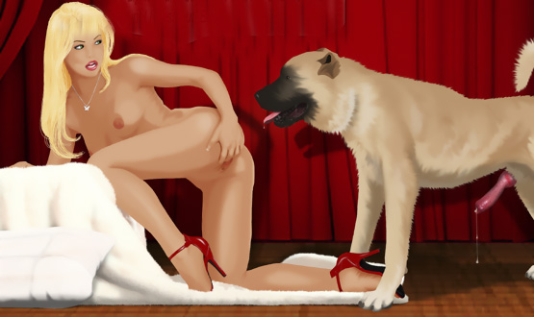



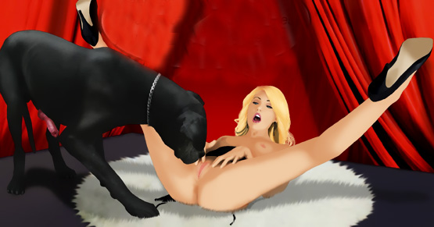



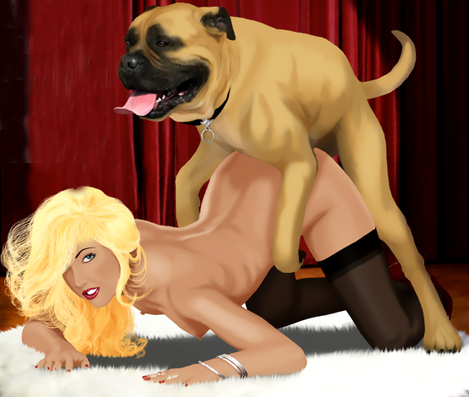

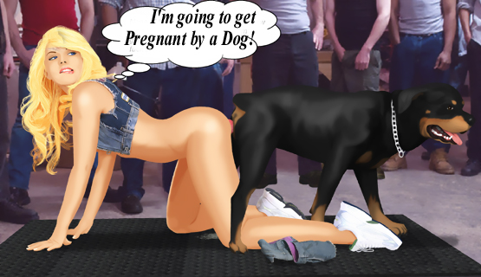

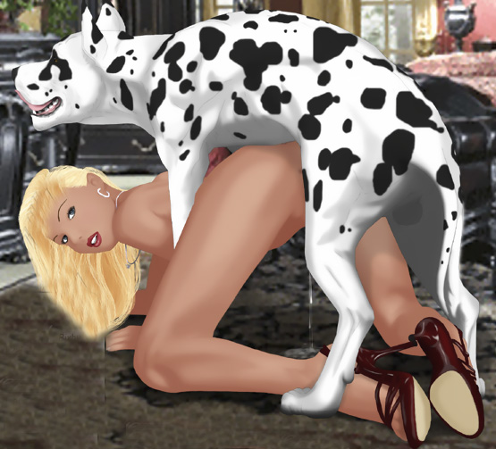

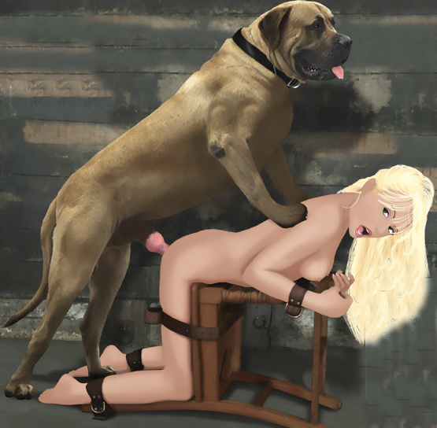

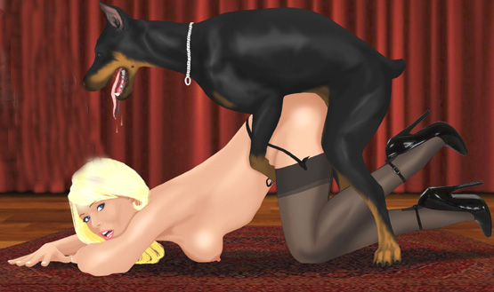

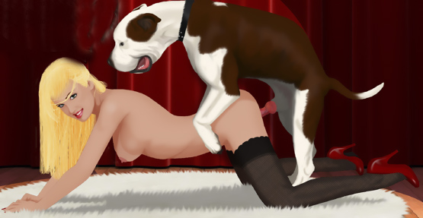

- - - - - - - - - - - - - - - - - - - - - - - - - - - - - - - - - - - - - - - - - - - - - - - - - - - - - - - - - - - - - - - - - - - - - - - -

https://www.beastforum.com/index.php?s=37396d4116c03faae513c4993bc3146f&showtopic=285507

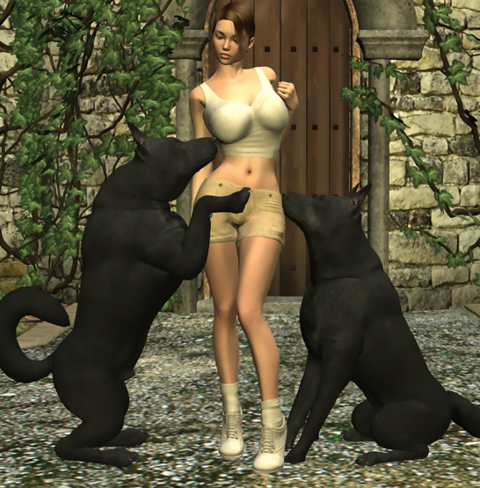

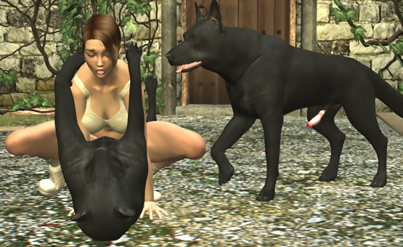

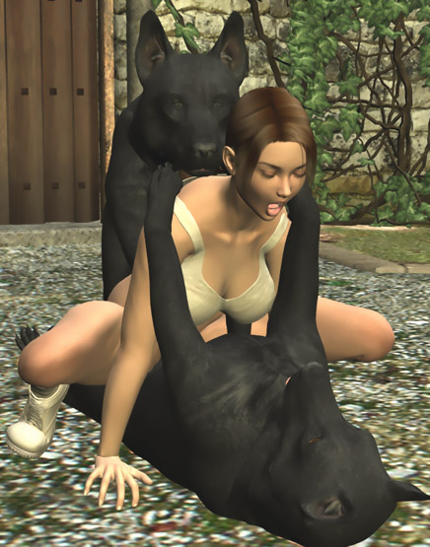

- - - - - - - - - - - - - - - - - - - - - - - - - - - - - - - - - - - - - - - - - - - - - - - - - - - - - - - - - - - - - - - - - - - - - - - -

https://www.beastforum.com/index.php?s=37396d4116c03faae513c4993bc3146f&showtopic=181986

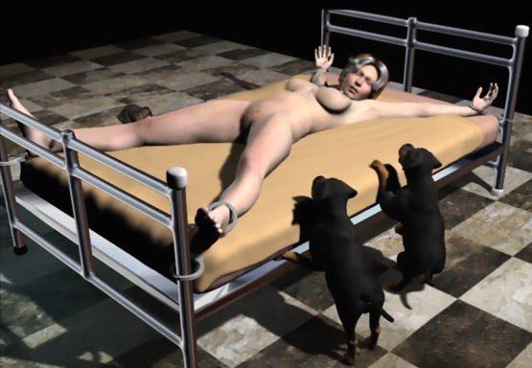

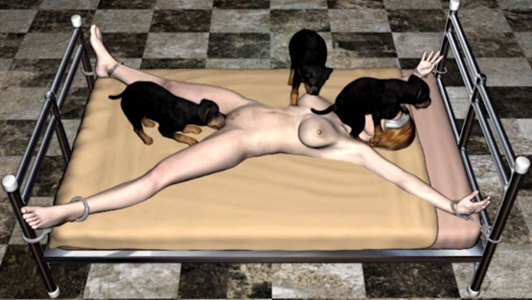

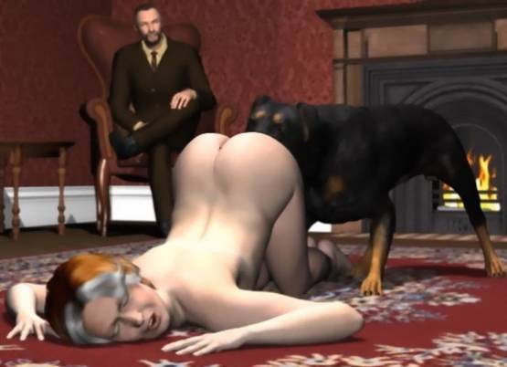

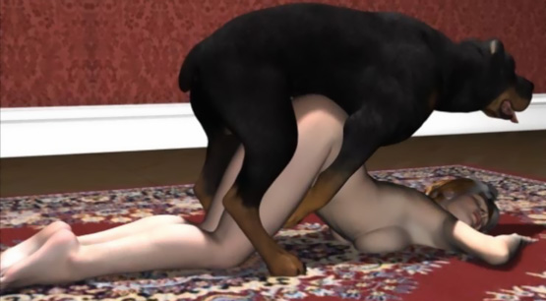

- - - - - - - - - - - - - - - - - - - - - - - - - - - - - - - - - - - - - - - - - - - - - - - - - - - - - - - - - - - - - - - - - - - - - - - -

https://www.beastforum.com/index.php?s=37396d4116c03faae513c4993bc3146f&showtopic=186726

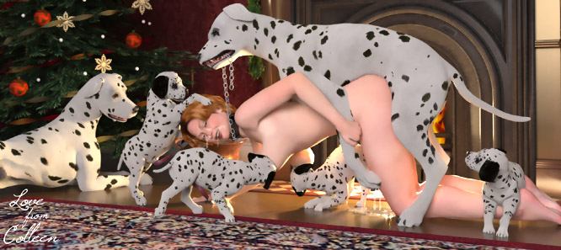

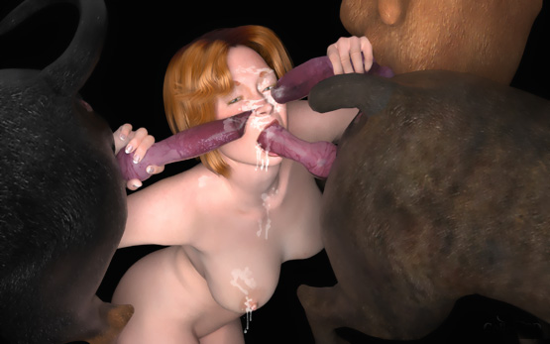



- - - - - - - - - - - - - - - - - - - - - - - - - - - - - - - - - - - - - - - - - - - - - - - - - - - - - - - - - - - - - - - - - - - - - - - -

https://www.beastforum.com/showtopic-267931.html

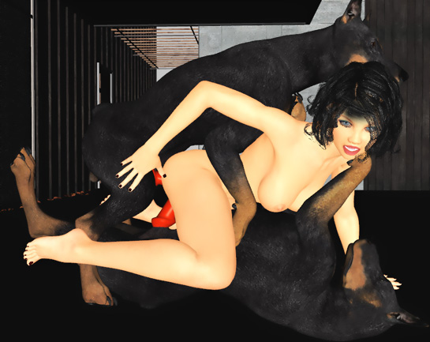

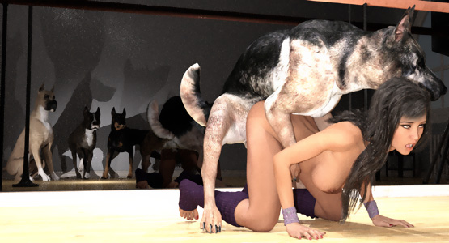

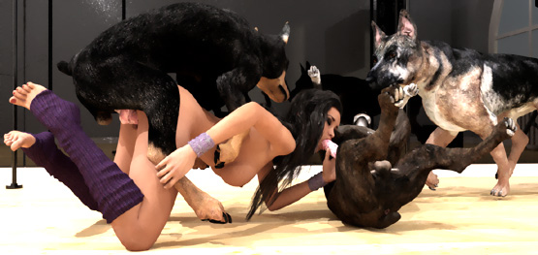

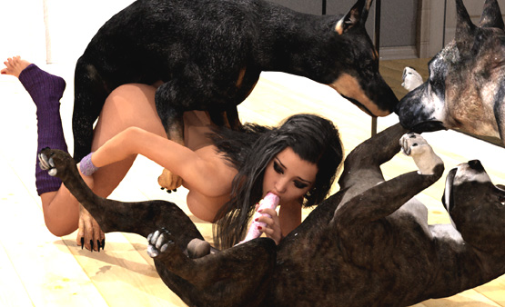

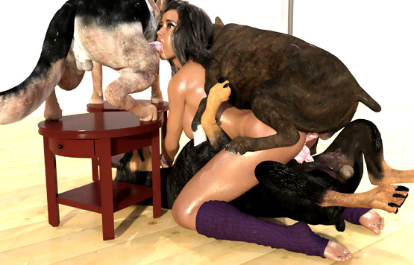

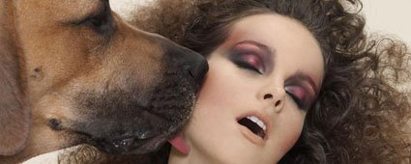

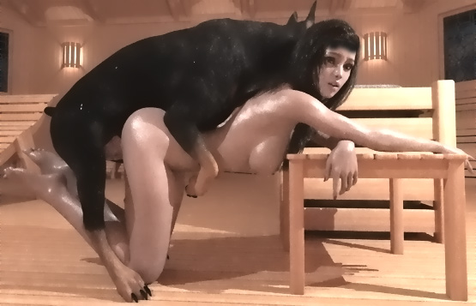

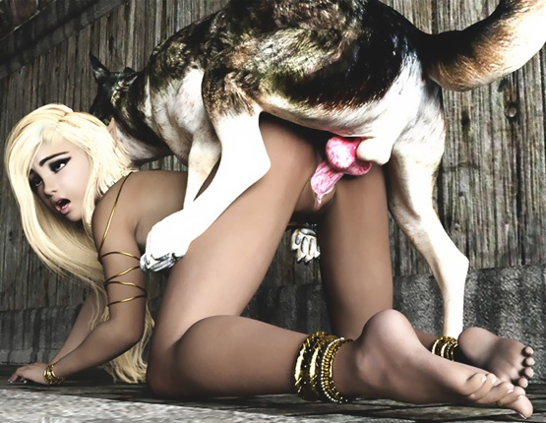

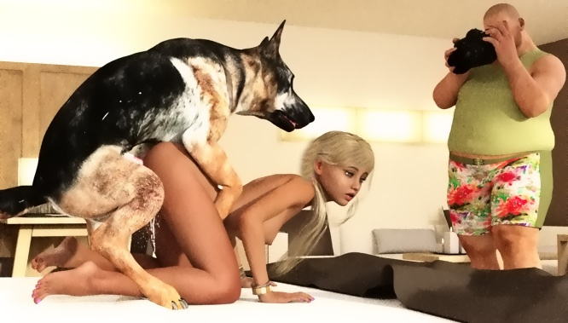

- - - - - - - - - - - - - - - - - - - - - - - - - - - - - - - - - - - - - - - - - - - - - - - - - - - - - - - - - - - - - - - - - - - - - - - -

https://www.beastforum.com/showtopic-287307.html

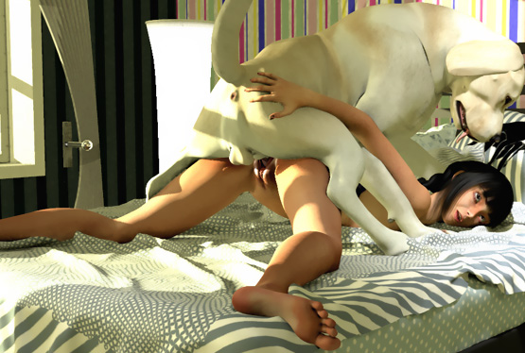

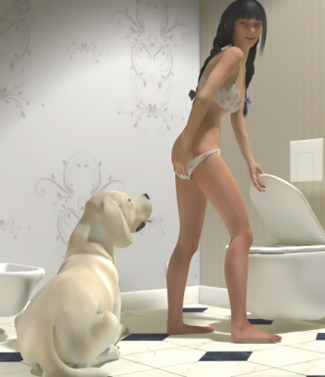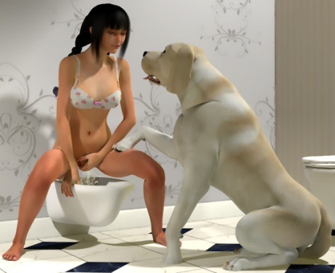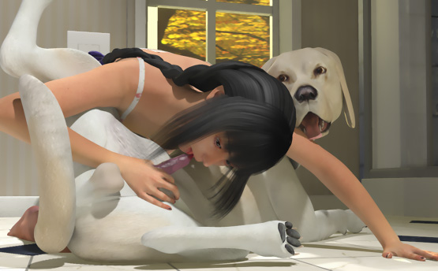

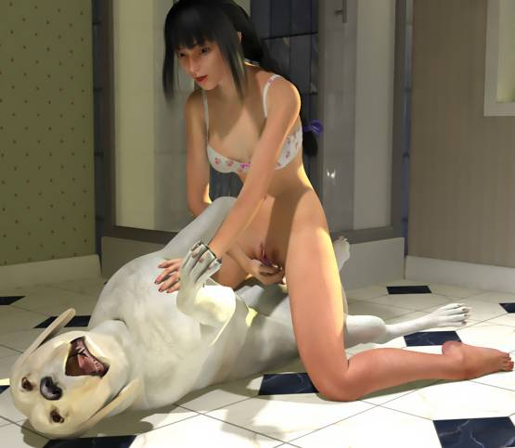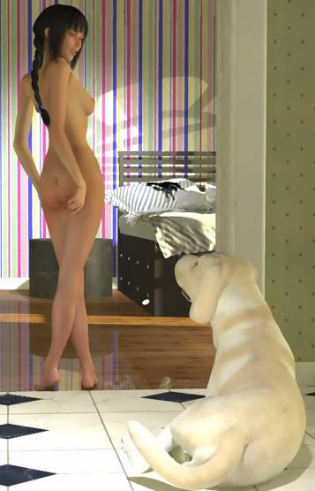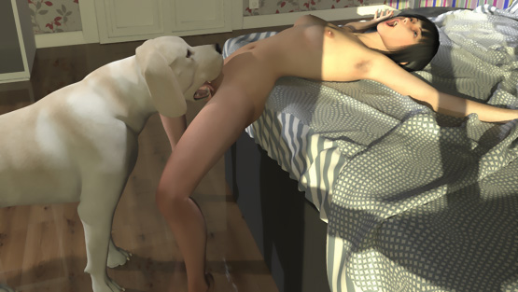

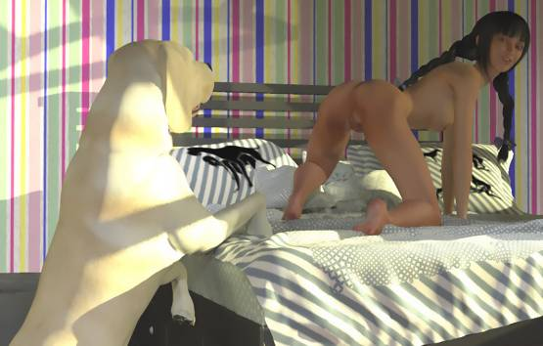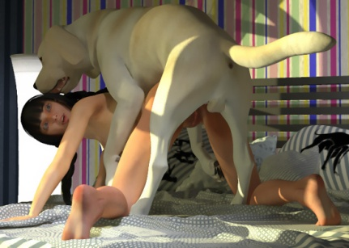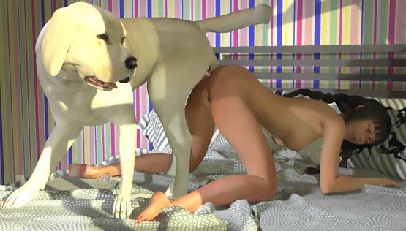

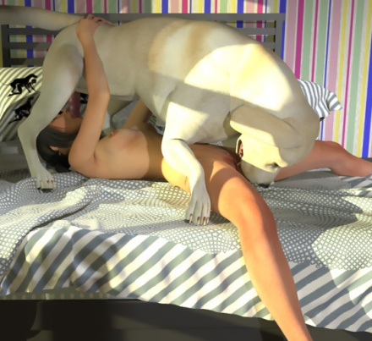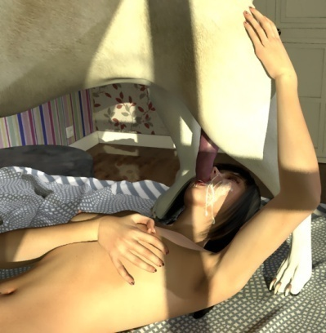

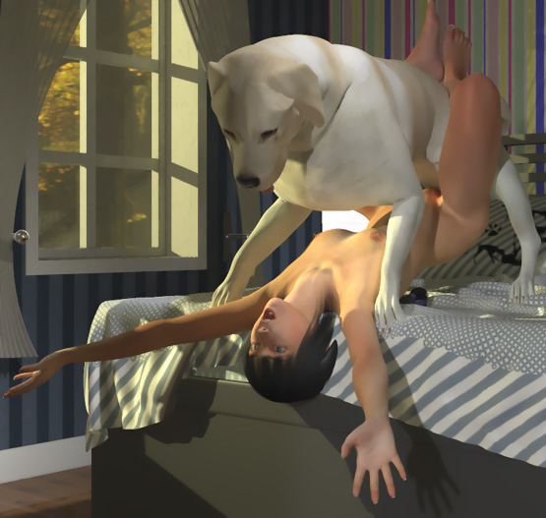

- - - - - - - - - - - - - - - - - - - - - - - - - - - - - - - - - - - - - - - - - - - - - - - - - - - - - - - - - - - - - - - - - - - - - - - -

https://www.beastforum.com/showtopic-277205.html

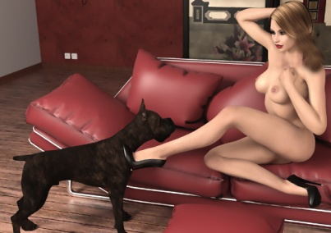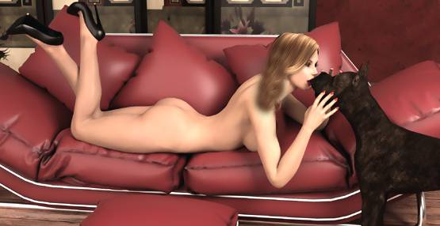

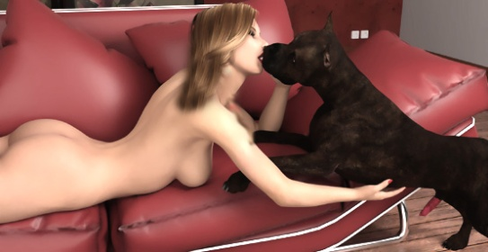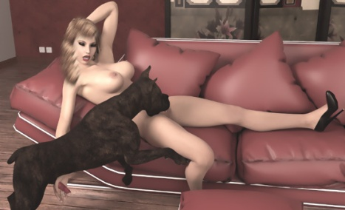

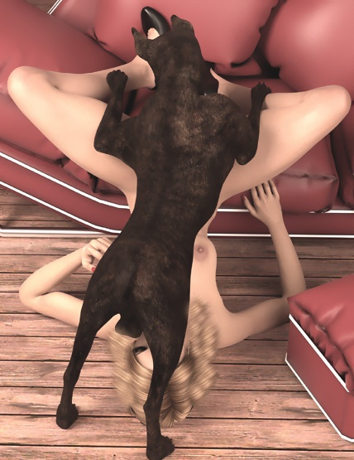









- - - - - - - - - - - - - - - - - - - - - - - - - - - - - - - - - - - - - - - - - - - - - - - - - - - - - - - - - - - - - - - - - - - - - - - -

https://www.beastforum.com/showtopic-254272.html

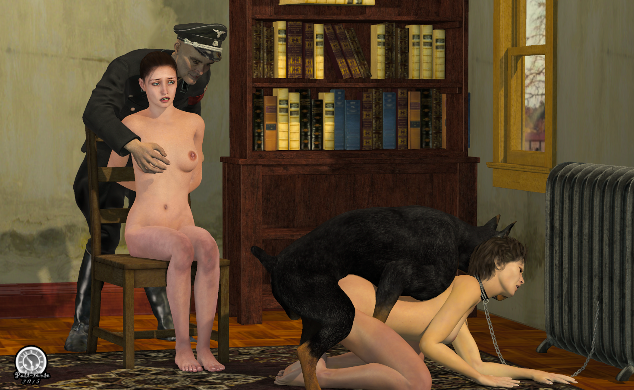

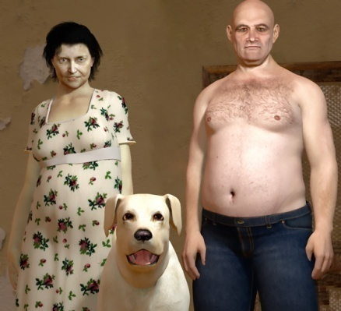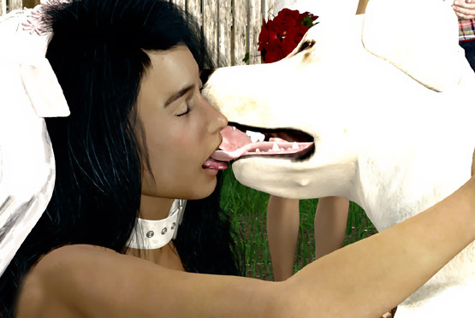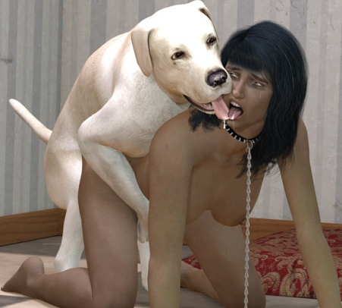

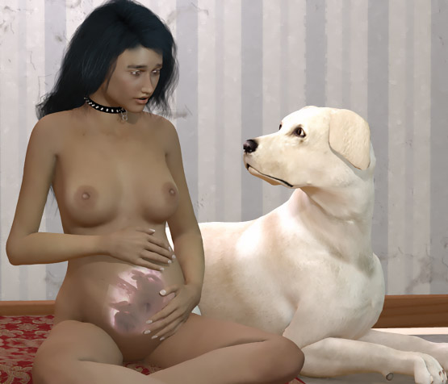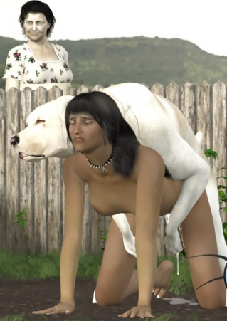

- - - - - - - - - - - - - - - - - - - - - - - - - - - - - - - - - - - - - - - - - - - - - - - - - - - - - - - - - - - - - - - - - - - - - - - -

https://www.beastforum.com/showtopic-203142.html

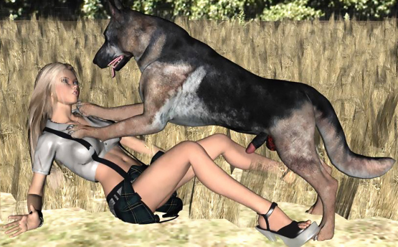

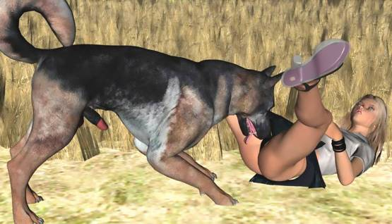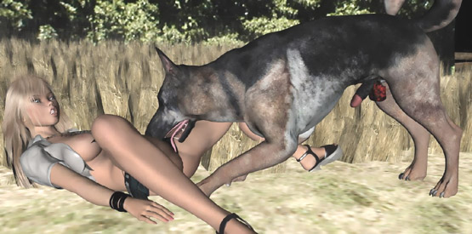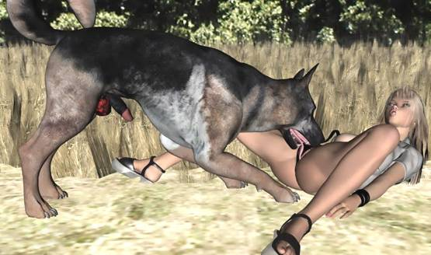

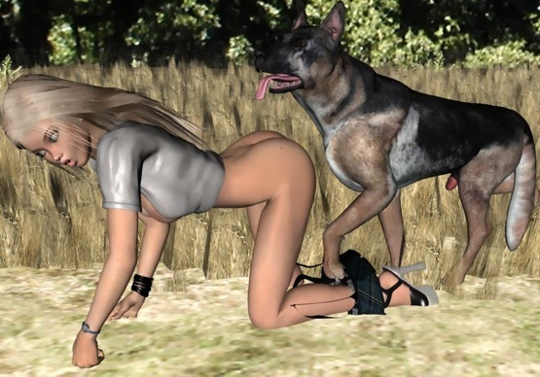

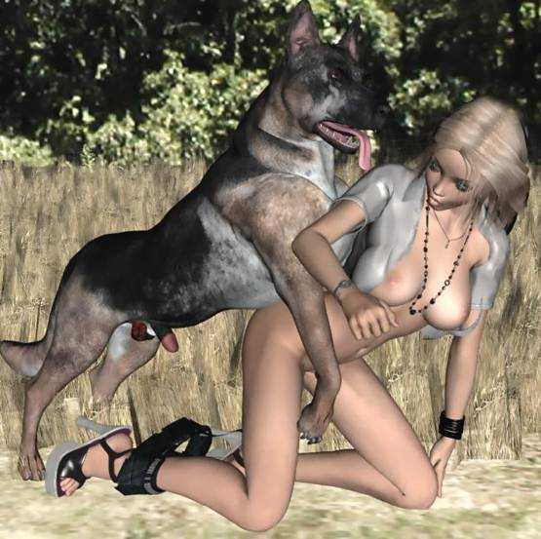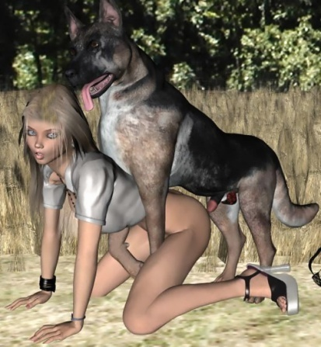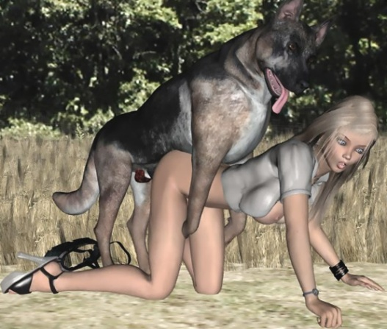

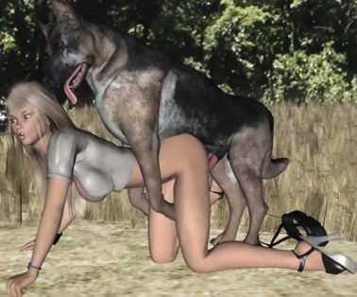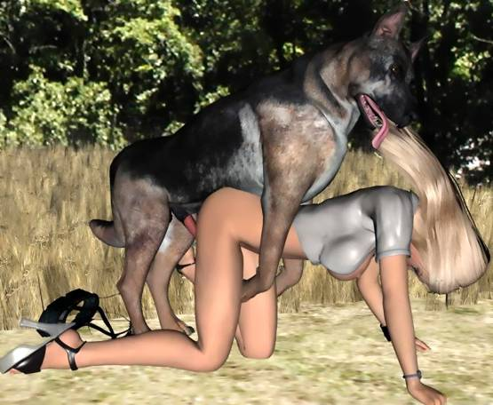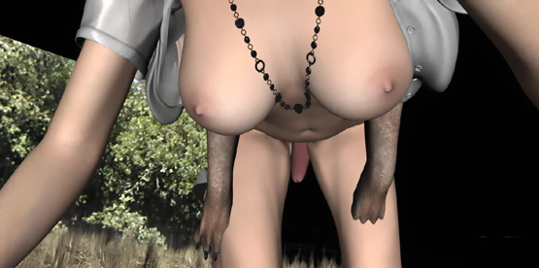

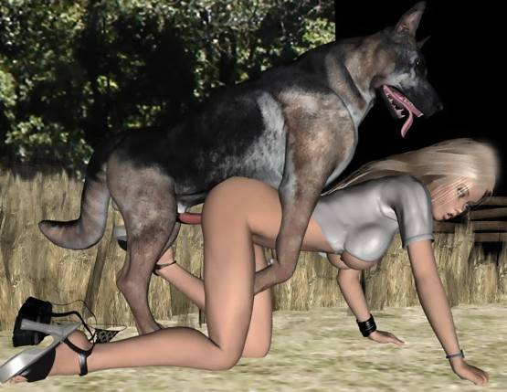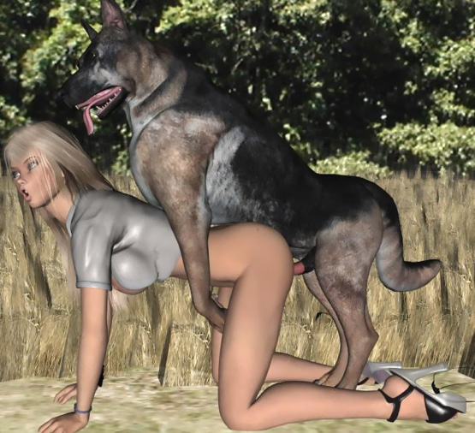

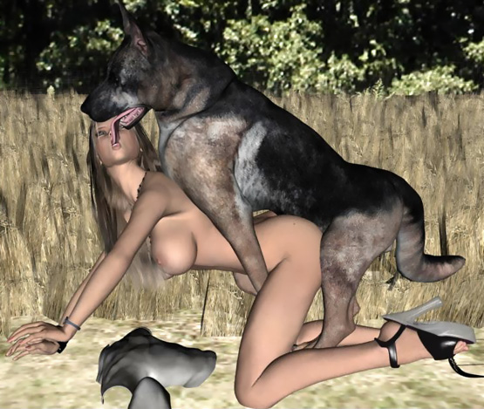

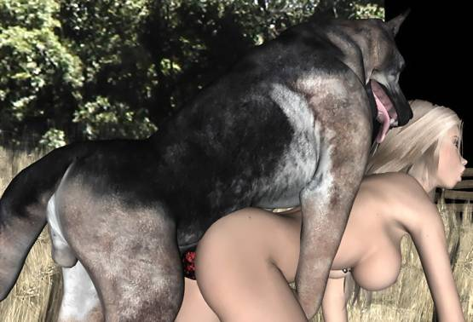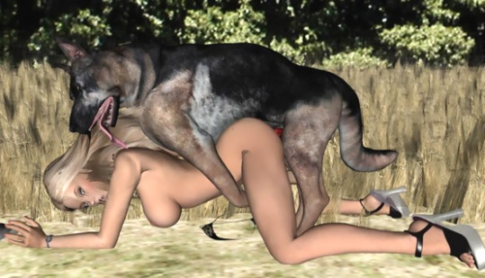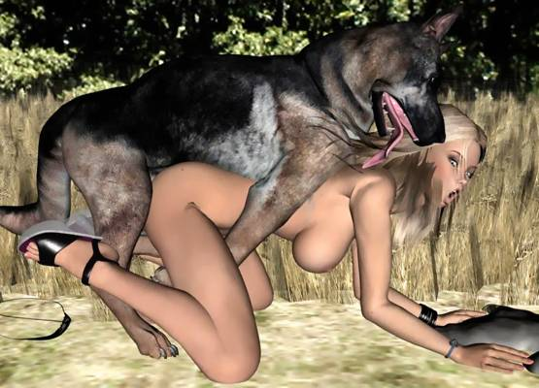

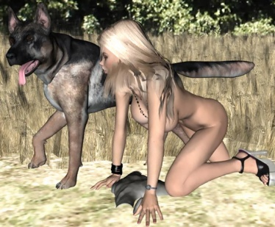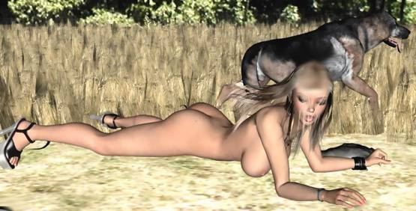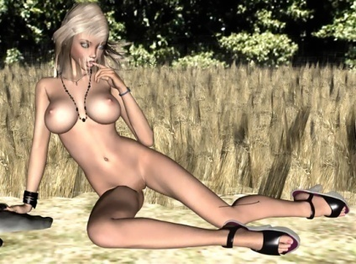

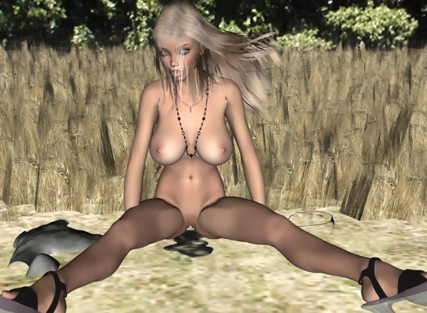

- - - - - - - - - - - - - - - - - - - - - - - - - - - - - - - - - - - - - - - - - - - - - - - - - - - - - - - - - - - - - - - - - - - - - - - -

https://www.beastforum.com/showtopic-114523.html

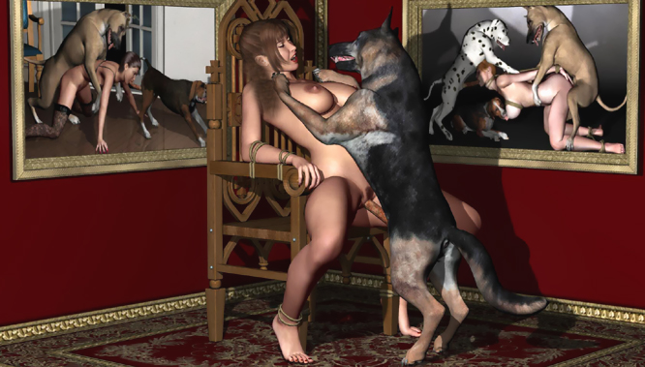

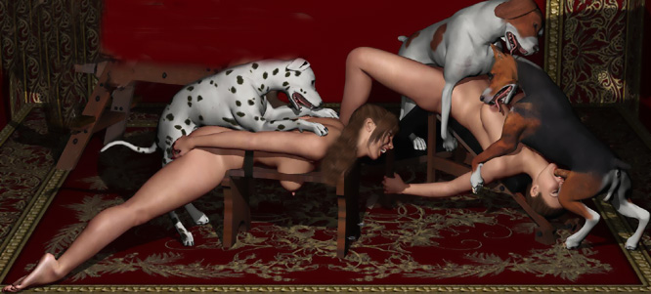

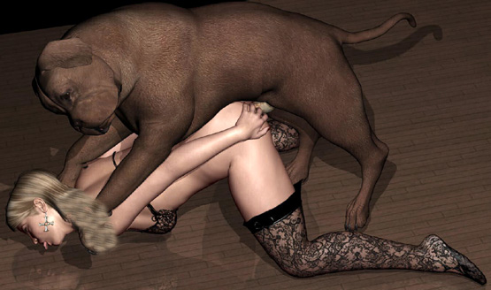

- - - - - - - - - - - - - - - - - - - - - - - - - - - - - - - - - - - - - - - - - - - - - - - - - - - - - - - - - - - - - - - - - - - - - - - -

https://www.beastforum.com/showtopic-246561-15.html

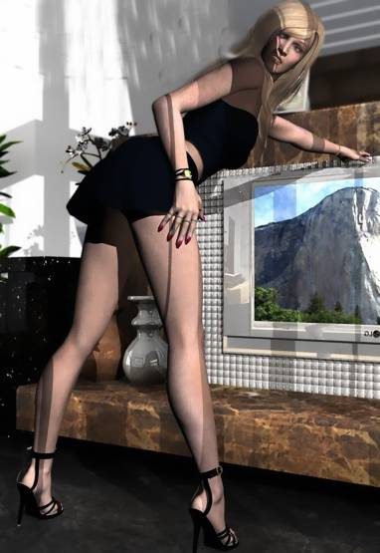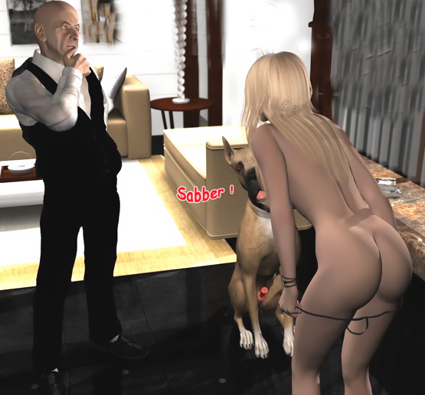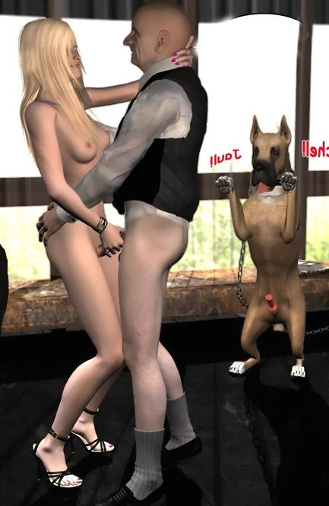

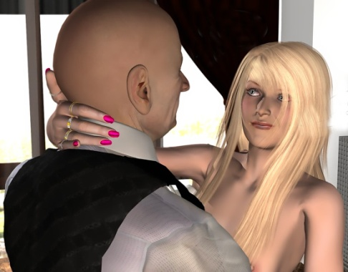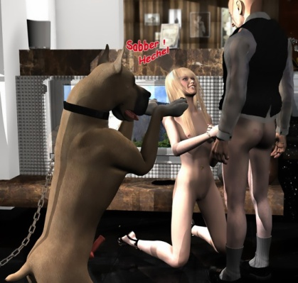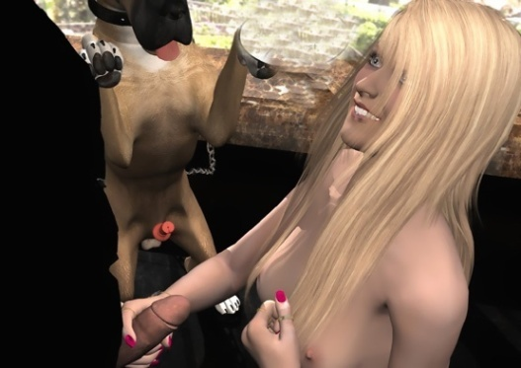

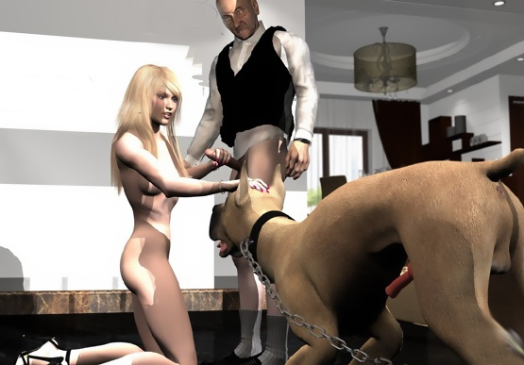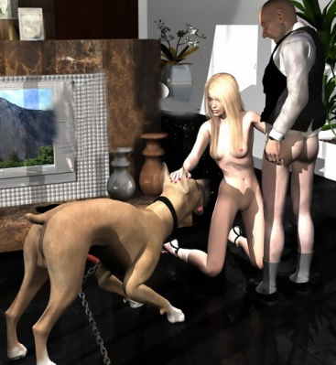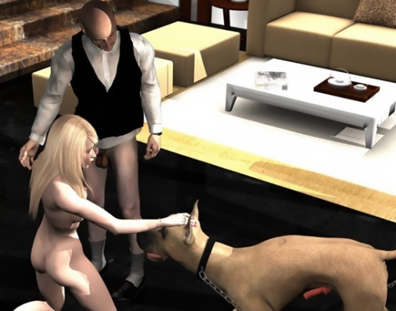

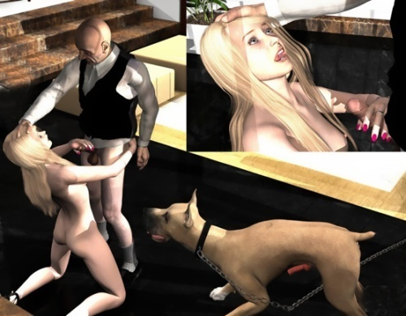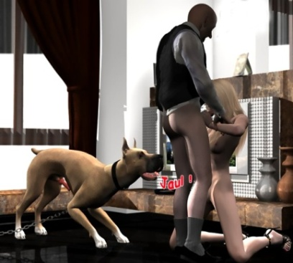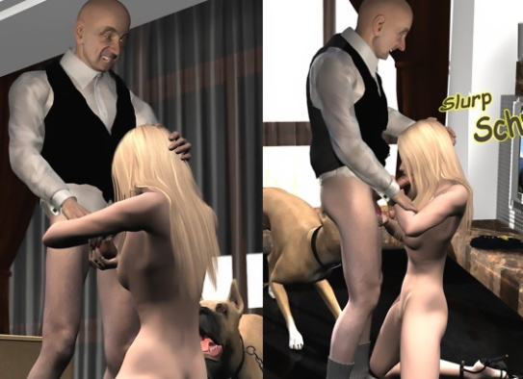

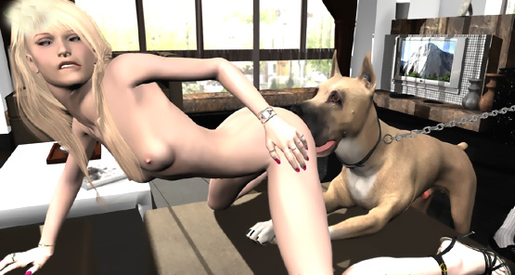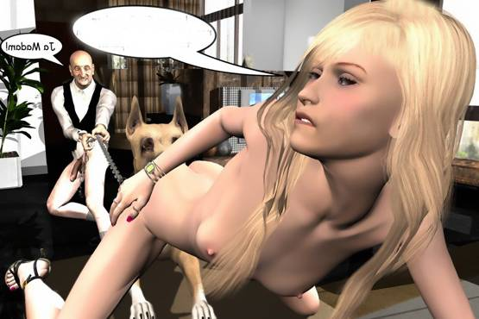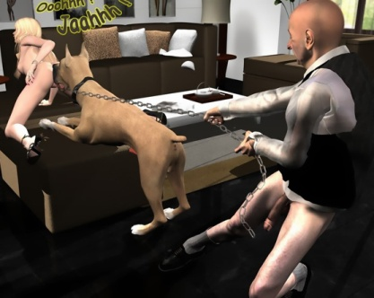

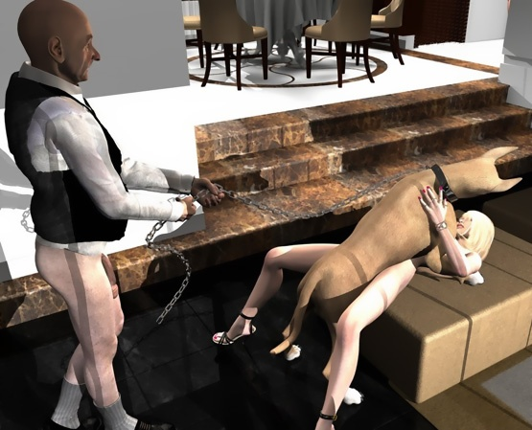

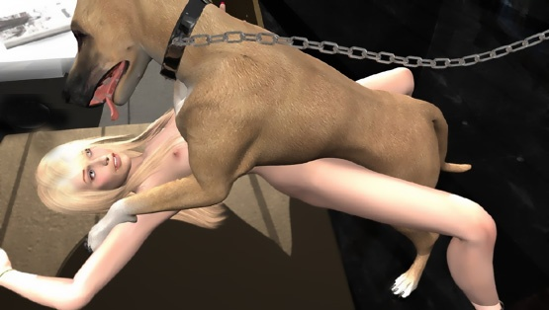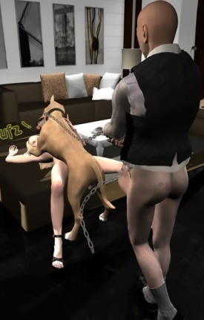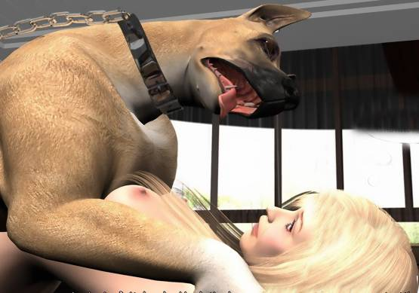

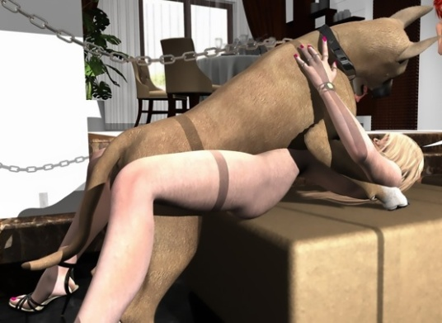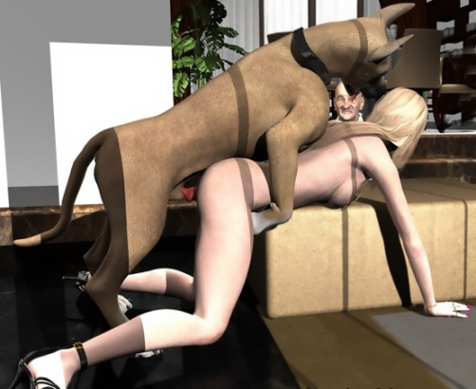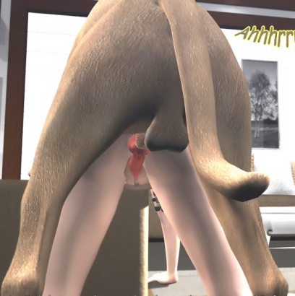

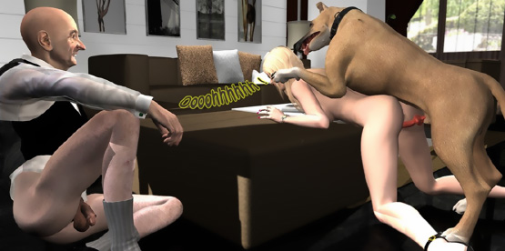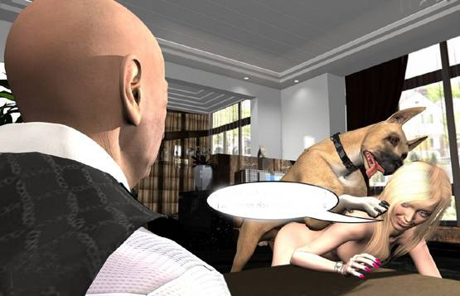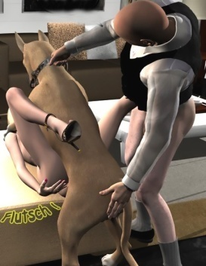

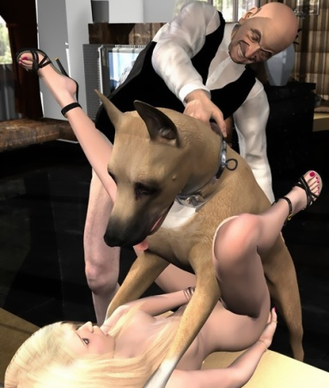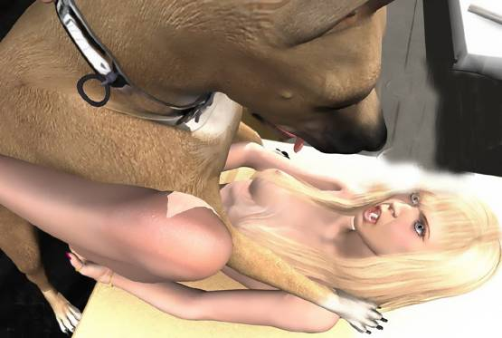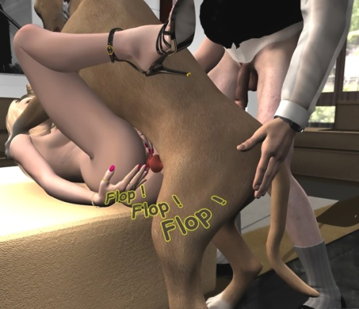

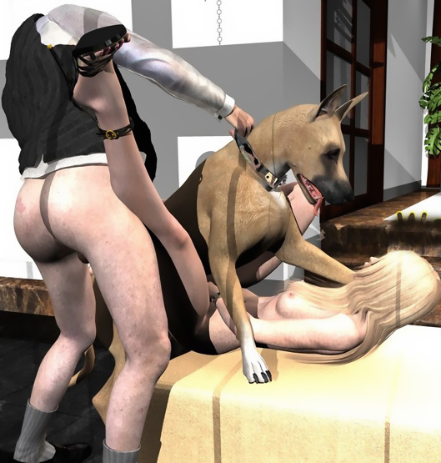

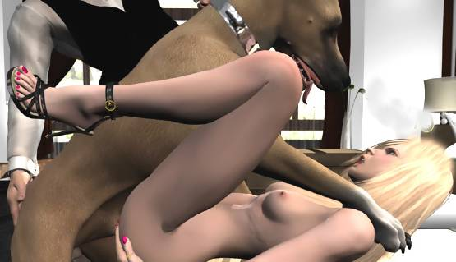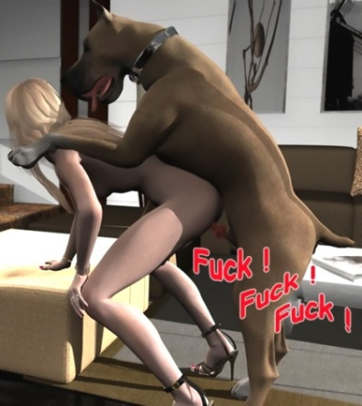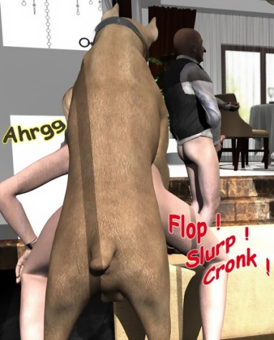

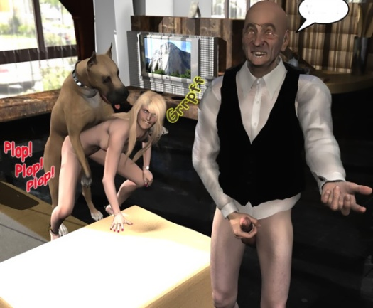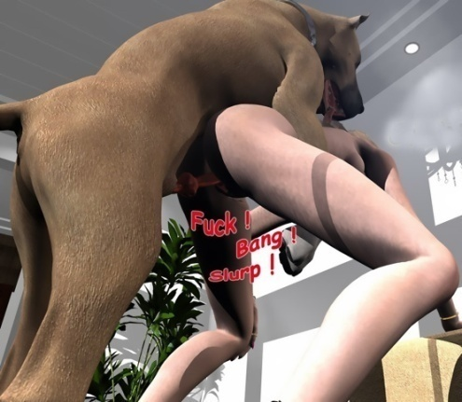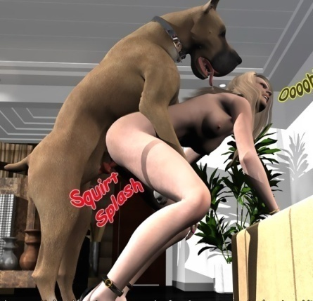

- - - - - - - - - - - - - - - - - - - - - - - - - - - - - - - - - - - - - - - - - - - - - - - - - - - - - - - - - - - - - - - - - - - - - - - -

https://www.beastforum.com/showtopic-291112.html

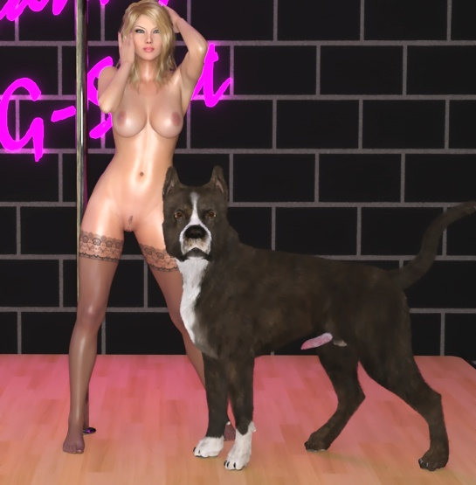

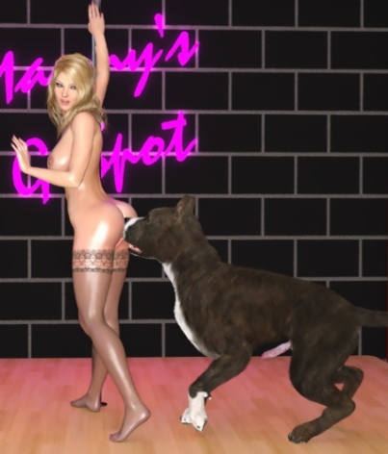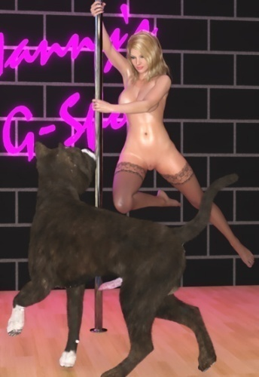

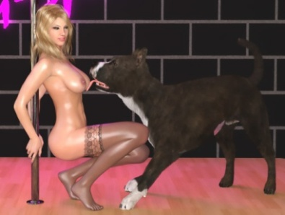

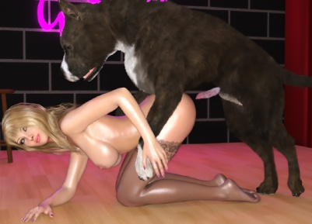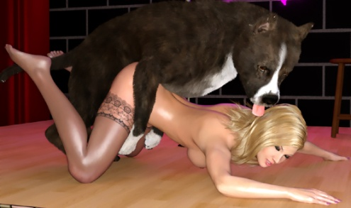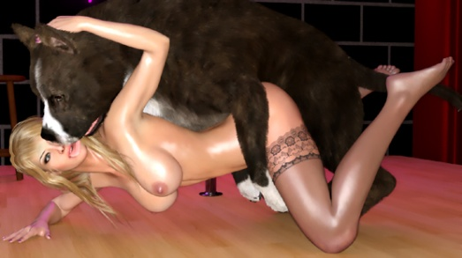

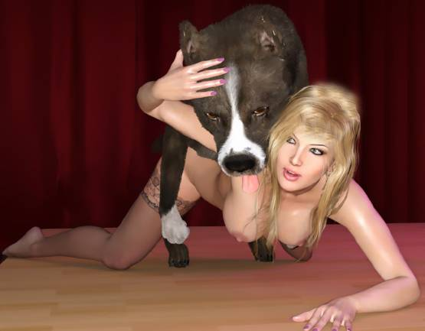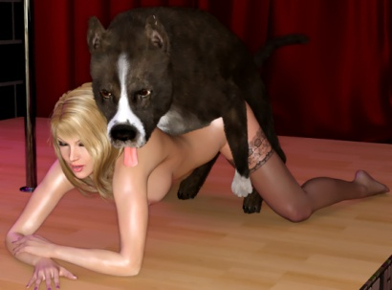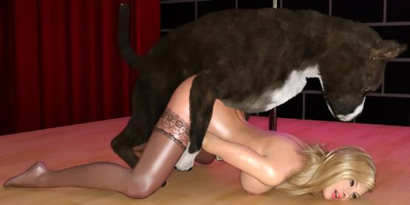

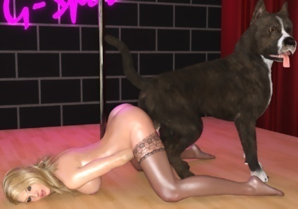

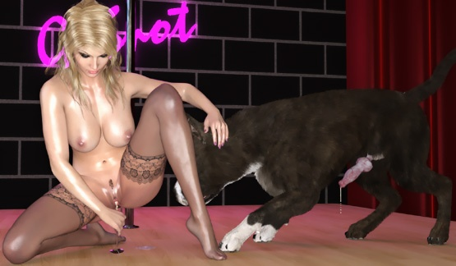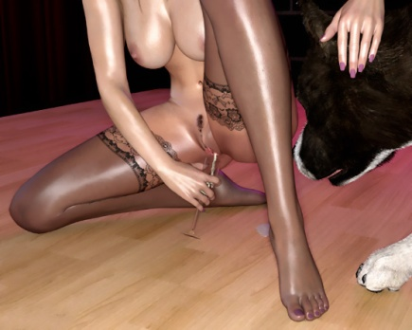

- - - - - - - - - - - - - - - - - - - - - - - - - - - - - - - - - - - - - - - - - - - - - - - - - - - - - - - - - - - - - - - - - - - - - - - -

https://www.beastforum.com/showtopic-192034.html

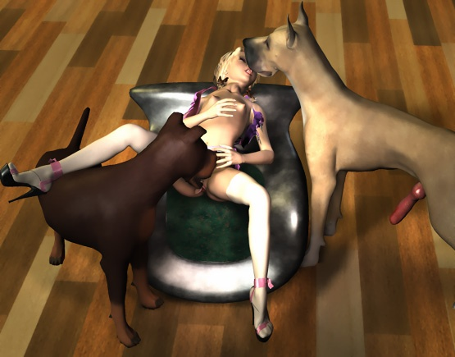

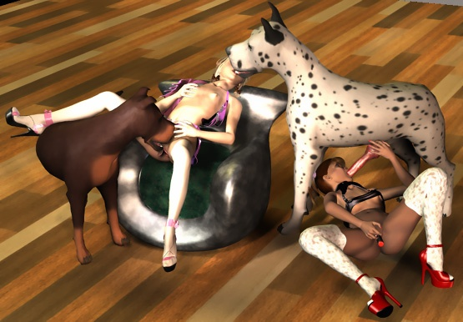

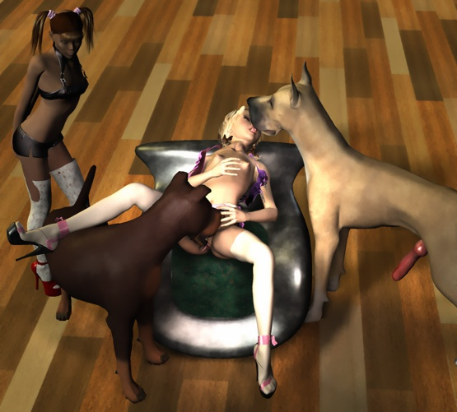

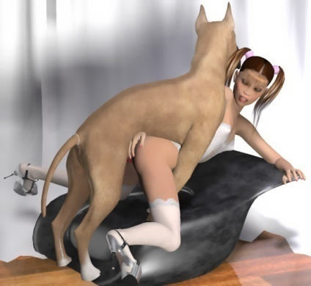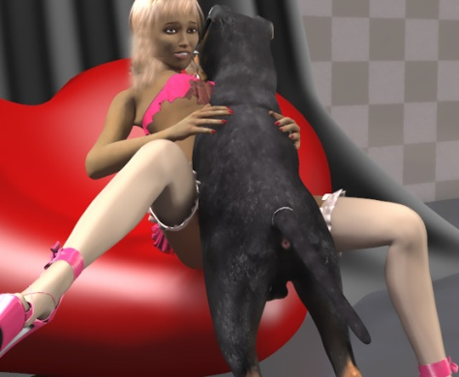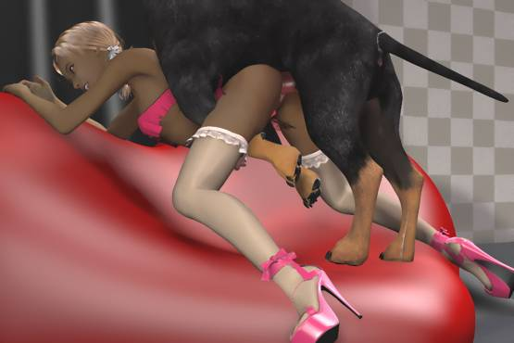

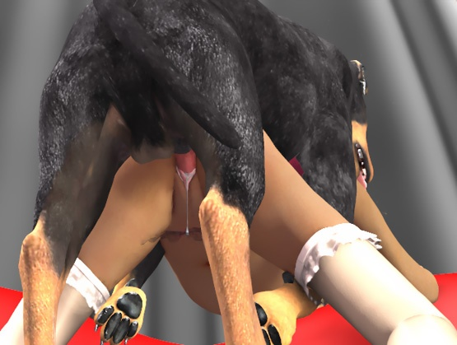

- - - - - - - - - - - - - - - - - - - - - - - - - - - - - - - - - - - - - - - - - - - - - - - - - - - - - - - - - - - - - - - - - - - - - - - -

https://www.beastforum.com/showtopic-209375.html

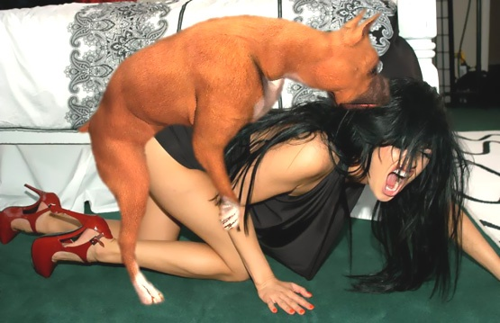

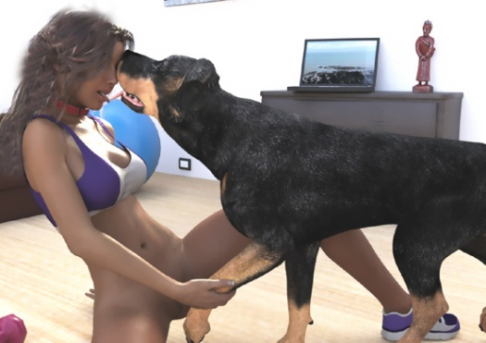

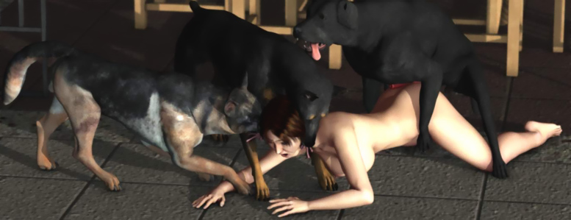

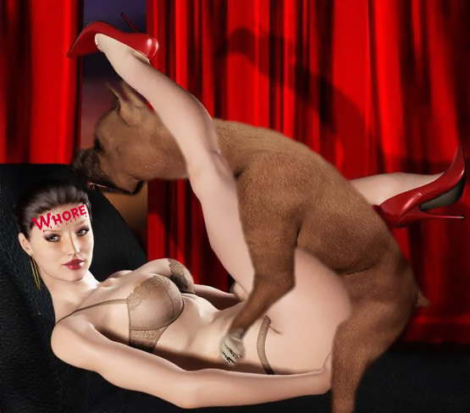



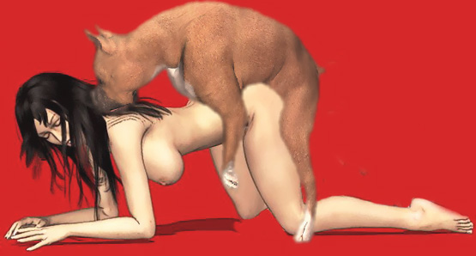

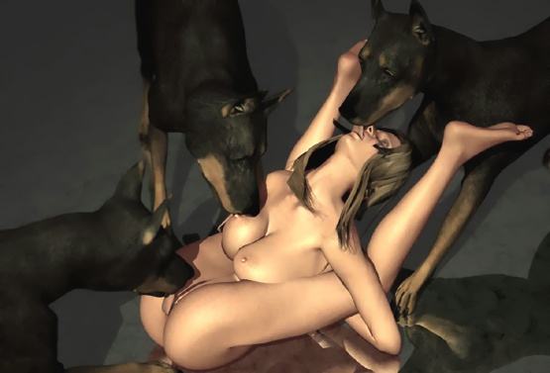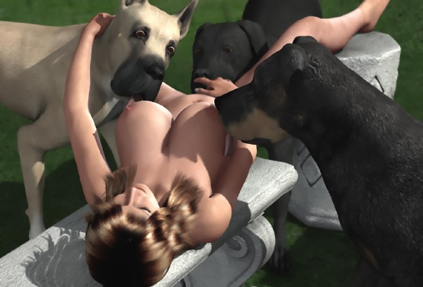

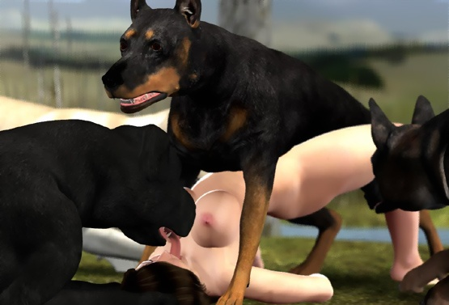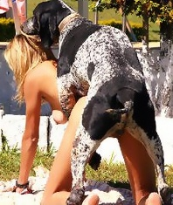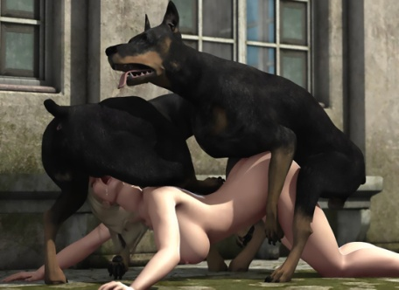

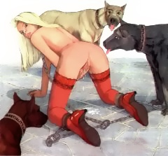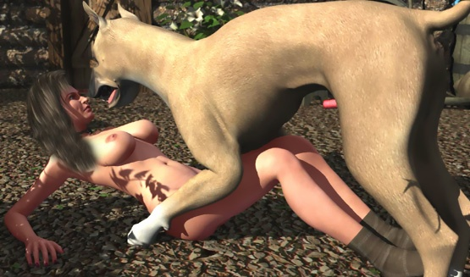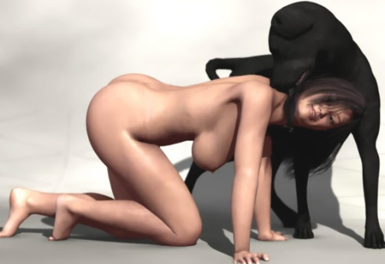

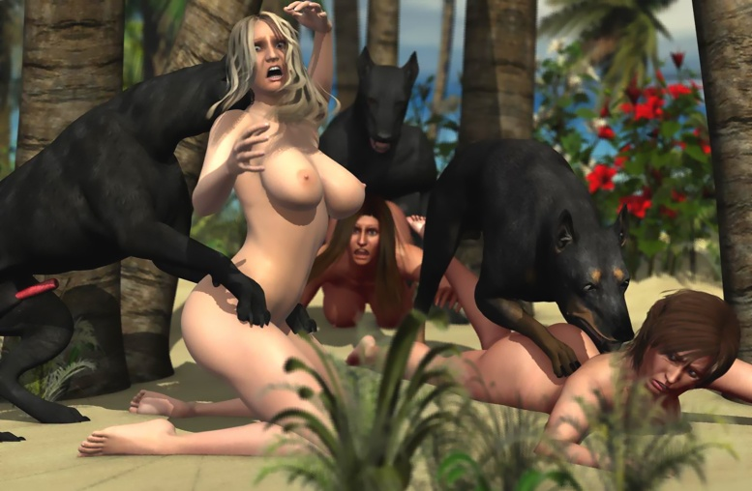

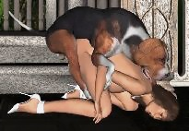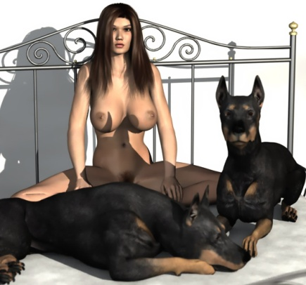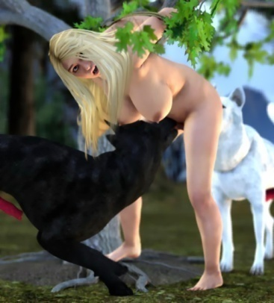

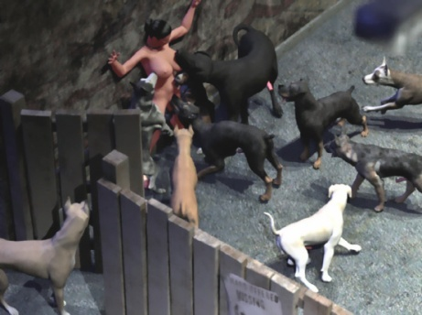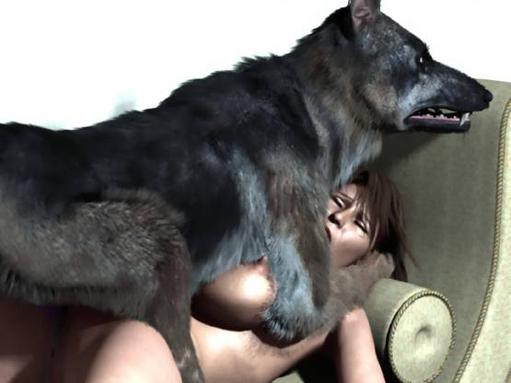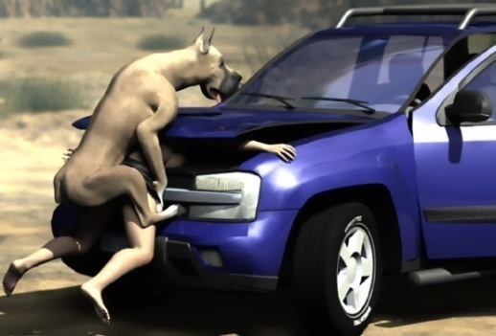

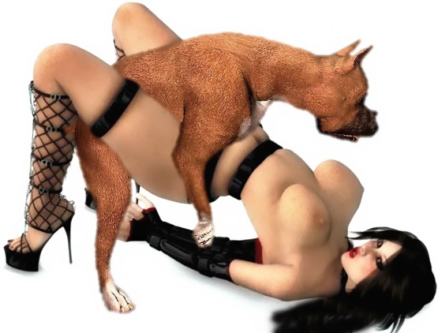

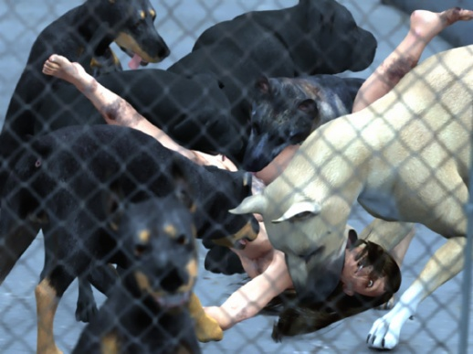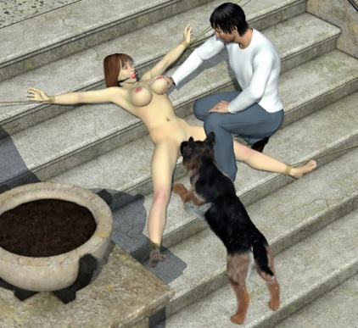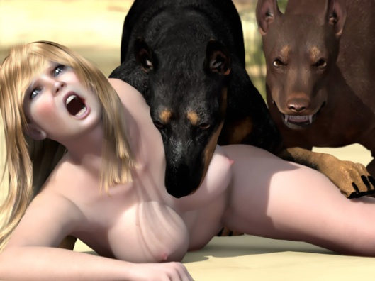

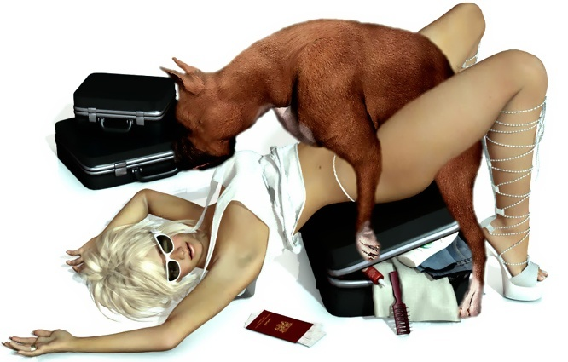

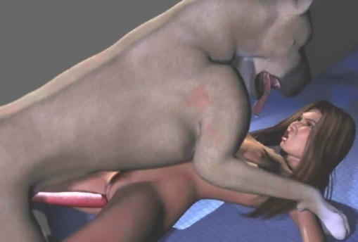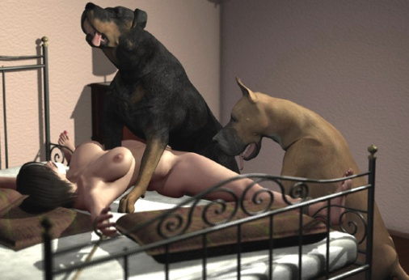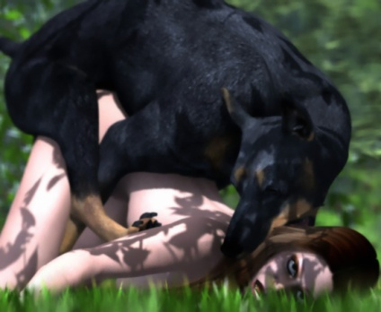

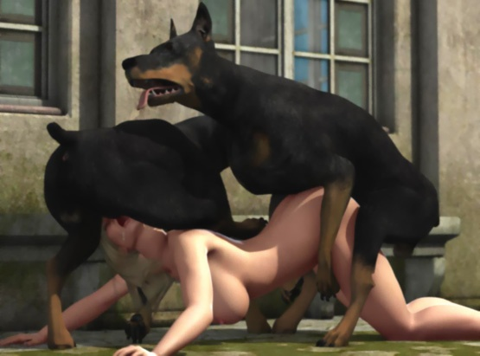

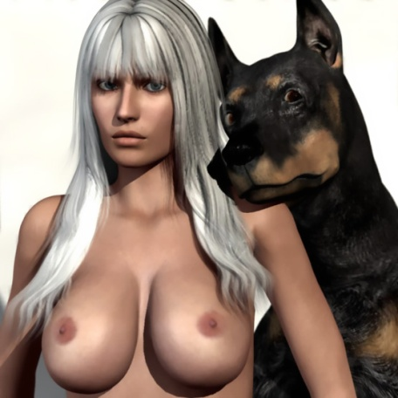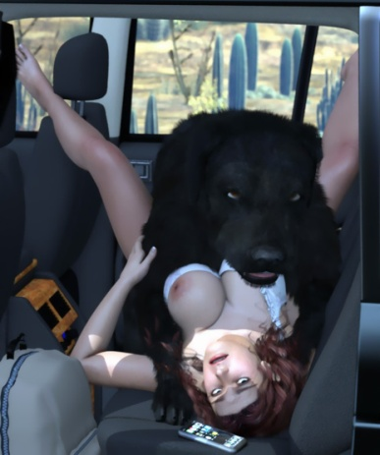

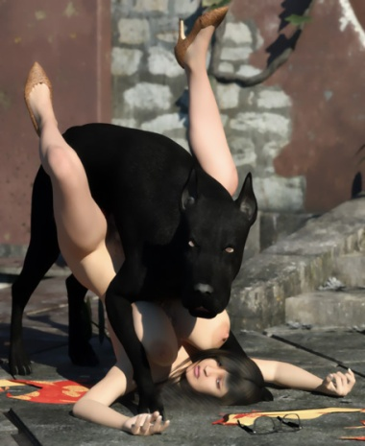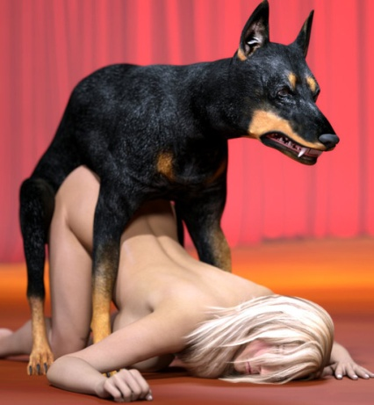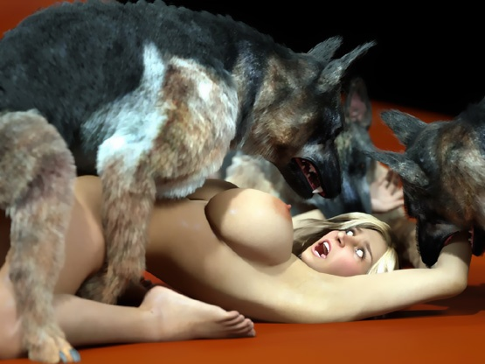

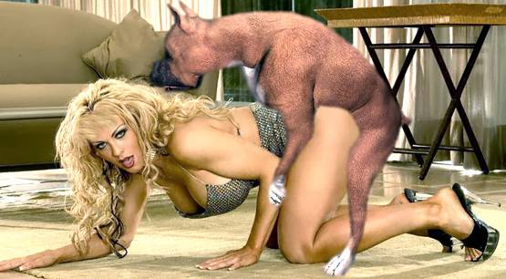

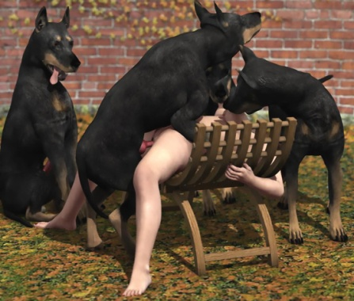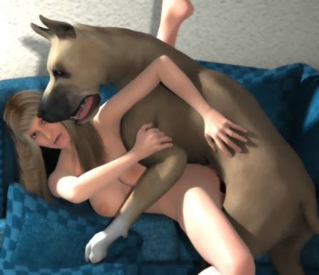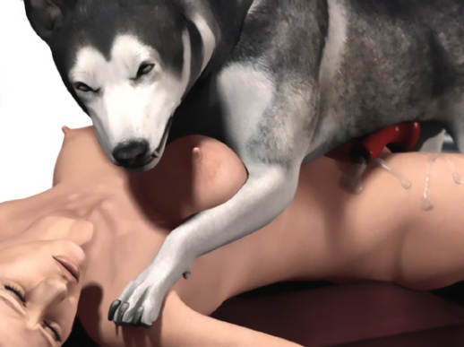

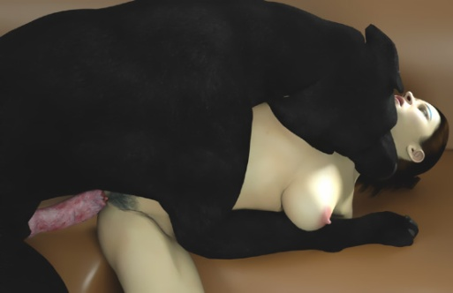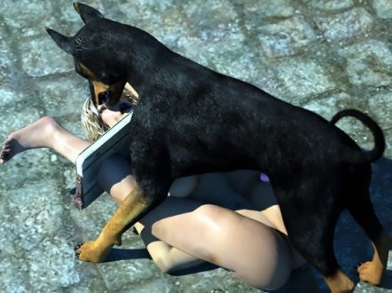

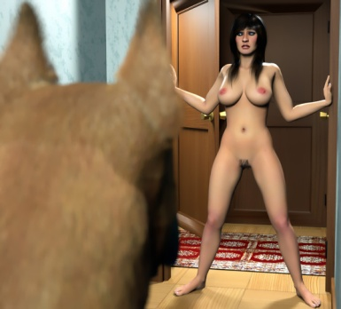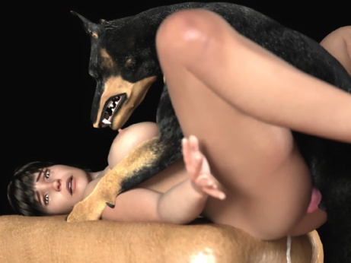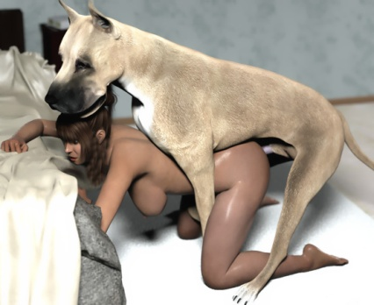

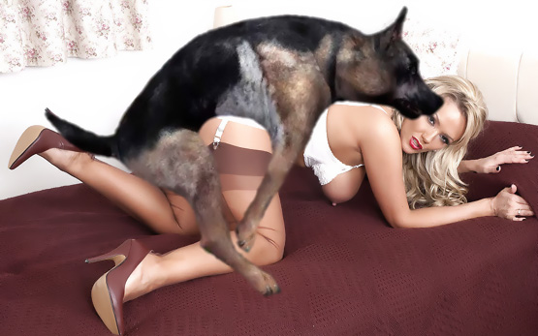



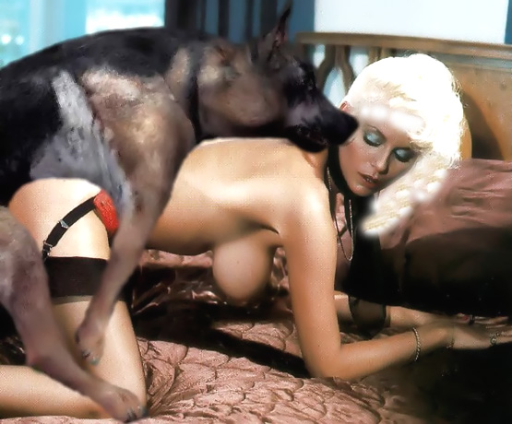

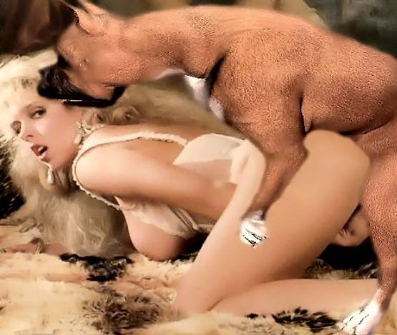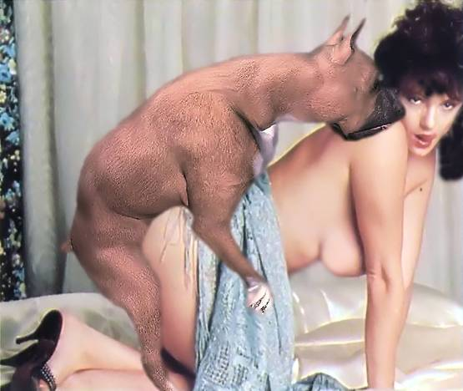

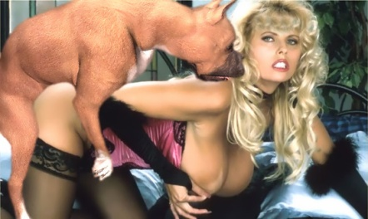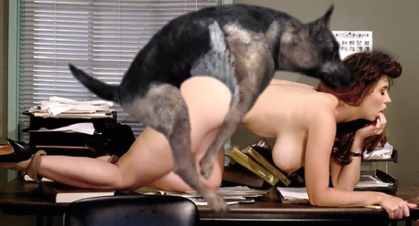

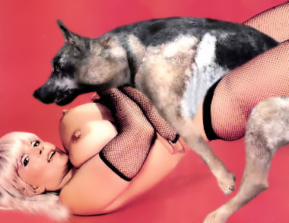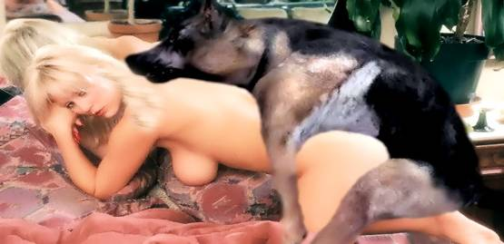

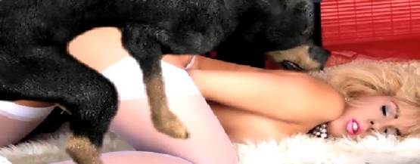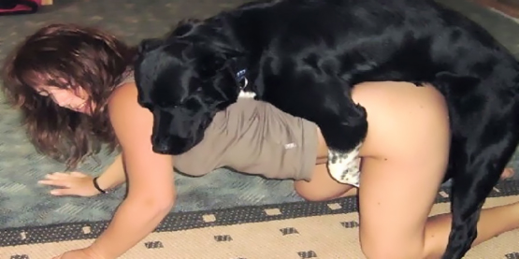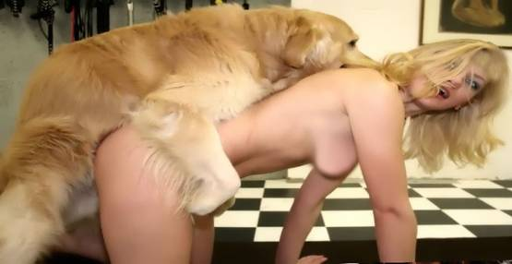

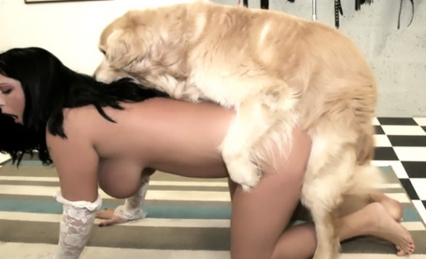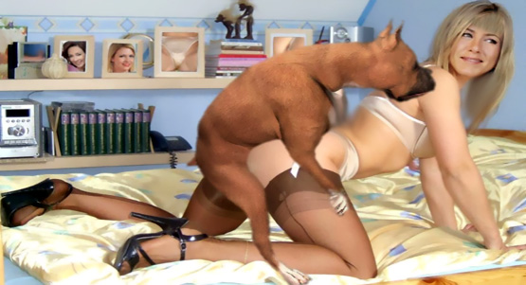

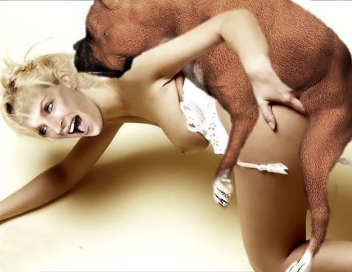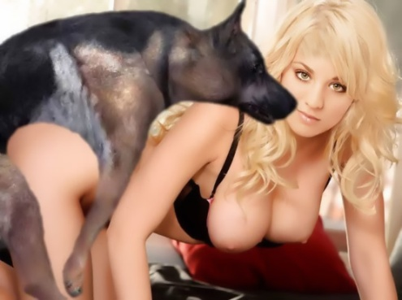

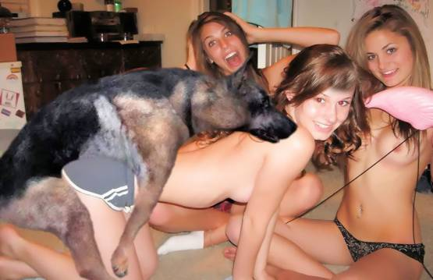

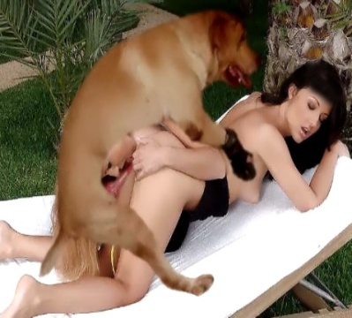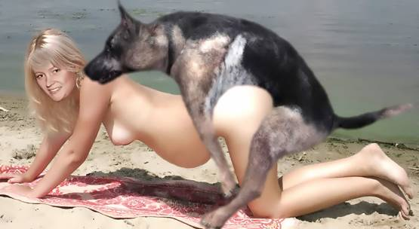

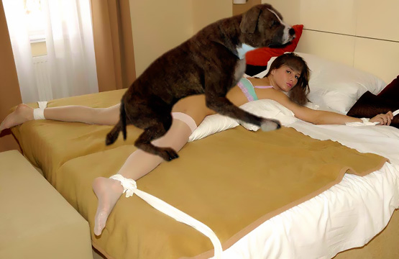

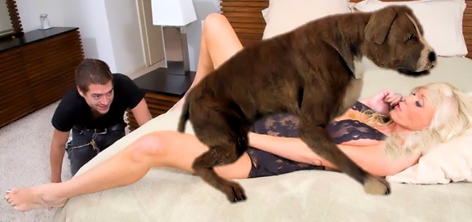

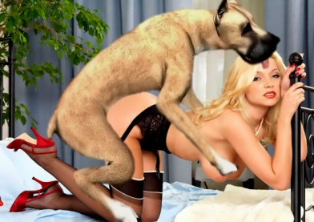

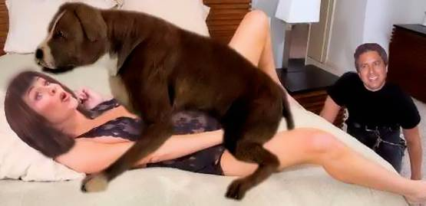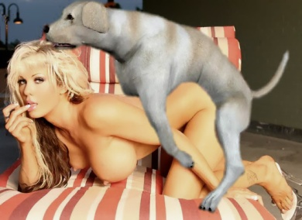

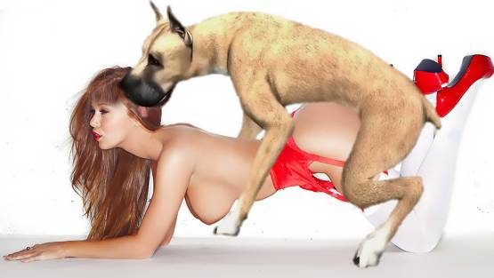

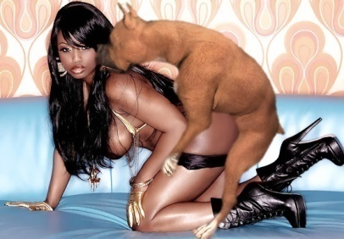



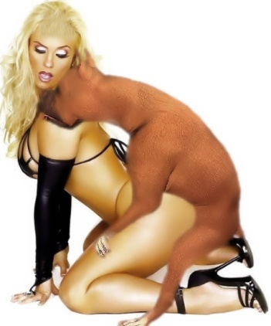

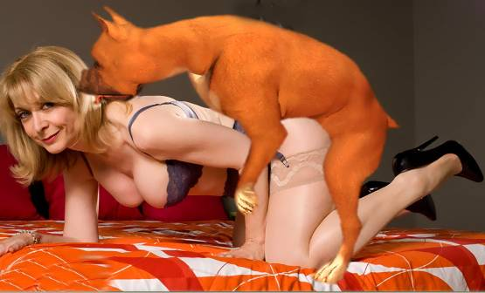

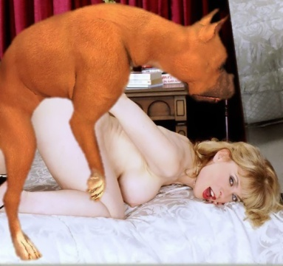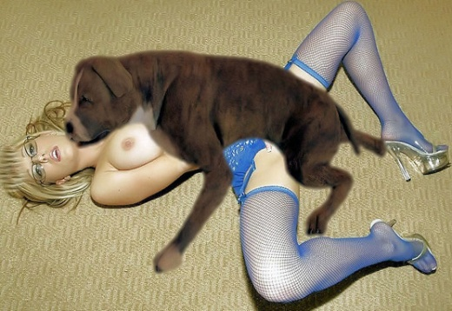

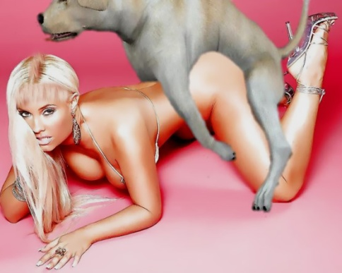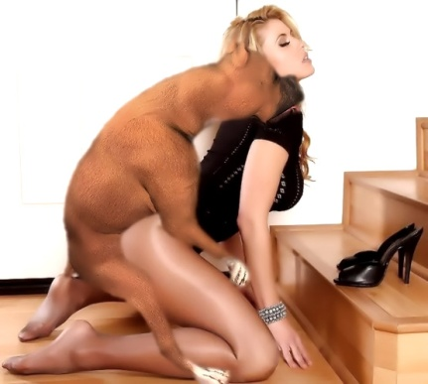



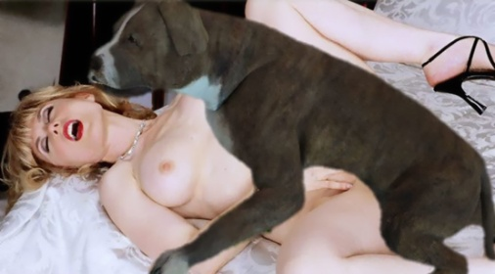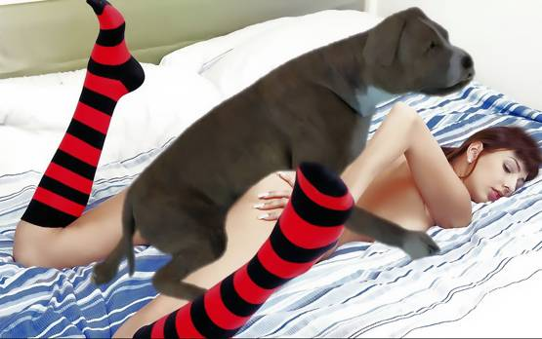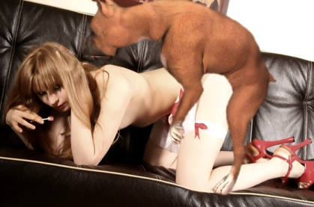

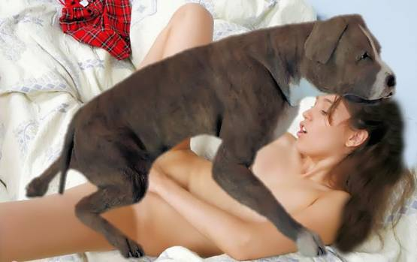

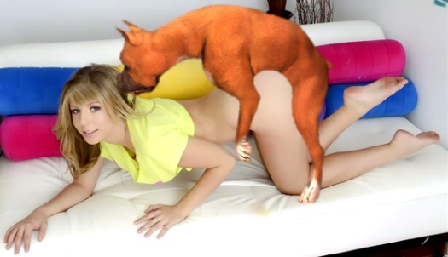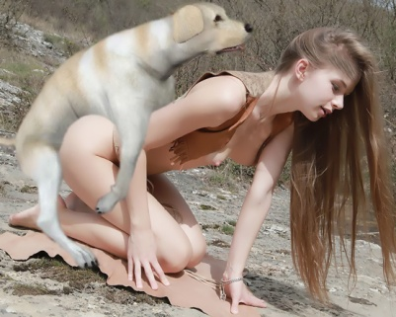

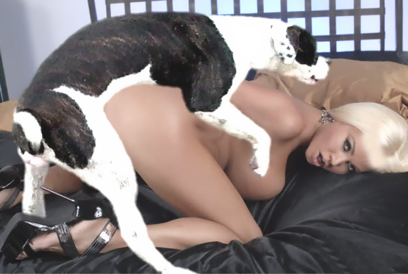

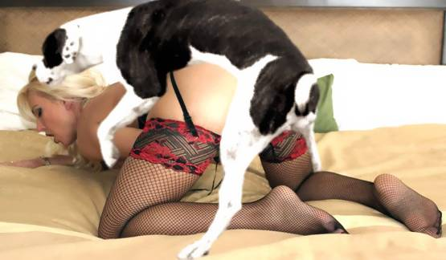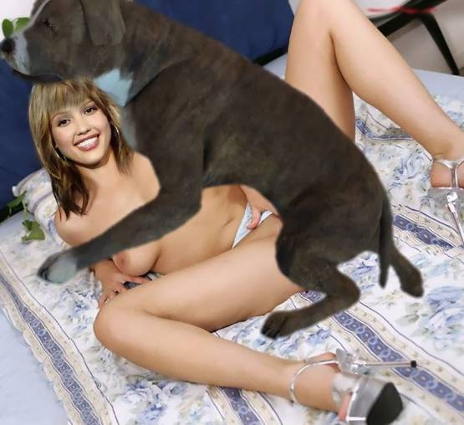

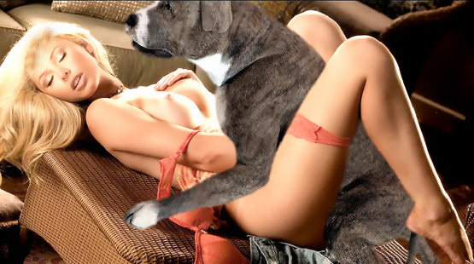





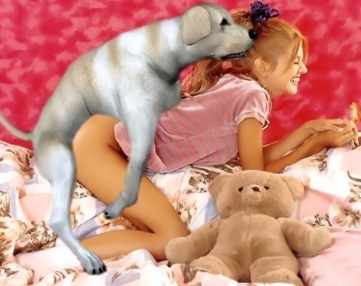

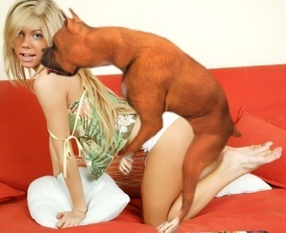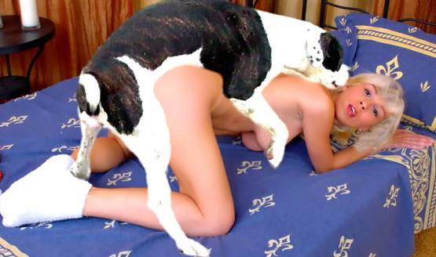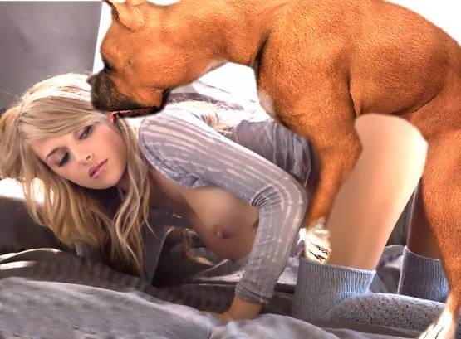



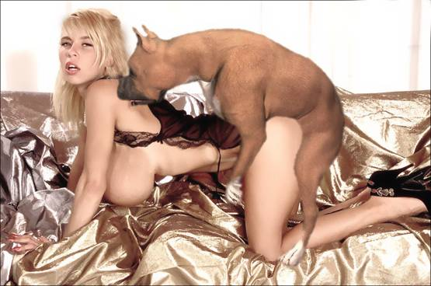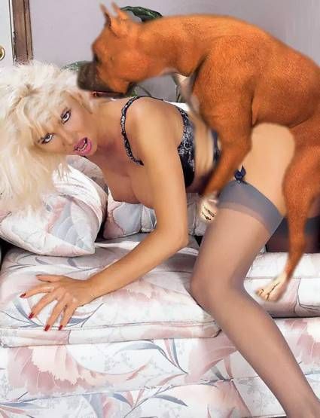

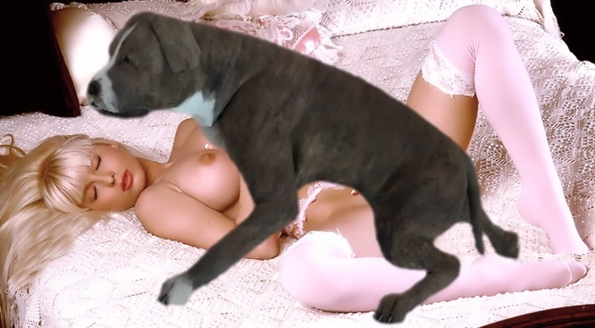

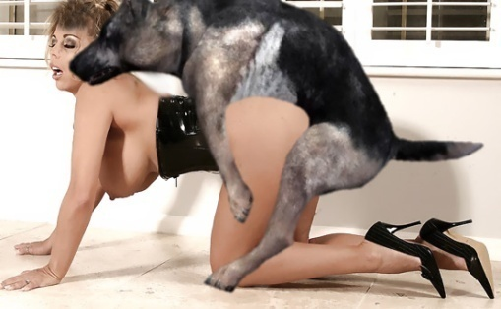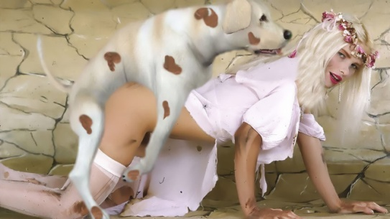



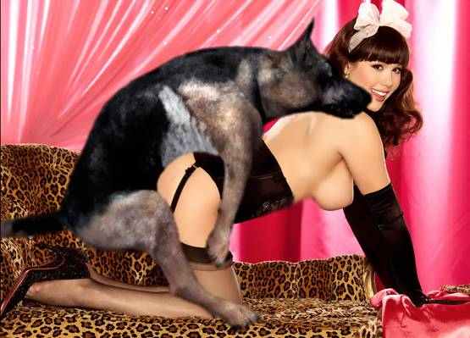

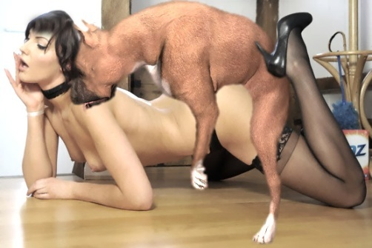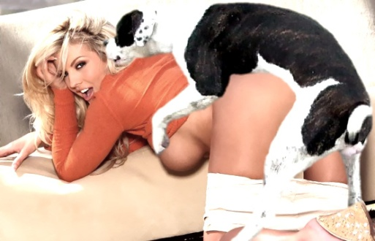

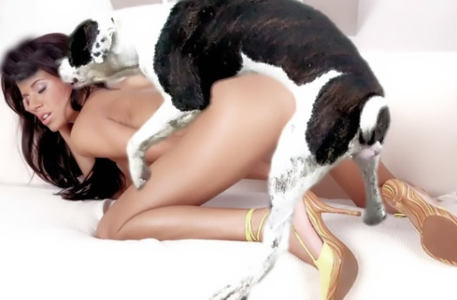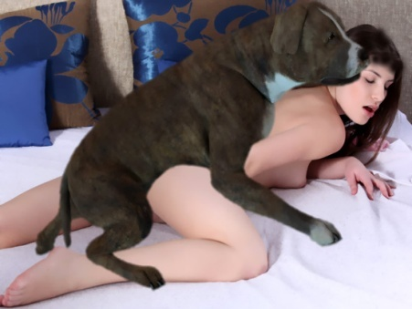

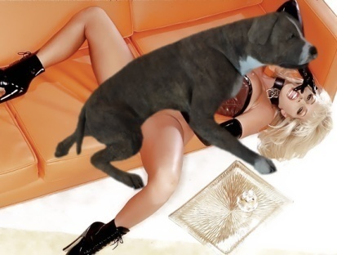

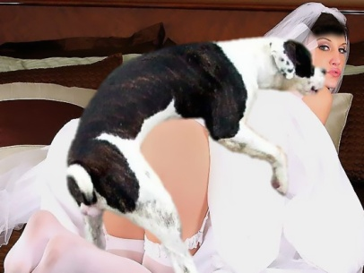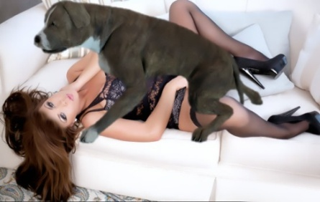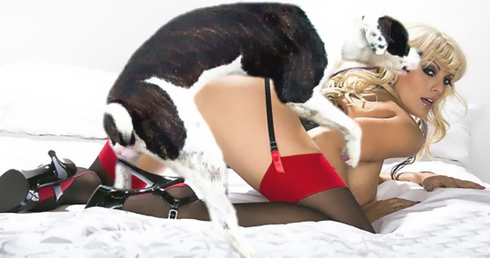



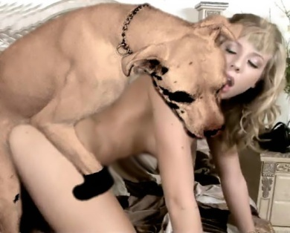







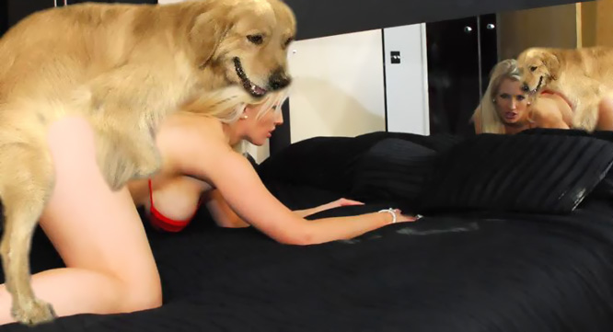

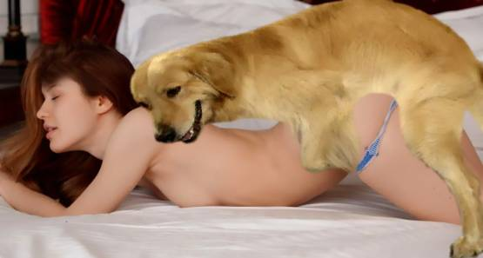

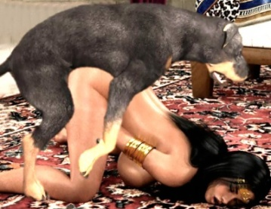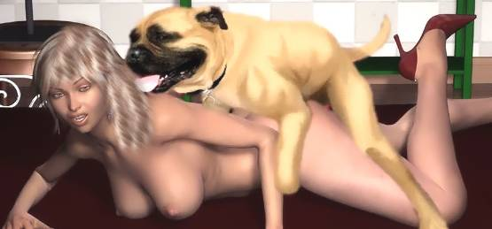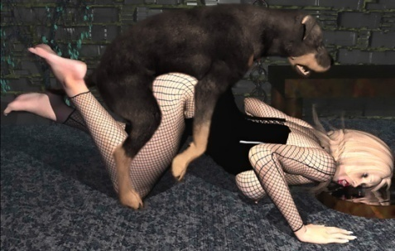

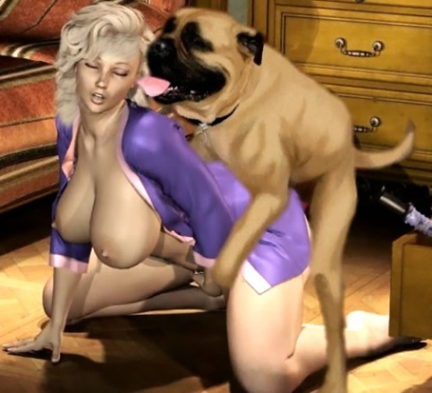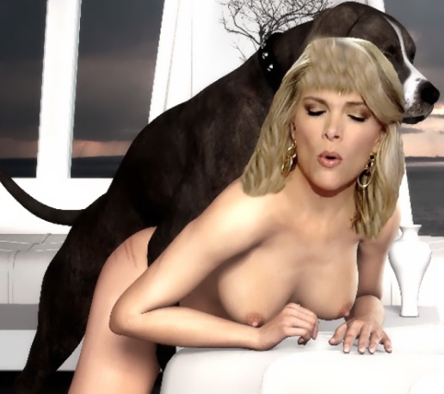

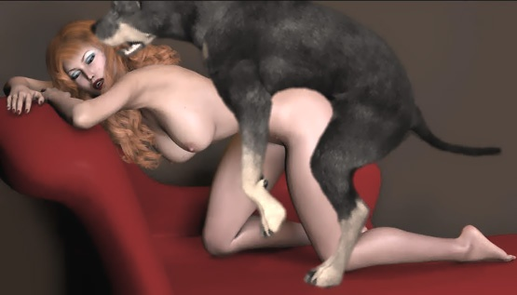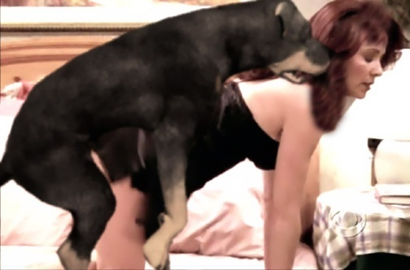

- - - - - - - - - - - - - - - - - - - - - - - - - - - - - - - - - - - - - - - - - - - - - - - - - - - - - - - - - - - - - - - - - - - - - - - -

https://www.beastforum.com/showtopic-209620.html



