Dog Rape Fantasies - 9

https://www.beastforum.com/showtopic-122030-1740.html
*** Bound for Beasts ***
by Canis 3

Day 1: Beverly

Some time ago I invited Beverly to my studio. At 6:00 pm I opened the door and she walked in.

She was an impressive tall woman with long legs and big (fake) breasts. Although she was not a thin woman, her body had an hourglass shape. She had done bondage modeling for years and her flexible tied body had illustrated hundreds of bondage magazines and webpages.

For Beverly, this was just one of many bondage sessions. I asked her to take off her clothes and lie down on a sofa, her head on the right-hand side headrest.

I asked her to straighten her right foot. I had a rope hanging from the ceiling which I tied around her right ankle so that her leg was pointing high up. I tied another rope around her left ankle and pulled it back while I tied the other end around the leg of the sofa.

I asked her to lift up her arms and tied her wrists together. I pulled the over her head and tied the other end of the rope around the same leg of the sofa.

Beverly had some ideas which made her body look even more sexy. When I was finished, I adjusted the lights and went behind my camera. She looked at the camera letting me know that she was helplessly tied up and I could do anything I wanted with her body, her tits, and her pussy. She was very professional.



After a few shots I told her that I was going to put a tape gag over her mouth. She had expected that. When I returned to my camera, my phone< rang>.

"Sorry. I'll be back in a minute" I said walked to my office and closed the door.

A few minutes later I walked back to the studio. Beverly was lying tied on the sofa. Her legs were spread wide so that the camera had a good view on her pussy. But now this view was covered.

Buster just stopped licking Beverly's pussy. He wrapped his forepaws around her waist and mounted her. Buster was the dog of my ex-wife and I had promised to look after him for a week.

Beverly looked at the dog mumbling something behing her tape gag. Her eyes told that she would kick the dog to the nearest corner if she could. But right now she wasn't able to do anything.

I was just about to rush to Beverly and push the dog away from her when Buster had hit home. Beverly was being raped by a dog in my studio!

I grabbed my other camera. Beverly was so terrified of the dog that she didn't even see me taking pictures of her (as it turned out, Bound for the Beast).

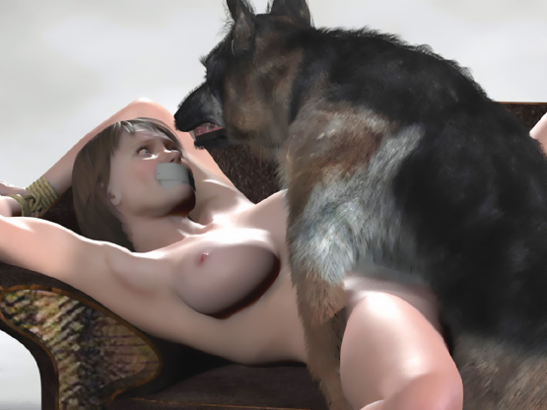

Beverly wiggled her hip to make the dog stop fucking her. The dog growled at her viciously as his penis slipped out of her pussy ...

... but in a second he jumped on her again. Quickly he wrapped his forepaws around her waist and pushed more than 7 inches of his wet cock into her pussy. Beverly wiggled and squirmed but couldn't escape the dog fucking her tightly tied body. Doggy semen was already dripping from her pussy as Buster lowered his head and grabbed her neck in his jaws.

He positioned his hindpaws firmly on the floor ... pulled her neck ... and pushed all of his cock into her pussy. The helpless woman let her head fall back as the dog held her neck tightly in his jaws and filled her with his puppy-making sperm.

When the dog had finished breeding her, I walked into the studio asking if everything was okay. Beverly just nodded and we continued our photo session. She looked even more sad in her bondage than usually. We both knew why.

Next day I sent her all the photos I had taken.

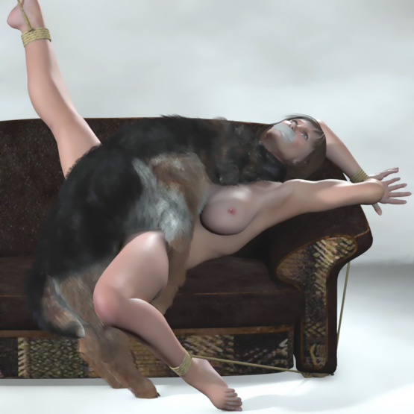

https://www.beastforum.com/showtopic-122030-1755.html

Day 2: June

Next day the editor sent June to my studio. She was one of the most beautiful bondage models of all time. I read her contract. Men we not allowed to fuck her and no injuries should be caused.

"Okay. Let's do this shit," she said. "You know the rules. Just tie me up, take your photos, and I'll get my money."

When she was all naked, I put metal cuffs around her wrists and ankles. I lifted her arms up with two chains and spread her legs with a spreader bar. Then I adjusted the lights and took my camera.

June was a beautiful woman with nice natural breasts. I took some photos of her naked body with her arms and legs spread wide.

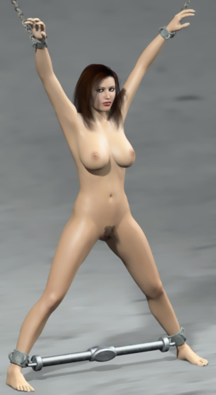

Then I took a few steps and took some close up photos of her face and tits.



"Isn't it frustrating?" she said. "You can tie my sexy body any way you want. But you can't fuck me. You can look at your photos knowing that this is the sexiest body you've ever seen. But you can never fuck it."

"Enough talking," I said and gagged her with a leather strap.



Using 2 chains I lifted her legs up and adjusted the height of her pussy right for Buster. I opened the door and let the dog in.

The leather gag stopped all her words and screams. But with wide open eyes she watched as the dog walked between her legs and gave her thighs and pussy a few wet licks.

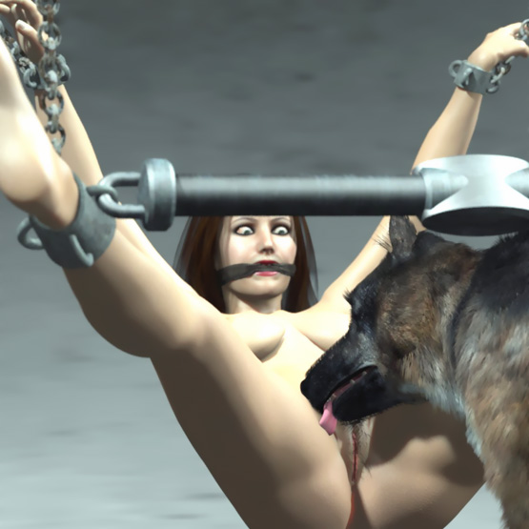

June closed her eyes and shook her head as the dog licked her pussy pushing his tongue deeper and deeper inside her. After a few minutes the dog lifted his forepaws on her thighs and wrapped his paws around her waist. June stared at the dog as he climbed on her.

Suddenly she looked at me gritting her teeth. She was scared, sad, and angry at the same time as the dog's penis poked her thighs. His pre-cum made the well-licked pussy even more wet. Soon his cock found her hole.

The dog danced on his hind paws and pulled her hip against his as he pushed his cock inch-by-inch into her vagina. Soon he hammered the pussy fiercely forcing his swelling cock deeper-and-deeper into the helpless woman's cunt. Her suspended body was shaking and swaying responding to the dog's fierce thrusts.

June looked at me looking for help. But it was too late. The dog had already knotted her and I was busy taking pictures of her bestial rape. Doggy sperm was already leaking from her pussy. For 10 more minutes, the dog pumped his semen deep into her knotted vagina.

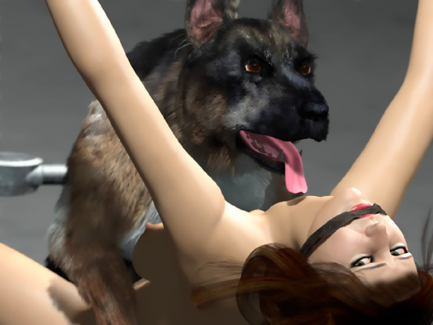

- - - - - - - - - - - - - - - - - - - - - - - - - - - - - - - - - - - - - - - - - - - - - - - - - - - - - - - - - - - - - - - - - - - - - - - -

https://www.beastforum.com/showtopic-156123-105.html
*** Lucy’s Doggy Date ***
by Canis3

Lucy is a young, rich, and beautiful woman who had everything. But now she wanted something new. She knew a producer of fetish films and aske, if she could have one of their dogs for a couple of hours. She wanted to have her pussy and big tits licked by a wet dog tongue. That was something she has never experienced before.

2 days later a man knocked at her door with him a huge Great Dane.

"This is Rex. We have used him in many movies and so he has become very experienced. But I must give you a warning. When we shoot movies, we have many staff members available. I am always there because I have trained Rex.

"So I advise you to be careful. When you play your games with Rex, don't try to make him fuck you. And always have at least one other person available in case Rex becomes too aggressive. Do you understand, Miss?"

"Yes, I understand. No problem," said Lucy and welcomed Rex inside.

"In this bottle you have some lotion that Rex likes very much. He will lick this lotion whereever you put it," said the dog's master and promised to be back in 2 hours.

After a while, Lucy undressed and called Rex to her and lowered herself on her knees. Rex sat down in front of her and gave a lick on her cheek.

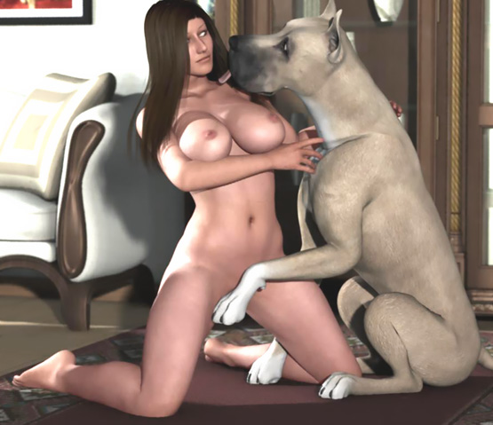

"We don't need other people here do we, Rex? You are a friendly dog and I just want you to lick me all over."

She took the bottle, splashed lotion on her palm, and spread it over her belly and breasts and also rubbed some on her pussy lips and inside her pussy. Then she laid down on her back on the carpet and called Rex to lick her. Rex came and soon he was eagerly lapping her big soft breasts, belly, and her pussy.

"Easy, boy. I want you to take your time," said Lucy.

Rex licked her pussy with his wet tongue.

"This is well worth it," said Lucy and enjoyed the licking. "Now I will turn on my hands-and-knees and spread my legs so that you can lick inside my pussy."

Lucy was now on her hands-and-knees. Rex pushed his tongue inside her pussy as far as he could, trying to get each drop of the delicious lotion.

Meanwhile, Lucy's pussy was getting wet. Her love juices mixed with the lotion and Rex became very excited. He started to <nip> at her pussy in order to get his tongue deeper inside. He tried to lick all the lotion and her juices deep inside her pussy. Rex was becoming aggressive and the licking and <nipping> was hurting Lucy.

"Stop it, Rex! It hurts!" said Lucy in a loud voice.

Rex gave a few more licks and then stopped.

"Good boy. You became too excited, didn't you?" Lucy tried to calm down the dog.

Rex, however, had other ideas. For him, the taste of female love juices was the taste of a bitch. He was trained to fuck human bitches. And this bitch was already in a fucking position on her hands-and-knees.

His penis was now visible and he decided to use it. When Lucy tried to get up, she felt the weight of the huge dog on her back.

"Get off me!" she shouted.

Rex wrapped his forepaws tightly around her waist and pulled her hip up and back, closer to his growing doggy cock. This was nothing new to him. He did this almost every day and he was trained for this. One might call him a professional human-bitch fucker. With a few thrusts, his cock found her pussy and slipped in.

Lucy screamed and tried to crawl away. But his forepaws were too strong for her. He pulled her back and thrust his cock even deeper inside her.

She tried to hit him with his left hand. But he grabbed her arm in his jaws. Her right hand couldn't bear the weight of her body and the dog. It gave in and her head hit the carpet. Like a wrestler Rex held her helpless on the carpet. But unlike a wrestler, he fucked her all the time with strong and rapid thrusts.

Lucy was whining and crying and tears ran down her cheeks. Her neck was painfully arched and with each thrust, her big breasts flopped nearly hitting her face. But Rex didn't stop. Instead he increased the tempo and stepped his right hind leg on her right leg to find a higher angle for his thrusts.

They almost fell over. But skillfully the dog kept balance. His cock was now huge. With each thrust, he slammed all of it into her cunt. She was all wet and some fluids leaked from her pussy.

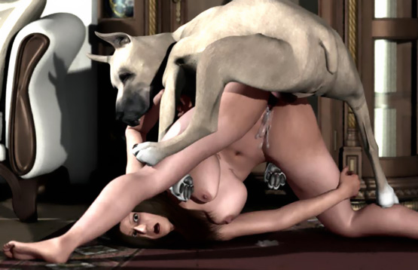

Then she felt the base of his cock getting thicker and thicker. With each thrust, it spread her pussy painfully wider and wider until suddenly it locked inside.

Then his thrusts became quick and short. She felt his huge cock throbbing inside her pussy shooting loads of semen inside her.

In his ecstasy they started to fall over. Rex released her hand and took few steps forward. But his cock was still shooting doggy sperm inside her pussy. Her pussy was "tied" to his cock and her head and shoulders laid on the carpet. Semen started to ooze from her pussy. It ran down her belly and chest.

Then the doorbell rang. When nobody answered, someone <knocked> at the door and opened it.

"Hello. I left the door unlocked just in case. Are you okay?" said the dog's master and entered inside.

He saw Lucy lying on the carpet with his pussy high up suspended by the dog's cock and doggy sperm running down from her pussy. Rex started walking towards his Master dragging Lucy behind him. The Master patted Rex and began to study the situation.

"Are you alright, Lady? You are still tightly locked. But I see no blood. I will support your waist to ease the pain and try to get his cock out of your pussy," he said calmly.

He had clearly done this before. After a few minutes, the dog's penis slipped out of her pussy. The Master carefully lowered down her waist.

"Do you remember what I said before, Miss? Don't do anything alone with the dog. And don't try to fuck him. I can't take any responsibility of this," the Master said.

"It seems to me that you have no physical damage and you don't need me here any longer. ... Have a nice day," the Master said and walked out.

Lucy laid on the carpet weeping.

- - - - - - - - - - - - - - - - - - - - - - - - - - - - - - - - - - - - - - - - - - - - - - - - - - - - - - - - - - - - - - - - - - - - - - - -

https://www.beastforum.com/showtopic-156123-120.html
*** Jen Walking ***
by Canis 3

Jen walked out of the hotel. It was a hot evening and the sidewalks were crowded with people. She was lightly dressed because of the hotness. Usually she wore a bra and panties. But not this time. It was so hot.

Her big breasts bounced heavily as she walked. She heard men whistle and saw them stare at her bouncing boobs. Jen turned to an industrial area. On a hot Sunday evening, nobody was walking there and nobody would stare at her breasts.

After a 10-minute walk, she noticed a huge black dog (a mastiff) sitting on a sidewalk and 2 big dogs (a Rottweiler and a black lab) walking behind her.

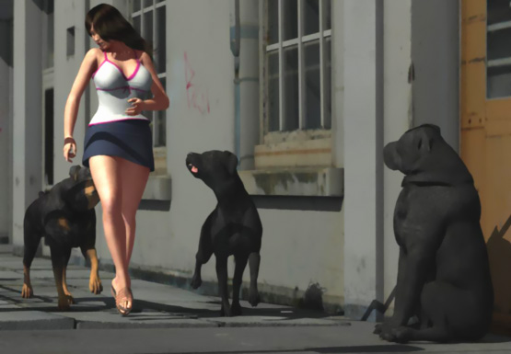

One of the dogs pushed his nose under his skirt and she <slapped> him. The dog growled and Jen felt a little scared.

Just when she was passing the mastiff, the two other dogs attacked her. One jumped at her back and the other grabbed her skirt in his teeth. Jen fell.

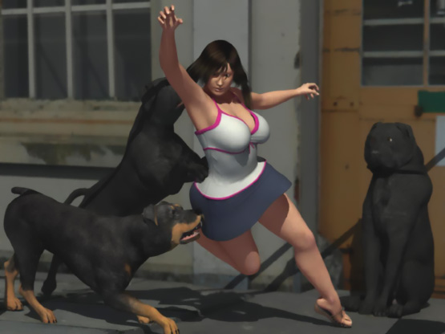

She felt her skirt slipping off her waist. She rose on her hands-and-knees and felt a dog pulling her skirt totally off her.


She was now half-naked. But she didn't have time to think about that.

She got up and ran to the other side of the street. The dogs followed her.

She passed a fence and looked back. There were now 4 big dogs following her! A German shepherd had joined the pack.

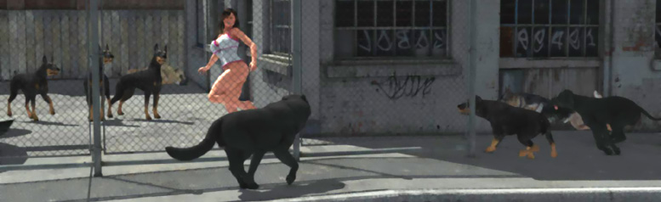

She was so concerned about the dogs following her that she didn't notice the 3 dobermans were waiting for her in the fenced area. And when she saw them, it was too late.

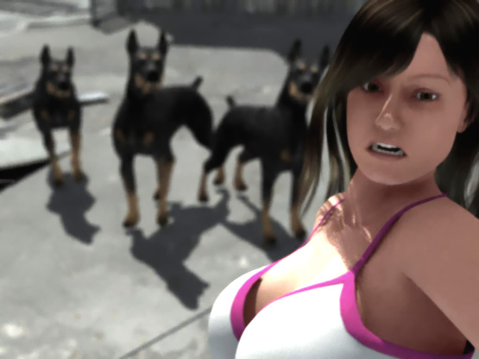

In a second she was against the fence. One dog put his front paws on her shoulders. One was tugging her shirt with his teeth. And the third had his nose in her crotch area.

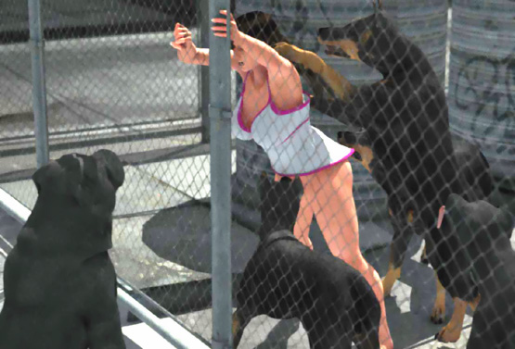

When the dog stepped off her shoulders, Jen stepped backwards. But she fell. She heard a ripping sound and saw her shirt in the jaws of a doberman. She tried to get up. But dogs were all around her.

One doberman was licking her pussy. A black lab was licking her right breast and the rotweiler her face. A Great Dane was lying in a corner watching her fate. The huge black mastiff walked towards her and growled.

Then a German shepherd grabbed her left breast in his teeth. It didn't hurt much. But Jen screamed louder than ever and tried to escape.

Then the third doberman grabbed her throat in his jaws. With her throat and left breast in the jaws of dogs, she couldn't do anything but wait and let the 3 other dogs lick her pussy, right breast, and face.

Her legs were spread giving the dog easy access to her pussy. When Jen tried to close her legs, the dog <bit> her clit and soon Jen’s pussy was again wide open for his tongue.

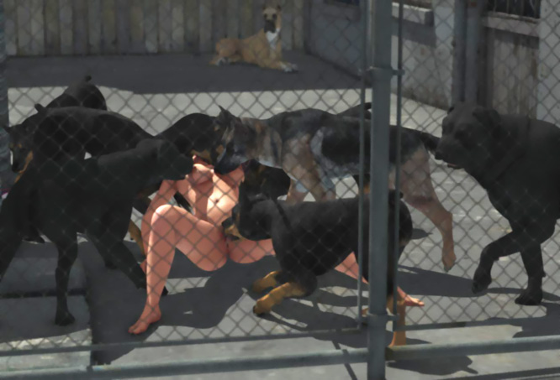

She opened her mouth to scream. But the Rotty put his tongue in her mouth and she felt the doberman’s teeth slightly sank into her neck. She froze.

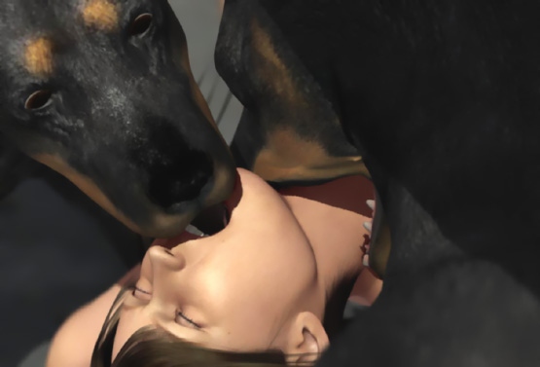

Her throat was tightly in the jaws of a dog when other dogs moved to give way to the huge mastiff approaching her. Her pussy was all wet and open for the dog. Her big soft breasts rose and fell with her breaths as she helplessly waited what the dogs were going to do to her.

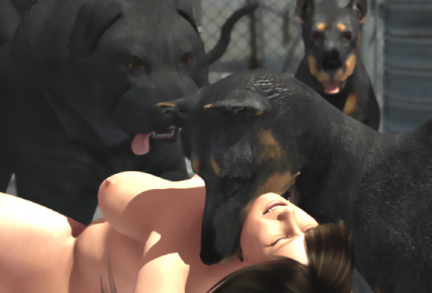

The mastiff wrapped his forepaws around her waist and lowered his hip. She felt the bad breath of the dog on her face. Then she felt something hard poking her crotch. Soon it found her pussy which was wet from all the licking.

The mastiff growled at her ... pulled her hip up and towards him with his forepaws ... and pushed a few inches of a thick doggy cock inside her pussy. She was going to be raped by a huge dog!!

She tried to move. But both dogs growled at her letting her know that she was going to be bred and she can do nothing to stop it.

The mastiff pushed his hind legs under her hip and pulled her with his forepaws. She felt her hip raise up and the doggy cock penetrate her pussy even deeper.

Now that she was totally at the mercy of the mastiff, the doberman released her throat. The mastiff started to fuck her. It wasn't easy to fuck her while supporting her hip up. But she felt how the cock moved back-and-forth in her pussy. And at each thrust, it was bigger than before. It was getting too big and painful even for her lubricated pussy.

Other dogs sat and waited, growling at her time-to-time. They all wanted to breed the bitch.

The German shepherd -- the one that had grabbed her tit in his jaws -- was especially aggressive. He started to bark and growl to tell others that he would not wait for his turn. He would grab the bitch in his teeth and fuck her now.

Jen was scared to death. While one dog was brutally raping her, another dog was starting to fight over her. She tried to stop the shepherd. The mastiff bared his huge fangs and gave a loud growl full of threat. The shepherd backed a little but kept snarling.

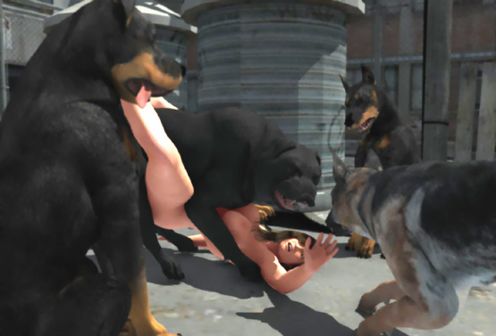

The knot at the base of the mastiff's cock was starting to grow. Pushing a huge cock into a tight hole while supporting her hips was difficult enough. It was impossible to get the knot inside. The dog stepped forward. When her back arched and her hip rose up, the dog could now use more force in fucking.

The dog took a few steps more. Jen almost fell over. Her face was tightly pressed in dirt. Her back was painfully bent so that her hip was just above her head and her legs high in the air.

Feeling that her pussy was supported, the mastiff started to thrust powerfully into her vagina. His huge cock hit her cervix. His knot slammed into her pussy. And at each thrust, her womb was stretched and her back arched painfully.

The thrusts were stronger-and-stronger. Jen felt that her pussy started to give way to the huge knot. Finally it sank in and they were locked.

Then she felt the dog start to ejaculate. First a couple of spasms and then rhythmic spurts of semen. A lot of semen! Her head went down and pussy was up she was like a bottle being filled in a brewery.

But she was not a bottle and it was not beer. Her pussy and womb were being pumped full of puppy-making sperm!

The mastiff waited for his seed to properly breed his bitch. The German shepherd growled at her telling her that it was his turn next. She also saw that the Great Dane, who had rested in the corner, now walked towards her. Then the mastiff tried to step over her legs. It wasn't easy because they were still locked.

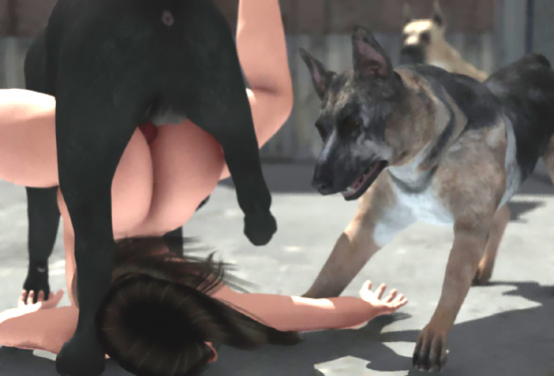

Finally they both rotated so that her pussy was up around his cock and her head was on ground face-up. She closed her eyes. The pain in her pussy was almost unbearable.

When she opened her eyes, she saw the huge jaws of the Great Dane approaching her. It grabbed her throat and lifted her head up from the ground.

The huge dogs used her as a toy. A Fuck Toy!

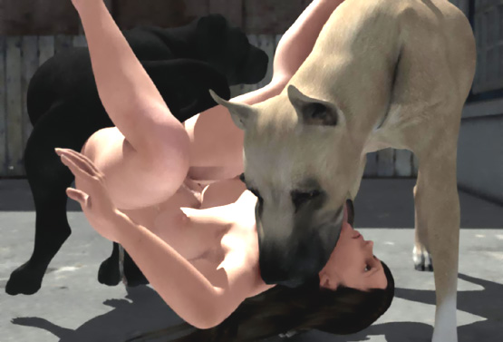

With a plopping! sound, the mastiff's cock slipped out of her cunt. Her hip and back fell on the ground. The Dane grabbed her throat deeper in her jaws and dragged her to his corner. Other dogs growled. Bt they knew that they had to wait for their turn. The Dane was the king of the neighborhood.

Nobody except the dogs heard her screams as King impaled her pussy with his mighty cock. If the mastiff cock hadn't already stretched her pussy, the Dane's cock wouldn't have fit in. She felt like she was giving one birth after another as the huge cock rammed her pussy.

King knew that his fucking was painful to the bitches. So they tried to escape him. But he was used to controlling the bitches. Nobody ever escaped him.

When his 15-inch cock slammed in, Jen felt totally impaled. It was like a forklift had impaled her and lifted her against the dog’s belly.

Then the cock was pulled back and rammed in again! She couldn't do anything or say anything. Not even scream as the huge cock plunged in-and-out.

Everything started to fade away in her eyes. She didn't feel pain any more. She hardly noticed when King used all his strength to force his knot inside her. She didn't feel the huge pressure inside her when King pumped her full of sperm. She was limp like an impaled rag doll. Semen ran out of her pussy making a pool on the ground.

King walked over her so that they were now ass-to-ass with his cock locked in her pussy. He walked towards the pack and the dogs gathered around Jen. As his cock subsided, sperm spurted from her pussy like from a hose until the cock plopped out and a thick stream of puppy-making semen flowed from her pussy to the ground.

She opened her eyes and saw 6 other dogs ready to rape her. She felt paws around her waist, teeth in her neck, and a soggy cock being slammed into her vagina. She was knotted and dragged.

Then another dog mounted her.

And another.

And another … ... ...

- - - - - - - - - - - - - - - - - - - - - - - - - - - - - - - - - - - - - - - - - - - - - - - - - - - - - - - - - - - - - - - - - - - - - - - -

https://www.beastforum.com/showtopic-156123-120.html
*** Babysitter ***
by Canis3

Renata is a 19-year-old blonde. A stunning beauty. Next door to her lives a family with 5-year- old daughter Michelle and a Great Dane, Sam. One day Michelle’s dad asks if Renata could look after Michelle for one night.

"Of course. Michelle is a lovely little girl. I’ll look after her," said Renata.

In the evening she enters their house when Michelle’s parents are leaving.

"Michelle is already asleep. Most likely she will sleep until morning. But it’s good to have you here if Michelle wakes up in the night. ... Anyway, Sam will keep you company. Make this your home," instructed Michelle’s dad and goes to his car with his wife.

Renata goes inside. She goes to Michelle’s room and sees that she is sleeping calmly. Renata closes the door and pats Sam’s head when he comes and sniffs her. She drinks some coffee and decides to take a shower and watch TV.

After a nice hot shower, she dries herself. She switches on the TV and sits naked on a chair. After browsing the channels, she starts to watch some erotic movie. A couple is playing some love games. A handsome man has tied a gorgeous woman on bed and massages her big soft breasts.

Renata moves her left hand on her breasts. They are big, soft, and beautiful. She squeezes her left breast, moves her hand up, and pushes her nipple in her mouth. She massages her breast and sucks the nipple. Her right hand moved down and she touches her clit with her middle finger. She closes her eyes and imagines herself tied on bed and caressed roughly by a handsome guy.

Sam hears the noises from the TV and the moaning of Renata. It comes closer and senses that Renata is horny. Michelle’s dad has been traveling a lot and his wife had secretly trained Sam to be her lover on those lonely nights.

Now Sam knows that Renata is ready to be fucked. His cock starts to grow and he becomes horny. It has been a long time since it had fucked anyone.

Sam comes closer to Renata who is now roughly massaging both tits and pussy. Sam raises his forepaws on the chair. But Renata doesn’t notice him until he licks her face. She opens her eyes and Sam licks her face again with his big wet tongue. Sam comes closer and she feels his penis touching he crotch.

"Stop it, you horny beast. I’m not your fucking bitch."

Sam just comes closer to her. She feels the weight of his body on her and starts to feel uncomfortable. The she feels his cock poking near her pussy.

"No way, you son-of -bitch. You’re not going to fuck me," she says and tries to push him off her. But Sam is too heavy. He doesn’t move an inch.

"Get off me, Sam!" Renata commands in a voice that is loud enough for Sam to understand that she means it but not too loud to wake up Michelle.

For Sam this is a new situation. He is horny and he is doing as he was taught to do. He was also taught to act quietly.

But now his bitch resists him and is making noises. He growls at her a low warning to tell her to be quiet and offer her pussy to his cock. He wraps his forepaws around her waist and pulls her waist closer to the edge of the chair.

Renata tries to fight back. But Sam is too powerful for her. She pushes him and tries to crawl back. But nothing helps. When she feels the head of a huge cock between her pussy lips, she gets a deep breath and tries to scream. But Sam grabs her throat tightly in his jaws and her scream stops before it had started.

Now Sam has a total control of his bitch. He holds her throat in his jaws to keep her quiet and to stop any resistance. With his forepaws he pulls her waist closer to him. His cock sinks 5 inches inside her wet pussy.

Renata’s terror-enlarged eyes are fixed to the ceiling. But she sees nothing. She only feels her throat in the jaws of a beast and her pussy being penetrated by a huge cock. One could can read “No!” from her lips but would hear no voice. Then one could see pain in her face as Sam pushes 3 more inches of his cock inside her.

The pain then changes to fear when Sam drags his cock almost out of her pussy. Suddenly her face is filled with enormous pain and terror as Sam thrusts his entire huge cock inside her and starts to fuck her. His thrusts are so rapid that she cannot adjust herself for each painful penetration. She spreads her legs to ease the pain and tries to stay in a position that is as painless as possible.

After some minutes of fierce fucking, Renata feels that at each thrust something is hitting her pussy lips and clit. A knot the size of a tennis ball has formed at the base of his cock. His thrusts are now even more powerful and painful.

She tries to move. But Sam growls. He has her throat in his jaws even tighter and pulls her hip even closer to him. All the time his hips work like a jackhammer! With his hind legs, he seeks for better leverage.

After a few mighty thrusts, his knot forces its way inside her pussy. Immediately several spurts of doggy semen shoot into her vagina.

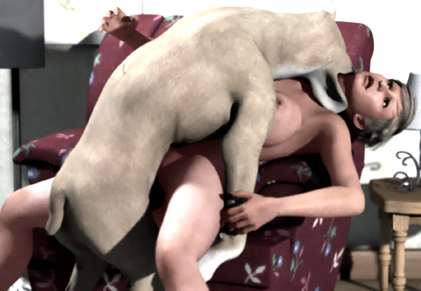

Renata closes her eyes. Her throat in the jaws of a beast and her pussy locked around his knot, she is being filled with doggy sperm. A few more thrusts and the last drops of semen are inside her.

Sam has stopped thrusting now. He releases her throat and growls at her. When she tries to scream, he grabs her throat is his jaws again. The grip of the jaws is now stronger than before.

Renata feels that she cannot breathe. When she is about to pass out, Sam releases her throat and growls. She takes a deep breath but doesn’t scream. When Sam sees that she is cooperating, he starts to lick her face.

After a few minutes, he drags his huge cock out of her pussy. Renata feels like all her guts were being dragged out of her. The huge cock left her pussy gaping open and empty as a stream of sperm was flowing from her pussy to the floor. Renata pushes her hip forward to prevent the chair getting messy. She doesn’t want anyone to know what she has gone through.

Sam walks to the kitchen to have some water. Renata cleans the mess and takes a new shower.

When she bows forward to take her clothes, she hears behind her a low growl and feels a lick in her pussy. Sam was not done with his bitch. Renata takes a few step, but falls against the chair as Sam jumps on her back. His cock enters her abused pussy easily.

During the night, Sam follows her everywhere and doesn’t let her touch her clothes. He rapes her 3 more times.

In the morning Renata is only half conscious. At sunrise Sam grabs her neck in his jaws and drags her to his own corner and fucks her once more. The semi-conscious woman hardly knows what is happening to her.

After her final doggy rape, Renata lies limp in Sam’s corner. Sam is lying above her with his cock still locked inside her pussy.

The door opens and Michelle’s mom and dad come in ...

- - - - - - - - - - - - - - - - - - - - - - - - - - - - - - - - - - - - - - - - - - - - - - - - - - - - - - - - - - - - - - - - - - - - - - - -

https://www.beastforum.com/showtopic-156123-135.html
*** Bedroom Bondage ***
by Canis3

Stacy and Earl had 2 hobbies. Bondage and dogs. They had a big household and 4 big dogs. The dogs had been abandoned and a few weeks ago they had adopted them.

One evening Stacy was lying on bed when Earl came with ropes. Gently he spread her legs and tied them on bedposts. Stacy was excited. She looked at Earl, lifted her big breasts with her hands, smiled at him and licked her lips.

"Do you want to take me, Big Boy? You have to tie me up first," she said playfully.

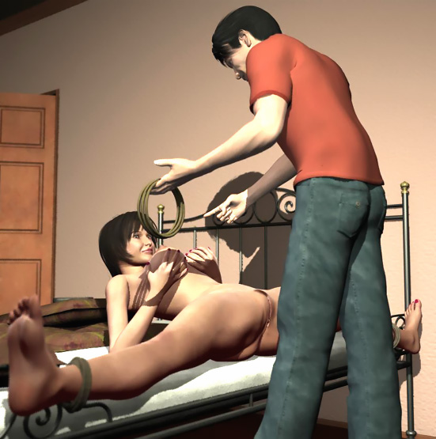

"I will tie you so that you can't move a bit and can't make a sound. Then I will give you the fuck of your life," he answered.

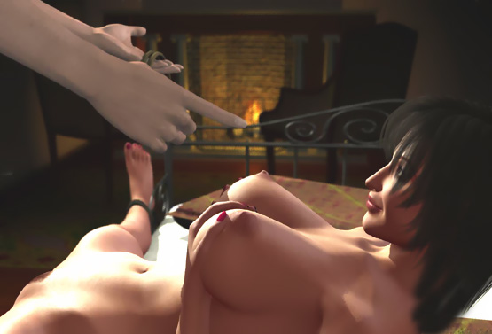

He spread her hands and tied them and tape-gagged her mouth. That was something Stacy liked.

He grabbed her big soft left breast in his left hand and squeezed and massaged it while massaging her clit with his right hand and pushing his thumb inside her pussy.

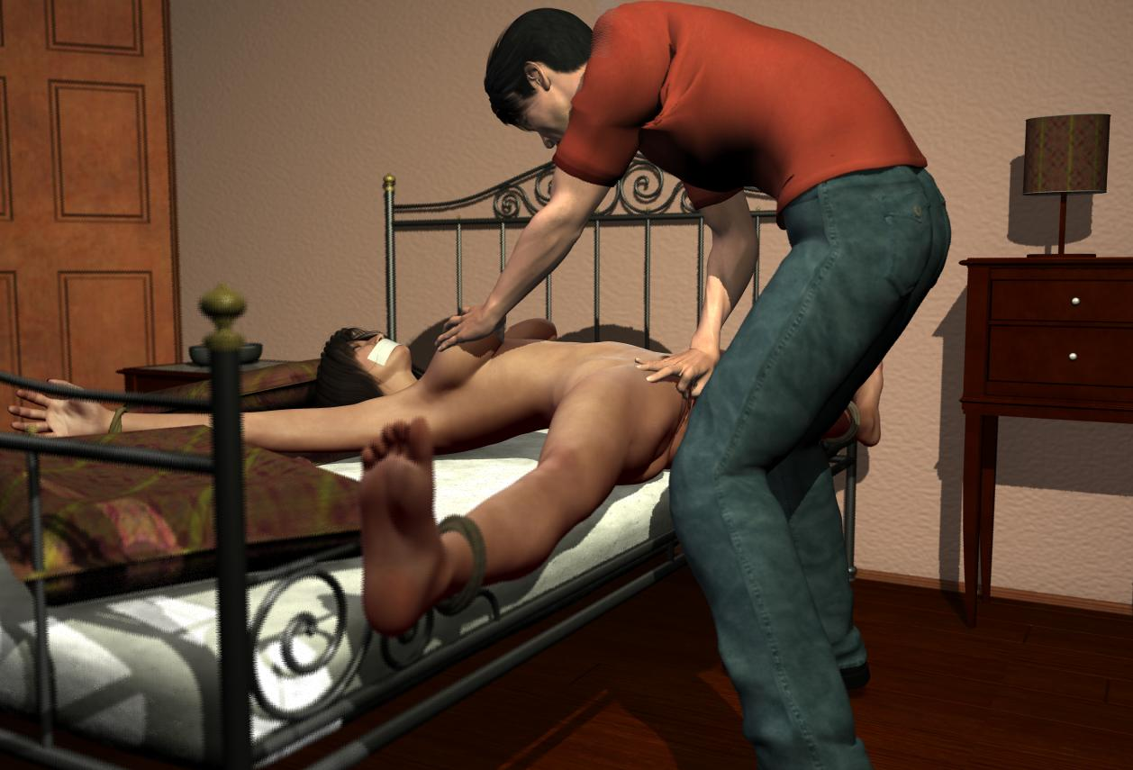

She squirmed and soon her pussy was all wet.

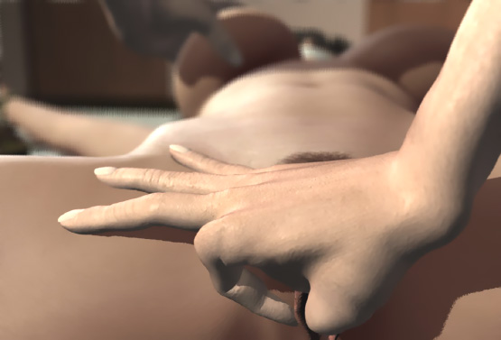

"Just wait here, my love. I will go downstairs and have a nice cup of coffee. You just wait here and think what I will do to you when I come back," he said at the door and left the room.

He left Stacy tied spread-eagled on the bed with her mouth gagged. They were going to enjoy their game for hours.

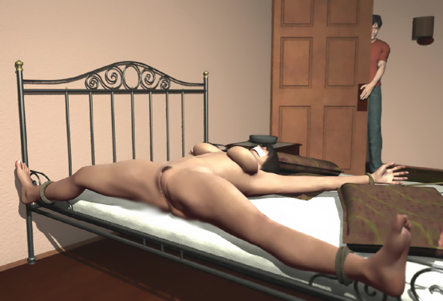

But Earl hadn't thought about the dogs. Two of them -- a Great Dane and a rotweiler -- entered the room. They had found the aroma of a human bitch in heat and saw Stacy lying on the bed.

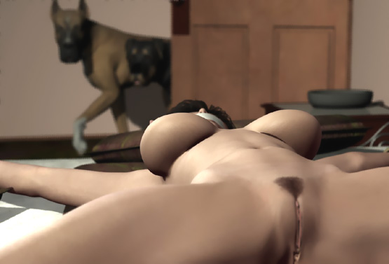

The dogs sniffed her pussy and licked her thighs. Stacy found her situation very uncomfortable. She tried to make the dogs go away. But in her spread-eagled position with a tape-gag on her mouth, she could do nothing. The dogs saw that their bitch was helpless and they were getting excited.

The Dane pushed his tongue deep inside her pussy. The rotty jumped on the bed and started to lick her face and breasts. Her big left tit moved up with his tongue and then dropped softly down. He liked the taste and the soft bouncing of her tit. He grabbed her nipple in his teeth and pulled and let go.

He kept licking and nipping her left tit as Sandra was squirming. She tried to fight the ropes but they were too strong and tight. Her pussy was getting soaking wet from the intense and deep licking by the Dane's tongue.

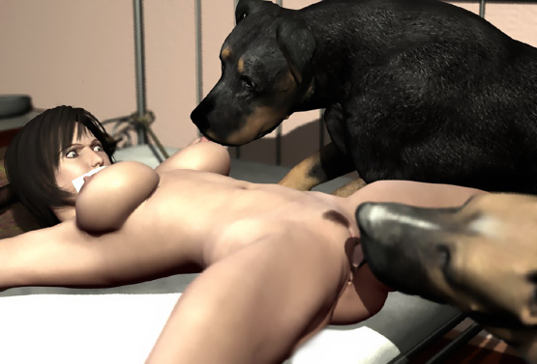

The rotty jumped down and both dogs were now licking her pussy. She was angry! She tried to yell at the dogs but couldn't make a sound. At the same time her pussy was all wet as 2 big wet tongues licked it giving her no rest.

She squirmed in agony when the dogs finally stopped. Her relief was, however, premature as she felt the rotty climb on her. The Dane sat down to wait for his turn when the rotty's big cock found her pussy.

Her eyes bulged. Her face became all red. She was both enraged and horrified at the same time when she felt the doggy cock invade her pussy.

When the rotty felt that his cock was inside her, he slammed it all in and started to fuck the hell out of her. His tongue lolled from his mouth as his hips worked like a jack-hammer!

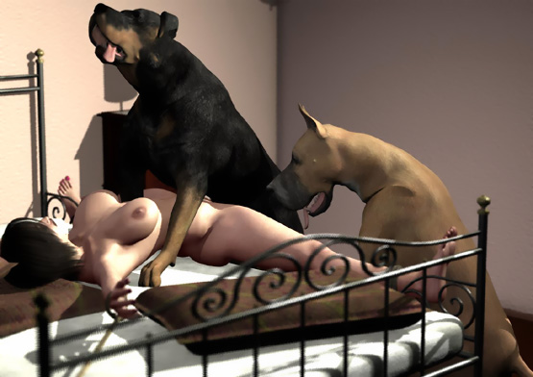

She tried to move her legs. She tried to escape the furious fucking. She tried to cry for help. But she could only take the raping. She felt herself as a fuck toy tied helpless for the dogs to use. She felt several spurts of semen in her pussy. And then his cock slipped of her pussy.

The rotty jumped on the bed to lick her face and then she felt that the Dane was mounting her. His penis found her open and well-lubricated pussy. Its tip penetrated her.

He started to push his cock inside her. But it was huge. It was painful even for her well-fucked pussy. The pussy stretched and inch-by-inch his cock penetrated deeper and deeper.

Then with a single mighty thrust, the dog slammed it all in! It hit her cervix painfully. But Stacy had no time to think about it because now he rammed it in again and again!

Her pussy was on fire. She just tried to endure the furious doggy rape that she was getting, pounded with a cock bigger than she ever could have imagined.

And just when the pain started to ease, she felt the knot at the base of his cock hitting her pussy and clit at each thrust. She knew that dogs had a knot they used to get "tied" with their bitches during the ejaculation. Now the Dane tried to push that huge knot inside her. She was horrified!

At the same time the rotty licked her right breast and <nipped> its nipple with his teeth. Then he licked her face, grabbed the tape in his teeth, and ripped it off. Sandra closed her eyes and screamed!

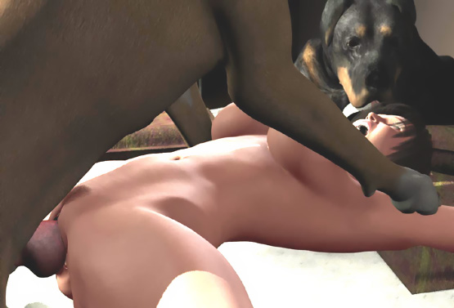

She felt the huge knot ripping her pussy and forcefully penetrating inside her. She was tied spread-eagled with ropes and a huge doggy knot was painfully locked inside her cunt.

She tried to scream again. But her voice muffled when the rotty pushed his cock in her mouth and deep into her throat.

Earl had heard her cries and he entered the room with two dobermans. He saw her wife helpless on the bed being raped by 2 big dogs. Sandra was in pain being knotted by the Dane and tried to breathe with a rotty cock deep in her throat and doggy sperm leaking from her mouth and nose.

He saw that the Dane was spurting semen inside her. She was being bred by dogs at both ends!

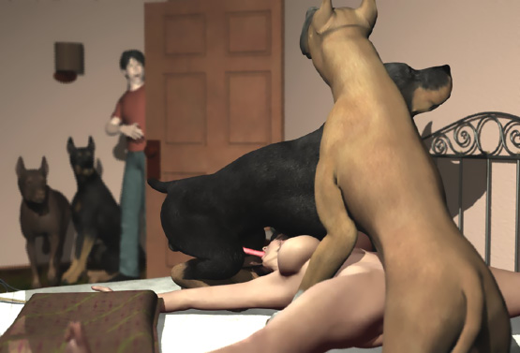

Earl rushed to help her wife. The rotty pulled his wet cock from her throat. She tried to swallow the semen and gasped for more air. Earl quickly loosened the ropes.

The rotty licked his sperm from her face and the Dane took a few steps back dragging Sandra with him by her pussy. Earl rushed to help her. He tried to support her hips to ease the pain in her knotted pussy.

The Great Dane was enraged. This human male tried to stop him from breeding his knotted bitch. He bared his teeth and gave a warning growl. The other dogs sensed that Sam was being hostile. The rotty jumped to the floor and growled at him while a doberman jumped at Sam snarling viciously.

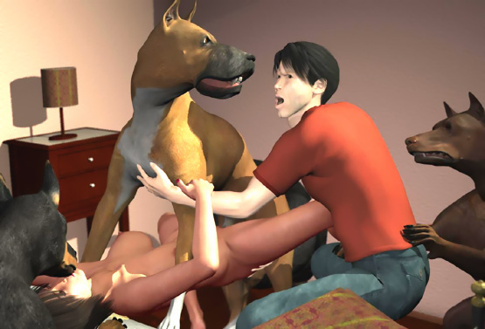

Earl fell on the floor against the bed seeing 2 snarling dogs with their long sharp fangs growling just a few inches from his face. He was scared and froze.

The Dane was not going to give up his human bitch. He grabbed her throat in his jaws. Stacy was now lifted up, her throat in the Dane's jaws and her pussy tied by his knot.

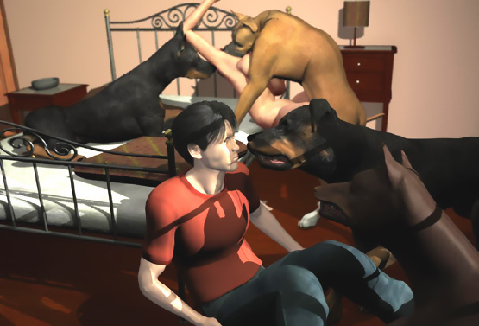

When the Dane tightened his grip on her throat, some more doggy sperm leaked from her mouth and nose.

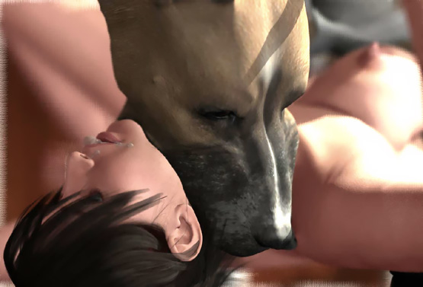

From the corner of her eyes, she saw Earl being attacked by 2 dogs.

"Escape, Earl," she said with a whispering voice before the increasing pressure of doggy jaws silenced her.

Slowly Earl rose up and backed to the door followed by 2 big snarling dogs. From the door he looked at her wife as a victim of a savage doggy gang-rape. He went out of the room and collapsed outside and cried helplessly. He couldn't think of anything, not even calling for help. He just sat there listening to the noises from their bedroom.

The 2 dogs went back to Stacy. The Great Dane was now standing on the floor. He had released her throat and she had her hands around his neck to help her head from hitting the floor. Her pussy was still tightly locked by the doggy knot.

The rotty licked her mouth and the Doberman licked her right breast. She waited for the knot to release her pussy. But she didn't know if that would be a relief.

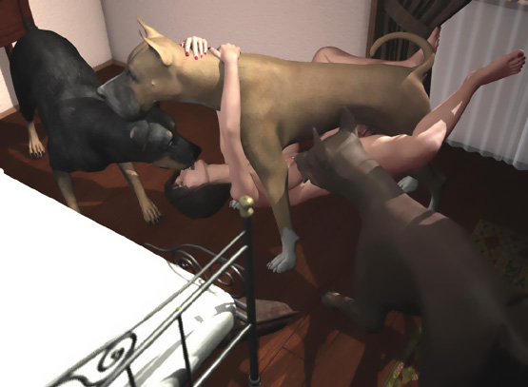

She knew that 2 snarling dogs with big glistering cocks were waiting for their turn to impregnate her. And at least the rotty had not been happy with just one round. Her thoughts were interrupted when the cock slipped out of her pussy and she fell on the floor.

Behind the door Earl heard the sound of tacy falling on the floor. He heard vicious snarling and growling sounds, some cries and whines.

Then he heard the sound of his wife's wet pussy being fiercely fucked. A few minutes of wait until a knot plopped out off her pussy ...

... and then the same noises repeated again and again. Sometimes her cries were silenced by jaws around her neck or a cock inside her throat.

After an hour her pussy was so sloppy that only the Great Dane could knot her.

After 2 hours she didn't whine or cry anymore. The dogs stopped growling. Only the fucking continued. Earl knew that the dogs were using his wife’s limp body as a fuck toy.

Finally the dogs marched out of the door. They growled at him and walked out.

Earl went into the bedroom. He saw Stacy lying unconscious on the floor completely drenched with doggy semen. There was a constant flow of sperm from her pussy.

He took her in his arms and carried her on the bed. She wailed softly.

"Don't tell anyone," she whispered and fell asleep.

Earl stayed awake and looked after her all the night.

3 weeks later they heard on the news that a naked woman had been found on a beach. She claimed that 4 huge dogs had raped her continuously all night long. Dog sperm was found in her pussy and mouth.

All experts claimed that the woman only tried to hide her unlawful relationship with dogs because dogs don't rape people.

"I'm glad we didn't tell anyone," said Stacy.

- - - - - - - - - - - - - - - - - - - - - - - - - - - - - - - - - - - - - - - - - - - - - - - - - - - - - - - - - - - - - - - - - - - - - - - -

https://www.beastforum.com/showtopic-156123-180.html

*** Rose Posing in a Park ***
by Canis3

Rose was one of those beauties whose bikini pictures appeared in many Internet sites. Last year she obtained new breast implants and her friends took some pictures of her posing in tiny bikinis.



After those pictures had "accidentally" spread on many Internet sites, many discussion forums were filled with questions about this busty beauty. Soon after that, her name was published and many new pictures of her were uploaded to these sites.

People around her used their mobile phones to take photos of her. She enjoyed that. She provided a good view of her cleavage but kept her nipples covered. She used to walk without panties so that occasionally some lucky guy could have an upskirt picture of her pussy.

On a hot afternoon, Rose was walking in a park with her dog Jessie. SIthe was a beagle-type dog that Rose had had for 3 years. Rose enjoyed the feeling of a soft wind on her chest where a bikini top covered her round breasts. She also felt the wind in her pussy that was covered by a mini skirt only. When she saw guys taking photos of her, she smiled at them, pushed her chest forward, and held her belly as flat as possible.

After half-an-hour, she sat on a bench closing her legs neatly. She leaned back and pushed her chest forward. Posing was now her second nature. Jessie jumped on the bench, sat on Rose's thighs, and tried to lick her face.

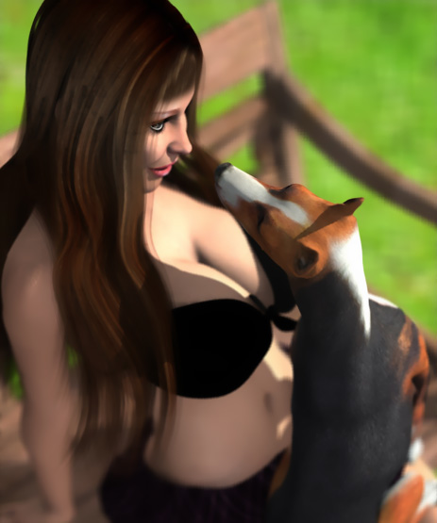

Rose patted her. But she suddenly felt wetness in her skirt.

"Damn, Jessie. You are in heat. Now just look at my skirt. It's wet and smells like a bitch in heat, Rose said and stood up.

Jessie jumped on the grass and ran a few yards away from her.

When Rose was wiping her skirt, a big male doberman walked from the bushes. Soon he was licking Jessie's ass and his penis was protruding from its sheath.

When Rose saw that her Jessie was about to get a breeding, she ran towards to big dog and pushed him away from Jessie who ran to the bushes.

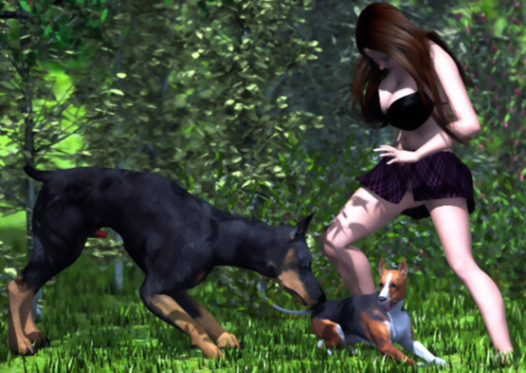

"Get away from here! I don't want your puppies!" Rose yelled at the dog and pushed him again, now with her leg.

The dog bared his big fangs and stood up. Now Rose realized how huge the dog was. She was not more than 5 feet tall and the head of the dog was almost at the level of her breasts. The dog snarled at her. Many people stopped to see what was happening.

"Stay still," said one man as the dog snarled at Rose. "Stay still and don't show any fear. The dog will go away."

Many guys took photos eager to publish them in discussion forums.

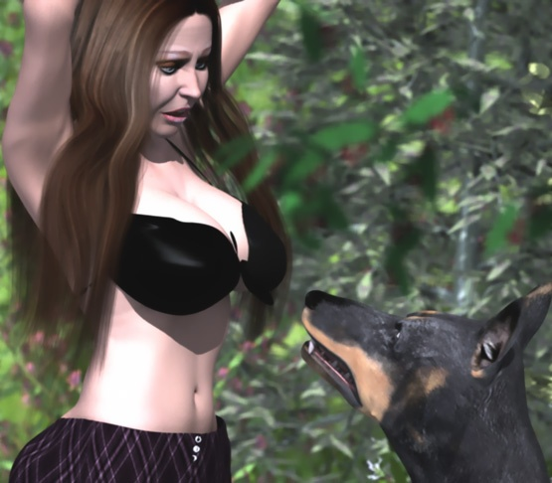

Rose stood still as the dog approached her. He found the smell of a bitch in heat in her skirt. His penis was again protruding from its sheath.

Rose was afraid but tried to look good in the pictures that she knew were taken all the time. People around didn't know if she was in real danger or was just playing a "damsel in distress". The dog lowered his head, lifted her skirt, and licked her pussy.

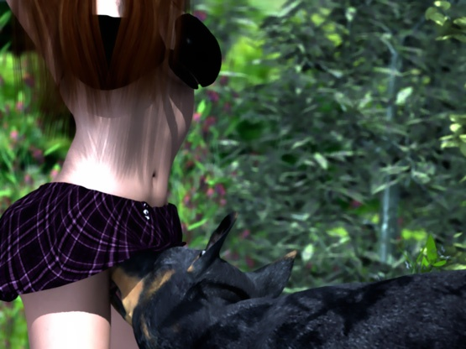

The dog was growling and licking her pussy. When she moved a little, the dog snarled and <nipped> her pussy with his teeth. He grabbed her skirt in his teeth and growled a warning.

Rose was frozen with fear and just stood still when the dog with a strong swift movement ripped her skirt off her. She saw the buttons at the front of her shirt flying around and disappearing into the grass.

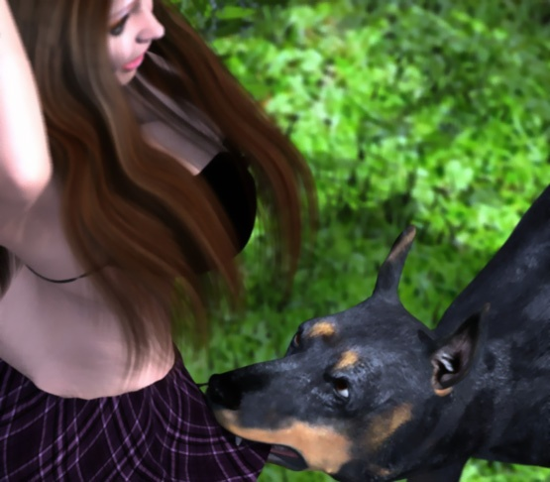

She tried to cover her pussy with her hands. But the dog growled at her viciously until her hands were up behind her head again. Then she felt the wet tongue eagerly lapping her pussy again. The dog's tongue was opening her pussy and she was getting wet. She could only stand still while the dog raped her with his tongue and people around laughed at her and took photos.

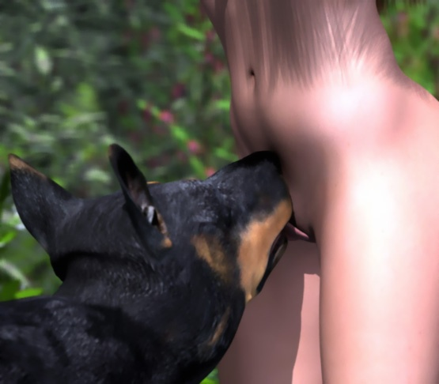

She tried to push the dog away, but he growled at her and grabbed the bikini top in his jaws right between her breasts. The dog pulled her forward until the knot that held the front of the top together broke loose. The dog had uncovered her breasts. Rose heard sounds of astonishment from the audience as well as clicking sounds of cameras taking photos of her uncovered breasts and of a huge fierce dog pulling the top off her.

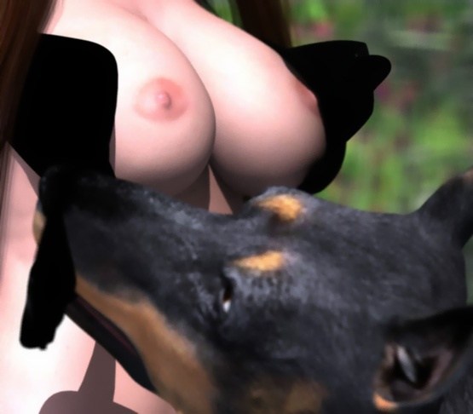

Rose bent forward and covered her breasts with her left hand and tried to hold the bikini top with her right hand. But with brute force, the dog ripped the top off her. She tried to resist the huge dog she fell on her hands-and-knees. The dog dropped the bikini top on the ground and jumped on her.

In a second, he stood above her pushing her head to the ground with his forepaws. Rose felt his sharp claws scratching her right cheek and something hard and wet touching her ass. Being pinned under a snarling beast, she had no escape.

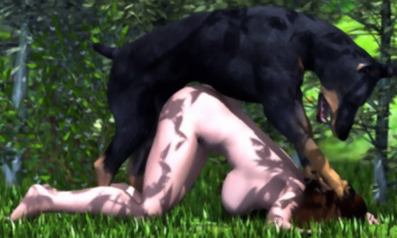

"Ohhhhh," Rose heard as people around her were surprised of the sudden turn of events.

Rose felt humiliated. People looked at her with their mouth open as the dog wrapped his forepaws around her and moved his hip back-and-forth trying to find her pussy for his penis. His weight rested over her and with his paws he pulled her pussy closer to his cock.

"Help me! "Somebody help me! The damn dog is raping me!" Rose screamed.

When a big man in a white t-shirt stepped forward to help her, the dog grabbed her neck in his jaws and snarled. Rose screamed. But the man didn't stop.

The dog grabbed her neck deeper in his jaws and snarled viciously as the man grabbed his neck and lifted the him up trying to throw him away from the poor girl. The dog, however, sank his teeth deeper into her neck so that the screaming girl was lifted along the viciously snarling dog.

"Aieeeeeeee! Stop! He's killing me!" Rose screamed.

She thought she would die when she felt the huge fangs sinking into her neck. All the time the dog tried to find her pussy.

"Get your hands off the dog! You will only hurt the girl," someone from the audience yelled. "Nobody can help her now. The dog won't let anyone stop him breeding his bitch. It's sad but true. Call 911."

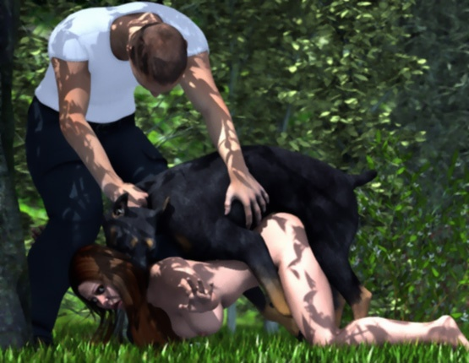

The man in the white t-shirt lowered the dog, released his collar, and stepped back.

"Go away," Rose said but screamed as the dog's cock sank deep into her vagina.

When the dog saw the man stepping back, it loosened his grip on Rose's neck but still had its fangs touching her neck. The dog's cock was thin and its pre-cum lubricated Rose's pussy.

The dog fucked her furiously! A few times the cock slipped out of her cunt. But in a second he slammed it all the way into her again.

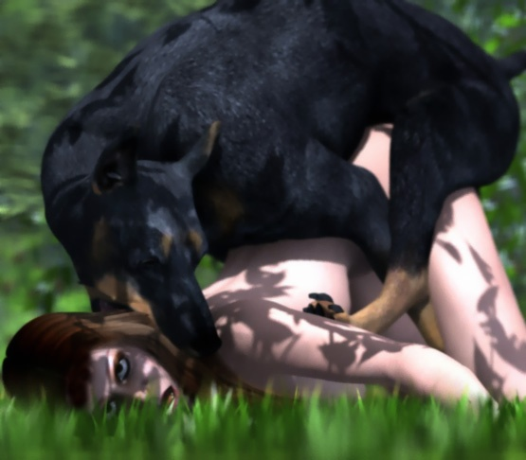

People around just stared like hypnotized at the dog raping the young beauty. Some of them took photos. Rose couldn't say a word. Tears ran down her horrified face and her beautiful tits flopped wildly under her.

The dog's cock was growing and his thrusts were now longer but no less fierce. People just stared at the big cock hammering the girl and heard the sounds of the it sliding in her wet pussy and the big knot at the base of his cock slamming against her wet pussy lips.

"No that's what I call fucking," said one boy to his girlfriend.

"Shut up!" she answered him and kicked him.

Rose's eyes were wide open and her vision was blurry. Each thrust stretched her sore pussy wider-and-wider as the huge cock sank deeper-and-deeper into her hitting her cervix painfully. Each thrust opened her pussy wider but also swelled the knot even larger.

"He can't get that enormous thing inside her. It's impossible," someone said.

"That dog can sink a football into her. Trust me," replied another.

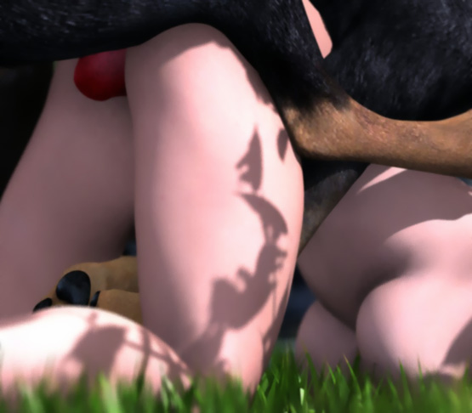

Rose opened her legs wider to ease her pain. She did that almost unconsciously. She didn't feel pain anymore. She didn't hear anything.

And she didn't feel any pain when with one mighty thrust, the dog slammed his entire huge cock into her pussy. She didn't hear the screams of the women around her when they saw the knot sinking into her.

For a moment it was totally silent. Everybody held their breath. They heard Rose wailing and the dog growling at her. The dog was now "tied" with the girl.

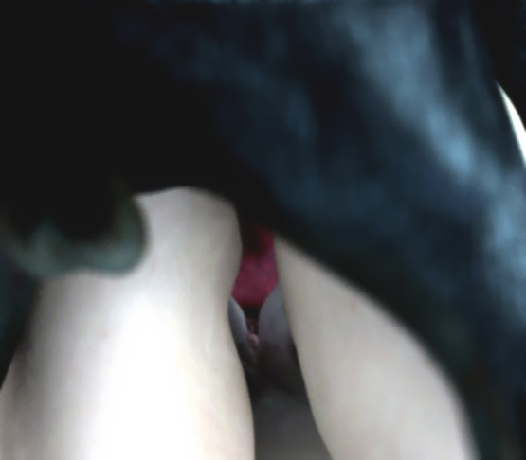

He made short stabbing movements pumping his semen into the moaning and shuddering girl. Her body spasmed 4 times involuntarily sucking his cock even deeper into her.

"She's cumming! She's cumming!" the audience gasped to each other.

After the powerful orgasm, Rose passed out. The dog was now standing and carrying her limp body by her pussy and neck.

"Is she okay?" someone asked.

"No, she's not okay. But at least she's alive," was the answer.

The man in the white t-shirt decided that now was the time to save the girl. But he stopped when the dog snarled displaying his big sharp fangs on the girl's neck. The dog was still pumping his seed into Rose. The huge knot sealed her pussy so that all the puppy-making sperm stayed inside her already-overstretched vagina and forced its way into her womb.

The dog waited suspending the unconscious girl by his cock and holding her by her neck like a rag doll. Because the dog sensed that he could be attacked at any time, he had his jaws tightly around her neck growling and snarling at the audience.

People around were horrified knowing that any rescue attempts could be fatal for the poor girl. They could only watch as the pulsating doggy cock pumped her body full of his sperm.

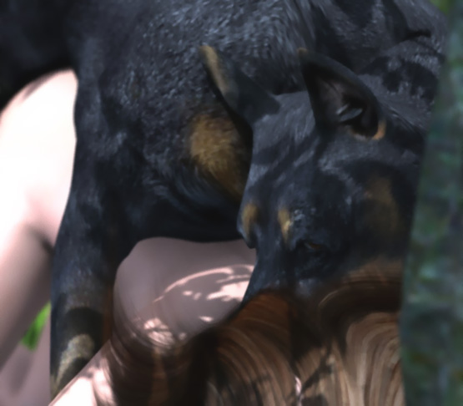

After about 15 minutes his cock began subsiding and the audience could see semen leaking from her pussy down her thighs.

Finally the dog pulled his huge cock out of her pussy. Her hip fell on the ground and huge amounts of doggy sperm ran out of her cunt.

People could not get their eyes off the dog's cock. It was huge! They had never seen anything like that. And a few moiments ago inside the girls pussy, it had been even bigger! They could not undestand how anything of that size could have fitted inside such a small girl.

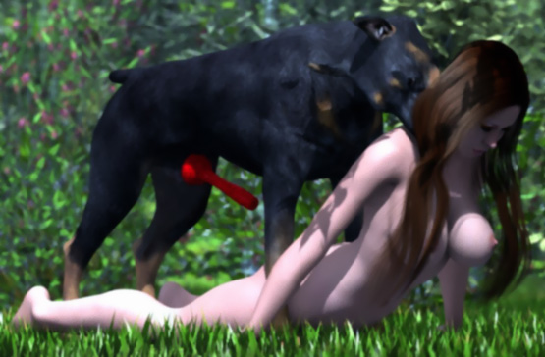

The dog released Rose's neck letting her fall on the ground. She was lying there limp, her gaping and sperm-leaking pussy wide open for everyone to see and photograph.

The dog stood beside her with his huge cock still dripping semen. Slowly people moved closed to her. The man in white t-shirt tried to catch the dog. But quickly it ran away and vanished behind the bushes.

Someone had a blanket that they had used for a picnic. She laid it over Rose to cover her naked body. Soon she began to wake up and a man in a uniform came to look at her.

"I'm a police officer. What happened here?" he asked.

"A dog raped her. I tried to help her but could do nothing. What took you so long?" asked the man in the white t-shirt.

"I was catching a thief. Chasing dogs is not our top priority. And besides, dogs don't rape people."

- - - - - - - - - - - - - - - - - - - - - - - - - - - - - - - - - - - - - - - - - - - - - - - - - - - - - - - - - - - - - - - - - - - - - - - -

https://www.beastforum.com/showtopic-156123-210.html
*** Ron and Julia ***
by Canis3

Ron and Julia had been lovers for 2 months. But their parents didn't accept their dating. They had to meet secretly in various hiding places.

This evening Julia's parents were visiting their friends and Julia was home alone. His dad had locked her home and left his largest guard dog with her to keep away any intruders. His daughter would be a virgin for the man of his choice.

Julia was sitting in her nightgown near the fire place and reading. The dog was lying on a carpet.

Suddenly something <hit> the window. The dog barked, raised up, and walked to the window. Julia laid her book on the table and opened the window.



"Hello, my love," said Ron down on the street. "I have been missing you. Can I come up there and kiss your sweet lips?"

"No, my darling," was her sad answer. "My dad locked me inside and left his dog here to guard me. It would surely attack you."

For some time the lovers talked about their love and how they would like to meet and caress each others. Ron felt something hard in his pants and Julia felt something wet running down her thighs.

The dog was very alert all the time. It sniffed the air and listened to their voices.

After some time it noticed that there was no danger in the situation. He growled softly but stopped when Julia patted her head and pushed it down. The dog's head was now between her legs and he found the smell in her pussy and her wetness running down her thighs. He licked her love juices from her right thigh with a single long wipe.

"Uuuuuhhh," Julia moaned.



"What is it, Dear?" her lover asked.

"Nothing, my dear. The dog just licked my leg," she answered.

"Uuuuuhhh," she moaned again. "Now he licked my other leg."

"Hey! Stop it!" she said to the dog in a stern voice as she felt the dog's tongue slide between her wet pussy lips.

"Don't mind him," said Ron. "He's just jealous of you and tries to get you out of the window."

"My love, he's licking my private parts! But he can't distract my attention off you. I'll just imagine that it's you licking me."

Ron felt the hardness in his pants grow. Julia's pussy produced even more juices for the dog's eager tongue that found its way even deeper into her pussy.

"Oh, my love. I can't wait until I meet you," she moaned.

"Hey! What the hell .., she said with a concerned voice when she felt the dog's paws wrap around her thin waist and the weight of the huge dog land on her back.

The dog pushed her upper body further out of the window. Her nightgown opened and her breasts bounced wildly as she fought to maintain balance and tried to get the dog off her back.

"Get off me!" she said with a loud voice to the dog.

"Get off her!" Ron yelled down on the street when he saw the dog mounting his loved one and pinning her in the window with her bouncing breasts open for anyone to see. More than a dozen people stopped to see what was happening.

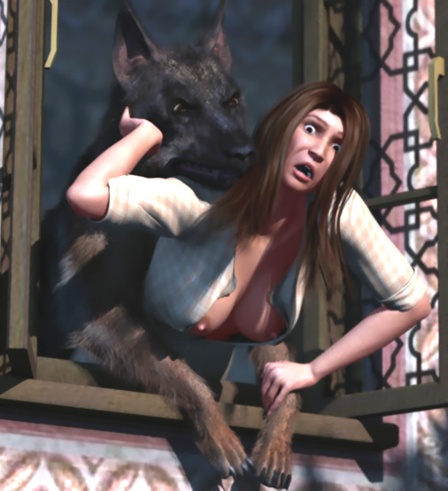

Julia felt a few pokes in her crotch and suddenly the dog's cock penetrated her pussy. She screamed and everyone in the neighborhood turned to look at her.

"He's in me, Ron! He's in me! I can't get him off!" she screamed.

"Get off her, you filthy beast!" yelled her lover helpless down on the street.

The dog's penis was stopped by her virgin hymen. But after a few strokes his cock was bigger and harder. The huge animal easily broke the hymen and penetrated deep into her love canal.

"Ron, I'm losing my virginity to a dog!" she screamed desperately.

"Just hold on, my love! He'll go away," Ron said without believing his words himself.

Now the dog fucked his victim with long-but-fast and powerful strokes. She couldn't speak anymore. She tried to endure the pain and the humiliation. Her hands keep her from falling out of the window because the dog had climbed on her back and was pushing her forward with each powerful thrust. Her nightgown was now totally open and the spectators on the street could see her body and breasts responding to the dog's thrusts.

She felt a bulge forming at the base of the dog's penis. It spread her pussy each time it penetrated her until it was too large to get in.

The dog slammed his cock into her twice with a furious force. Her mouth opened, her eyes spread wide, and she almost fell out of the window.

With the third try, her pussy finally spread wide open and the huge knot slipped in and locked inside. She felt the knot growing inside her until the cock was tightly locked inside her. She was filled completely and her vagina was tightly stretched around the dog's huge tool. She could feel the blood circulating in the cock's veins.

Then she felt the cock throbbing and ejaculating sperm into her, spurting load-after-load of his seed into her. Not even the tight knot could stop all of the puppy-making semen oozing from her pussy.

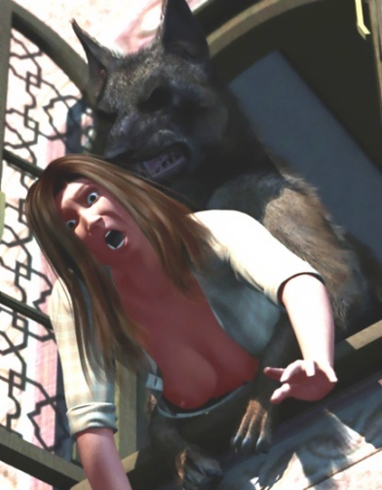

Julia was gasping for air. Her vision was getting blurred.

"He filled me! He bred me like a bitch dog," she whispered to her lover.

"I'm so sorry, my love," her lover said.

People on the street saw the dog raising up and turning around.

"Oh my God! He's turning! His cock is turning inside me. It hurts!" she wailed as the dog turned ass-to-ass with her.

His ass was suspeded by her pussy which held his "tied" cock inside.

"Now he's trying to get his cock out of me. ... No! It's too BIG! It won't get out! He's dragging me with him ..."

Ron could only watch as the huge dog dragged his loved one from the window. He heard a noise when she fell on the floor.

Then it was quiet. The dog had dragged his bitch by her pussy to the carpet and layed down there waiting for his raping cock to subside.

On the street, Ron felt a hand on his shoulder.

"What are you doing here?" Julia's dad asked him. "You won't take the virginity of my daughter, that's for sure. I am just going to tell Julia who is her fiancé. I have promised to keep my daughter as a virgin for him.

That said, Julia's father and mother then walked home ...

- - - - - - - - - - - - - - - - - - - - - - - - - - - - - - - - - - - - - - - - - - - - - - - - - - - - - - - - - - - - - - - - - - - - - - - -

https://www.beastforum.com/showtopic-156123-225.html

*** Goddess of the Caribbean ***
by Canis3

A young black woman and a black dog swim desperately in a sea. Behind them one could see a burning sail ship or what still remains above the water of the sinking ship.

The woman Mimbo was being transported to the governor as a slave. As a unique beauty, she was extremely valuable and had been locked in a cage separate from other slaves. Next to her in a cage of his own was a huge black dog. It was a guard dog for the late governor's widow.

They were sailing round a cape when suddenly numerous explosions shook the ship and tore its structures. A pirate ship had fired with a dozen cannons from a close range. A few seconds later, the cannons fired again breaking the walls of the 2 cages and tearing the side of the ship. Mimbo saw her opportunity to escape and she jumped into the sea followed by the dog.

Mimbo was not a good swimmer. But she found a broken tree trunk to use as a floating aid. Meanwhile the pirates seized the ship ... captured all people that were still alive ... robbed everything valuable ... and finally sunk the ship.

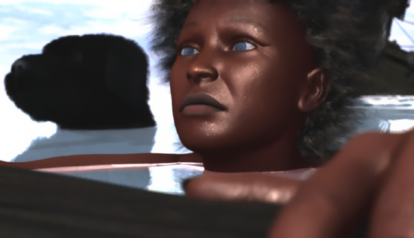

When the ship had sunk and the pirates gone, Mimbo and the dog reached a beautiful beach with big round rocks and palm trees bowing to the sea. Walking on the beach, one could really see Mimbo's beauty. She was about 5' 3" tall with long legs, a round butt, thin waist, and big firm breasts.

The dog followed her by her side. It was huge, about 3 feet tall at the shoulder. In the ship it had been very hostile to all people walking close to his cage except to Mimbo. Sometimes she had thrown some food to the dog. (As a highly valuable slave, she was given some.) Now the woman and the dog stood side-by-side under palm trees looking at the sea.

The sea was empty. No ships, no land, even the pirate ship was gone. Just a few gulls flying above the sea. Mimbo patted the dog who listened to every noise and sniffed every smell. When Mimbo walked on the beach, the dog followed by her side growling at all suspicious noises.

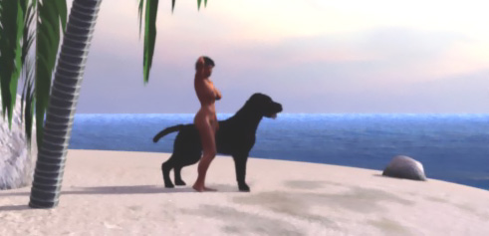

The dog had been trained to protect the widow of the late governor. It was supposed to be not only an ultimate guard dog for the widow but also her companion. The rich widow was very suspicious about men who wanted nothing but her pussy and her money. She had paid a huge sum for the special training of the dog as her partner.

When the dog was a puppy, he was taught to lick women's pussies and tits. His master had rubbed a special liquid on their tits and deep inside their pussies. The dog had to lick every drop of the liquid. Otherwise he was beaten cruelly.

Later he was taught to fuck human females. First, his master tied female slaves in different positions and taught the dog to fuck them. When the master was satisfied with his ability, he locked rebellious female slaves in his cage without tying them.

The dog greeted the women by lifting his right paw. Then he licked their tits and pussies. Finally he fucked them. Most of the slaves screamed, kicked him, and tried to push him away. If he didn't fuck a woman in his cage, he was beaten.

Soon the dog learned to break the resistance of all slaves thrown into his cage. Usually he grabbed a woman's neck in his jaws and dragged her like a rag doll. When the woman stopped screaming and kicking, the dog, still holding her neck in his jaws, pushed his cock deep into her pussy and fucked her fiercely.

After a few days in the dog's cage, the slaves were obedient again. When they got on their hands-and-knees every time the dog growled at them, they were ready to be returned to their own masters. Teeth marks on their neck were the visible sign of their education.

Of course, Mimbo didn't know anything about the dog's training. She sat down on a rock wondering what would be her fate in a land far a way from her home which she would never see again.

The dog stood in front of her panting. His head wan almost at the same level as Mimbo's. Mimbo looked at his eyes and talked calmly to him. The dog lifted his right paw and Mimbo took took it on her left hand.
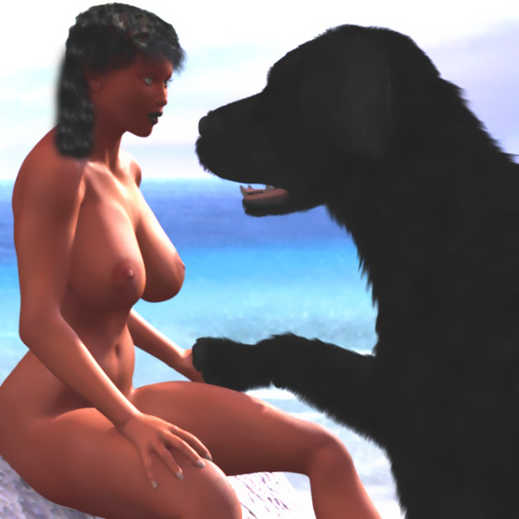

She didn't know that she was introducing herself as a bitch to the dog. Mimbo leaned back, looked at the beautiful sea, and felt a soft warm breeze on her body.

Suddenly she felt the dog's hair touching her chest and a big, wet tongue lifting up her right breast that in the next moment fell down bouncing, ready for the next sweep.

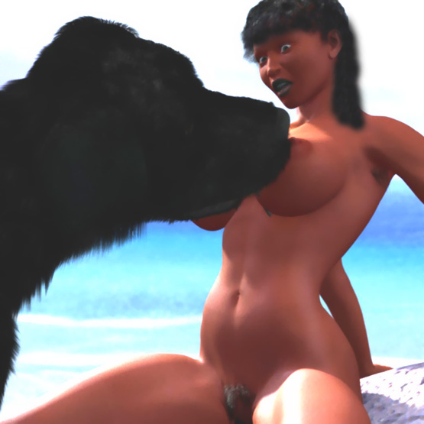

Mimbo was a little uncomfortable about the dog playing with her breasts. Gently she tried to push his head away. But the huge dog took a step forward and pushed her on her back.

The dog was now standing between her legs lifting his paws on her thighs and pushing her legs wide open. Mimbo tried to push the dog away and close her legs. But she couldn't move the huge dog who growled at her and <nipped> her right thigh with his teeth. This act of aggression made Mimbo scared.

Now nothing stopped the dog from licking her pussy and pushing his tongue deep inside her followed by long wet sweeps giving special attention to her clit.

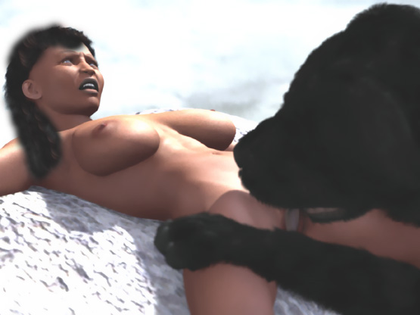

When Mimbo tried to stop him, he growled at her and <nipped> her slightly. After 3< nips>, Mimbo gave up. She just waited for the dog to stop the licking.

After some time the dog tasted wetness in her pussy. He stepped over her pinning her shoulders against the rock. Then Mimbo felt something hard touching her pussy.

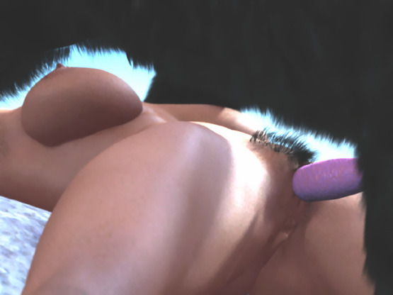

She had seen animals mating before. And now this dog wanted to mate with her. She shouted at the dog, screamed, and tried to move away. But the massive dog had her pinned down against the rock.

The dog snarled at her until she stopped screaming. His huge fangs were only a few inches above her throat.

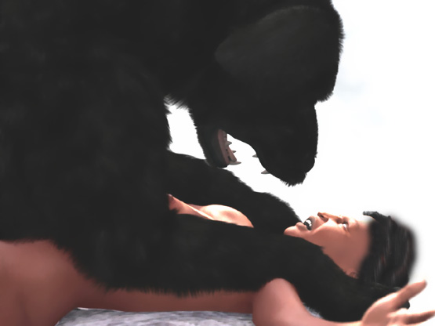

She had seen lions ripping open the throats of they prey. She knew that in front of a lion, it was better to stay still and hope that the animal would walk away.

She was now lying still on the rock. The dog stopped growling. His big penis was slowly penetrating Mimbo's pussy until he thrusted his tool all the way into her vagina.

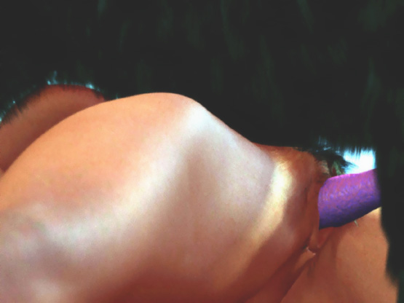

The dog started to fuck her with incredible speed. Mimbo thought that the animal would crush her against the rock during the fierce fucking. She felt the canine cock growing inside her even bigger.

She couldn't think of nothing but surviving and desperately tried to crawl away. The dog grabbed her nech in his jaws and lifted her head up while pinning her arms with his forepaws. Her body was totally under the dog's control.

His cock was growing thicker and thicker until she felt a bulge forming at the base locking it into her vagina. Soon the dog was shooting several loads of dog semen into her.

Now the dog stopped thrusting. He just stood in place and filled his bitch with his sperm one load after another. The dog has stretched Mimbo body totally immovable. She felt pressure around her neck, her arms were pinned, her shoulders were twisted back, and the dog's cock was "tied" in her womb.

The dog growled at Mimbo if she tried to move. She could only wait for the animal to shoot all his sperm into her. Sticky ejaculate was oozing from her pussy.

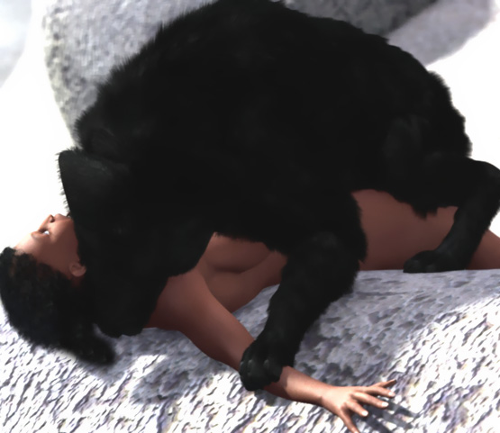

After a couple of minutes, her vagina was full of doggy semen and the dog released her neck. He tried to pull his penis out of her pussy. But they were still locked. He licked her face and pulled again. But the result was the same.

After about 10 minutes, his cock had subsided enough and the dog pulled his huge tool out of her cunt. Huge amounts of sperm leaked from her pussy down on the rock. But the dog licked her pussy clean.

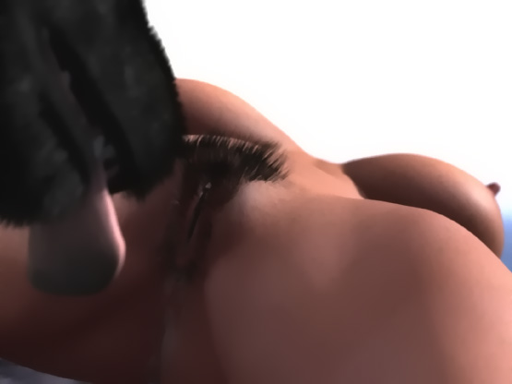

Mimbo was exhausted and too tired to look for food or water. She found a level spot on the beach and laid down. The dog followed her, licked her face and her pussy, and laid down beside her.

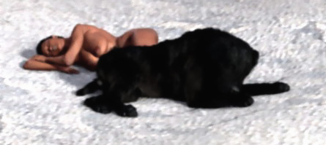

In the morning, Mimbo woke up hearing numerous birds singing. Hungry and thirsty, she was getting up being on her hands-and-knees when the dog's huge forepaws landed on her both sides. Mimbo was afraid of another beast mating and tried to leap forward. But huge jaws closed firmly around her neck.

She lowered her hip ... but soon raised it up again when the dog tightened his grip and growled at her. Her still-sore pussy felt the head of the dog's penis. A second later, the dog slammed it all the way into her!

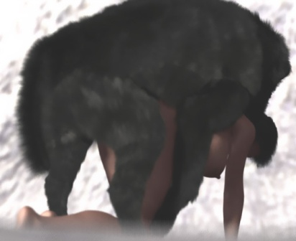

He held her neck in his jaws and fucked her like a jackhammer. But this time he didn't knot her. His sperm flew all over as he fucked his human bitch.

When he was satisfied, he released her neck and pulled out his cock. Mimbo collapsed on the ground crying. She was thinking about her destiny in a strange place alone with a huge dog that was using her as its bitch.

In the afternoon the dog was walked in the jungle and she saw her opportunity. She ran into the jungle trying to get away from the dog and to find something to eat and drink. Soon she found some water falling down a rock. The water tasted good and she drank it and washed herself. She drifted off to sleep ...

Mimbo was only semi-conscious when she realized that her head was in the dirt and her butt was pointing up. She hardly realized that something was penetrating her pussy ...

... and soon the dog was fucking her again. For the dog, Mimbo looked like a bitch to fuck and he did what he had been taught to do. Each thrust pushed her head into the mud and she could hardly breathe.

When her head cleared, she tried to raise up her head and gasp for air as she felt the dog's huge cock spreading her pussy painfully and finally locking inside her. She was a captive and a fuck toy for a dog having his huge cock "tied" inside her and shooting loads of doggy semen deep into her.

After a while, his penis subsided and he pulled it out of her pussy and walked away. Mimbo was hardly conscious.

She bathed in the water washing off the mud and doggy sperm. Her pussy was sore. It was still open and sticky semen was leaking down her legs. Cold water felt good in her pussy and eased the pain.

In the jungle, Mimbo and the dog found some fruits and berries to eat. First she gave them to the dog to sniff. Then she tasted them carefully. If they both thought that the food was okay, they ate it. They also found some coconuts and drank the milk and ate the fruit flesh.

When they came back to the beach, she was optimistic. They could find food and water in the jungle and the dog would protect her. Maybe she could even stop him from raping her.

In the evening they went to sleep. She was happy that the dog hadn't fucked her since earlier.

In the morning she woke up and looked around. She couldn't see the dog. She was relieved that the dog didn't rape her again. But at the same time she was worried of being alone. She opened a coconut, drank and ate, and walked to the beach to bathe in the water.

Suddenly she heard some voices. 3 men were rowing a boat towards her from a ship further away. How couldn't she have seen them before? Anyway, she was happy that finally she was saved. She stood on the beach waving to the men and ran to them when the boat came ashore.

2 pirates were sent to see if they could find a good place for the ship crew to spend a few days. They saw Mimbo bathing in the sea and waiting for them on the beach. The men had never seen such a beautiful woman. They knew that she had to be an escaped slave, most likely from the ship they had sank 2 days earlier.

When Mimbop came to them, one man put his arms around her and kissed her. Then he pushed her to the other man. He grabbed her from behind and cupped her breasts in his hands. Then he twisted her hands behind her back as the other one massaged and sucked her tits.

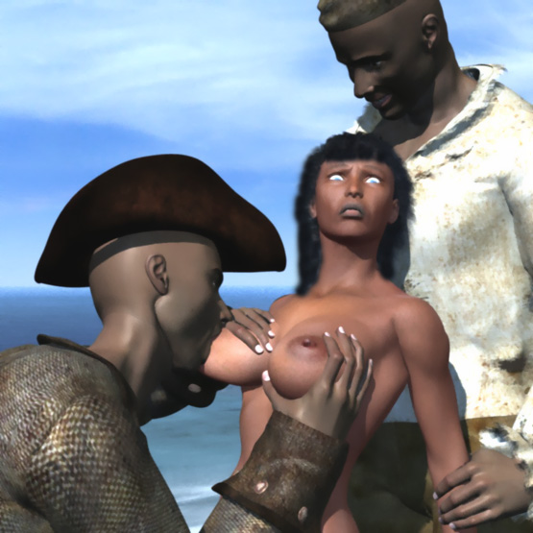

Then he grabbed 2 pieces of ropes from their boat. He tied Mimbo's breasts while the other pirate tied her wrists behind her back.

For a while they admired the tied black beauty. They kissed her mouth and her breasts. Mimbo was screaming but nobody came to help her.

The pirate behind her took off his pants and lifted up her tied wrists bending her upper body forward. Then he inserted his dick into her wet pussy. Mimbo screamed until the pirate in front of her grabbed her tied wrists with his left hand and with his right hand pulled her head forward and pushed his huge cock into her mouth. The men laughed and fucked Mimbo while hearing the men in the ship cheering at them.

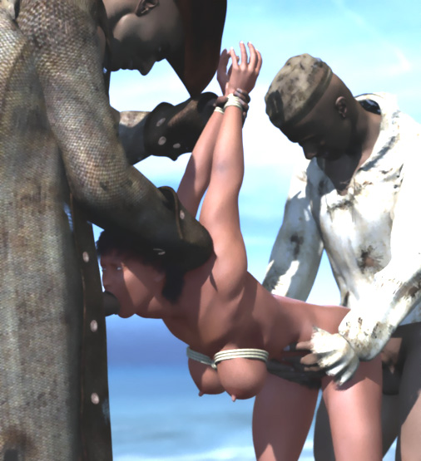

The pirate fucking Mimbo's pussy grabbed her tied tits and squeezed them, slamming his cock deep into her pussy and pushing her forward so that the other cock sank deep into her throat. Mimbo gagged.

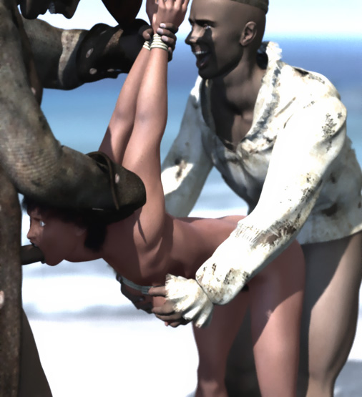

"I want to see her huge tied tits while I fuck her," said the pirate fucking her pussy.

Loudly laughing, they untied her wrist, laid her on a round rock, and tied her wrists to her ankles. She was lying there totally helpless, the hard nipples of her tied breasts pointing up to the sky and her pussy wide open for them to use.

The pirates took off their clothes and kneeled. One pirate pushed his cock into her pussy. The other one tried to put his cock into her mouth. But Mimbo kept her mouth shut.

The pirate grabbed her tied breasts in his hands and squeezed hard. As Mimbo screamed in pain, he pushed his cock into her mouth. With strong hands he squeezed and massaged her breasts while thrusting his big dick deep into her mouth while the other pirate fucked her pussy with long strokes.

Suddenly, the pirates heard a deep growl. A huge black dog stood a few feet from them snarling.

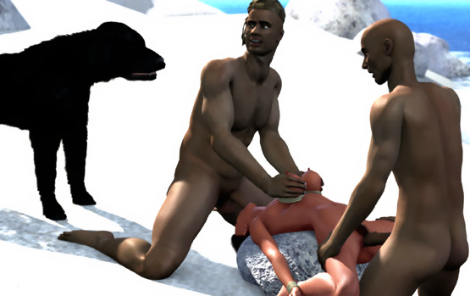

Slowly they pulled their cocks off Mimbo ... stood up ... and took a few careful steps toward their boat when the dog attacked. He leaped toward one pirate who raised his arm to protect himself. The dog grabbed his arm in his jaws and a crunching sound told that the bone was broken. The man fell down but continued running to the boat ...

... while the dog grabbed the leg of the other man in his jaws. He dragged the screaming man from his foot like a rag doll. When he released his leg, the pirate crawled to their boat dragging his bleeding leg behind. The wounded pirates rowed to their ship terrified of the huge ferocious beast snarling at them at the beach.

When the pirates were helped to their ship, the dog approached Mimbo. She was happy that the dog had saved her again and she tried to tell him to bite the ropes. The dog stood above her, his body pressing her bound breasts and his cock poking at her crotch.

She could only lie there tied and helpless, waiting what the huge dog would do to her. She hoped that the dog would be friendly and cut the ropes with his sharp teeth. She was relieved when he licked her neck and chin. But then she felt his cock grow bigger and harder.

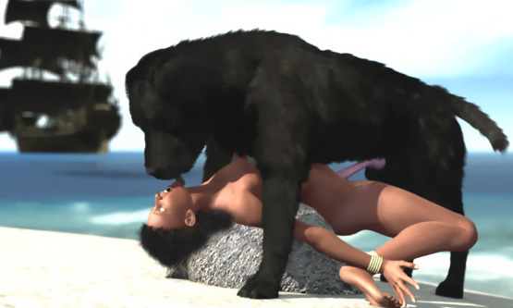

His cock found her open pussy easily and he pushed in slowly penetrating her pussy. But the angle was bad. Mimbo pleaded the dog to stop. But he lowered his hip and pushed his cock deeper making her body slide a little forward, rotating her pussy up giving his cock a better angle.

When the dog wrapped his forepaws aroung her thighs, Mimbo knew that the dog would thrust his cock all the way into her and she screamed! In a second she felt strong jaws around her neck and she froze. The dog held her neck tightly. But he was careful not to sink his teeth through her skin. Then he plunged his cock all the way into her!

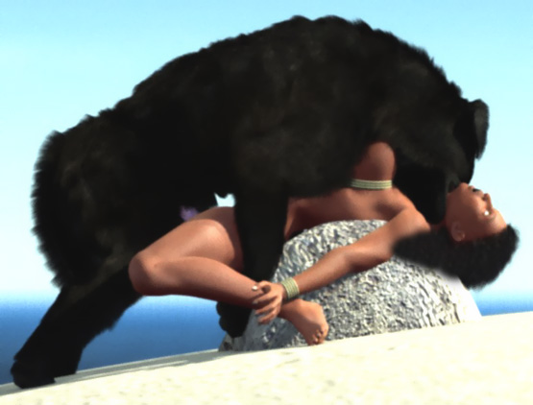

On the ship, the pirates heard Mimbo screaming. They saw the dog grabbing her neck in his jaws and the screaming stopped.

The ship sailed away. The pirates had seen enough.

On the beach Mimbo's pussy was again being fiercely fucked and painfully stretched. Tears fell down her cheeks as the huge dog pounded her pussy! She had thought that the dog was her friend. But now she was nothing but a fuck toy for him. Even though she was tied, he had her neck in his jaws.

Soon his cock locked into her pussy and his sperm was mixed with the pirate's semen in her vagina. His cock filled her cunt totally stretching her painfully. She wailed in pain but stopped when the dog growled and increased the pressure in her neck.

Tears ran on her cheeks as she felt totally humiliated. The dog had saved her from the human rapists only to rape her himself.

Slowly the dog released her neck ... dragged his cock out of her pussy ... and walked away giving her face and tied breasts a few wet licks.

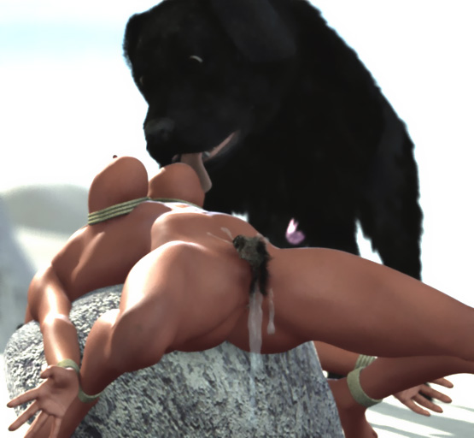

3 times the dog came back, fucked her, and licked her face and breasts. She didn't know that the dog was just following his training. He had been taught to fuck tied women.

She tried to tell the dog to bite the ropes and finally the dog started to bite the rope in her left wrist until it was cut. Now she could open the knots and get free of the ropes.

She crawled to the place where she had stored some coconuts and other fruits and ate some. The dog sat beside her, wagged his tail, and gave her face and breasts a few licks. She was too afraid of the dog to stop him. But at the same time she knew that the dog tried to be friendly with her.

After half-an-hour she fell asleep. The dog licked her pussy, breasts and face, and lied down beside her.

- - - - - - - - - - - - - - - - - - - - - - - - - - - - - - - - - - - - - - - - - - - - - - - - - - - - - - - - - - - - - - - - - - - - - - - -

https://www.beastforum.com/showtopic-156123-315.html
*** Doggy Island ***
by Canis3

Donna leaned slightly forward and gently closed her right hand around Tim's cock. She felt heat inside her growing and her pussy getting wet. She had only known Tim for 2 weeks. But he was the best lover she ever had. Donna had a black curly hair, lips waiting to be kissed, a shapely body, and big round breasts.

They had rented a small island called Doggy Island for a week to lie on the beach and make love. When the boat of the landlord had disappeared from their sight, they took off their clothes and spread a towel on the beach. Tim had opened a Pepsi and Donna had laid 2 apples on the towel.

"Shep and Rusty, go away!" Tim said sternly to his dogs, a shepherd and a doberman that sniffed around Donna.

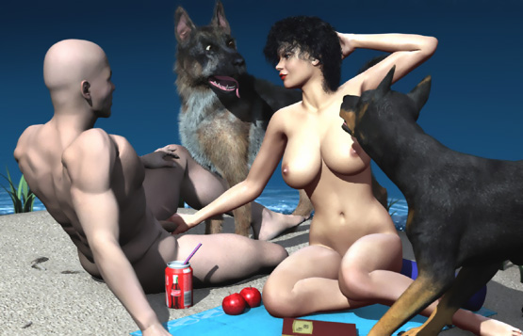

"Never mind the dogs. I want to make love to you on this beach," Donna said grabbing Tim's hardening cock tighter and squeezing her big soft tits with her left hand.

Rusty the doberman came closer to Donna ... laid his left forepaw on her thighs ... and wrapped his right forepaw around her back. Shep sniffed and licked her right cheek. Donna felt doggy fur on her both sides. But she didn't care. All she wanted was Tim's cock into her wet pussy.

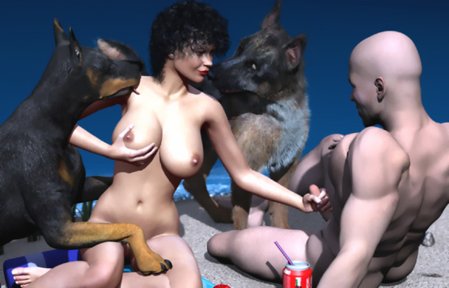

Donna fell forward. She was on her hands-and-knees with her face touching the ground. Rusty wrapped his forepaws around her waist. Donna giggled when Rusty's penis was poking her crotch.

But she froze when it found her pussy. This wasn't funny any more!

Rusty pushed 2 inches of doggy cock into Donna's pussy ... pulled if out almost completely ... and a second later pushed his entire cock into Donna's human pussy!

"Get him off me! Your crazy dog is raping me!" she yelled at Tim.

Tim moved to help her. But he stopped when Shep lowered his head and snarled at him with his huge fangs only a few inches above Donna's neck.

Tim knew his dogs. When they were breeding a bitch, nobody -- not even their Master -- could stop them.

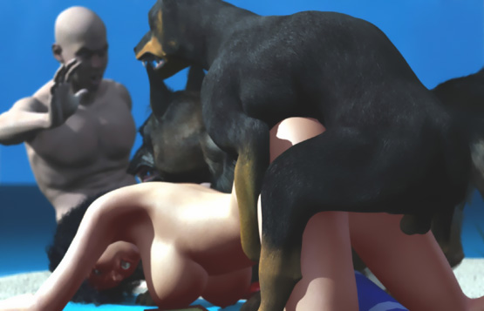

"Get him off me, Tim!" Donna yelled desperately.

Rusty had a tight grip around her waist and his cock was driving back-and-forth in her pussy with enormous pace making her breasts brush the towel. Shep laid his left forepaw on her back and snarled a few inches above her ear.

"G-g-g-g-get him off me!" she sobbed with her body shaking and her tits swaying wildly as Rusty kept slamming his cock into her pussy.

"Get off her!" Tim yelled at his dogs. But his command had no effect on the 2 snarling beasts breeding their bitch.

"Get off her!" he yelled again. But Shep lowered his head and was ready sink his huge fangs into Donna's neck at any moment.

"No, no, no, no!" was all that the terrified girl could say following the rhythm of the raping dog.

Rusty's cock had grown and was now filling her completely. A bulge at the base sealed it inside her pussy. His hip movements were now shorter. But Donna's body was forced to follow his every move.

"He's cumming inside me, Tim! He's filling me with his fucking sperm!" she cried to her lover who could only watch her misery.

For about 10 minutes Rusty stayed on her back with his cock locked into her vagina. Donna wailed as he tried to pull it out.

Finally the cock popped out and a steady flow of doggy sperm leaked from her pussy.

"Thank God it's over," Donna said leaning to her hands.

But soon she felt the weight of Shep landing on her back.

"Noooooooo! Not again!" she whimpered as Shep's penis found her wet and open pussy.

When Tim moved, Rusty grasped Donna's neck in his jaws and snarled. Nobody would take their bitch away from them! Donna was totally at the mercy of her two canine rapists who controlled her every move.

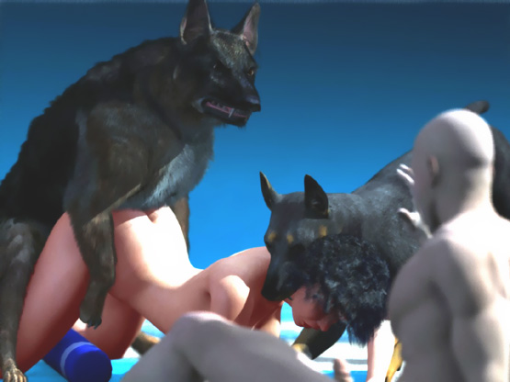

Donna wailed as Shep fiercely fucked her pussy and Rusty held her neck in his jaws. The dogs used her as their bitch and there was nothing that she or Tim could do to stop it. She tried to relax and wait for her doggy rape to end.

Shep's cock was growing in her pussy. It was rubbing her g-spot and with each thrust, Shep hit her clit. Donna was feeling desperate. But she also felt her pussy starting to suck in Shep's swelling cock.

"No! No! I can't be cumming to a raping dog!" she moaned.

Shep's cock was now locked in her pussy and Donna felt she was bursting. When Shep started to shoot his sperm into her, Donna spasmed and screamed uncontrollably as a powerful orgasm shook her body.

For a moment Shep stayed still on her back. Then he lifted his left hind leg and turned around. Donna screamed in pain as the huge cock rotated inside her pussy. She was now but-to-butt with Shep with her neck in the Rusty's jaws.

Rusty stood up and pulled Donna's head and chest up. She tried to push Rusty's head away with her left hand. But Rusty only snarled at her and grabbed her neck even tighter in his jaws.

Tim was helplessly watching as his dogs used her girlfriend as their fuck-toy. They had raped her and knotted her. They had even made her cum.

Now Shep was shooting last drops of his semen into her pussy. Rusty, with her neck in his jaws, lifted her breasts beautifully on display. After her fierce orgasm, she was weak and sensitive to every movement of Shep's cock inside her pussy. She moaned and breathed heavily. Her heavy breasts swayed softly with her every breath. They flopped left-and-right as Rusty shook her by her neck.

Donna was at the verge of another orgasm when she saw Tim's massive hard-on.

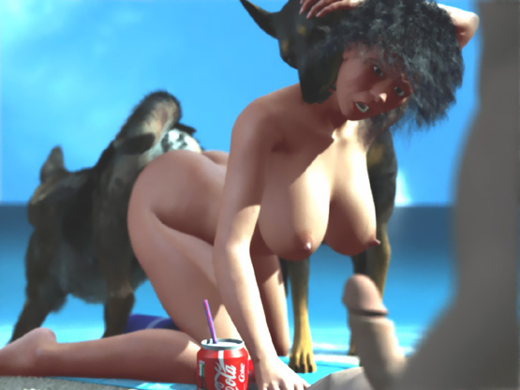

Tim forgot Donna's misery. He just saw her sexy body tense and her eyes stop as Shep's huge doggy cock locked inside her and throbbed and pumped another massive load of puppy-making semen into her.

She started to squirm. Her perfect, big, soft breasts swayed wildly. But she had to stop when Rusty growled beside her ear and tightened the grip around her neck.

She looked desperate. An orgasm was growing inside her. But she was unable to move. She grabbed her breasts with both hands and squeezed them harshly. She forgot the pain, closed her eyes, and moaned in agony.

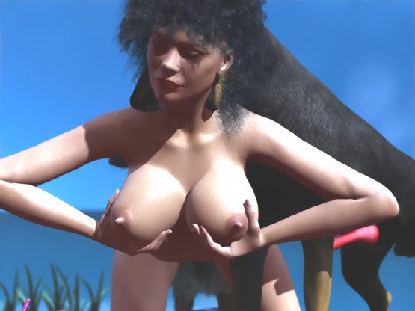

This was just too much for Tim. He came closer to Donna. She could barely move her head. But he bowed and twisted his body and pressed his lips against hers. His hands replaced her hands on her breasts. He could feel the orgasm growing inside her. He pushed his tongue into her mouth and she tried to swallow it. He squeezed her tits that felt bigger and softer than ever before.

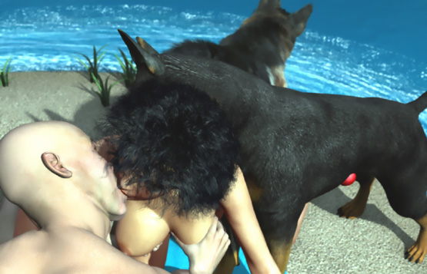

Her pussy milked Rusty's cock that was still shooting sperm inside her. The knot sealed the cock into her pussy. But a steady flow of doggy semen was running down her thighs. She was completely filled by a throbbing canine cock.

Then she took a deep breath. Her body tensed and relaxed. She was cumming! Her body spasmed helplessly between Shep's cock and Rusty's jaws.

Tim's hands, tightly closed around her delicious breasts, felt several waves of orgasms go through her body. He kissed her. He felt her nipples in her soft breasts grow long and hard. Tim felt his cock throbbing and shooting several loads of his sperm on her breasts.

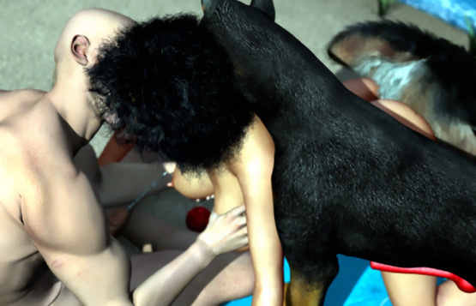

Shep was now finished with his bitch. Donna wailed as Shep made several attempts to pull his cock off her pussy.

Finally the cock popped free and huge amounts of doggy sperm flowed down her thighs. Rusty released her neck and her head fell on Tim's thighs. Her body was still trembling.

Tim grabbed her head and guided his cock into her mouth. She sucked it clean while the dogs licked her sensitive pussy.

"Go away, you bastards!" Tim yelled to his dogs.

They growled at him and gave a few more licks to Donna's shivering pussy as if to tell him that she was now their bitch.

Then they walked away ...

- - - - - - - - - - - - - - - - - - - - - - - - - - - - - - - - - - - - - - - - - - - - - - - - - - - - - - - - - - - - - - - - - - - - - - - -

https://www.beastforum.com/showtopic-156123-330.html
*** Breeding the Teacher ***
by Canis3

Akiyo was opening the door to a classroom and when she took a last look at the corridor. It was empty. All students were in the classrooms. Some bags lay on the benches.

"Don't they ever learn? This is a security issue," Akiyo thougt.

At the end of the corridor she saw a huge brown doberman. He was King, the guard dog of the school. Usually the janitor kept him at his home in the daytime. But for some reason, King was now walking in the corridor.

Akiyo liked dogs. She had a bitch dog at home. It was "in season" and Akiyo had to keep her home be'cause she didn't want any puppies. In the morning as every morning, she had jumped on Akiyo's lap and licked her face before Akiyo left.

"King! Come here boy," she said to the dog in the school corridor.

She waited for the dog and together they entered the classroom.

Akiyo was a young sexy woman of Japanese origin. She was about 5' 5" tall. Her face was beautiful with big, deep brown asian eyes and full lips. Her black hair was tinted brown. She had a blue skirt, no bra, and a red blouse that provided a generous view on her impressive cleavage. This was her first year as a teacher.

"Good morning," she said to the students.

" 'Morning," said some of the students, indicating that they couldn't be less interested about the teacher.

"Good morning, Sexy Thing," said a group of boys in the back row.

Akiyo heard the students laughing at her. She blushed but kept her dignity.

"Today we are discussing breeding ...," she started and projected on the screen a photo of 2 dogs mating.

"Is King gonna breed you?" asked one girl while adjusting her makeup.

"We will discuss the breeding of animals," Akiyo continued trying to ignore the remark and laughter.

She was now facing the students and the huge panting dog was sitting and looking at her. Most of the students were chatting with each other and the paid no attention to their teacher.

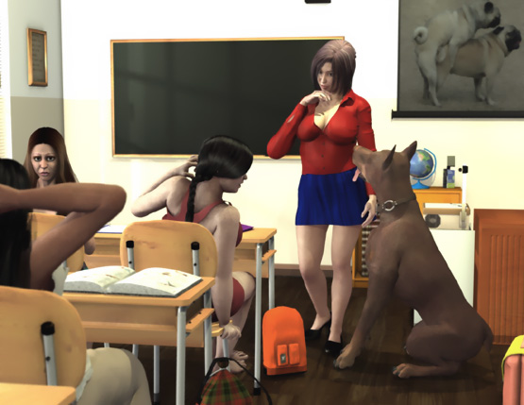

"You all know King. Do you know which breed he is of?

"He's a Doberman, We all know that," answered one of the girls.

"Yes. King is a Doberman. And a handsome one. You can see his huge size, beautiful muscular shape, and shining brown fur. He has won many prizes. And he has been used as a stud dog. Many people will pay a lot of money to have King breed their bitch dogs. Today I will tell you why. Come here, King."

King walked to Akiyo who patted his head. He found the smell of a bitch dog in Akiyo's skirt and his penis started to protrude from its sheath.

"What's that? I can see his cock!" shouted one of the girls in the front row.

"Show us his cock, Akiyo!" shouted the boys from the back row.

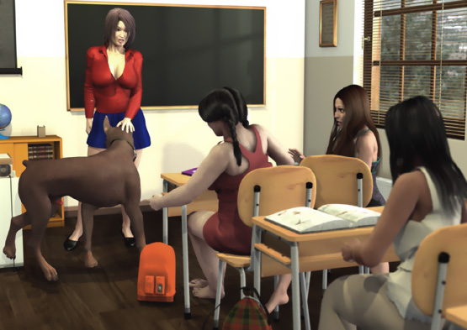

King didn't like the noise. He turned quickly toward the students ... barked twice ... and growled.

Soon it was totally silent. One could hear the dog's nails hitting the floor as he walked back to Akiyo.

"Be quiet, everyone. Dogs don't like noise," Akiyo warned and patted the dog.

King got on his hind legs, raised his forepaws on Akiyo's shoulders, and gave her face a friendly wet <lick>.

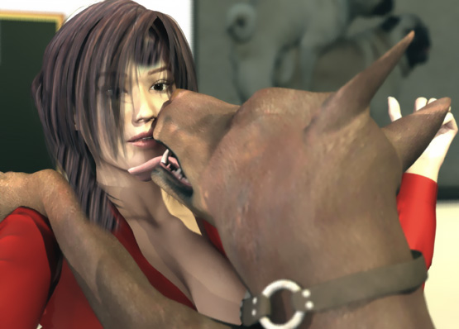

When he lowered himself down, his forepaws got stuck in her blouse and ripped the buttons open!

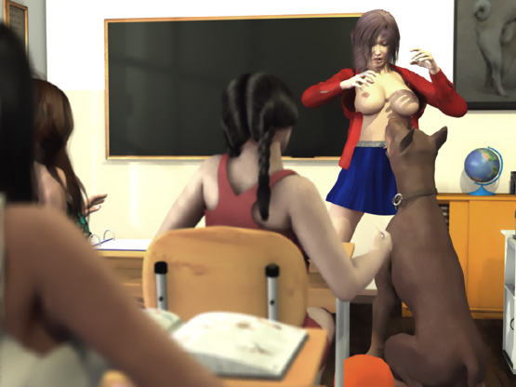

For a second the students stared at her large naked breasts until she quickly pulled her blouse to cover her chest. She started to button the blouse but felt King pushing his head under her skirt and licking her crotch.

She grabbed King's head in her hands and tried to push him away when she heard the boys laughing and whistling! Her blouse was open and her arms pushed her breasts together like she was posing in a porn photo.
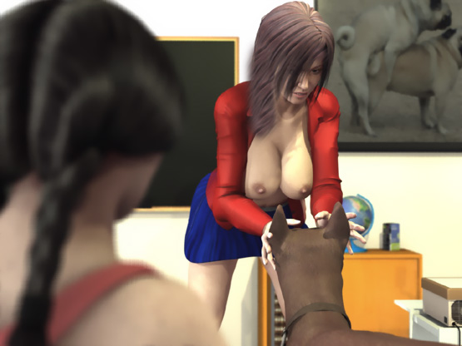

King turned around and rushed forward. He raised his forepaws on a table. His fangs were about 10 inches from the face a terrified woman and he snarled until everyone was quiet again.

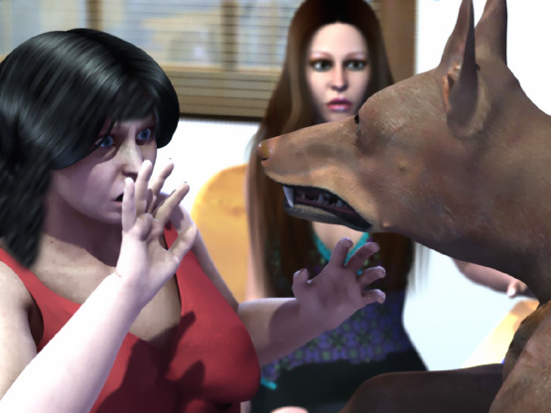

"Don't say anything. Just look," whispered one of the students. "No matter what happens."

King growled and walked back to Akiyo who was getting scared also.

"Go away, King!" she said sternly to the dog.

King, however, pushed his head again under her skirt. She stepped back. But King growled and followed her until she was standing against the wall.

She covered her breasts with her left hand and with her right hand tried to push the dog away. But King snarled at her and <nipped> her hand. He pushed his head again under her skirt and <nipped> her slightly until she spread her legs. She could only stand helpless against the wall facing her students with her legs spread like a whore, covering her breasts with her hands and offering her crotch to the licking beast.

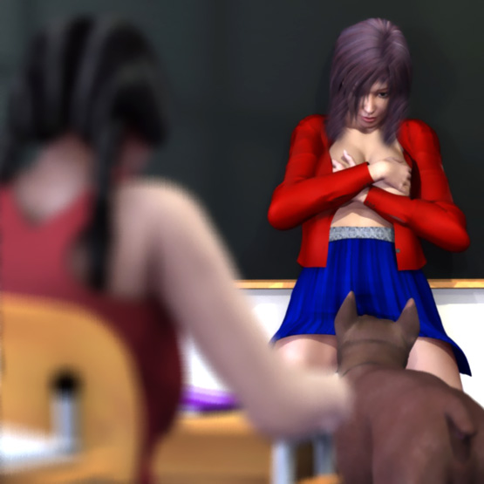

The licking was making Akiyo's pussy wet and King tried to lick every drop of her love juices. His penis was growing and he pushed his snout tightly against her crotch trying to lick deeper. But his tongue was stopped by her panties.

"Go away, King," Akiyo said with tears in her eyes.

Akiyo's eyes froze when she felt the dog's teeth nipping her crotch. After a few <nips>, King grabbed her panties in his teeth. Everybody heard the ripping sound as King tugged Akiyo's panties. She closed her legs. But King pulled her panties lower.

Akiyo had to spread her arms to maintain balance leaving her huge tits uncovered. The students looked at her big swaying breasts with small areolas and hard nipples. Then they looked at the huge dog dragging Akiyo's panties off and his growing cock. Then they looked at her tits again.

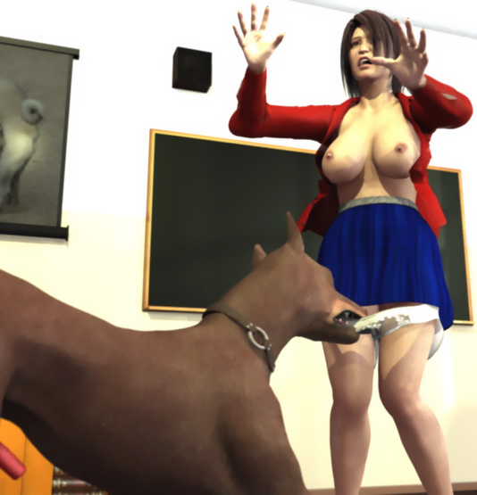

When King had lowered Akiyo's panties to her knees, his tugging caused Akiyo to fall on her back. King took advantage of the situation and pulled her panties further down her legs. At her ankles the panties got stuck first in her right shoes which was soon removed from her feet together with the panties. Then the panties got stuck in her right shoe.

The huge dog pulled the panties spreading Akiyo's right leg until the shoe slipped off. Soon the dog was standing looking at the frightened teacher lying on the floor in front of him, leaning on her hands. Her legs were spread wide and her skirt was up so that both the dog and the students could see her wet pussy leaking her juices. Her huge naked tits moved softly up-and-down as she breathed heavily.

King started to lick her pussy again. This time the panties didn't stop him. He pushed his snout and tongue into her wet pussy. Akiyo sobbed softly as the dog's tongue slipped into her wet pussy.

The sound of a wet tongue lapping her wet pussy filled the classroom. Some students leaned to get a better view of her pussy and laughed at the misery of their teacher who tried to keep her dignity even in this humiliating situation. But some girls covered their faces while staring the lewd show in front of their eyes.

"We must get someone to help her," said one of the girls.

"Nobody goes nowhere," said one of the boys. "The dog will kill you if you try anything."

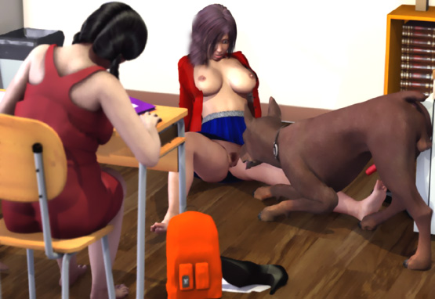

King heard the noise. He raised his head and snarled. Everyone was quiet again.

Akiyo saw her opportunity. She started to get up ... but felt the weight of the huge dog on her back and fell on her hands-and-knees. King wrapped his strong forepaws around her waist and pulled her back and started poking her crotch with his penis. Desperately the poor teacher tried to crawl towards the door. But strong jaws closed around her neck stopping her efforts.

She was now facing the students. Soon they saw her eyes and mouth open wide and they knew that King's cock had penetrated her. With her neck firmly in his jaws, King fucked his bitch with enormous pace and strength. Akiyo's head shook and her breasts flopped wildly as the dog pounded her pussy. Tears were running down her face and she closed her eyes in shame as King demonstrated how a bitch was bred.

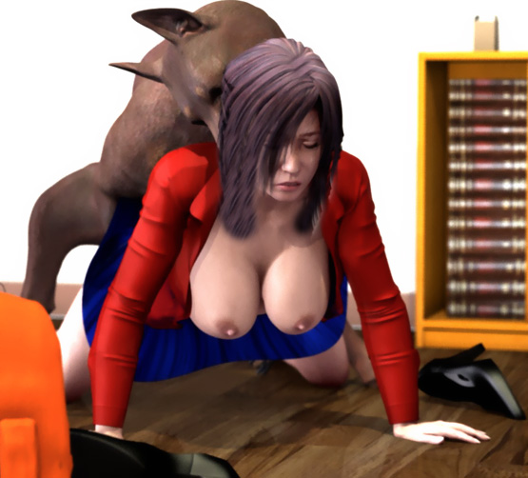

The dog's cock was growing and soon it reached more than 10 inches. With each push he sank his cock to the hilt into her pussy. Akiyo's vision was blurring as the huge cock painfully stretched her vagina and hit her cervix.

"No-o-o-o-o-o...," the students barely heard her wailing.

Soon Akiyo and the dog were facing the door and the students could see the huge doggy cock pounding her pussy. Occasionally his cock slipped out of her pussy so that the students could see the breeding tool that was more that 10 inches long and as thick as their wrists.

In a few seconds the dog's cock sank into their youngteacher's pussy again and the fierce humping continued. After about 10 minutes of fierce humping, the knot started to swell.

"Look at that!" whispered one of the girls in the front row and pointed at the bulge forming at the base of King's cock.

Akiyo's pussy was now stretched even more. But she tried to retain her Asian dignity. The students could see the pain in her face. But she didn't scream. Her pussy, however, was getting even wetter, lubricating the huge cock invading her vagina. Finally the bulge grew so large that it got stuck inside her pussy.

"Look! His cock is locked inside her!" someone whispered.

King grabbed her neck even deeper in his jaws ... fiercely pulled her back ... and pushed his huge cock deeper inside her abused vagina. The dog pumped his semen into her with short jabbing movements.

Her blouse was being pulled back so that the students could clearly see her big tits with their big erected nipples shaking wildly as the dog pumped his puppy-making seed into her. On the screen the students saw a picture of 2 dogs mating. But under the screen a huge dog was breeding their helpless prissy teacher-bitch.

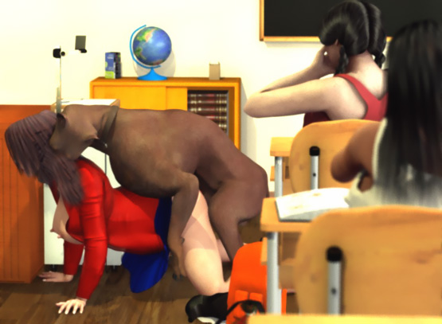

Akiyo didn't understand that the dog's cock was "tied" in her pussy. She just wanted to escape. She crawled forward and tried climb on the teacher's table. But the dog followed her without letting her go.

She was half-way up exhausted and sweating, her arms and chest already on the table. But she couldn't get higher. The dog's forepaws were tightly around her waist and his cock was locked inside her pussy. He grabbed her neck even deeper in his jaws and pulled back stopping her further attempts.

The well-trained dog had a secure grip of Akiyo's neck without causing her severe injuries. His fangs just slightly broke her skin. But Akiyo knew it was dangerous to fight back.

King was now banging her against the table with short strong jabbing movements, pushing his cock deeper-and-deeper, making it swell bigger-and-bigger and stretching the vagina of his helpless bitch. The wet flopping sound of Akiyo's tits bouncing on the table were mixed with the slurping sounds of her wet pussy being raped by the huge canine cock.

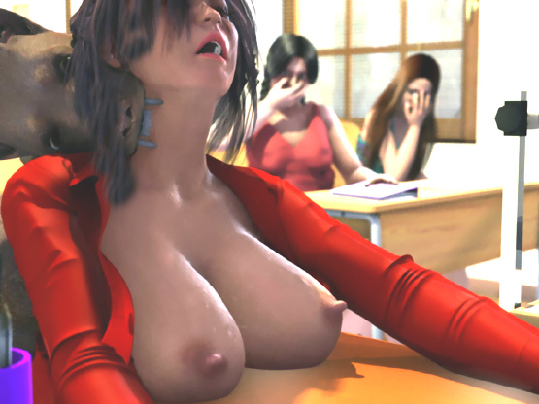

King, however, was not satisfied with the situation. He released her neck and stepped a few steps back dragging Akiyo by her pussy off the table down to the floor. Her pussy was pointing high up giving better access to King's cock.

Akiyo's pussy was now reacting to the fierce fucking. There was a mixture of pain and pleasure on her face, wet and messy after a continuous flow of tears.

When the canine cock now filled her stretched vagina completely, King stopped humping. Without knowing it, Akiyo kept pushing her hip back. Soon her body was shaken by a powerful orgasm as the dog pumped the last jets of puppy-making semen into her. Some sperm was leaking from her pussy flowing down her thighs and forming a small pool on the floor.

"Look at her," said a male student. "She's nothing but a whore in heat!"

King grabbed the neck ofthe exhausted teacher in his jaws and lifted her upper body up. The dog wanted to have complete control over his bitch to make sure that every drop of his sperm found its way deep into her fertile womb.

Akiyo's tits hung heavily and her body was still shivering after her orgasm. The sound of the dog and the woman breathing heavily was the only sound in the classroom.

After several minutes King lowered his head and released her neck so that her shoulders and head fell on the floor. Her hip was still high in the air. King lifted his left hindleg and turned around rotating his huge cock inside her pussy until they were butt-to-butt. Obviously the dog didn't know what to do next. So he walked around on the podium dragging the helpless teacher by her pussy.

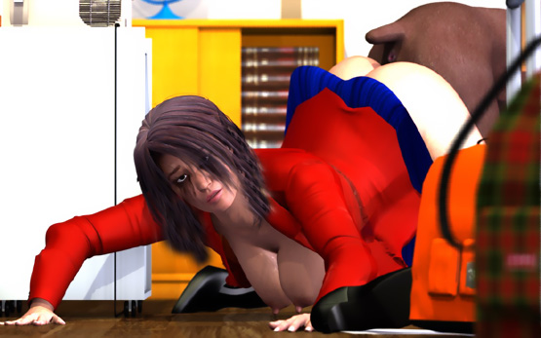

Finally his cock subsided and with a wet plopping! sound slid off her pussy. Akiyo's lower body fell on the floor. Her legs were spread open so that the students could see the enormous amount of doggy sperm flowing out of her pussy

King licked her pussy a few times. Then he sat down and licked his cock clean and walked out of the door.

Akiyo turned on her back ... covered her pussy and breasts ... and sat down on the floor crying. She looked at her students. Most of them were crying and looked terrified. But some of the male students were laughing and silently cheering.

"Please don't tell anyone," Akiyo said sobbing just before the bell rang.

The class was over and the students walked out of the classroom. Their breeding lesson was over.

Akiyo was barely able to get up. But she took a towel and wiped off the semen on the floor and on her thighs. She grabbed her teared panties and slowly walked to the restroom.

In the evening, the cops took King into their custody. The rector called the parents of Akiyo's students telling them that the students had seen a dog severely attacking their teacher and the school would arrange psychiatric help to all students.

2 weeks later, Akiyo returned to school and entered the classroom.

- Good morning, Akiyo, the students said in one voice, and Akiyo knew they ment it.

She looked at her students and smiled for the first time in 2 weeks. She also saw Chuck, the leader of the boys at the back row, getting up.

"I just wanna let you know how sorry we are 'bout what happened to you," Chuck said suppressing an evil grin. "We haven't told anybody but the shrink and the cops what the dog did to you you. I know we haven't been very nice to you. But from now on we'll try to do better. Okay?"

"Ok. And thank you," Akiyo said and smiled.

But Chuck and the rest of the boys were thinking: "Fuck you, Whore! Since you like dogs so much, we're going to round up some and see if we can't get your pregnant with some puppies. You fucking slut ...!"

- - - - - - - - - - - - - - - - - - - - - - - - - - - - - - - - - - - - - - - - - - - - - - - - - - - - - - - - - - - - - - - - - - - - - - - -

https://www.beastforum.com/showtopic-155137.html
*** Open Door ***
by Canis3

Rosina and Nathan have been lovers for 2 years. Rosina, a 20-year-old slim and busty brunette, was a dream come true for Nathan. S he had been the girl of his fantasies since they first met at a local disco 5 years ago. Nathan was a photographer and he had a large portrait of Rosina on a wall above his bed.

It was a warm and sunny afternoon when Rosina came. They kissed passionately as Nathan undressed her caressing her shapely body. When she was totally naked, Rosina jumped on the bed and teased him squeezing her breasts and rubbing her pussy while Nathan was undressing. It didn't take long when Nathan was with her.

He started to kiss her big perky breasts. But Rosina was in a wild mood. She pushed him under her and held him there. Then she turned around facing his semi-erect penis and with her thighs on both sides of his head and her ankles undert his neck, she pushed her pussy against his face.

Nathan licked her already wet pussy pushing his tongue deep inside her and moaned as she started to kiss his dick. She sucked it, licked it, and pushed it deep into her mouth and throat while smothering her lover with her wet pussy.


When his dick was full erect, she turned around again. Sitting with his head between her thighs, she pushed her pussy against his mouth as hard as she could. She grabbed his head with both hands and pulled his face into her wet and wide open pussy.

Suddenly Rosina pushed Nathan's head on the bed and moved backwards. She bent down and made him kiss her big soft tits. Then she played with her boobs dragging them on his chest.

Finally she felt his cock in her crotch. She moved her hips so that his cock touched her wet pussy lips and was just about to let him penetrate her …

… when she pulled her hip up again, teasing him. After a few minutes of cock-teasing, she moved forward and kissed him.

"Now, I want your cock deep inside me," she whispered in his ear.

She moved backwards …

… and screamed! A huge dog had jumped on the bed and wrapped his front paws around her waist.

"Nathan, help!" she screamed.

She tried to get up. But she was pinned between her lover and the huge dog.

"Go away, you filthy dog!" M Nathan ark yelled.

But the dog snarled at him. It grabbed her more tightly between his forepaws and started poking her crotch with its penis.

"The door … We left the door open!" Nathan remembered.

Then he tried to push the dog off her. But the dog snarled even more viciously. Being pinned under the girl and the dog, Nathan was not in a good position to push the huge animal.

" Nathan, he is trying to fuck me! Get him off me!" Rosina screamed desperately.

"Nooooo!!" she yelled as loud as she could when she felt 2 inches of doggy cock penetrating her pussy.

"Get off her now!" Nathan yelled and slapped the dog.

The huge dog had his cock inside his bitch and he was not going to give up. He grabbed Rosina’s neck in his jaws. Feeling sharp teeth around her neck ,the girl stopped screaming.

" Nathan, help me," she sobbed terrified.

Nathan raised his fist to hit the dog. But the dog looked straight into his eyes and sank his teeth slightly into her neck. Rosina opened her mouth and looked at Nathan with her wide open eyes. M Nathan knew that the dog wouldn’t release her neck if he felt a threat. Rosina could be in severe danger if he tried to attack the dog.

There was nothing he could do to help her. When the dog saw Nathan lowering his fist, the dog knew that he had gained total control over both humans.

"I'm sorry, Rosina. He would hurt you bad if I’d try to push him off. Try to keep him out of your vagina. Maybe he will go away," Nathan said sadly.

But it was too late for that. The dog started to fuck his bitch with strong and fast movements. His cock penetrated deeper into her inch-by-inch and it was growing all the time.

Finally he slammed all 12 inches of his steel-hard cock into her. Her desperate scream was cut out, when the dog bit deeper into her neck.

"Get off her!" Nathan yelled. But it had no effect.

The dog pulled almost all of his cock out of her pussy … and then plunged it into her again. With her neck in his jaws and his forepaws around her waist, he held his bitch in her place and with a powerful thrust on his hip he pushed all of his cock into her cunt. He did this again-and-again increasing his tempo all the time. The cock was so thick that it stretched her love canal. And when he slammed it, it hit her cervix.

Rosina was in pain. With tears falling from her eyes, she looked at her equally terrified lover under her. They both cried.

R osina felt like a baseball bat was being pushed in-and-out in her pussy with a furious strength and pace. Her neck was tightly in the dog's jaws and he controlled her hip with his forepaws. She was crying,. She was sweating. And she was getting exhausted.

Rosina felt the dog hitting painfully her pussy. But luckily for her, the cock was too big to enter any deeper into her. The dog pulled her neck bacwards and pushed his cock powerfully into her. But he could not get his knot inside her.

Then she felt several rhythmic spurts of semen inside her pussy. With powerful thrusts the dog tried to implant his seed as deep into her as possible.

"He's cumming inside me!" she said looking at Nathan with pain and fear in her voice.

Nathan felt doggy sperm flowing from her pussy on his stomach and thighs.



"I'm so sorry, Rosina. Try to hold on," he said and tried to calm his abused girlfriend.

She supported her weight with her hands on his shoulders to ease the pain in her neck. Her big breasts played a rhythmic dance on Nathan's chest as the dog fucked her now with a lower pace but stronger and longer thrusts.

Finally he pushed his cock deep into her and pulled her neck backwards and waited for the last drop of his puppy-making sperm to enter deep into his bitch. Her back and neck were painfully arched. And her big tits with hard long nipples swayed in front of Nathan's face as the dog finished breeding the beautiful girl.

Then the dog released her neck and pulled his cock out of her pussy. Nathan felt huge amounts of warm dog sperm flowing on his stomach and down his thighs.

"Thank God it's over," Rosina sighed.

"Damn dog! You raped me!" she yelled at the dog hitting him at his head.

That was a wrong thing to do.

The dog snarled at her, jumped on her back wrapping his forepaws againg around her waist, and grabbed her neck tightly in his jaws. Rosina and Nathan screamed and yelled. But they both stopped screaming when the dog's fangs started to sink into her neck. The dog had learned to control his bitch without causing her any unnecessary injury. And he did that very effectively.

Again Rosina felt his cock penetrate her pussy. This time all 12 inches of doggy cock sank into her wet and stretched vagina with the first thrust. The dog had not stopped breeding yet. He hadn't been able to "tie" with his bitch the first time. But it was going to do that now.

"No, no, no! Not again!" Rosina wailed as the dog pushed his huge cock into her again-and-again.

Nathan was terrified. But he could only watch his girlfriend shaking over him, her body gliding on his stomach, and her big tits swaying in front of his eyes as the dog repeatedly pushed its huge cock into Rosina's pussy.

"Please let her go!" he pleaded, to no avail.

Nathan saw more-and-more horror in Rosina's face as the dog’s huge knot was hitting at her pussy lips and then painfully stretching her pussy wider little-by-little. The dog's thrusts were now stronger than ever before.

Rosina was exhausted and the continuous pain in her cunt made her dizzy. The dog tightened the grip in her neck and pulled her backwards. Rosina was barely conscious and moaned lightly when the huge knot entered her violently stretched pussy.

Now the dog's thrusts became quick and short as he filled her with a new load of semen. Her womb was tightly sealed with the huge knot and she wailed in a semi-conscious state as the pressure in her vagina increased with each new spurt of doggy sperm.

Finally her vagina was totally filled and stretched to the limit by the huge cock and the puppy-making sperm that forced its way into her womb.



Nathan saw that his girlfriend had passed out. The dog still pulled her neck back and held her in place while he emptied every last drop of his sperm inside her. Her eyes were closed and her head swayed uncontrollably from side-to-side, supported only by the dog’s strong jaws in her neck.

Seeing this, Nathan tried to support her and ease the grip of the dog with his hands. The dog allowed this now that he had planted all his seed inside her.

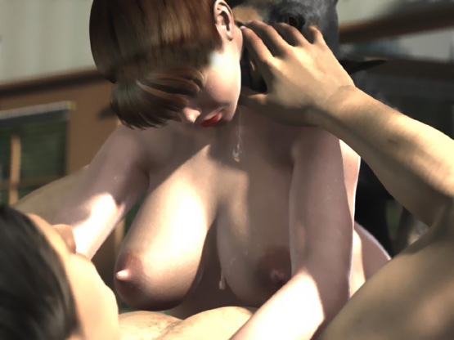

Finally the dog released her neck and she fell on Nathan's chest. He hugged her wet body and held her in place as the dog pulled several times until his knot popped out of her pussy and a huge amount of doggy sperm poured from her pussy. The dog stepped forward and snarled at Nathan to let him know whose bitch the girl was.

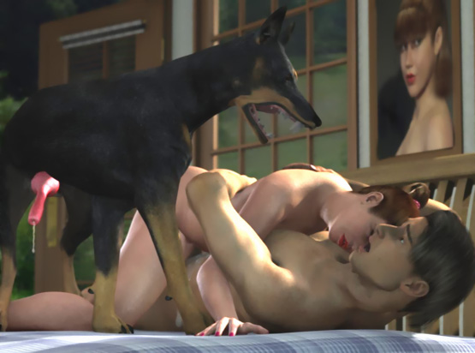

Nathan saw the huge doggy cock still dripping sperm. He couldn't believe that all of this monster had been inside her girlfriend's pussy a moment ago.

Then the dog took some time licking her pussy … jumped off the bed … ran out of the door and disappeared in the forest.

Nathan was lying on the bed with his hands around Rosina. He felt tears falling on his chest as he hugged the weeping girl with both arms. He calmed her and soon the exhausted girl fell asleep. After a while, Nathan was almost sleeping when he felt Rosina quiver.

"Nathan, somebody is licking my pussy. I think it is a dog," she whispered with a trembling voice.

Before Nathan could raise his head, a big German shepherd leaped on the bed on his left side followed by a huge black dog on his right side. That was the biggest dog Nathan had ever seen. Rosina screamed and kicked at the third dog licking her pussy and Nathan yelled at the dogs.

Facing these acts of aggression made the dogs angry. Rosina heard the dog on the floor growling. And in the next moment the German shepherd snarled with his maw just a few inches from her face.

The black giant laid his big paw on Nathan's throat and snarled with his long sharp fangs almost touching Nathan's face. Rosina felt heavy paws on her buttocks and sharp teeth taking a hold of her neck.

With a sudden powerful movement, the dog behind her (a rotweiler) pulled her head up and back while his forepaws held her hip down. Her back was stretched to the limit. The shepherd in front of her sniffed her face and gave her a lick.

"Let her go!" Nathan shouted, but was only faced with a huge black maw snarling at him.

He hit the dog with his fist. But it had no effect on the huge animal except that he grabbed Nathan's neck in his jaws and shook his head violently.

"Don't fight, Nathan. I don't want to lose you," Rosina pleaded.

Meanwhile the shepherd had turned his attention to her big perky breasts and was lapping them with his tongue.

With his neck firmly in the jaws of the huge dog, Nathan couldn’t see Rosina's big tits bounce and sway on the dog's tongue. Her breasts were the dream of every male in the neighborhood . And now they were violently pulled on display by a big dog and eagerly licked by another beast. Her nipples responded to the licking and pointed out long and hard.

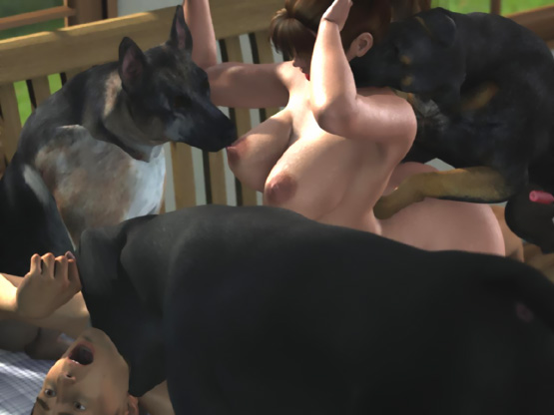

When Nathan stopped yelling and hitting, the black dog released his neck. But it looked at him intensively ready to attack if needed. Nathan knew that he was no match to the huge beast who watched his every movement.

The black dog stepped to the floor and the shepherd took his place. The rotweiler released Rosina’s neck and Nathan held the terrified girl on his chest. Then she lifted up her head.

"Please no! Let me go! Let me go!!"

The rotweiler had wrapped his forepaws around her waist and was mounting her. In no time his cock found Rosina’s pussy which was still wide open and lubricated by doggy sperm.

"No! No! No!" she cried as the dog pounded her with his cock which was at least as large as that of the first dog.

Nathan tried to move Rosina away. But he but stopped when he faced 2 big snarling dog just a few inches from his face.

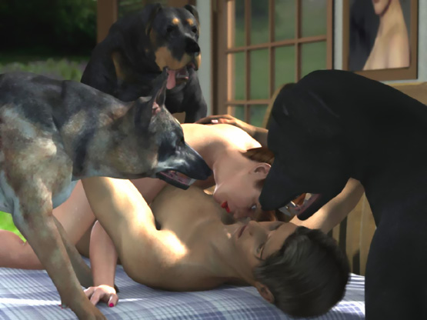

"No-o-o-o-o!" Rosina’s voice was shaking as she was being raped by the beast.

The shepherd stepped on Natha’s left side and started to hump her face. The dog had his forepaws in her armpits controlling her upper body. The rotweiler pounded painfully her vagina with his knot and Rosina opened her mouth.

"No-o-o… mmmph!"

The shepherds cock found her mouth and he pushed his cock deep into her throat. Rosina gagged. The shepherd pulled his cock back and pushed it again into her throat.

It seemed as if the dogs were synchronized. As the rotweiler pushed his cock into her pussy, Rosina’s mouth was pushed towards the shepherd's cock. As the shepherd pushed his cock deep into her throat, Rosina was sliding along the cock in her pussy.

Just above his head, Nathan could see his girlfriend’s mouth invaded by a huge doggy cock. But he could do nothing to help her. A huge dog snarled even at his slightest movements. Nathan could only hold his arms around her shivering body that was pushed back-and-forth by the 2 fucking beasts.

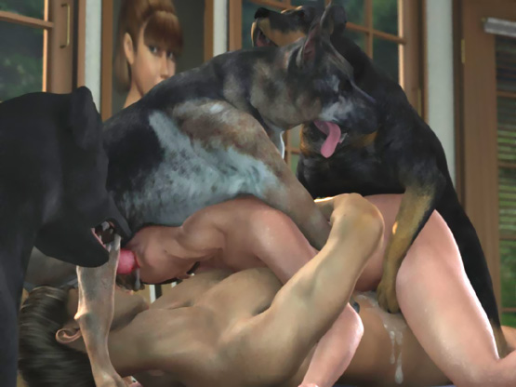

Rosina’s body swayed uncontrollably as she was being pushed from one doggy cock to another. With a huge cock in her throat, she couldn’t make a sound.

The rotweiler was now banging his knot against her pussy lips. The pain made Rosina open her mouth even wider so that two knots entered her simultaneously. One in her cunt and the other in her mouth. Her jaws were painfully open as the shepherd’s knot filled her mouth.

Then she felt both cocks throbbing and streams of doggy semen filled her pussy and throat. She gagged as streams of sperm started oozing from her mouth and nose. She could only wait as she was being filled with puppy-making sperm at both ends.

When the dogs had finished emptying their ejaculate into her, they tried to get their cocks out of her. Rosina was being tugged back-and-forth and her jaws and pussy were painfully stretched. Finally the cock in her pussy has subsided enough and the knot popped out of her pussy followed by a huge cock and a stream of doggy sperm.

After a few tugs, the shepherd pulled his cock out of her mouth. Rosina gagged and a solid stream of doggy sperm leaked from her mouth and nose falling on Nathan’s face and chest. He tried to wipe it off. But the black dog snarled as he made even a slightest move with his hands.

Then the huge black dog rose up and started to mount Rosina. She couldn’t any more clearly realize what was happening to her. But Nathan was terrified when he saw the dog’s cock. It was enormous!

"Rosina, stay down. Don’t let him mount you," he warned Rosina.

But he couldn’t estimate the power of this huge dog. He wrapped his forepaws around her waist and lifted her hip up like a feather. Rosina felt something enormous being pushed into her already-stretched pussy.
"No! It won’t fit in! Let me go!" she screamed.

She tried to crawl away. But huge jaws clamped around her neck and stopped her.

The jaws and forepaws held the poor girl like in a vice while a huge cock was being pushed into her abused pussy. Her face was covered with dog semen. And doggy sperm was still dripping from her mouth to Nathan’s face and chest. His right eye was covered with sperm so that he could see with his left eye only.

Nathan tried to move to help Rosina but was again stopped by the snarling shepherd having his sharp fangs almost touching his throat. The rotweiler was growling at him on his left side.

"Help me! He’s killing me!" Rosina cried. But Nathan couldn’t help her.

"No, no, noooo!!" he yelled. But he could only watch the huge dog rape his helpless girlfriend.

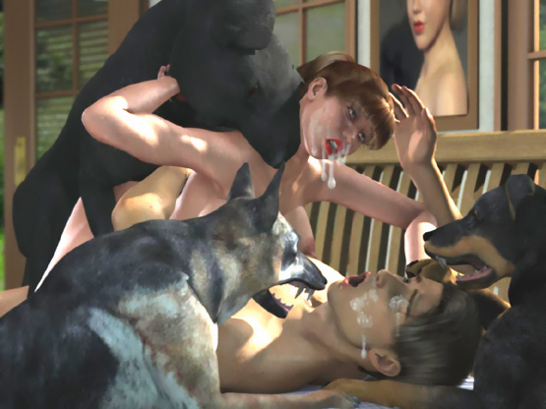

Rosina felt her pussy stretch as a second inch of the doggy cock penetrated her pussy. Then another inch. And then another. Tears fell from her eyes and mixed with the dog semen on her face.

The huge dog held her in place with his jaw and strong forepaws and forced his enormous cock into her pussy. With each thrust, her hip was lifted up. And when she landed down, the cock was again deeper inside her. Her big soft breasts flopped violently on Mark’s chest.

Finally all but the knot was in her pussy. She felt like not only her pussy but also the whole hip was being stretched to accommodate the huge cock. She could feel nothing but the cock inside her. She even forgot the jaws around her neck. Not only her vagina but also her whole body felt like a sheath of this huge cock that had total control of her body.

But still the dog wasn’t satisfied. He increased both strength and tempo of fucking. Her pussy started to give way to the knot until it locked inside. Rosina was like a rag doll as the huge dog fucked her and pumped her full of dog semen. It felt like there was no end as the dog bred her with his sperm.

She closed her eyes. Her body spasmed and she was shaking all over with a powerful orgasm. The dog pushed his cock even deeper inside her lifting her hip up and squeezed the last drops of his sperm into her.

Rosina was exhausted when the dog lowered her limp upper body on Mark’s chest and released her neck.

When the dog was finished, he turned around so that his cock rotated painfully in her pussy and they ended in an ass-to-ass position. Rosina screamed when she felt like all her insides were being turned around.

Before she could adjust to the new situation, the dog walked towards the door and the knot inside Rosina’s pussy pulled her with the dog. Nathan tried to grab her hand but was stopped by the 2 other dogs.

He felt Rosina being dragged towards the door until she fell on the floor. The huge dog didn’t stop but walked across the yard to the forest dragging the screaming and kicking girl with him. Doggy sperm was still dripping from her mouth as she helplessly looked at Nathan lying on the bed guarded by 2 dogs.

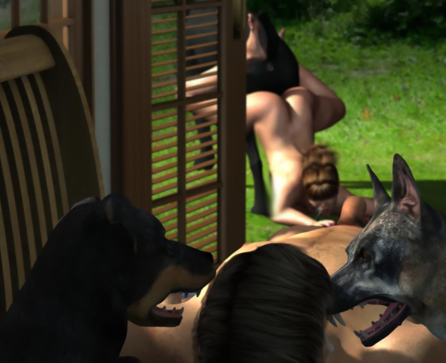

After about 10 long minutes, Nathan heard several dogs barking at a distance. Then he heard Rosina’s screams. He feared that all male dogs in the neighborhood were gathering to breed her girlfriend. He wanted to rush to save her. But he knew he couldn’t get outside alive.

He could hear her screams go faint. But the sounds of the dogs were still loud. One dog after another was breeding her and she was losing consciousness.

Finally Nathan couldn’t hear any sounds and the guard dogs walked away. He quickly ran to search for the girl. After a few minutes he found her behind a large rock lying on a log with her ass up. She was covered with dirt and dog semen and more sperm was running from her gaping pussy down her thighs.

Her feet were in a pool of puppy-making sperm. She must have been fucked by a dozen dogs! One dog was still licking her pussy and thighs. But he ran quickly into the forest.

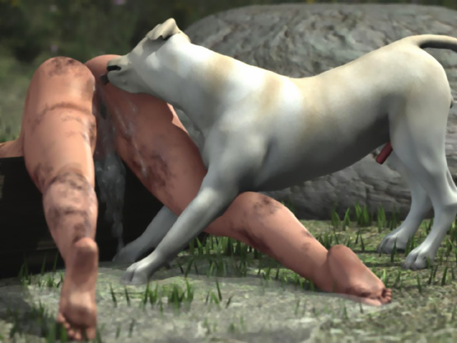

"Nathan! They fucked and fucked me. All the dogs fucked me," she sobbed.

Nathan lifted her up and started to walk home.

"Nathan, I don’t want anybody to know about this. Promise me," she said.

"I promise," said Nathan.

He was concerned about the days to come now that all the male dogs in the neighborhood had claimed their breeding rights over Rosina.

Next week Kaoru, the Japanese wife of Nathan’s best friend John, came to visit Rosina. Nathan and John went hunting and Nathan had asked Kaoru to stay with his wife while he was out. After a few cups of coffee, Rosina called Kaoru to the bedroom. There she told what the dogs had done to her.

"I am so sorry, Rosina. I promise that I won’t tell anyone. Not even John. The problem is that the men of this neighborhood like big male dogs. Each new dog must be bigger and stronger than the dogs of their friends. There are no female dogs around

"I have lived here for two years and I have become a bitch for these dogs. Almost every week some dog comes to fuck me. If I resist, he hurts me and takes me by force. I just let him do it and he will go away. And our own dog Sam fucks me whenever he wants to. But only when John is not home."

"No, Kaoru. I don’t believe you. How can you do that?"

"2 weeks after I had married John, it was a very hot day and we were lying naked on our yard. John went to get some drinks and a big dog came to me. I talked him friendly. But he growled at me. He pushed his head between my legs and started to lick my pussy. I jumped up and started to run to the door. But the dog knocked me down and started humping me.

"With his forepaws he pulled my hip up. I screamed and tried to kick him. But he was too strong. I felt some pre-cum in his penis as it poked my crotch. In no time he was inside me. First his cock was thin. But during the furious fucking, it was growing all the time.

"John saw from the window what was happening and rushed out. But the dog never stopped fucking. He snarled at John. When John came closer, the dog grabbed my neck in his jaws and I felt his fangs sinking into my neck.

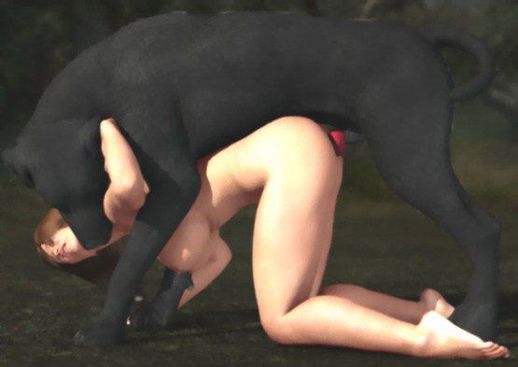

"When John saw the dangerous situation, he turned around and ran inside. Meanwhile the dog thrust his knot into my pussy and soon he was spurting his semen into me. Then John came back with a rifle and shot the dog. I was lying under a dead dog with his cock tightly locked into my pussy. It took some time before John managed to pull the dog’s cock out of my pussy and move the dog’s body away.

"That was horrible," said Rosina.

"But that’s not all," Kaoru continued. "When John was dragging the dog’s body away, he faced 2 hunters and their dog. They said that it was their dog that John had shot and they will teach him not to ever shoot their dogs. One of them pointed John with his rifle while the other found some stakes and pieces of rope.

"First he tied a rope around my neck and then hit 4 stakes into the ground. They forced John to lie down on the ground and tied him spread-eagled with his wrists and ankles tied to the stakes. They also tied a loop of rope around his waist.

One of the grabbed me and pulled my hands back while the other squeezed my breasts. Then he covered my mouth with his hand and pushed his finger deep into my pussy. He laughed when he felt my pussy filled with dog semen. Then he continued squeezing my boobs and playing with my pussy until he felt than my own juices were mixing with the doggy sperm. John was yelling at them. But the guy pulled his finger out of my pussy, grabbed a stone, and forced it into John’s mouth.

"Then they made me lie on top of John facing his cock. They tied my wrists to John’s legs and my ankles to his arms and forced me to suck his cock. I sucked and felt their dog licking my pussy. When John’s cock was fully erect, they pushed my head down and tied my neck rope to John’s waist rope. I was lying there tied and gagging with John’s big cock deep in my throat when the dog mounted me.

"After a few pokes, the dog slammed his big cock into my already-stretched pussy. There was nothing gentle in his fucking. He pounded my pussy with unbelievable speed. Once-or-twice his cock slipped out of my pussy. But he slammed it in a second.

"I felt the base of his cock swell and with each stroke my pussy was stretched wider and John’s cock penetrated deeper into my throat. I felt his cock throbbing. And when the dog’s cock locked into my vagina, John ejaculated in my throat.

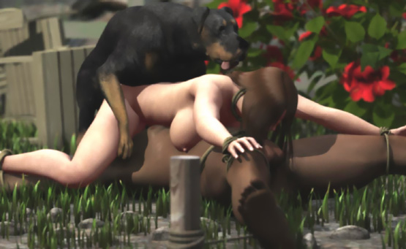

"The dog pushed his cock deeper into my pussy and John tried to push his cock deeper into my throat. I tried to swallow his cum. But some of it was leaking from my mouth and nose. "Then I felt huge amounts of hot cum spurted into my pussy. The dog rested on my back and filled my womb with his sperm.

"After about 5 minutes, his knot had subsided enough and the dog started pulling his huge cock out of my pussy. With huge pressure, semen was flying all over from my pussy until the cock was totally out. John had seen the fierce fucking of my cunt right in front of his eyes. Then he saw the huge cock being slowly pulled out of my pussy and finally a steady stream of dog semen flowing down from my gaping pussy.

"When the dog left me, the hunters cut as loose. They said that if John ever attacks their dogs again, they will come back and we will face something much worse than this. Then they left."

"Kaoru, I am so sorry," said Rosina

"Next week, the same damn dog came when I was in the garden. John saw the dog and warned me. I started running. But the dog was much faster and he knocked me down. I tried to hit him. But he <bit> me in the arm, snarled at me, and then mounted me. I had a short skirt and no panties because it was so hot. Soon I felt his penis in my pussy.

"After a short-but-fierce fucking, he knotted me and ejaculated. I was sobbing under him when he waited for the knot to subside. Then he pulled his cock out and walked away. John could only watch.

"Next day John was not home when the dog came with 2 other dogs. I tried to escape. But they knocked me down and <bit> me. And then they all fucked me. They knotted me and dragged me by my pussy.

"After that all the dogs in the neighborhood have raped me whenever they have wanted to. Sometimes they have taken me in front of their masters. I have cried for help. But they have done nothing to stop their dogs. The next evening they may have been playing poker and joking with John buttelling him nothing."

"Haven’t you told John about this?"

"No. And you mustn’t tell him either. He would leave me if he knew that I was a filthy bitch for all the dogs in the neighborhood."

"What do you think when the dogs rape you? Have you started to like it?"

"Hell no! I hate it. But there is nothing I can do.

"Can’t you just stay inside and keep the doors locked?"

"I tried that a couple of times. A year ago I saw dogs around my house. But I didn’t let them in. After an hour-or-so, I heard the doorbell ringing and opened the door for the mailman. He was immediately attacked by a dog and 2 dogs rushed inside.

"The mailman escaped to his car with only minor injuries. But we had a letter from the mail company asking us to keep our dogs away or they will end the mail delivery. I tried to calm the dogs and went on my hands-and-knees to let them fuck me. They fucked me alright. But they were very violent. They treated me as a reluctant bitch.

One week after that, John was in Mexico and a huge dog came to fuck me. But I stayed inside for 2 days. The next day I drove to a local store and I saw the dog and his master there. The dog attacked me and raped me in front of the store. Nobody came to help me. Everybody just watched and cheered. Mothers guided their children away."

"How can the people be so cruel?"

"I don’t know. Somebody told me that almost every family in this neighborhood lost a son in Pearl Harbor. They won’t raise a finger to help a Japanese woman."

"That’s terrible!"

"After that I have walked to a forest and lay down on a log and the dogs have fucked me there, hidden from the eyes of other people. Now dogs won’t attack me at home but let me walk to their breeding spot.

"That must be where the black dog dragged me and all other dogs gathered to fuck me," Rosina said.

"I guess so," said Kaoru.

Having shared their experiences, they hugged each others.

After a while, Kaoru continued ...

"Do you know Will? The big guy driving a yellow pickup?"

"Nathan has told me about him," Rosina said. "Everybody’s afraid of him and his pals."

"One day I visited the Henderson store. That old store a couple of miles from here," Kaoru told her. "At the door Will saw me. He laughed and asked if I want to fuck his dog. I told him to go to hell. He grabbed my arms and held them behind my back bending me forward. He ripped off my panties and pushed his finger into my pussy while his dog was licking it. I asked the people around to help me. But they just watched and laughed.

Then Will ripped off my dress and pushed me to the floor on my knees and bent me back. He sat down and made me lie with my head on his thighs. With his legs he held my arms locked behind my back and pushed his fingers again into my pussy while his dog was licking my clit."

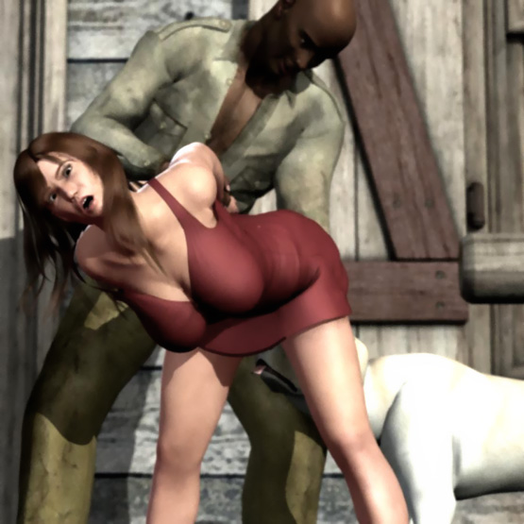

"Soon the dog mounted me and in no time found the opening of my vagina and started humping me. Will held my head with his right hand and squeezed my breasts with his left hand. When I tried to scream, Will covered my mouth. I saw some people laughing. Some of the women looked terrified, But even they just watched me being raped by a dog."

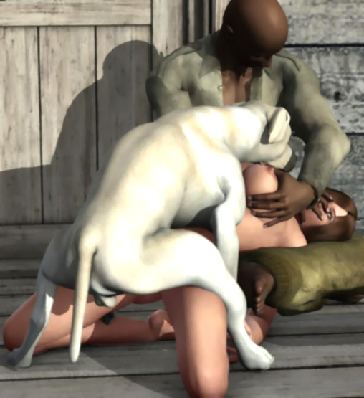

"Soon the dog was banging his knot against my pussy lips and pushed it in. For a couple of times, it came out. But then it locked inside my pussy. Some people stepped forward to better see me being knotted by the dog. Then I felt the dog squirting his seed into me. It felt warm and filled me completely.

"The dog waited for a few minutes. Will asked everybody to come closer to see a bitch get knotted. Some men even tried with their hands how a knotted pussy felt. It was so humiliating.

"Finally the dog pulled his cock out of my pussy. I heard voices wondering the size of the cock and the amount of doggy semen leaking out of my womb. The dog licked my pussy as if he tried to keep all his sperm inside.

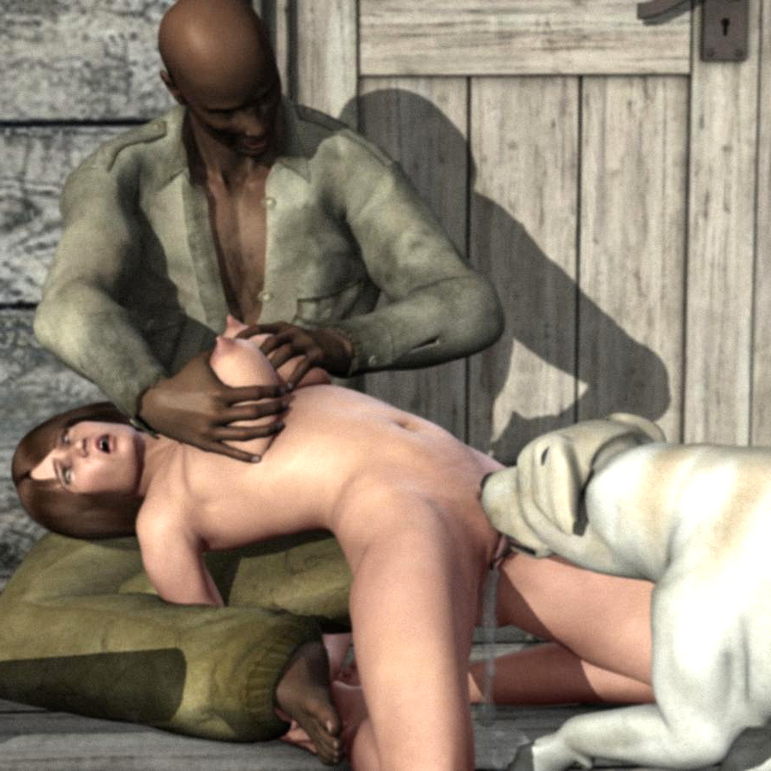

"Then Will pushed me on the floor, got up, and walked away with his dog. I saw him change a few words with a police officer before he stepped into his car with his dog. Then he drove away. I sobbed, put on my dress, and walked home."

When Nathan and John came, Kaoru went home with John. The next morning, John was in a meeting while Rosina was working in the garden.

Suddenly she saw Will standing in front of her.

"Hello, beautiful. I guess you haven’t met Giant," he said pointing to a huge Great Dane beside him.

Before Rosina could escape, Will grabbed her. Quickly he hogtied her and put a ball gag in her mouth. Rosina couldn’t say anything and couldn’t even move as Will ripped her clothes off her. Then he carried her under a tree, tied her hands high up, and lifted her left foot back and up and tied it there.

She was standing on her right foot unable to move as the huge dog started licking her pussy. With his big wet tongue, he licked her from her clit to the ass while Will massaged her large breasts. After a few minutes of intense licking, her pussy was wet and the huge dog climbed over her. Will guided the dog’s penis into her vagina and the dog pushed it in. With every thrust the cock grew larger and sunk deeper into her.

"I'll leave you 2 lovebirds here. Giant will come home when he’s done with you," Will said and left.

The dog thrusted his huge cock in-and-out and Rosina could only hope that the dog would finish soon. The cock was already stretching her pussy painfully when she felt the knot hitting her pussy lips.

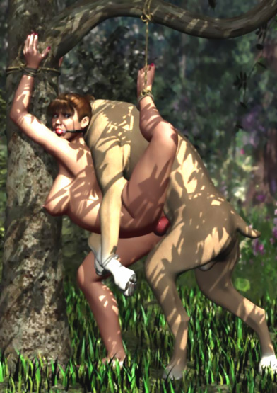

As the dog was pushing his knot into her pussy, Rosina heard Nathan coming. She tried to cry for help. But that was impossible.

Then she felt her pussy give up to the huge knot. They were now tightly locked.

"Rosina! Where are you?" Nathan was calling her when the first spurts of sperm entered her cunt.

Rosina could just hope that Nathan would fing her soon as she felt several rhytmic spurts of puppy-making semen inside her. She was "tied" and bred by the huge dog ans her husband tried to find her. She felt like her womb was totally filled with sperm. But the breeding continued.

The dog pounded her against the tree so that her chest and breasts were scratched and sore. She felt like the dog was going to rip her pussy into peaces. And then Nathan saw her. At the end of the yard, his wife was being tied to a tree and fucked by a huge dog. He hurried to help her.

When the dog heard Nathan coming, it tried to pull its cock out of Rosina’s pussy. But the knot kept them tightly locked. The dog kept pulling and pulling. Tears were running from Rosina’s eyes as the dog tried to stretch her pussy to get his cock free.

Just when Nathan was reaching the dog, the cock slipped out and the dog ran away. Huge amounts of sperm started running from Rosina’s gaping pussy down her right leg when Nathan reached her.

"This will end now," he said when he untied her and carried her home.

Next week Will was arrested with several other men. Tnd the police took away the dogs in all houses and hunted down all the dogs in the forest.

Mark had called the FBI. And after hearing the stories of Rosina, Kaoru, and some other women, the FBI decided to make the neighborhood safe for women again.

- - - - - - - - - - - - - - - - - - - - - - - - - - - - - - - - - - - - - - - - - - - - - - - - - - - - - - - - - - - - - - - - - - - - - - - -

https://www.beastforum.com/showtopic-297771.html
My name is Sharon. I'm 19 yrs old and a virgin with blonde hair, blue eyes, and 38D breasts nice and perky with puffy nipples 5'4". I had dressed sexy for my date and was late. So I ran outside and started my car. It was an hour drive from our country home.

I stepped on the gas and was halfway there when my car skidded and in the ditch i went. Getting out of the car I thought how stupid I was to drive like that on a loose gravel road. I began to walk hoping to flag a car down or find a house to get help.

After about 20 minutes I could see the flicker of a light as got closer. There was a house with a gravel driveway. I thought it looked kind of scary but decided i had no choice. Finally reaching the front door, I <knocked> and waited. After a few moments, the door opened.

"Hello," said the lady.

I stammered and asked if I could use the phone.

"Sorry, dear. The phone lines are down. What is the matter? And why are you out walking at this time of night?"

I explained what had happened. She told me to come in out of the cold which I did. She closed the door and showed me to the living room.

She yelled: "Fred! Come down here!"

Her husband came downstairs and she explained what had happened. He said that he would get the tractor and try to pull me out of the ditch and for me to just relax and warm up while he was gone.

At the fireplace laid a huge dog. His name was King, the lady told me. She got up and asked if I would like a warm cup of tea. I said "sure". She went into the kitchen.

As she walked away, King lifted his head and sniffed the air. "What a huge dog!" I thought. He got up and slowly walked towards me. I offered my hand and he licked it. I began to pet him.

Then he stuffed his head under my miniskirt and sniffed. I felt his tounge lick me. It sent a shiver all over me. Shocked, I pushed him away as I was called to come and have my tea. As I walked, the dog kept putting his nose under my skirt.

I came into the kitchen. The lady rose and said: "Sorry about that. King likes to sniff and does not have manners."

I sat down. As I was sitting, Rose spilled some liquid on my skirt. She apologized and told me to take it of she would clean it. Which I did.

"Here is a towel. Wear it until I get it washed and dried," she said.

She left with my miniskirt and I sat and sipped my tea. Again I felt King under the table. He again went to smelling me. He placed his nose to my panty-covered pussy and again began to lick. I tried to push him away. But he was stuck firm. So I just petted him instead.

Rose came into the kitchen and sat down and said to relax. The skirt would be done in 10 minutes. But it was hard to relax when you have someone licking you.

Rose broke the silence and began to tell me that they were a kennel and that King was the prize stud. People paid them $1,000 dollars for his stud services. I was feeling a bit horny and tired. I sipped more tea.

I felt a rush of air on my pussy and realized that King had pushed my panties to the side giving him access to my bare pussy. I felt my nipples hardening as he was on my bare pussy and I felt myself getting very excited. Rose got up and I think she knew what was happening. She poured me more tea.

"Let's go into the living room," she said.

I said "Sure" and pushed King away.

I got up and took my tea and sat on their chesterfield. Rose began: "Our cable is out. Wuld you like to see some videos of the dogs?"

"Okay," I replied.

Rose started the video. It was King and he was going to another dog. Suddenly he was on top and humping madly. The other dog was howling!

Meanwhile King had come over to me and I petted him. I was kind of hot and my nipples were sticking out. I was transfixed on the dog mating on the video. So I did not feel King put his head under the towel. But when he licked me, I blushed.

Rose smiled. "It's alright, dear. Do not worry. Just relax."

Suddenly the dogs quit humping on the video. King turned ass-to-ass and was panting heavy. M eyes widened as after 10 minutes like this, he pulled an enourmos penis out of his bitch. Halfway up was a ball.

Rose laughed. "What do you think of the size?"

I stammered: "It's huge!"

The towel had fallen away and my legs had widened to allow King access. I was now breathing heavy and my nipples were really extended.

Rose sai "It looks like King has a new friend" as she walked over to me.

She bent over and started to undo my blouse. She put her hands behind me undoing my bra.

"Very nice," she said as my erect nipples poked free.

She grabbed and squeezed one and then the other.

I whimpered: "Please don't. I am a virgin."

"That is alright, dear. Just relax."

She brought her mouth to my left boob and I went off like a firecracker.

"Hang on, dear."

She pushed King away and pulled my panties down and went back to sucking my boobs. King went to work on my pussy. I spread my legs more.

Rose left my boobs and went back to the tv and loaded another video.

"I think you will like this one," she said.

Iwas now beginning to sweat as I had my knees wide apart. King now was inside me snaking his long tounge into me lapping my river of juice.

The tv went on and there was this brunette woman with King. She was petting him. She stood up and pulled her top off and her skirt down. My mouth dropped open at the sight. My tummy started to shiver as I came hard on King, letting loose my juice which he quickly swallowed.

Rose came back and again was pulling my nipples and massaging my tits. I looked at the tv. The woman was on her knees and King was quickly on her humping. She screamed as he was in her in a flash. He began to hammer away. I pulled my legs out wider ...

Just them the door opened. I tried to cover up.

"Hi, everyone. Well, it looks like King has a new friend," and he went upstairs.

Rose told me to relax which i did. King was at me again. My eyes were transfixed on the tv watching this woman-whore and King.

Rose said to me: "Would you like to play with King's penis, dear?"

I blushed.

Then she said: "Come on. He has been pleasing you."

So I inched to the edge and placed my hand to him. I could not believe how big he was. My boyfriend was 6". But King was double that and still not fully extended.

I stammered to Rose: "But I am a virgin."

"Do not worry, dear. Dogs cannot get a human pregnant."

I could feel another orgasm as King manipulated my pussy which was super wet. I moaned as i came again.

"Why don't you get on all fours like a bitch, dear?" Rose asked.

Which i did. All of a sudden King mounted me.

"Rose!" I yelled. "I am a virgin."

She smiled. "Not for long, you filthy whore."

Then I felt King line up and began to push into me. It hurt like hell and i was tearing up! I put my head to floor crying and pounded my hands down.

"It hurts, rose!" I screamed as i felt him push.

Then it stopped as I felt him panting hard. He was stuck and he shuffled his feet. I relaxed my body. Then he pulled back and pushed harder. My mouth fell open and my eyes widened as he impaled me and pushed all it the way in.

I was really crying now. Rose began to pet my head saying: "It's alright, dear."

King was not moving. I felt a sudden warm rush in me as i became accustomed to his intrusion into me. He began to stir. Again it hurt like hell as he pulled me back with him as he tried to piston in-and-out. I moved with him. My pussy was squeezing him and he howled.

It took 15 minutes for me to loosen up enough. Then he started to really pound me! The hurt was fading as I was now pushing back. Rose again started to play with my nipples and boobs adding to my newfound excitement. I felt the familiar warmth in my tummy as I was now cumming. This time my toes curled as I rocked and soaked him.

I did not hear her husband. But suddenly I felt something on each boob. I opened my eyes and saw that I was hooked to a breast pump. Wow! I came again. My pussy was now milking King. He howled and shot a puppy-making load up in me. I could not believe how warm it. I was now humping back on him. My ass was a blur of movement.

I could feel something big hitting my lips and i pushed back. I was wanting more. But it seemed too much.

Rose again said "It's alright, dear. Just relax."

I tried. But as it spread me, it hurt like hell. Again I screamed! It was now in me.

"What is that?" I yelled.

Rose said: "It is his knot, dear. Relax."

I was breathing and huffing and trying to adjust when again King started to fill me with warm liquid. I relaxed.

"There now," Rose said. "Isn't that better?"

I smiled as I again creamed on him. The breast pump was doing its thing stimulating me. I could see my nipples being pulled and released. I felt great! I was warming up again and my tummy rippled and my toes curled up as I again came.

"Look, dear," she smiled to her husband. "She curls her toes when she cums."

I felt King tug and lift his leg over. We were now ass-to-ass. I could feel his heavy panting as he unloaded and kept filling me up with his doggy semen. We were "tied" for 20 minutes before I felt him go down enough to pull free. He was now out of my cunt and I fell to the floor spewing sperm all over.

After I was finished, I laid exhausted with dog cum running down my legs with a mixture of my virgin blood. I thought well, I was now deflowered. And by a dog no less!

Rose said: "I did not realize you were still a virgin. Your car is in the driveway."

She proceeded to get my skirt from the dryer. I was in a total confused state. I could not believe what had happened. But the funny thing was that when I looked at the dog and his eyes, I sort of felt happy.

Rose came in with my skirt and a tub, a washcloth, and towel. She proceeded to clean me. As she cleaned my pussy, her finger went in and she licked it.

"Sweet," she snickered. "I expect you will be going. If you ever want to, you may return. I really enjoyed our adventure."

I hurried and went outside starting my car. And this time I drove slowly.

I could not go and meet my date. So I stopped and turned around and headed home. I started to cry.

I slowly recovered and thought about what happened. I was ashamed. How would I everexplain?

I pulled into the driveway. No one was home. I hurried in and went to my room. I took my clothes off and stood naked. I had to clean myself. I ran a tub of hot water. I sat down and the hot water soothed my aching muscles.

I noticeed white blobs coming up in the water. I got on my knees and soaped myself and scrubbed myself. I thought "Why did i allow this to happen? And to make things worse, I had lost my virginity. Tpo a damn dog!"

I rose and dried myself and went to bed. As I drifted off to sleep, I began to dream that I was a dog and had been brought to the kennel to be bred. They were showing me all the studs and the dog penises. I was cowering and tried to get away. But they allowed each dog a turn on me. I felt warm and tingly all over as each stud bred me ...

Suddenly I awoke. I had no blankets on and was sweating. My boobs were hard, my nipples were sticking out, and my pussy was craving. I placed my finger and began to finger myself. I pulled on my nipples. This went on for 15 minutes till I had a tummy-rippling orgasm.

I got up and dressed for school. I went downstairs. My mom was there and asked how my date went last nigh. I said that I got halfway there and felt sick. So I came back home and went to bed.

I ate and hurried off to school. I had to drive by Rose's house. I slowed down ... and then stepped on the gas. It was a hard day at school. I could not concentrate. I saw my date and explained that I was sorry and had been sick. He said it was alright and would see me after school.

School finished. In the parking lot he was waiting. We chatted and agreed to meet at our secret spot. I walked over to his car. We began to kiss. He undid my blouse and lifted my bra and started to suck my nipples and and squeeze my boobs. I pushed him away and said "No."

He looked at me and said "When?"

I replied: "When we get married."

The funny thing was that I was so wet between my legs that I really felt like it. So we kissed and then I went home. All that week I would awake after erotic dreams of being bred with dogs. I was yearning to go to Rose's and do it again. I had a difficult choice to make. Should I?

My boyfriend tried to make out several times and was truly frustrated. He asked "Is there someone else?" I looked at him and said "Why?" He again took my hand. He looked me in the eyes and said "You are acting like you are not here. And I am going to break up with you. I cannot take this anymore."

As he dropped me off, tears started to flow. I was sort of hurt. I went in my house, went upstairs, and had a hot bath. But my mind was starting to wander back to Rose's house and the magnificent stud there. I thought of his firm muscles and how he ate my pussy. I placed my finger to my pussy. My eyes closed and I felt my tummy quiver with an orgasm.

It was now 3 weeks after the incident and I was horny as hell. Men were the furthest thing on my mind. I went to bed ...

I awoke. The Sun was shining and i was in a horny state. My nipples were sticking out and my boobs seemed heavier. Getting out of bed, I took my nighty off and marveled at my figure in the mirror. Wow! My boobs were definitely bigger and my nipples seemed to be more developed. Plus my pussy was really wet and I was in heat. I was puzzled and horny.

I began to dress. Pantyhose, bra, panties ... I decided no to wearing panties. A short mini-blouse. I proceeded downstairs and wolfed my food down. Mom looked puzzled as i hurried out and said bye.

While driving, I was again thinking of how the dog had ate me and made out with me. A as I got near Rose's driveway, i slowed down. I slowly went by ...

... and suddenly I stepped on my brakes. I sat there staring for about 15 minutes

All of sudden there was a <tap> on my window. It was Rose! I rolled the window down and said "Hi."

She said: "How are you, dear. We have missed you."

All of a sudden the dog was looking in too. It seemed to be crying. That broke my heart.

I put the car in park and got out. Rose let him go. Hee bounded to me with his tail wagging. I bent down and petted him. His head promptly went under my skirt. Wow! I started going off like a firecracker. I spread my legs to give him more access.

Rose came over and said: "It seems that you 2 lovers need a quite place to be private."

She opened the back door of my car. I went in and her dog followed. She got into the drivers seat and proceed back to her house. In the meantime I pulled my pantyhose off to let him feast on my pussy and juices.

We hurried into the house. I pulled my blouse and my mini-skirt off.

Rose looked at me smiling and said: "My! Your breasts are developing and are much larger."

In the meantime the dog was going at my pussy.

"Hang on, Rose" I said.

"I will give you some tea," she said.

She grabbed me by the arm and led me to the kitchen. I was like hell sitting with the dog at me. I needed release. But Rose said " Sit and relax. The tea will help."

I obeyed, opening my legs wider as he now had his mussel deep in my pussy slurping my juices up.

So I left off sitting at the table. Rose poured tea and was chatting. King was busy licking me and i was in a daze.

Rse said: "Dear, you and King left quite a mess the other week. And by the blood mixture, I suspect that you were a virgin."

I just nodded my head and apologized.

"That is alright, dear. ... Fred!" she yelled

Hr husband answered "Yes?"

"Bring the paper."

Fred walked in with a big smile.

Now this paper is a consent form saying that you are not being forced and you agree to our terms," he said. "Please sign."

I could not read because I was in heat. So i just hurriedly signed it.

"Fred, get her present and i will give her more tea," Rose said.

Fred walked away with big grin on his face. Rose got up and came around to my back and placed a thin studded collar on my neck.

"Now I know as King deflowered you, a virgin's first love is always his. So i will explain. The tea you are drinking is to help your breasts to develop and to ease your mating with king. After today I will package some up for you. You will take this tea 3 times a day. And with all of that, now to King's private mating room

So Rose led me to a room which had a rubber floor. All the time King was persistent

"Now you are his honey."

She patted King. "Do a good job with your slut-bitch, boy."

She shut the door. I got my skirt off snd hurried into my position. My pussy was spazzaming in anticipation. Icould feel my lips as juice was now leaking and my lips were opening and closing. King just seemed to ignore me and walked around me. I whimpered as i raised my ass and fingered myself. I brought my finger and as he walked by, I put it to his mouth and he licked it.

I whimpered again wagging my ass. "Please!" I thought. I felt him lick. I whimpered and spread myself more for him. But he again pulled away and circled me.

As he again went to my back, he suddenly jumped onto me wrapping his legs over my shoulders. I could feel his skinny penis squirting. I spread my legs wider and opened my pussy lips for him. I felt him begin to enter me and gasped in pleasure.

Then he pulled away. I banged my fist to the floor in frustration! I looked at the wall and could see a smile on his face. He was teasing me

I again felt him at my pussy pushing back. I had 2 inches in me. I whimpered and rotated my ass for him. He pushed and I pushed. I could feel him and he was getting bigger. My mouth was open wide and I was panting and pushing back for all I was worth. I could feel his penis getting bigger as he held still. I began a rythem of pushing and pulling. He held still. Ii was getting frustrated and wanted more.

Suddenly he started to push. I yelped and now he began a steady pace which i matched. I could feel him. He was now fully in me with a huge bulge in me. He began spaying warm fluid in me and i gasped! I put my hand to my nipple and and pulled on it.

I was now looking under us and could not believe how my pussy was accepting such a large object. My pussy lips suddenly contracted on him. He howled and tried to pull back. But I had him. My cunt and love canal was milking him. My nipples hardened, my tummy rumbled, and my toes curled as I came on his weapon. I got a reward as he again spewed his seed into me. I had him locked tight to me as I convulsed on his weapon. My nipples felt damp and were extended. I was now sweating as I purred and knew I was now his whore-bitch.

I was lost in la-la land when I felt King lift his leg and turn. It hurt because we were "tied" together. His panting got faster and he again started to fill me up. I looked and my belly was getting a bit bigger. I started to push back and my pussy walls started to squeeze him as I had another mind-blowing orgasm.

All of a sudden someone was petting me. I looked and it was Rose.

"See, dear? You now have a real lover. But before you finish, I would like you to suck off Fred."

And with that, fred walked in front of me undoing his pants to reveal a 9-inch cock which he promptly stuffed into my mouth. He grabbed my hair and pulled my head back-and-forth until he shot a huge load in. I began to gag.

Rose said: It's alright, little whore. Just relax."

She started to pull on my nipples like she was milking a cow.

"Well, dear. We hope you had a nice date. Those nipples of yours will grow much bigger."

As she spoke, King pulled out of me and doggy semen sprayed down my legs.

Rose said: "King, clean!"

And King started to clean me. His licking felt so good and my pussy closed to hold his seed.

Rose laughed and said: "Clean up and dress yourself. You look like a used slut. I hope to see you tomorrow."

I got home and hurried upstairs before my mom realized that I was home. I felt a warm glow as I entered my room and also a sloshing sound from my tummy.

I heard my mom call: "You home, dear?"

I yelled "Yes! I am going to have a hot bath."

I need to explain that my mom is a very good-looking woman with 38DD boobs and a figure to match. 5'3" tall and blonde also.

I heard my bedroom door and my mom called out: "Just getting the laundry, dear. ... What is this in the bag here?"

I said: "Oh, it's just some herbal tea that a friend gave me. It makes you relax.

She replied: "Okay. I will put it in the cupboard downstairs."

I laid back and felt my pussy and rubbed my extended nipples. Mom again came up and said a boy from college called and asked if I would call him back. I said that I knew who it was and did not wish to talk to him.

I lifted my legs and again rubbed my pussy lips. I noticed white globs start to bubble up. I snickered. I was soaking for half -n-hour before I got out and dried myself. I looked in the full length mirror to admire my growing breasts and my swollen pussy.

Dressing up, I went downstairs to find mom at the table. She looked flush-red.

I asked: "Are you alright?"

"Yes, dear," she replied. "I'm just trying your tea. It's in the pot."

So I sat and poured some for myself. I could see as we chatted that mom was getting fidgety. She blushed and excused herself and went to her room.

I asked "Are you alright?"

"Yes" she replied and off she went.

I drank my tea and was surprised that my nipples started to extend and get hard. I went upstairs and could hear a buzzing noise and my mom moaning. I quietly went to her door and peeked through the keyhole. I was shocked!

Mom had a huge black dildo in her and was naked on her bed. I was shocked. But i began to admire her full boobs and large areollas and her huge nippels. I watched for about 10 minutes until she tensed up and groaned. I knew that she had cum. I hurried to my room and got dressed for bed.

I drifted off to sleep and had fantastic weird dreams. I was suckling my mom's huge breasts.

I awoke in the morning dressed and went downstairs. Mom was really happy and humming. I noticed that she left her bra off. I did not realize how big her boobs were. Her nipples stuck out and i was sort of jealous.

I hurried and wolfed my breakfast down and told mom that I had an appointment. I got in the car and headed to Rose's.

As I arrived, Rose came out and said that she did not know what to do. She and Fred had to go for some sort of emergency and would I mind looking after King. I looked and knew it was important. So I asked if I could use the phone. I called home and told mom and she said sure.

I got the leash and brought King to the car. He right away stuck his head under my skirt and started to lick my pussy. I started the car and headed home thinking to myself maybe mom will watch King while I go shopping.

I got home and said: "Hey, Mom. I have to meet some friends. Wuld you mind watching King? He is a gentle dog."

"Sure" she replied and took the leash from me. "I have some of your tea. It's hot. Do you have time for some?"

"Sorry, Mom. I am late."

And off I went.

"Darn!" I thought to myself. "What if King starts to try with Mom? No, that won't happen."

I kept on driving.

I was in town for an hour before I finished and headed home. I pulled into our driveway and went in the house. It was super quite. As I got closer to the kitchen, I could hear a soft moaning.

I stopped dead in my tracks as my eyes bulged out. Mom was on her hands-and-knees. She was pulling her huge nipples and rubbing her g-spot with her other hand. King had her. His huge knot was in her. I could see her pussy pulled out and stretched. I slowly walked backwards and headed out of the house.

But curiosity got the best of me. So I went around the back to watch from the window. I was amazed at how Mom was pushing back on him. She was now sweating. I could see King's penis outline in her tummy and saw her body reacting to his large cock. She was now oh-h-h and ah-h-h-ing to his pounding. Her ass started to go faster and faster. And so did he.

Suddenly her head flew up and her eyes were blank. Her toes curled and I knew she was cumming. The bastard dog! How could he cheat on me and with my mom?

They were "tied" for a long time, him panting and mom gasping. So I thought I had better leave and come back.

I drove down to Rose's and sat in the driveway and started to tear up. I had a good cry.

Getting my composure back, I started back home. As I pulled into the driveway, I blew the horn. I got out and went into the house.

Mom called: "Is that you, Dear?

"Yes. It's me," Ii replied.

"Come into the kitchen. I have some tea on."

Not wanting to let on, I sat at the table and drank tea. I noticed wet spots on Mom's blouse where her nipples were sticking out.

I asked: "How is King?"

She smiled and said "A perfect dog" and got up stretching out.

I thought: "Yeah, right. You whore!"

Mom sat back down and noticedthat I was a bit upset. She looked and asked what was the matter. I had to think fast and said that my car was not running right. "Oh" she replied and got more tea for us.

I could not stop looking at her big boobs and wondered if mine would get like that. Her nipples and the wet spots were getting bigger.

King came and went under the table. But he did not come over to me. I saw my Mom turn red and laugh.

"Bad dog!" she said and pushed him away.

He went and laid by the back door. I noticed red sticking out and was a bit jealous.

Wel, Mom said that we should get to bed. Ausy day tomorrow. I agreed and went upstairs. I was so horny now. I took a big dildo out and as I laid in bed stuffed it into me. I must have fallen asleep.

But I was awakened by squealing. "What-the-hell is that?" I got quietly up and opened the door nervously. I looked. No one there.

Then I heard King's panting. I now knew that he was with Mom. I moved to peek in the keyhole. I could just make them out in the moonlight. Mom was on her back on the bed. Her short legs were dangling and King was on top licking her boobs. I could see her juices on his large cock shining as he hunched into her. I knew she was knotted.

"The dirty whore!" I said to myself. I was mad.

I put my finger to my pussy and started to finger myself. I also started to pull on my nipples with my other hand. King sniffed the air and looked to the door.

Mom pulled his muzzle back to her boob. Now her ass was humping back to his onslaught. I came hard.

I crept back to my room reinserting the dildo and fell asleep ...

- - - - - - - - - - - - - - - - - - - - - - - - - - - - - - - - - - - - - - - - - - - - - - - - - - - - - - - - - - - - - - - - - - - - - - - -

https://www.beastforum.com/showtopic-175296-45.html
*** Black Emanuelle in a Hotel ***
by Canis3

Emanuelle was a journalist traveling around the World. She became familiar even with bestiality, both consensual and nonsonsensual. She was tracking a film producer who kidnapped and blackmailed women for his bestiality movies. She tried to get information from him the way a sexy woman can do best.

One day she was walking with him and two of his dogs when the man asked her to his hotel room. They made love and soon he got a phone call. He asked Emanuelle to take care of his dogs for an hour and left.

What Emanuelle didn't know was that this was the room that the producer used for his business. Behind the mirror was one of his assistants with video camera and the dogs that had been specially trained.

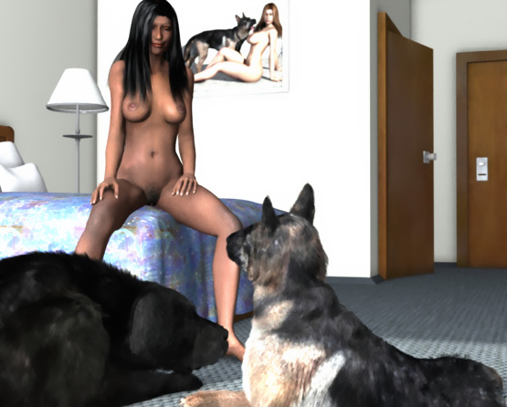

She grabbed a pillow and layed down. The German Shepherd jumps on the bed and licks her face. Then she feels a big wet tongue in her pussy. She tried to get up but faced the fangs of a snarling beast. Soon the tongue forces her pussy open and squirms its way inside her now-wet pussy.

Behind the mirror, 3 men and video camera see every move of the woman and the dogs.

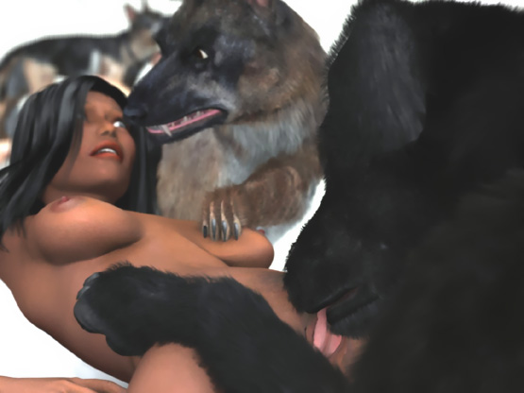

The huge black dog climbes up pinning the helpless reporter between the pillow and his heavy body. He wraps his forepaws around her waist. With a single swift movement he pushes his cock into her wet open pussy. The dog fucks her with an incredible speed pushing his growing cock deeper and deeper.

Emanuelle is totally helpless. She tries to push the dog away. But he is too heavy. After 10 minutes of fierce fucking,she pushes her head back and her eyes roll uncontrollably as a strong wave of orgasm goes through her body.

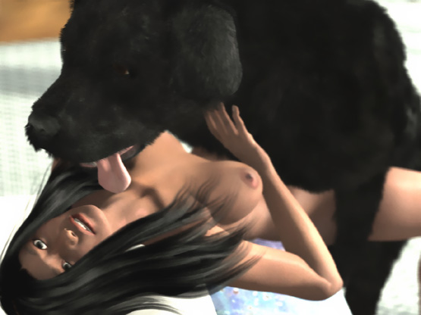

Emanuelle wakes up to reality when her vagina is painfully stretched. The dog is pushing his knot into her. She has seen a dog's knot once before when a dog was made to rape her bound friend.

She mad a desperate attempt to roll over and push the dog off. With one mighty thrust the dog pushed his knot into her cunt. Emanuelle felt the knot lock inside her. Then they fell off the bed.

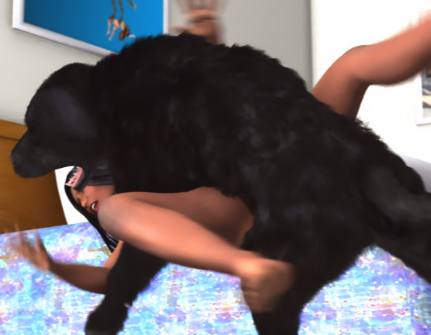

On the floor, Emanuelle was lying over the dog. She tried to get up but his knot was tightly locked into her pussy. The dog's cock was throbbing and with a high pressure filled her vagina with doggy cum. It was followed by another spurt. And then another...

Emanuelle leaned on the dog's forepaws and closed her eyes. Tears ran down her face when the dog pumped its puppy-making semen into her vagina. She hardly noticed that the shepherd licked and played with her right breast.

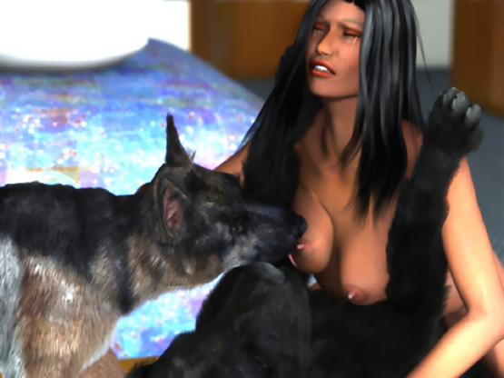

The Shepherd moved behind her and started to lick her pussy and butt. The feeling of a huge throbbing cock in her sperm-filled vagina and licking of her knotted pussy and butt was building another orgasm in Emanuelle's body. The black dog grabbed her waist with his forpaws to hold her still when she came again on the huge doggy cock.

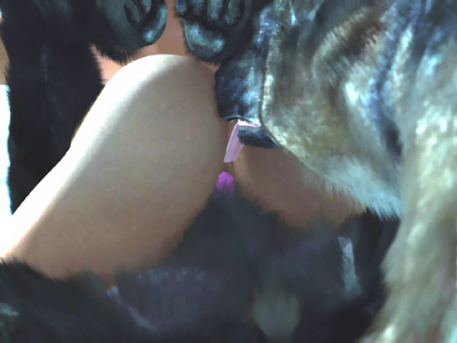

She was still being hit by waves of orgasm when the Shepherd climbed on her back and started to find a hole for his penis. With her pussy locked around the black dog's cock, Emanuelle's ass was vulnerable. She squirmed desperately. But the Shephed wrapped his forepaws around her waist and pushed the tip of his cock into her butt.

She screamed and tried to get up. But the dog on her back was too heavy. The dog's pre-cum made her ass wet and slippery for his cock. Inch-by-painful-inch he penetrated her tight virgin rectum. Emanuelle tried to crawl and squirm away to escape the fierce pounding.

Suddenly the dog grabbed her neck in his jaws and pulled back. Emanuelle stopped and felt the Shepherd's cock painfully stretch her ass and lock inside. She opened her mouth to scream.

But she could only muffle. A big soft cock was stuffed into her mouth!

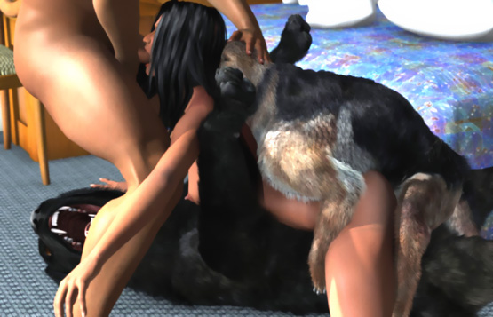

The producer's assistant had taken advantage of the situation. With her neck in the Shepherd's jaws, Emanuelle could not move her head. The assistant patted the Shepherd's head and fed Emanuelle's mouth with his own cock which was getting bigger and harder.

The Shepherd was shooting his sperm into her ass as the man pushed his cock back-and-forth in her throat. Finally he pulled his cock out and shot several loads of human semen on her face of the exhausted reporter.

The Shepherd held her neck for a few more minutes in his jaws. Emanuella was too exhausted to wipe of the sperm from her face. She just breathed heavily without any more understanding what had happened to her.

The producer looked at Emanuelle lying between 2 dogs, doggy cocks locked in her pussy and ass, and sperm dripping from her face suspended by the jaws of the German Shepherd.

"She's ready now," he said to his assistant.

- - - - - - - - - - - - - - - - - - - - - - - - - - - - - - - - - - - - - - - - - - - - - - - - - - - - - - - - - - - - - - - - - - - - - - -

https://www.beastforum.com/showtopic-175296-150.html
*** Pam on a Beach ***
by Canis3

On a warm sunny day in California, movie-star Pam was walking on a beach. Nobody else had found this beautiful-but-quiet beach as her friend had told her. She laid her red bag on the sand, raised her arms behind her head, and looked around behind her large sunglasses. There were no paparazzis nor anybody else on the beach to admire her perfect body covered only by her red bikini.



Pam took off the red bikini top letting her big breasts fall free and removed the bottom part. For a moment she enjoyed the wind on her pussy and breasts until she knelt down and put the bikini in her bag.

She heard some panting and a sound of somebody walking behind her. A dog. She turned her head smiling towards the dog.



When she raised her left arm to pat the dog, she suddenly felt the weight of a big Doberman on her back. The dog wrapped his forepaws around her slim waist and pushed her chest forward. Pam felt the dog's hairy body on her back and the rough skin and sharp nails of his paws scratching her tummy.

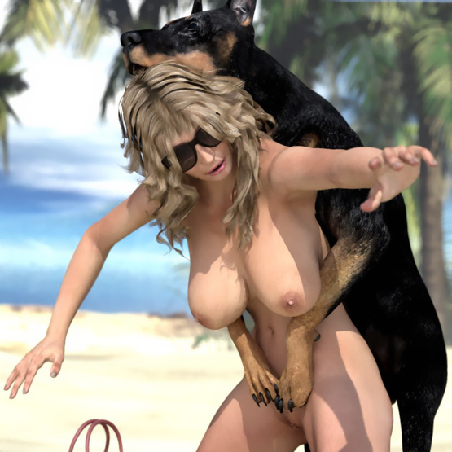

"Hey, buddy. Calm down. Nice to see you too," she said laughing as she fell on her hands-and-knees.

She waited for the dog to jump off. But instead he grabbed her waist. Pam felt something hard poking on her crotch.

His cock! The dog was trying to fuck her.

"No way, mister. Get off me now or I will kick the shit out of you," Pam commanded the dog.

The dog responded by growling.

"That's enough, you damn mutt. Now you go," Pam said and hit the dog in the neck with her left elbow.
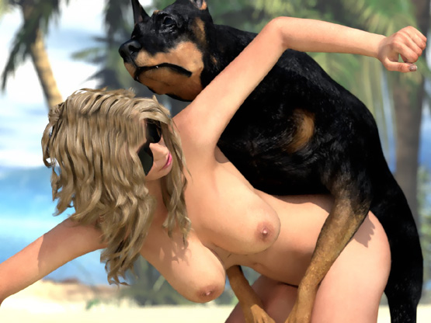

First the dog whined. But then he growled and barked a few times loudly just behind Pam's ear and grabbed her arm in his jaws.

"Stop it, you stupid dog! Don't you dare try to bite me!" Pam shouted.

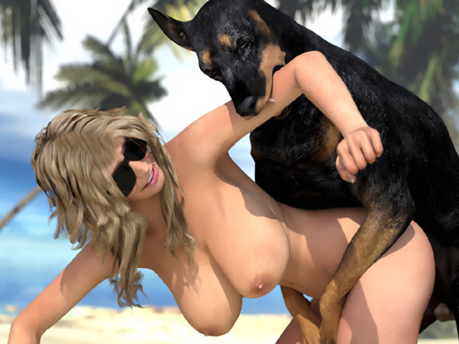

Pam was relieved when the dog released her arm. But soon his cock was again poking her crotch, occasionally touching her pussy. His pre-cum was making her wet. It was only a matter of time until the cock would find its way into her pussy.

Pam knew that a dog could not rape a woman if she didn't want to. She decided to get up and push the dog off her back. The dog, however, wrapped his forepaws around her even tighter. It leaned forward and grabbed her neck in his jaws.

She tried to get flat on the ground. But the dog sank his fangs deeper in her neck and pulled her upper body back and up. Her neck was hurting. She wanted to scream. But she didn't want anybody to see her naked with a dog mounting her.

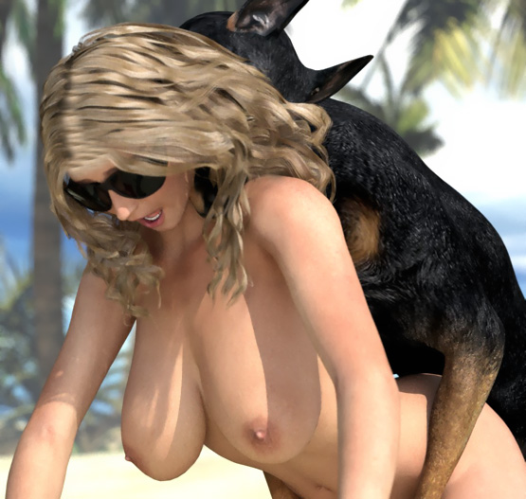

Suddenly Pam felt the dog's cock touching her pussy lips. Her cries died in her throat as the dog pulled her neck further back and sank several inches of his cock into her vagina.

With her neck in his jaws, she had no escape. She could only surrender to her bestial rape and wait until her misery was over. The dog's cock was already spurting sperm making her vagina wet and easier to penetrate.

Pam sobbed as the cock sank deeper-and-deeper into her cunt. It was rock-hard and almost as thick as her wrist. It was already at least 10 inches long and it was still swelling. Her big tits flopped back-and-forth as the dog thrust his cock into her fertile womb with tremendous force!

"Why are you doing this to me?" Pam cried. "I'm not a bitch. I'm a woman!"

Pam felt a bulge at the base of the cock. Tears ran down her cheeks as the dog pushed the bulge deeper inside her. Her vagina was being painfully stretched and suddenly the cock was locked inside her. The bulge was too big to be pulled out of her pussy.

The dog's thrusts were now shorter. The cock was throbbing and shooting big loads of puppy-making semen into her vagina. The dog was breeding her filling the helpless beauty with his seed.

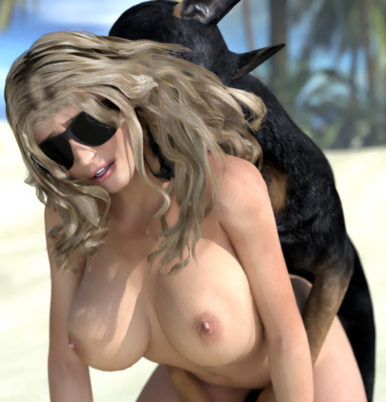

After a few minutes the dog was still holding her neck in his jaws and growling at her every move. He tried to pull his cock out. But it was still "tied" inside Pam's vagina.

After a few more minutes the dog pulled even harder. Pam grit her teeth trying not to scream as the dog forced his huge breeding tool out of her pussy. Huge amounts of doggy sperm gushed out of her pussy.

The dog released her neck and let her lay down on the ground. Slowly the exhausted woman leaned on her arms and with tears in her eyes looked at her canine rapist for the last time. The dog looked at his new bitch snarling and ran away. The breeding was over.

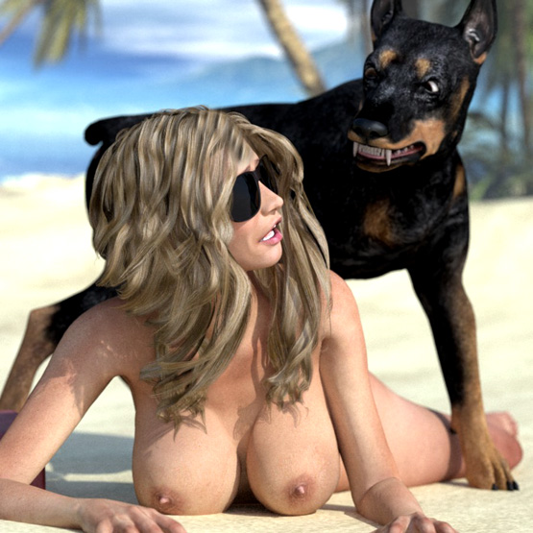

- - - - - - - - - - - - - - - - - - - - - - - - - - - - - - - - - - - - - - - - - - - - - - - - - - - - - - - - - - - - - - - - - - - - - - -

https://www.beastforum.com/showtopic-122030-3180.html
*** A Tough Morning for Sandra ***
by Canais3

It was raining again. Sandra opened the TV to see the morning news and the weather forecast. The whole day would be rainy. She was shivering in her white nighty even though it was hot and humid.

She looked at the stool where she had presented her pussy to Zeus and he had fucked her. Neither she nor Jim had been able to stop him. She could still feel his fangs on her neck and his cock and knot in her pussy.

The weekend had been calm and she had been able to rest and talk with Jim. Zeus had been the same old Zeus as before. Jim had told her that Zeus would not try to mate with her if she didn't tease him. And she would not.

However, today she was alone with Zeus for the first time after the incident.

"Time to make breakfast," she thought and walked away from the TV.

She stopped to listen to the news summary when she felt the forepaw of Zeus scratching her left tit and his chest against her back. She fell on her knees and supported herself against the table.

"Stop it, Zeus. You will have breakfast in a second," she said giggling to the dog.

Zeus wrapped his forepaws around her waist and pulled her hip back. She felt something hard and wet poking her crotch and lifting her nighty up, giving access to her pussy.

"Stop it, Zeus," she said. "Get off me. I'm not your bitch."

She started to push herself up. But the growling behind her ears made her hesitant.

"Stop it, Zeus! I'm not presenting myself to you," she said again trying to push the dog off her back.

Suddenly she felt the dog's jaws close around her neck and his cock spreading pre-cum on her pussy.

"Nooo!" she yelled as his penis penetrated her vagina.

The dog's pre-cum soon made her cunt wet. The dog took a few steps and then slammed his cock all the way into her pussy!

"Nooo, Zeus! Please, not again!" she cried. "I'm not your bitch..."

Zeus took a tighter grip of her neck. He took a few steps and spread his hind paws to get better leverage. He pulled her neck making her back arch as he furiously banged her pussy.

Tears were flowing down her cheeks when she understood that her dog was raping her and there was nothing she could do to stop him. Zeus was already shooting his semen into her vagina and his knot was expanding. Soon the dog would lock his penis inside her vagina and fill her with his sperm.

"Nooo! Please Zeus! Let me go!" she sobbed knowing that nothing would stop the horny animal.

The dog's fangs in her neck and her arching back were hurting her as well as the huge hard doggy cock stretching her vagina. His dick was hitting her cervix, forcing it open. It was now "tied": inside her and it was still swelling. The pain of her stretching vagina and the pressure against her cervix was almost intolerable. The helpless wife wailed almost silently.

Finally Zeus had stopped banging her pussy. He kept his human bitch locked around his cock and her neck in his jaws while he kept shooting his seed inside her. Sandra wept feeling each load moving up the throbbing cock and shooting through her cervix into her uterus. She would carry the smell of his sperm for ages.

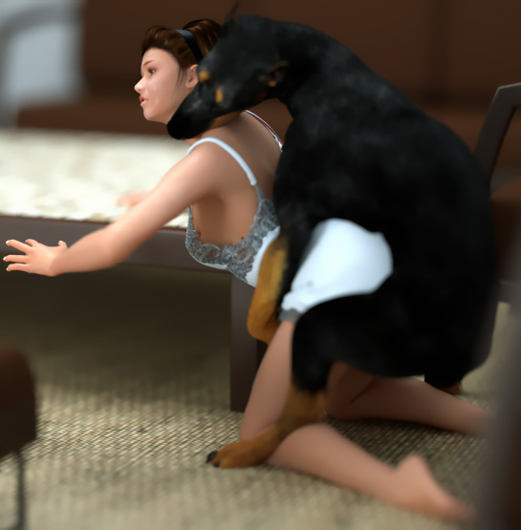

Sandra had lost her sense of time. Through her tear-filled eyes, she could see nothing as her dog still held her neck tightly in his jaws pulling her against his cock locked inside her stretched vagina. She couldn't help thinking about her misery.

A few days ago she had presented herself to her dog. And now he would use her as his bitch, take her by force, and breed her. Nobody would believe her if she told that her dog raped her. Even Jim would think she had behaved like a whore.

When Zeus finally released her neck and pulled his huge knot and cock out of the gaping pussy, she knew that this wouldn't be the last time her dog's sperm was gushing down from her pussy. Zeus was behaving like a nice doggy, when Jim was home. But he would keep raping her when Jim was not there.

For 10 minutes she wept for her misery. Then she got up, had a shower, cleaned the doggy semen from the floor, and made breakfast for herself and her dog.

The next day (2), Sandra was making breakfast when Zeus growled at her and ripped her nightie off her. She ran to the living room. But Zeus jumped on her back and quickly mounted her.

Desperately she tried to crawl away. But Zeus wrapped his forelegs around her waist, pulled her back, and sank his cock into her pussy. Sandra tried to squirm away. But Zeus grabbed her neck in his jaws and harshly pulled her back, fucking her with jabbing thrusts.

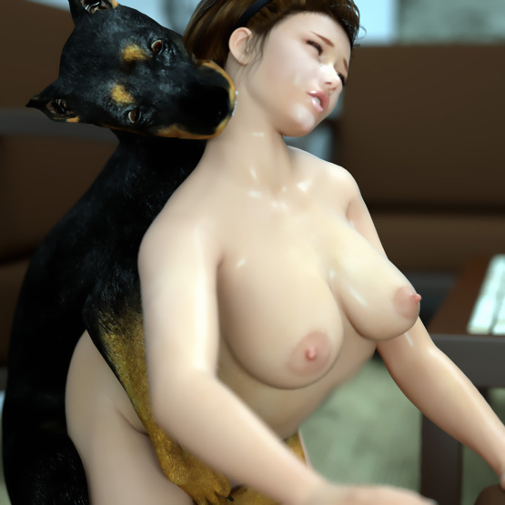

After 10 minutes the dog pulled his knot and cock out of Sandra's abused pussy and left the sobbing woman on the floor. He gave her sperm-gushing pussy a few licks and walked away.

Next morning (3). Sandra felt so humiliated. Zeus raped her again. Now she was painfully knotted and suspended. His huge knot locked inside her pussy. Her vagina tightly spread and wrapped around the dog's throbbing cock.

She felt sick sensing load-after-load of puppy-making sperm being shot inside her. Some semen was leaking from her knotted pussy down her belly and butt.

She was waiting for the end of her brutal bestial breeding. Waiting for the huge cock to slip away fro her gaping cunt. Waiting for the feeling of emotiness in her spread pussy. Waiting for her suspended hip and sperm-gushing pussy to fall on the floor. Waiting her humiliation to end …

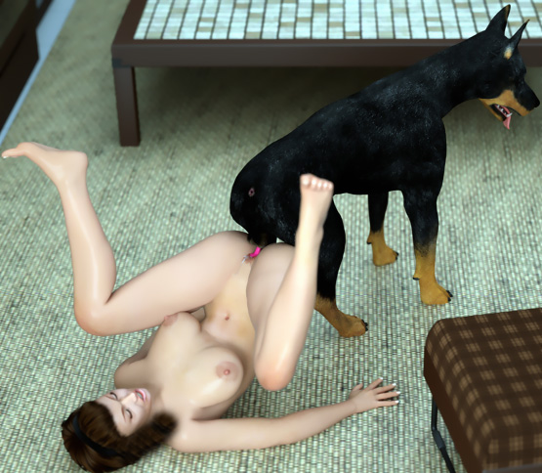

She could never tell her husband how their dog dominated her and brutally raped her every morning after he had left.

Next morning (4). Dominated and made to surrender before breeding.

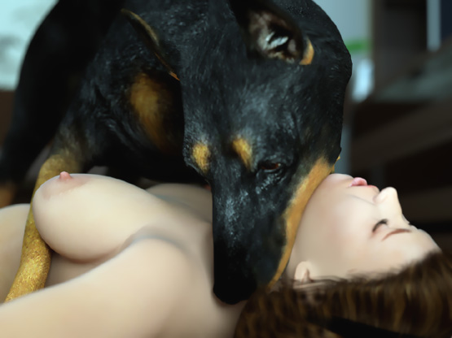

Tough Morning 05 …

Sandra had been crying on her bed all morning knowing what the dog would do to her. She was standing and looking around with only her nightshirt on because Zeus would get mad if her pussy was covered by her panties. She heard Zeus growling behind her.

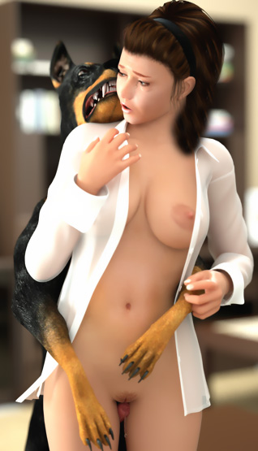

Suddenly, she felt his strong body on her back. His forepaws wrapped around her waist opening her shirt. The maw of the growling dog touched her right ear. S andra froze.

Zeus stepped closer. Sandra felt his big wet penis between her thighs spreading pre-cum on her crotch. The desperate woman felt her nipples getting hard, her pussy getting wet, and tears falling down from her eyes. Her mind resisted what her body anticipated.

In a few seconds she fell on her hands-and-knees, pinned under the big Doberman. She heard a growl behind her ear as the the dog's penis penetrated her pussy.

"Please no," she said just before the dog slammed his cock deep inside her wet vagina.

On the Couch (6)

Sandra is sitting on the couch naked and looks at Zeus approaching her, growling. She sees his penis protruding from its sheath and automatically spreads her legs in submission to the dog.

"Don't hurt me, Zeus. Please. I won't fight you," she pleads the dog.

Zeus stops and sniffs her pussy …

Suddenly he jumps on her and pins her down on the coach. The fangs of the snarling beast are only a few inches from the throat of the helpless frightened woman. Sandra feels his pre-cum-dripping cock touching her crotch and, disappointed at herself, feels her pussy getting wet in anticipation of her pending bestial mating.

Carefully Zeus studies his human bitch until he sinks his dick into her cunt and furiously fucks the screaming woman. After a few minutes of fucking, he knots her. Sandra stops screaming and sobs in humiliation as the dog pumps her full of his sperm. Zeus is no longer growling but licks the tears from her face and waits for his semen to flow into her uterus.

After about 10 minutes, the dog pulls his knot out of her womb and walks away, leaving his sobbing human bitch on the couch as huge amounts of doggy sperm gushes from her pussy down to the couch on to the floor.

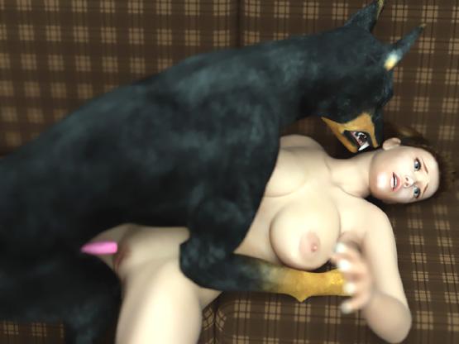

Jim Comes Home (7)

In the afternoon, Zeus growls and barks at Sandra and grabs her dress in his jaws.

"Calm down, Zeus. Jim is coming home. You can't fuck me now," she says.

Zeus runs aroung her barking and snarling. Then he starts <nipping> at her thighs and pulling her dress.

"Okay, Zeus. I'll take off my dress. You can lick my pussy. But nothing more."

She takes off her dress and throws it on a chair as the dog walks around her growling, dominating his bitch. Sandra sees the dog's penis protruding from its sheath and knows that the dog wants to fuck her.

"Zeus, not now! Jim is coming home. You can't ..."

The dog leaps on her back making her fall on her hand and knees. Before she can say anything, she feels his jaws closing around her neck, his cock poking at her crotch and sinking deep inside her pussy.

" Noooooo!" she cries. "No-o-o-o-o-o-o!"

Soon her cries turn into grunts as the dog starts pounding her. Her big tits flop back-and-forth. Her eyes stare forward without seeing anything. Her mouth is open. But she can't give a sound. She can hear only the dog's panting, the squishy sounds from her fiercely fucked vagina, and the dog's balls slapping against her pussy.

She feels the base of the dog's cock getting thicker with every thrust and her orgasm building up. She feels desperate.

Then the knot locks in, filling her pussy as the dog's cock shoots loads of semen inside her. S he closes her eyes and cums. The huge cock fills her vagina and pumps new loads of doggy cum inside her.

"O-o-ooohhhhhhhh …" she moans and cums again.

"Well, well,. What do we have here?" she hears Jim's voice beside her. "You know how I love to see you being fucked by Zeus."

Sandra opens her eyes and sees Jim kneeling beside her looking at her, grinning.

"Your tits look so delicious swinging like that as the dog bangs you," he says.

"Jim, you don't understand," Sandra whispers with the dogs jaws still clamped around her neck. "He raped me! He has been raping me every day since our first time. Jim! Please help me!"

"You little slut. Zeus can't 'rape' you if you don't give your body to him like you did first time," Jim says. "And I saw you cumming. Twice!"

Sandra gives a deep moan as Zeus pushes his knotted cock even deeper inside her.

She doesn't know what to say. Jim wouldn't believe her. Gently he touches her face and grabs her big soft breasts.

Zeus is now standing still. With his forepaws around her waist, he pulls her hip back and his jaws around her neck make sure that Jim would not try to stop the breeding. But Jim has no intention to stop the dog from breeding his wife.

As the dog keeps shooting his sperm into his master's wife, Jim massages her tits and tells her how he loves seeing her as his dog's bitch. Her breasts are so big and soft and he feels her body shivering as the dog shoots a new load of doggy sperm deep inside her.

"Honey, this is awesome. You must let Zeus fuck you every time he wants," Jim says thinking that now his dream had come true.

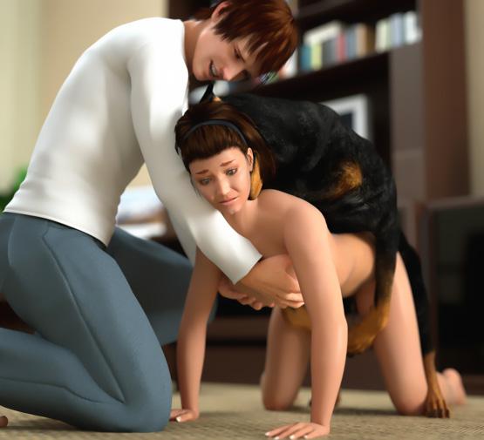

Sandra cries in her misery. Jim is no longer caressing her breasts. He is harshly squeezing the tits of his dog's human bitch and holding her still for his dog to breed her. Doggy sperm is dripping from her pussy as she waits for her breeding and abuse to end.

That evening Sandra and Jim had a serious discussion. Sandra knew how foolish she had been for not telling her husband that their dog had raped her every morning. Jim begged for forgiveness for humiliating her.

"I will forgive you," Sandra said. "But if that dog is here in the morning and rapes me once more, you will never see me again!"

In the morning Jim had gone to work and Zeus was gone. Sandra found the business card of a local veterinarian on the kitchen table. She started to cry ...

but her tears were tears of JOY!

- - - - - - - - - - - - - - - - - - - - - - - - - - - - - - - - - - - - - - - - - - - - - - - - - - - - - - - - - - - - - - - - - - - - - - - -

https://www.beastforum.com/showtopic-156123.html
*** Bad Day For Denise ***
by Canis3

(This is a compilation of short stories about one day in the life of an unlucky woman.)

Part 1: Denise Knotted in a Park

Denise is a small woman. But she has large natural breasts, a perfect shapely body, and a beautiful smile. She would be a dream-come-true for most men.

She likes to walk in a park in a summer dress that does not hide her beauty. She doesn't wear a bra because she likes to feel her breasts bounce up-and-down. She also likes to tease men who cannot get their eyes of her titties.

On hot days like today, Denise walks in the park without bras and panties. She has heard what happened to her friend Carla in this same park. She is a little frightened. But seeing other people walk in the park, she feels safe.

She starts to think about the evening and meeting a handsome guy she met at a disco last night. She wants to kiss him and feel his hands squeeze her big breasts. She goes behind a tree in a place where no one can see her. She opens the buttons of her dress and starts to fondle her breasts and puts a finger inside her pussy. She closes her eyes and forgets everything around her.

Then she feels something cold touching her pussy. She opens her eyes and sees a big dog starting to lick her finger and her pussy. Knowing what happened to Carla, Denise starts to run away. But the dog grabs her dress in his teeth. It slips easily off her. She loses her balance and falls on her hands-and-knees. Before she can do anything, the dog grabs her waist between his forepaws in a tight grip.

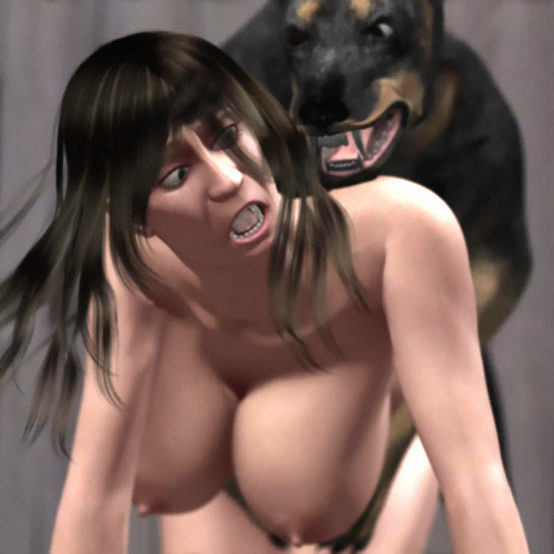

Denise starts to cry for help. But the dog <nips> her neck with his teeth and gives a low warning growl. She opens her mouth. But before she can make a sound, the dog grabs her neck in his jaws. He holds her neck ... pulls her head backward with his teeth ... and takes her neck deeper in his jaws.

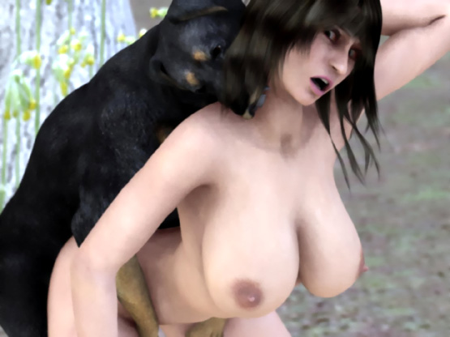

Denise feels intense pain in her neck. But she forgets it when a huge doggy cock forcefully slams into her pussy. She has never had anything so big inside her. All she can feel is a huge cock hammering her sore pussy and strong jaws around her neck pulling her head painfully backwards.

In her agony, she feels how the knot in the dog's cock starts to grow bigger and bigger. Each thrust becomes more-and-more painful as the growing knot moves in-and-out of her pussy until the huge knot locks inside her pussy. The cock starts to throb and sends a huge amount of semen inside her. And again and again. Denise feels a pressure increase in her pussy when new bursts of doggie sperm fill her locked pussy.

Finally the dog stops thrusting. He tightens the grip in her neck and waits a while to ensure that his bitch is properly bred.

He releases her neck and turns around. The pain is unbearable as the huge knot turns inside her pussy. She tries to ease the pain by turning also. But they end butt-to-butt with her left leg between his hind legs and her right leg pointing up. Her pussy is now wide open. But the huge knot stays inside keeping her ass in the air.



The dog hears some people talking not far away and starts to walk away dragging Denise behind him. After 10 feet, they cross a path. They see a family stopping on the path and staring with their eyes and mouths wide open as a big dog dragging a voluptuous exhausted beauty by her pussy.

Just in front of their eyes, the knot pops out of her and a pool of doggy sperm flows from her wide open abused pussy.

Part 2: Claimed Bitch

In the evening, Denise meets the man of her dreams in his home. She doesn't want to spoil this evening and decides not to tell him anything about what happened in the park.

They enjoy a nice dinner and after a few kisses and drinks they are ready for bed. Denise goes to the bathroom. The guy turns off the lights and goes to bed waiting for the most beautiful and sexy woman he has ever met.

Denise comes out of the bathroom. But in a dark hall, she stumbles and falls on her hands-and-knees. Then she hears a familiar low growl and feels paws gripping her waist and strong jaws around her neck. The dog in the park was his dog!

Denise dares not to move nor give a sound. She only moans painfully when she feels his penis enter her pussy. More than 10 inches of fat doggy cock slam in-and-out of her pussy. Then she feels the knot. A few powerful thrusts and the knot is in her already stretched pussy.

Then the dog releases her neck and Denise calls for help. The master of the dog comes quickly to see what has happened. He sees Denise on her hands-and-knees mounted and knotted by his dog. Denise looks at him begging for help. But the dog greets him with a menacious growl. It wasn’t going to share its bitch with anyone. Not even with its master.

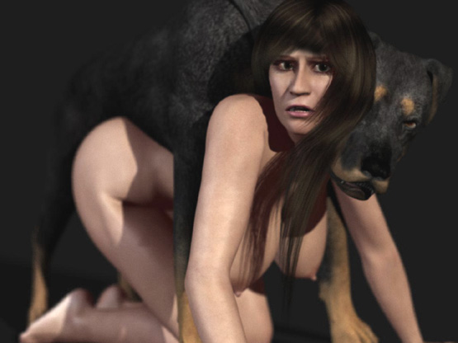

Denise felt as doggy cum started to fill her pussy. They were still locked and the dog had her tightly between his forepaws. When his master moved, the dog grabbed her neck in his jaws and held it in a powerful grip until his master backed off. The same repeated 3 times until the dog dragged his cock out of her abused pussy. As a stream of dog sperm flowed onto the floor, the dog released her neck and walked away.

For Denise, this day was supposed to be a dream-come-true. But it was worse than a nightmare. Totally exhausted and sobbing Denise buttoned up her dress and walked into the darkness without saying a word.

Part 3: Sister’s Home

After a few blocks, Denise stopped at her sister’s house. She <knocked>. But her sister wasn’t at home. So Denise opened the door with her key and stepped inside.

"Sis, are you home? I had a terrible day. I’ll rest here for a while, take a shower, and go home."

The house was silent. Denise walked upstairs and entered her sister’s bedroom. She sat on her bed and covered her face with her hands as she remembered all that had happened to her today.

"Okay. I’ll take a shower and go home," she said to herself after a few minutes.

She took off her clothes and put them on a chair. Then she sat on the bed and lay down looking at the ceiling but seeing nothing. Her feet rested on the floor.

She was almost asleep when she felt a wet tongue in her pussy. It was still gaping open and leaking doggy semen. Sam, her sister’s Great Dane was eagerly lapping her pussy with his big wet tongue.

"Sam, stop it! I don’t like dogs today. Go away, please."

She didn’t see that Sam’s penis was already protruding from its sheath. Sam was getting horny. When Denise tried to get up, Sam stepped forward and put his forepaws on her shoulders.

"Sam, no! Not you!" Denise said to the dog when she felt the dog’s cock easily slipping into her pussy.

With the weight of the huge dog resting on her, Denise couldn’t move. She was too tired to scream. She could only weep quietly as the dog pumped into her.

When the cock slipped off her pussy, Denise lifted her hip and tried to make the dog stop fucking her. Sam tried to find her pussy. But it was too high for his cock. Denise felt it poking her crotch and suddenly she screamed!

Sam sunk his cock into her ass! Now Denise was scared. She screamed and tried to push Sam off her. But the dog was too heavy. He growled at her and she felt saliva dripping on her face.

Then she heard barking and her sister’s 2 other dogs -- a hound and a boxer -- jumped on the bed. They thought that Denise was playing with Sam and they wanted to play with them.

The hound licked Denise’s face and mouth while the boxer licked her right breast. He played with the big soft tit pushing it with his paw and snout and licking it with his tongue enjoying the soft bouncing movement he could generate.

Meanwhile Sam’s cock had grown to huge dimensions as he was plunging her ass. Denise just tried to endure the pain. Her eyes opened wide open when she felt Sam pushing his knot into her ass.

"No, no!" she said before the dog’s tongue in her mouth silenced her. With a mighty thrust, Sam forced the knot inside. His cock was now locked in her ass. She felt doggy sperm spurting into her in several waves. Sam licked her face as he bred her.

The two other dogs also started to hump her. The boxer was humping her right breast and the hound was humping her face. Denise could only keep her eyes and mouth closed. She felt relief when Sam started to get up.

"Finally this is over," she thought. But her joy was premature.

Sam tried to turn and step off the bed. But his cock was still locked in her ass. Denise screamed in pain as the huge cock twisted in her ass. Her scream was abruptly stopped when the hound’s penis found her open mouth.

She was lying ass-to-ass with Sam whose cock was locked in her ass and her mouth was being fucked by the hound. She tried to push the hound off when she felt the weight of the boxer landing over her. He was poking her pussy and soon his cock found the gaping and wet opening and penetrated her. She tried to move a little. But all the 3 dogs growled at her.

She felt the boxer’s knot hitting her pussy lips. She opened her mouth as wide as she could (like a good whore) when the hound’s knot hit painfully her lips. She wailed and tried to move but was again faced with 3 growling and snarling dogs.

Soon she felt the boxer’s knot forcing its way into her pussy. The pain made her open her mouth a little more, just enough for the hound to sink his knot into her mouth. Also Sam’s cock was again growing and throbbing. With 3 huge doggy cocks inside her, she tried to ease her painful position. But again the dogs snarled at her. They wanted their bitch to stay still during the breeding.

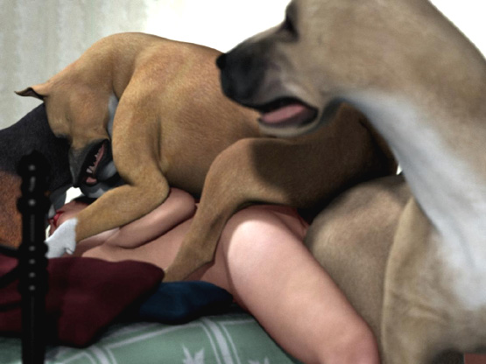

First she felt the hound shooting big loads of semen into her throat followed by the boxer spurting his sperm into her vagina. Even Sam filled her ass with more ejaculate. All 3 dogs snarled at her and filled her with their puppy-making sperm. She felt like an inflatable doll being filled from 3 holes simultaneously. She just wanted this to stop. But more-and-more sperm was pumped into her. Finally she passed out ...

After an hour she awoke. The dogs had gone and doggy sperm was leaking from her mouth, nose, cunt, and ass. She took a shower. But when she entered the room again, she saw her dress in Sam’s teeth.

"Give me my dress, Sam," she pleaded the dog. But Sam walked with the dress in his teeth to the corridor and to the next room.

Denise followed him. It was a large room that was in no use since her sister had divorced. The walls were empty and the only furniture was a big bed.

Denise followed the dog on the bed. Sam dropped her dress on the floor and growled when she moved. She froze. The huge dog was now walking behind her sniffing her and growling at her.

Denise was scared. She understood how stupid it was for her to follow the dog. Sam put his head between her legs and lifted her hip up and started to lick her pussy. Denise could only hope that it was all Sam wanted.

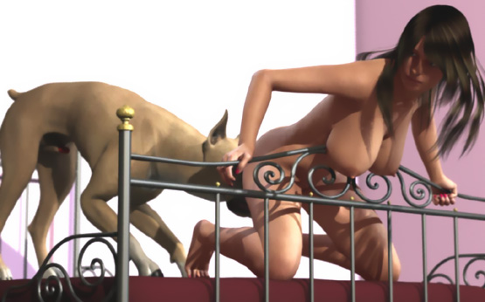

"No, Sam. Please let me go," she said. But the dog answered with a low growl and continued licking her pussy with his big wet tongue.

Because the licking was hurting her sore pussy, Denise lowered her hip so that Sam couldn’t lick her pussy any more. Sam didn’t like that. He snarled at her. Denise tried to escape. But Sam grabbed her neck in his huge jaws. Denise was like a rag doll in his jaws.

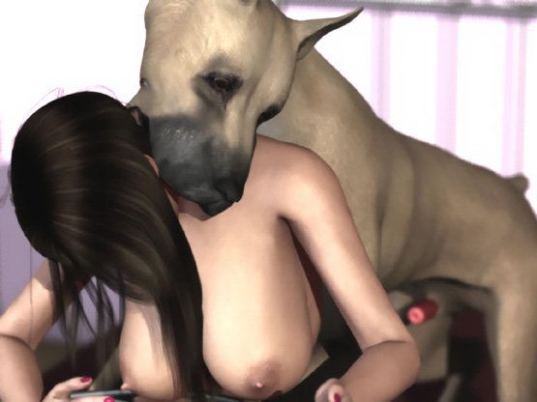

Sam dragged her around the bed by her neck and finally pushed her head against the bed with her hip high up. Then he mounted her. Her neck and shoulders were on the bed carrying her weight. Her hip was high up and her pussy wide open for the huge dog to fuck. With her hands she tried to maintain balance.

She could see the huge cock pumping in-and-out. Her huge soft tits were flopping following the rhythm of the dog. She felt Sam’s knot hitting painfully her pussy lips.

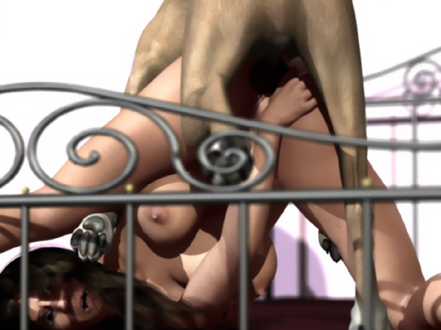

Sam used now more force. But skillfully he kept them in balance. Gradually her pussy spread more-and-more open. With one mighty thrust, Sam’s knot was "tied" inside her pussy.

His thrusts were now quick and short. His penis filled her vagina and stretched it painfully. Denise felt his cock throbbing and shooting new loads of doggy sperm with a high pressure into her womb. Denise felt like she was pregnant as the doggy cock and semen filled her completely.

Then she had a powerful orgasm. She spasmed and sobbed because her body had betrayed her. Her vagina sucked every last drop of sperm from Sam’s cock.

Sam waited for a few minutes with his huge cock inside the weeping woman. When his cock had subsided enough, he pulled it out of her pussy. A solid stream of doggy cum was now flowing from Denise’s gaping pussy down her thighs and her stomach. Soon her breasts were covered with thick semen.

This time she didn’t take a shower. She quickly put on her dress and walked out.

Part 4: Home at Last

After a horrible day, Denise arrived home. A dog had raped her twice. She didn't want anybody to know what she had gone through. All she wanted was to sleep in her own bed.

Her dog Giant - a large but gentle black lab - gave a welcome lick on her cheek. He was so BIG that he could do it standing on all four feet with just a little help from Denise.

She took a shower and walked slowly to her bedroom thinking about all that had happened to her. She sat on her bed and patted Giant on his head. He gave a few licks to her breasts and they responded bouncing softly.

Then he smelled something strange. She had doggy sperm in her pussy! She was a bitch for some dog!

Denise was upset when Giant started to growl and lick her pussy. She tried to push his head away. But Giant could not be pushed by a slender woman.

Denise saw that his cock started to grow. Soon it was enormous! More than 15 inches and thicker than her wrist.

She tried to crawl backwards. But Giant was over her, his strong forepaws holding her in place and his hind legs between her legs prevented her from shutting entrance to her pussy.

She shouted loudly: "Stop, Giant! Go away! Bad Dog!"

But all she saw was an enormous cock searching for her already abused pussy. Terrified, she felt how it found the entrance but was far too big to enter.

With a mighty thrust, Giant was able just to get the head of his cock inside her pussy. Even for her stretched and abused pussy, this cock was too just too BIG. But Giant had not stopped.

He growled at her and with enormous strength he pushed several inches of huge doggy cock inside her. Her ass was lifted high above the bed while his cock kept penetrating her pussy inch-by-inch.

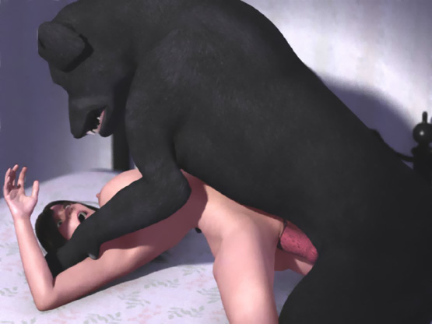

Finally all 15 inches were inside her. She couldn't believe it. Her pussy was stretched to the limit and she felt almost like being pregnant.

Then he started to fuck her. When he pulled his enormous cock almost totally out of her pussy, she felt like giving birth.

Then the enormous cock slammed back inside her! Her ass was high in the air. Her back was arched painfully as his forepaws stopped her from sliding backwards. In-and-out. In-and-out. Giant started to push into her like a jackhammer! Her vision blurred. She couldn't stand this any more. Then she passed out ...

Denise woke up in the morning. Her legs were still spread-eagled like a whore. Her pussy was wide open and her crotch was covered with sticky doggy sperm. She tried to close her legs. But it was too painful.

After a while Giant walked to her and started licking her clean. He smelled her pussy and lapped the semen inside.

The huge dog was satisfied. He could no longer smell any strange doggy sperm in her pussy. He was a gentle Giant again ...

... but Denise knew that something had changed.

- - - - - - - - - - - - - - - - - - - - - - - - - - - - - - - - - - - - - - - - - - - - - - - - - - - - - - - - - - - - - - - - - - - - - - - -

https://www.beastforum.com/showtopic-122030-3285.html
*** Terry on a Rock ***
by Canis3

Terry was sitting on a deck chair and gently touched her nipples and smiled as they got stiff. She touched her short pubic hair which she wanted to keep trimmed (because you never know...).

Her first year in college had just ended and finally she could enjoy the summer. It was warm and sunny. Her parents were on a cruise and she was able to enjoy the sun naked without getting tan lines. She closed her eyes and rubbed her clit until her pussy was getting wet.

Some noise made her stand up. It was a dog walking and sniffing around. A Rottweiler.

"Must be the neighbor's dog," she thought.

She sat down on a big stone beside her chair and waited for the dog. She let him sniff her legs and gave him her fingers to sniff and lick.

"You naughty, boy," she said. "You like the taste of my love juices."

When the dog was done with her fingers, he pushed his head at her crotch giving her pussy a quick lick.

"No, no. That's not for you, doggy. Some day a prince will come. He'll be the one to take my virginity," she giggled and pushed the dog away.

The dog didn't like being pushed and told it with a loud bark.

"Be quiet, doggy. I don't want anybody here while I'm naked," she tried to calm the dog.

The dog walked toward her and Terry saw something red under his belly. It was his penis protruding from its sheath.

"Go away! I don't want a stud dog walking here with his cock dangling under his belly while I'm naked," she said and pushed the dog away.

Suddenly the dog growled and jumped on her. Terry fell on the stone and saw the face of the snarling dog only a few inches from her face. She was lying on the rock with her arms and legs spread and the dog was standing between her thighs. His forepaws were tightly on both sides of her chest. Both the woman and the dog were panting. The woman's chest and her soft tits were heaving with her every breath.

"Please don't hurt me! Please let me go!", she pleaded,.

But the dog only snarled at her.

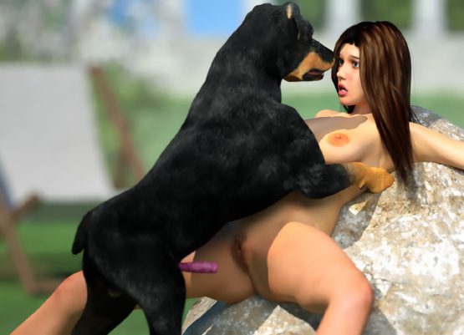

Terry adjusted her position to push the dog off her chest. But the dog snarled and <snapped> his jaws close to her face. She knew she was no match for the dog. She might even not survive if the dog attacked her.

She moved only slightly … But a vicious snarl made her stop.

For a minute the dog and Terry looked at each other. She hoped that the dog would soon get tired of playing with her and walk away. What she wanted least of all was that somebody would come and see her naked with a male dog.

Terry felt dog's fur touching her inner thighs as he took a few steps. He pushed his hip forward and Terry felt his penis touching her crotch. It was stiff. But its head was soft and wet. She tried to close her legs. Bt the dog pushed his jaws closer to her face and throat and snarled.

He pushed forward again but missed. He wrapped his right forepaw below her left thigh and pushed hard. Terry grunted as the dog's cock hit painfully at her clit.

He had made his intentions clear. He was going to fuck his bitch. And his bitch was Terry.

The dog stopped for a moment, pressing her clit with his cock. She looked at the snarling dog, shocked. She was going to lose her virginity to a dog!

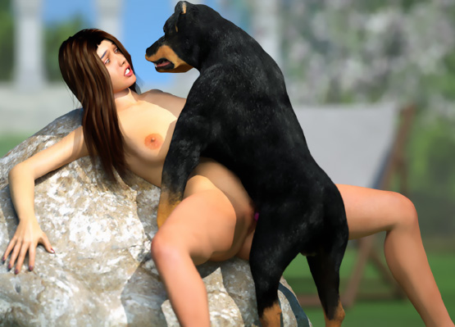

The dog started thrusting his cock powerfully against her crotch. Terry wanted to scream. But the fear of humiliation won her fear of pain and one could only hear muffled cries and grunts each time the cock painfully hit her clit. The dog was getting frantic and Terry's pain was getting intolerable.

Raising her knees up lifted her hip slightly up and the dog's cock hit slightly lower. This eased the pain and that was all she could think of. She lifted her knees as high as she could and spread her legs as a whore whould do. Her pussy was now at the right height and angle and open for the horny beast who sank his cock into her pussy painfully hitting her hymen.

Suddenly she understood what she had done. Tears fell down her cheeks as she grunted from pain and disgust.

"Please stop! Please don't do this to me! I don't want to loose my virginity to a do-o-o-oooog, …!!" she said as the dog with one powerful thrust broke her hymen and sank his cock a couple of inches into her womanhood.

Terry grunted and sobbed as the dog pounded her pussy, ripping her hymen, and stretching her vagina with his swelling cock.

"No, no, no, no! This can't be happening to me!" she wailed in pain.

"I'm not a bitch! I'm not a bitch! I'm not a bitch!" she cried. But her words were only a whisper.

The dog was shooting his semen deep inside her vagina. But her pussy was too tight for knotting. His knot kept painfully hitting her pussy lips and clit as he pounded her like a jackhammer.

The doggy sperm had made her pussy wet and she heard horrible squishy sounds as the dog slammed his cock deep into her pussy and pulled it almost out …

… only to slam it back again, deeper than before, nailing her against the hard rock.

She'd had many dreams of what her first lover and their first sexual intercourse. Now her face was filled with pain and disgust as the dog's huge cock slid back-and-forth inside her. There was nothing gentle in her first fuck. The dog snarled at her every move and forced his cock deeper and deeper, brutally filling her with his puppy-making sperm.

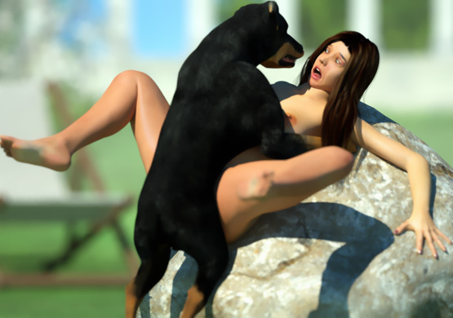

That horrible raping cock filled her entire vagina. Her pussy lips were tightly wrapped around it and followed its every move in-and-out. She lifted her knees more up to give the dog better access into her pussy and relieve the pain in her stretched vagina. The dog's cock penetrated her now even deeper. But it didn't hurt as much.

She wanted to throw that raping dog away. But the huge fangs of the snarling beast were too terrifying. Doggy sperm was splashing from her pussy on her thighs as the dog hammered her pussy. But she could only wait until her canine rapist was finished with her and had used her as his bitch and filled her with his puppy-making semen.

After what felt like an eternity, the dog pulled his cock out of her pussy. She stared at the huge red sperm-dripping doggy cock. Her pussy was gaping and gushing doggy sperm. In her sorrow and pain she had only desperate thoughts.

"That damn dog has ruined me," she sobbed. "I'm full of his sperm. I will always carry the smell of his sperm. Wherever I go, all male dogs will smell the doggy sperm in me and they want to fill me with their own seed. No man will ever want to fuck my sloppy pussy smelling like a dog."

The dog growled at her and licked her face as if to say 'Good bitch.' He licked her pussy like he owned it. Terry wailed. For her abused and sore pussy ,even licking was painful.

The dog looked at her … growled and barked twice … and walked away. She knew what he meant.

She closed her eyes and felt doggy sperm leaking from her ex-virgin womb. How could she ever tell anyone that today the neighbor's dog had made her his bitch?

https://www.beastforum.com/showtopic-122030-3375.html
Part II

Terry was sitting on the ground weeping. She felt doggy sperm leaking from her pussy. The neighbor's dog had just raped her and she couldn't tell anyone. Not even her parents.

And some day the dog might come back and rape her again. He was too strong and fearsome for her to stop. What could she do? She couldn't stay inside all days for the fear of the raping dog.



Suddenly, she felt something wet touching her left thigh. She opened her eyes and saw 3 huge dogs standing close to her. A brown Doberman was pushing his snout toward her crotch while a black Doberman and a Great Dane stared at her.

She saw their penises protruding from their sheaths and she knew what the dogs were after. They had smelled a bitch in heat. And she was the bitch!

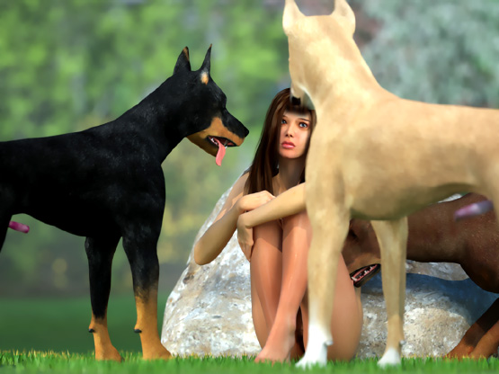

The dogs came closed and started to lick her face and her tits. Many dogs had licked her in the past and she knew a friendly lick. But these licks were not friendly. They were dominating, demanding.

The dogs growled and licked. She could only stay still and let them lick her as they wanted. The brown Doberman played with her left breast while the black one licked her face. She had seen dogs mating and she knew that this was part of the domination game leading to mating. Luckily, she was sitting and the dogs had no access to her pussy.

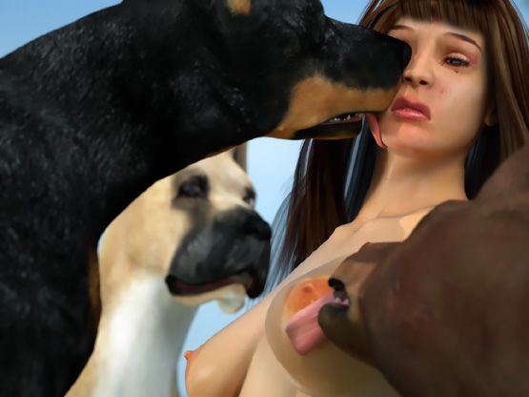

The black Doberman snarled at her.

"Wha-what do you want from me?" the scared girl asked starting slowly to get up.

She looked at the black dog snarling at her and screamed when the dog jumped at her, making her fall against the rock. In a second the dog's jaws closed around her neck pushing her tightly against the rock.

Before she could say anything, she felt the brown Dobermans tongue between her pussy lips. The dog licked the doggy sperm still leaking from her pussy. She saw the Dane's head above her growling at her.

These dogs were not playing. They were brutally forcing her to become their bitch.

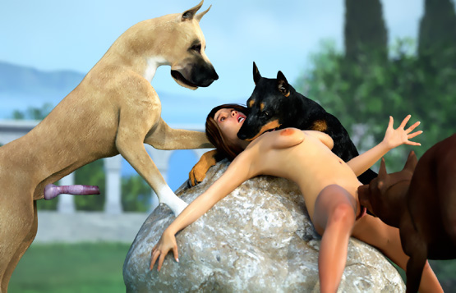

Terry stopped resisting and soon the black dog released her neck. With his forepaws on her neck and tummy, he pinned her against the rock and kept snarling at her. The brown Doberman pushed his tongue deeper-and-deeper between her pussy lips and with a long swipe licked her clitoris. Terry moaned. She hardly felt the Dane licking her face as the brown Doberman almost made her cum.

"Why me?" she sobbed as the dogs displayed their dominance over her and prepared her for mating.

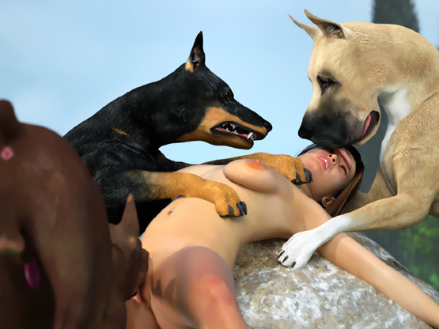

The Dane pushed his tongue in Terry's mouth and for a moment, she forgot the brown Doberman … until she felt his hairy body against her tummy and chest and his cock quickly sinking into her gaping, wet pussy. With her eyes wide open the terrified woman stared forward without seeing anything.

The big wet Dane tongue licked her face and mouth while the brown Doberman with quick jabbing hip movements forced his penis deeper-and-deeper into her vagina. Tears ran from her eyes as the dog pounded her pussy. His cock was swelling and already shooting semen inside her. It was already bigger than the Rotty's cock and it was still swelling, stretching the walls of her vagina. Her wailing and crying was interrupted only by the Dane's tongue invading her mouth.

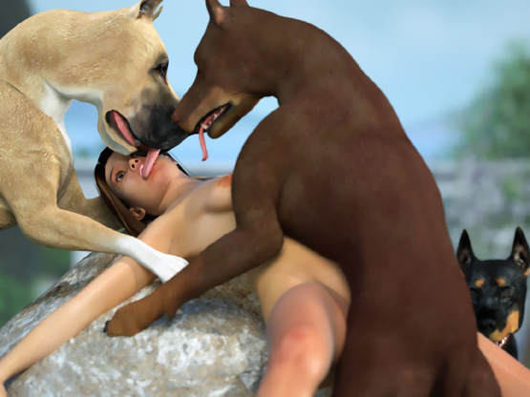

The dog banged her hip painfully against the rock. She grunted and cried as the dog's knot hit against her pussy as he forced his huge breeding tool deeper into her vagina. Her mouth opened in a silent scream as the dog forced his knot inside her pussy. Immediately, it swelled and locked inside.

The dog was now tied with his bitch filling her with his sperm. Terry's vagina was painfully stretched as she felt huge loads of doggy sperm being shot into her. She felt the huge cock throbbing just before it shot a new load of semen into her.

The Dane kept licking the face and mouth of the helpless woman staring at the sky, feeling only the rhythmic sperm shots inside her. Her body was totally abused by the dogs. The cock inside her was still swelling, forcing its way deeper-and-deeper into her. She couldn't think anything. She was just lying on the rock being raped by the big dog.

Sperm shots were becoming smaller and less frequent. The cock inside her was no longer stretching her and soon the dog started to out of her pussy. The pain made her close her tear-filled eyes as the brown Doberman slowly pulled his cock out of her pussy. The knot almost tore her pussy before it slipped out with a popping! sound. Doggy sperm gushed out of her aching cunt.

She tried to get up. But the Dane pushed her neck back and kept licking her face. Doggy semen was dripping from the Doberman's cock on her tummy as the dog stood above her looking at his well-bred bitch leaking his sperm.

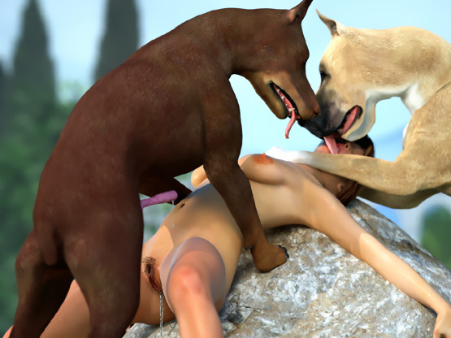

Soon the dog stepped down. But the Dane held Terry against the rock and the black Doberman climbed at the mating position.

"Terry-dear! What-the-hell is happening here?" she heard her mother Darla saying.

Terry's mother, a voluptuous red head, stood staring at her daughter abused by 3 huge dogs. All the dogs were now growling at her. She saw the semen leaking from her daughter's pussy and the penises dangling below the dogs' bellies.

"Mom! Help me, Mom!" Terry sobbed.

"Get off my daughter!" the furious mother yelled.

But she quickly lowered her voice, not wanting the neighbors to find her daughter being used by a pack of dogs.

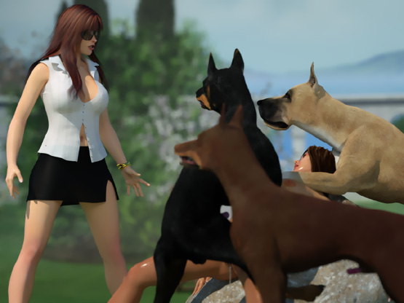

The Dane stepped down and started walking towards the mother from her left side. The brown Doberman approached her from her right side. When she made a move toward her daughter, the black Doberman grabbed Terry's neck in his jaws and growled. The Dane snarled on Darla's left side and the brown Doberman snarled in front of her.

She stood still looking terrified at the Doberman holding her daughter's neck in his jaws. Her white shirt couldn't hide her impressive breast cleavage as she breathed in-and-out. Her black short skirt hardly covered her pantyless crotch. She dared not stop the snarling brown Doberman pushing his hear under her skirt.

"No. Please no," she said as she felt the fangs of the snarling beast touching her pussy and his long tongue swiping her pussy lips.

The Doberman <nipped> her pussy snarling and the Dane growled at her even louder. The brown Doberman kept <nipping> and licking her pussy and the Dane kept growling at her. But she couldn't get her eyes off her daughter whose neck was tightly in the black Doberman's jaws. She saw the dog moving his hip back-and-forth. It was trying to sink its doggy cock into her daughter's gaping sperm-leaking vagina.

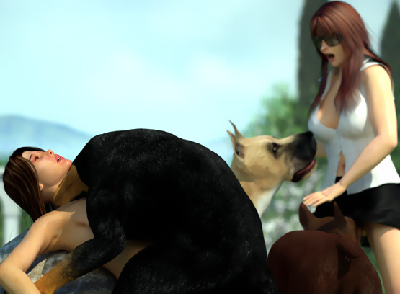

From her daughter's face, she saw that the dog had found her pussy and rammed his cock inside her. Terry's tits jiggled as the dog slammed his cock deeper-and-deeper into her womb. The young woman was too exhausted to say or do anything as the dog banged her keeping her neck in his jaws, claiming her as his bitch.

Darla had not noticed that the Dane had walked behind her until when she felt his weight on her back. She spread her arms to keep balance as the dog pushed her upper body forward. The buttons could no more resist the weight of her huge breasts and her shirt opened. The brown Doberman grabbed her shirt opening it further, revealing her huge naked tits.

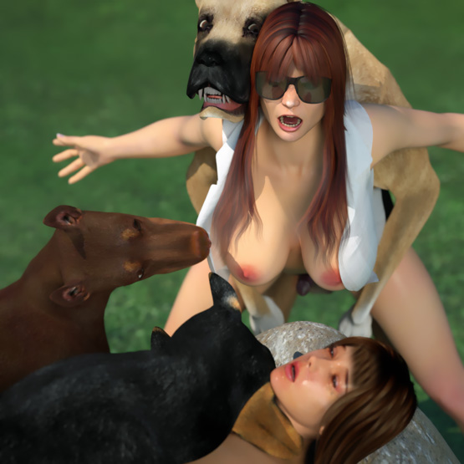

Darla felt something hard touching her crotch. The Dane's erect penis hit her pussy. She felt like she was sitting on a pole pressing painfully against her pussy lips. Having her breasts revealed and her pussy harshly touched by dogs made her feel humiliated. But feeling her pussy getting wet made her feel even more degraded.

In sorrow she looked at her semi-conscious daughter being once again pumped full of doggy sperm. And she knew that there was nothing she could do to help her.

As the Doberman had torn and ripped off her shirt, Darla tried to escape. But the Dane held her tightly with his forepaws wrapped around her waist. Her big tits swung back-and-forth as the Dane's huge cock kept hitting her pussy as she tried to get free from the grip of the huge beast.

After a few steps, the dog grabbed her left shoulder in his jaws and pulled her hip back. Her butt was tightly against the dog's hip and his hard cock was tightly against her pussy lips. With tear-filled eyes, she felt her pussy getting wetter as she waited for the dog's next move and watched her daughter right in front of her eyes in the jaws of the black Doberman.

She heard the squishy sounds and her daughter's soft wails and moans as the doggy rammed his cock deep into her and shot new loads of puppy-making semen into her sperm-leaking vagina. Her hip bent up between the dogs paws. Being pinned against the rock made her pussy an excellent target for the dog's penis. Her pussy was fixed in place like in a vice for the dog to savagely smash his huge cock to the hilt into her vagina.

Terry hardly knew what was happening to her. She grunted softly as the dog with a series of powerful thrusts stretched her pussy wide open and forced his massive knot inside her, sealing her pussy to make sure his cock could not be pulled off his human bitch. The huge amounts of doggy sperm he kept shooting inside her didn't leak out of her vagina,but found its way into her uterus.

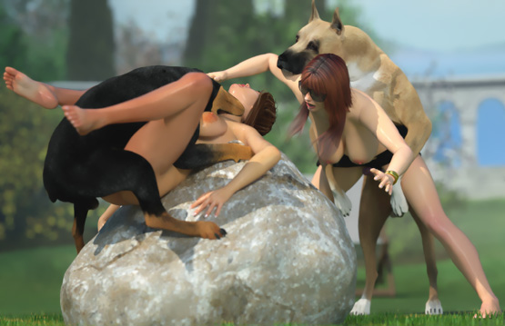

Darla fell on her knees with the huge dog on her back pressing her face on the ground. Her skirt was up and her naked pussy was pointing up. It wrapped his forepaws behind her thighs and with enormous force pulled her hip back until his waiting cock touched her crotch.

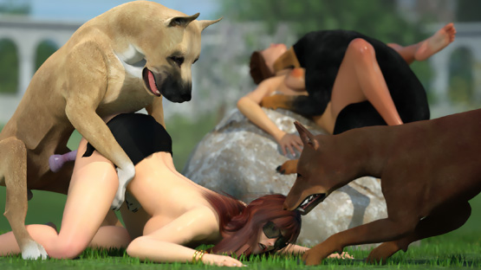

For a few seconds both the dog and the woman waited. Darla tried to lower her hip but the Dane pulled it up again. She felt a few painful jabs on her pussy as the tip of the dog's penis opened her pussy lips. His pre-cum lubricated her already wet pussy making it a little easier for the huge cock to slide into her tight pussy. Before the terrified mother could say a word, the Dane rammed 2 inches of thick doggy cock in!

"No! No! Take it off meeee…!" she wailed. But the dog forced his cock an inch deeper.

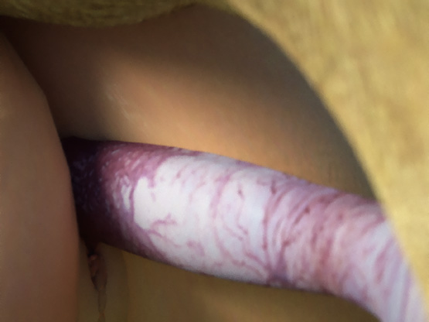

Darla's torn skirt provided no protection. She screamed as the Dane slammed his entire cock to the hilt into her pussy.

"No, no, no!" she wailed as the huge growling dog started viciously banging her cunt.

The Dane's cock was much bigger than her husband's, previously the only penis that had ever fucked her pussy. With the speed and power of a jackhammer, the dog pummeled her pussy. Its cock slid in-and-out in her vagina. And at each thrust the swelling cock was bigger than before. Darla felt like somebody was forcing a baseball bat into her pussy. But her pussy and lower body was starting to convulse around the huge canine cock.

"No! This can't be happening!" she thought.

The Dane felt her pulsating vagina around his cock and with more energy that before, started slamming his tool to the hilt into Darla's womb.

"No-no-no-no-nooooooooo …", she moaned as a powerful orgasm shook her body.

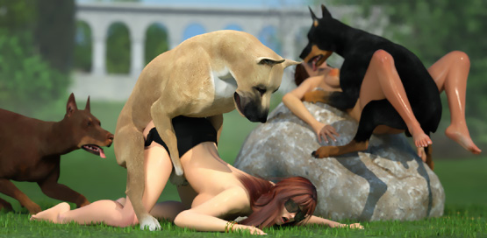

Meanwhile the Doberman was filling Darla's daughter with its sperm. With his cock tightly knotted inside the younger woman, the dog released her neck. Terry was exhausted and her skin was all wet, being bred by 3 huge dogs. The Doberman leaned forward and licked her face while he kept pumping his semen inside her.

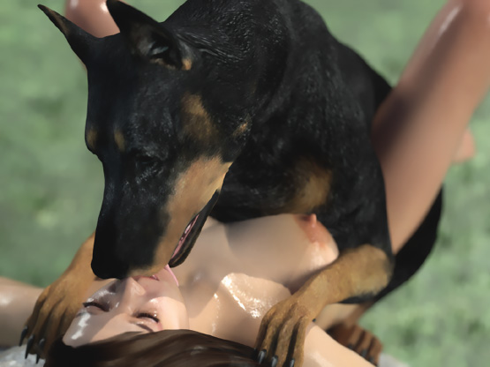

The Dane's cock was huge. Much bigger than Darla's husband's. The dog kept banging her pussy to sink his penis deeper. But it hit her cervix and Darla's vagina was too short for the dog to force his swelling knot inside the woman.

"P-please N-oooo!" Darla cried as the dog kept hitting her cervix.

The sharp tip of his cock hit the small opening of the cervix and each thrust opened it a little wider. Her big tits flopped uncontrollably on the grass. Her body shook. And her hair swayed back-and-forth as thrust-after-thrust the dog forced her cervix open.

"Noooo! It's too BIGGGG!" Darla wailed.

With brutal force the dog hammered his cock into her cervix and forced his knot into her pussy. When it was locked inside his bitch, the dog stopped thrusting. Darla had given birth before to her daughter. But it was nearly 20 years ago and her body had been preparing for it for 9 months.

Now she was totally unprepared for this huge breeding tool in her womb. The dog's knot kept swelling, spreading Darla's pussy to the limit and sealing it. The swelling knot tightly locked in Darla's pussy pushed the huge cock deeper into her cervix. And all the time the dog kept shooting his puppy-making semen inside her uterus.

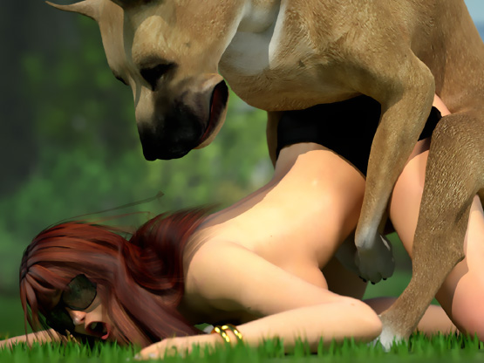

Darla felt the knot swelling until it was as big as a grapefruit. She cried desperately! Her canine rapist had made her orgasm.

Now his huge throbbing cock, locked inside her and shooting massive loads of doggy sperm, was making her cum again. For 5 minutes the Dane stood still above the poor mother and kept filling her with his sticky semen.

Darla cummed 3 more times, her vagina impaled around the huge throbbing doggy cock. In all her misery, one thing gave her comfort. She was happy that this Dane didn't rape her daughter.

Meanwhile the Doberman had pulled his penis out of Terry's pussy and was licking his semen gushing from her pussy. With tear-filled eyes, Terry raised her head and looked at her mother being pumped full of doggy sperm.

"M-mom, are you okay?" Terry sobbed.

But her mother could not hear her. Darla was wailing and moaning. Terry knew that the Dane had knotted her. She knew what it felt like being knotted. But even she couldn't imagine the enormous size of the Dane's cock impaling her mother's vagina and penetrating her cervix and the size of his knot locked inside her pussy.

Terry saw contractions and spasms in her mother's lower body followed by a deep moan and desperate cries. Terry knew that dog had made her mother orgasm against her will.

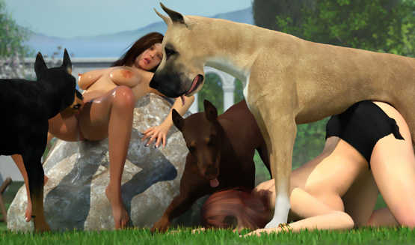

Darla was only semi-conscious when the Dane was finally able to pull his cock out of her pussy. The popping! sound was followed by a gush of puppy-making semen.

A few seconds later, the Dane's cock finally slipped off Darla's pussy letting her limp body fall on the ground. The poor mother was lying on the ground with doggy sperm gushing from her gaping pussy. Beside her, the pussy of her exhausted daughter was gushing the sperm of her 3 canine rapists.

The dogs gave a few licks on their pussies and walked away.

What an ordeal the ladies were forced to endure. Three rapes#/forced mounting for Terry and one penetration by an extreme canine weapon for Darla. And the feeling of shame and humiliation will make them keep it secret.

Which will leave them both vulnerable to repeat offenses!

- - - - - - - - - - - - - - - - - - - - - - - - - - - - - - - - - - - - - - - - - - - - - - - - - - - - - - - - - - - - - - - - - - - - - - - -

https://www.beastforum.com/showtopic-122030-660.html
*** Tom's Alley ***
by Canis3

Pete and Tom walked along an alley to their homes in an abandoned industrial area. Their homes were at the 3rd floor with windows just opposite across an alley. The alley was lit by a streetlamp and a few other lights. Between two buildings was a fenced vacant lot which was mostly inhabited by local stray dogs.

The dustbins were full and people had thrown black garbage bags in 2 corners. A few dogs digged the garbage bags looking for something to eat. The boys shared their memories of the last days in the high school which they had finished a few days ago. After a few funny memories, they said good night and went home.



Tom woke up very early in the morning. He had had again one of those dreams. For 1 one year he had had powerful sexual fantasies. And recently the object of his fantasies had been Pete's mom. She was small in size. But she had large breasts and a round butt. And she didn't hide her curves. Men called her a pocket-size sex bomb and used to whistle after her. She answered by lifting her tits with her hands and smiling.

When Tom visited Pete in the evening, his mom was usually dressed in a thin nightgown. It offered a generous view of her cleavage. And the rest could almost be seen through the thin material. When she saw that Tom couldn't get his eyes off her huge breasts, she crossed her arms just below her breasts squeezing them and lifting them so that sometimes Tom could see her nipples.

Sometimes she even came very close to him so that Tom (being much taller than her) almost dropped his eyes in her cleavage. She smiled when she saw the hardness inside Tom's pants. He knew that she teased him just like other men. But for him, she was the Sexiest Woman on Earth.



This morning Tom woke up after such a dream. In his dream, Pete's mom came to the alley dressed in her nightgown carrying a trash bag in her right hand. She saw Tom looking at her from his window and smiled at him. With her left she had pushed her tits up giving Tom a good view of them.

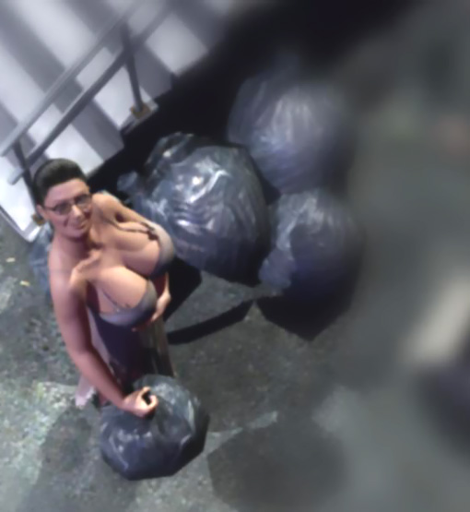

After she had put away the bag, she turned around and saw 3 big naked men in front of her. They all looked as Tom's neighbor Jim. And they all had huge cocks.

One man stepped behind her, ripped her nightgown off, and pulled her arms back while another covered her mouth with his left hand so that she couldn't make sound while he put his right hand on her pussy sinking his middle finger into her.

The third man massaged her big tits like a baker his dough. Her head was pushed back and her eyes were fixed on Tom who watched her huge soft breasts being rudely massaged by strong hands. Her areolas began to bulge and her nipples swell and her pussy was getting wet.



The men played with her tits and pussy for some time and then laid her on a pile of trash. One of them held her legs wide open while another fucked her holding her tits firmly in his hands. The third man held her arms and pushed his huge cock into her mouth. In his dream, Tom saw two huge cocks sink deep into Pete's mom.

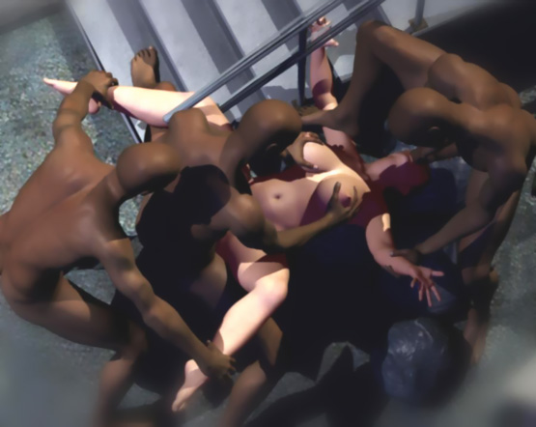

When they all had fucked her, they left her lying on the trash bags covered with their sperm.

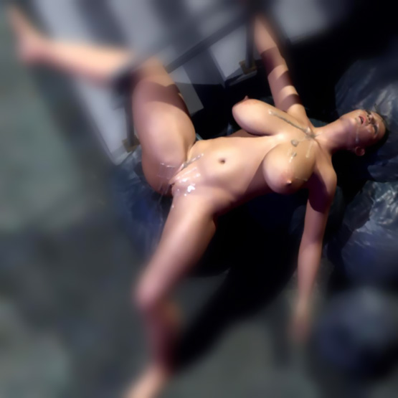

At this point Tom woke up with a huge hard-on. He stood up and looked out of the window. It was still dark. The alley was lit by a few lamps. A big dog was digging a trash heap just beside Pete's outer door. Tom turned his head to the left. There was another trash heap beneath a street lamp with a huge dog searching some food.

All windows were dark except one. There was light in Pete's kitchen window. Tom saw Pete's mom in her nightgown grabbing a trash bag and walking to the door. Soon she stepped on the alley just like in his dream. She carried a trash bag in her right hand.

The dog, a big rotweiler, saw her coming and started to walk towards her to see if she had something for him to eat. Tom was looking at her from above. He had a generous view of her big boobs which bounced beautifully when she walked. She saw Tom at the window, smiled at him, and pushed up her tits with her left hand.

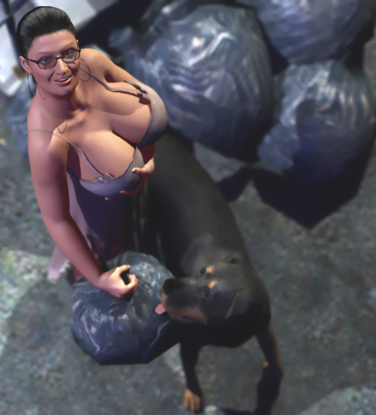

Tom was almost cumming when her leg hit the dog and the trash bag fell to the ground and broke. Tom was admiring her swaying breasts inside an even more loose nightgown when she cursed and kicked the dog so furiously that her tits fell totally out. The dog whined and stepped back.

She kneeled down to pick up the fallen trash. But she didn't see the dog behind her. He grabbed her nightgown in his teeth and ripped it off her. She was totally naked when she turned around. She said something to the dog and <slapped> him on his face. The dog whined first ...

... but then Tom saw a scared look at Pete's mom's face as the dog snarled at her. For Tom this was even more exciting than his dream. He looked at the dog circling around the naked woman. He hoped that the dog would mount her. Tom could see tears in her eyes. But she didn't cry for help. Obviously she didn't want anyone to see herself naked with a dog.

Tom saw that she was shivering from fear as the dog stood in front of her growling. It gave a few licks on her face. Then it walked behind her and licked her pussy. She tried to close her legs. But a <bite> on her thighs made her open her legs again. Now Tom had a good view of her pussy being licked by a stray dog.

She closed her legs again when the dog's tongue forced its way into her pussy. But a growl and a <bite> made her open her legs again. The dog pushed his tongue deep inside her pussy to taste her juices.

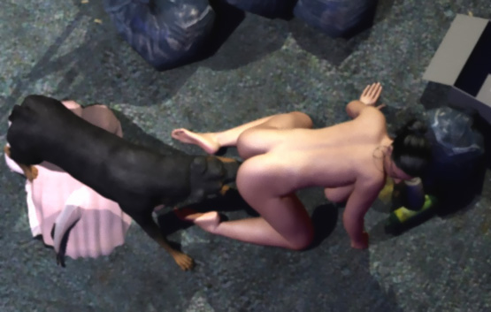

Desperately the small woman tried to push the big dog's head away. But he grabbed her arm in his teeth and held it still. After a few seconds he released her arm and walked to her side. But he attacked her arm furiously when she tried to move it.

The dog circled her again growling. He was on her right side and licking her right breast when her body tensed and she tried to rush to the door. The dog, however, sensed her attempt and grabbed her right breast in his jaws.

Tom could see pain and desperation in her face as the dog's teeth sank into her big soft breast. With her breast firmly in his jaws, it pulled her on her back and dragged her near the wall behind the trash. From his window, Tom, however, had an open view on them. He saw Pete's mom wailing and trying to ease the pain with her hands and legs as the dog dragged her.

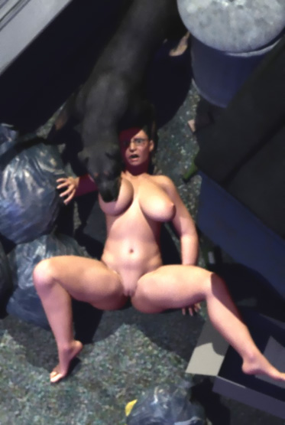

When the dog was satisfied, he released her breast and let her upper body fall to the ground. Now the beast stepped over her and she could see his big red cock just above her face.

When the dog had walked over her, she decided to make a final attempt to escape. She turned on her hands-and-knees and tried to get up. But the dog leaped on her back. Fiercely she tried to kick and push the dog away. She punched then dog with her left arm. But the dog grabbed her arm in his jaws. She tried to kick him with her left leg. But her attempts were futile.

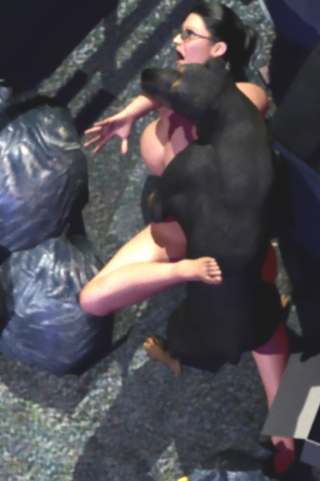

When she stopped fighting, the dog released her hand and wrapped his forepaws tightly around her waist. Snarling at her, he started to pull her hip toward his hip to find her pussy for his cock. When she tried to move, he snarled at her and <nipped> her neck.

The woman was desperate! She tried to push the dog off her but stopped as she felt strong jaws grabbing her neck in a firm <bite>.

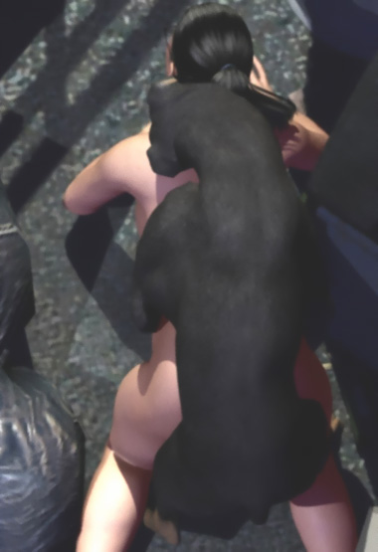

Tom couldn't watch any more. Quickly he put on his jeans and rushed to help his friend's mom.

When Tom reached the alley, he saw the dog had released the woman's neck and was sinking his cock into her pussy. Her huge breasts swayed wildly almost touching the ground.

"Damn dog! Get off her!" he yelled as he rushed towards the dog.

When the dog heard Tom's voice, he sank his cock even deeper into Pete's mom's pussy and snarled viciously at Tom. The woman looked at Tom with mixed feelings. She didn't want anyone to see her naked being raped by a dog. But also maybe Tom could just throw the dog away.

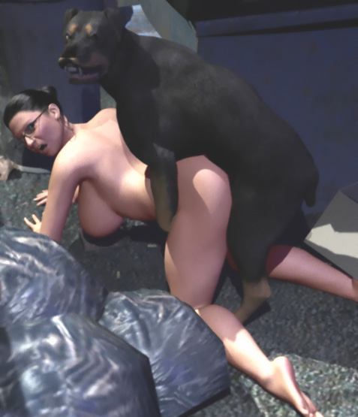

When the dog saw that Tom didn't stop, it grabbed the woman's neck in his jaws like a bone. It looked at Tom straight in his eyes and snarled viciously.

"Stop, you damn bastard!" she yelled at Tom. "Don't you come here to enjoy my misery. The dog kills me if you don't go. Go away!"

Then she wailed quietly as the dog tightened his grip on her neck. Tom stopped. Right in front of his eyes, the mom of his best friend was being brutally raped by a dog and he couldn't help her.

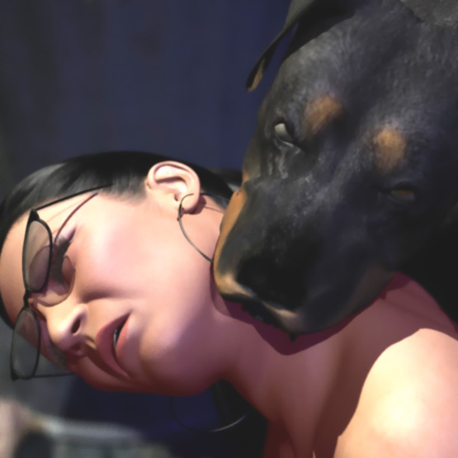

Her body and her voice were shaking and her glasses flew on the ground. But Tom's eyes were fixed on her huge tits swaying wildly almost brushing the asphalt as the dog fiercely jabbed his cock into the small woman's pussy.

Tom stepped back and the dog released her neck. Now he saw how huge the dog's cock was. It was more than 12 inches and as thick as his wrist. He saw that her vagina was painfully stretched and with each thrust the cock sank to the hilt into the poor woman.

The thrusts were fierce and rapid. Tom could hardly see the huge cock before it was slammed into her again. Her big breasts swayed wildly and she bit her lower lip to endure the pain. Tears ran from her eyes and she sobbed in humiliation. But she didn't scream. Tom felt increasing hardness in his pants.

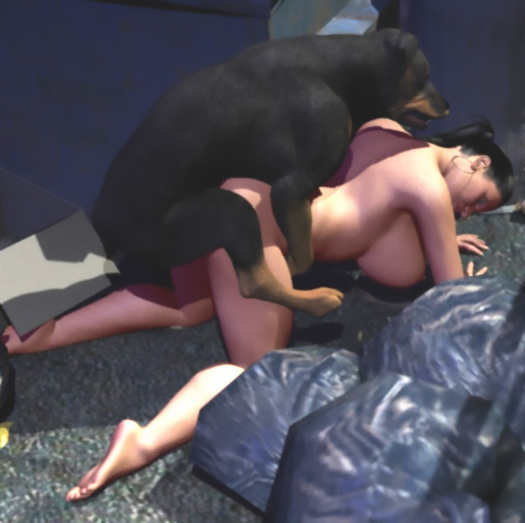

Tom noticed a bulge growing at the base of the dog's cock. It was about the size of his fist and it spread the woman's pussy even more.

"Uuhhhh! Uuhhhh! Uuhhhh!" she wailed in agony.

After some time, the knot was too large to penetrate her cunt and it was hitting painfully her pussy lips. The dog thrusted into her even more fiercely in order to get his knot into her pussy. Tom felt a huge hard-on inside his jeans. He remembered his dream. But this was beyond anything he could have imagined.

"Aeeeee! Help me, Tom! Help me!"

Tom took a step to help her. But at the same time the dog pushed the knot with a tremendous force into her pussy and grabbed her neck again in his jaws and pulled. The woman gave a muffled scream and Tom stopped.

"I'm so sorry. But the dog has you. I can't do anything," Tom said with a sad voice trying to hide the erection inside his jeans.

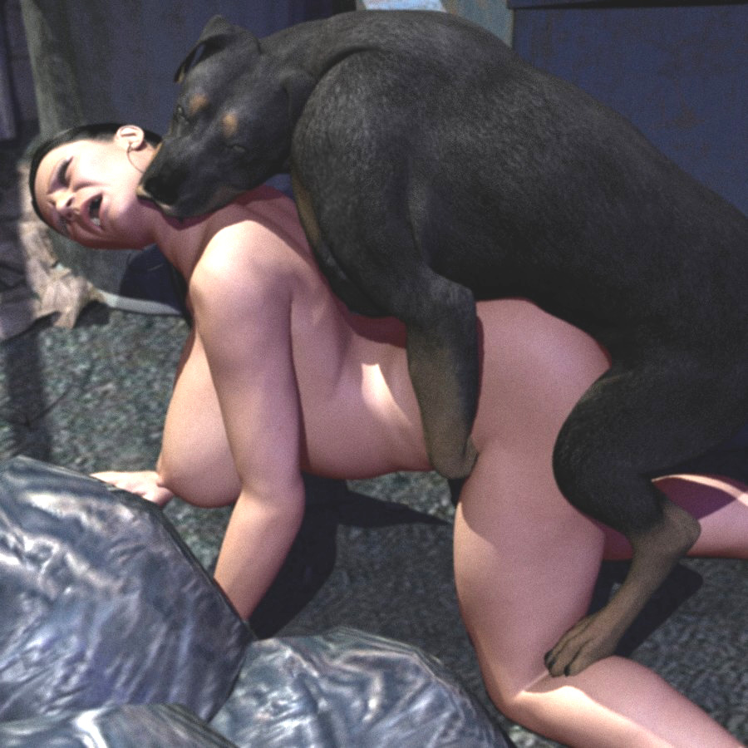

Her back was painfully arched as the dog pulled her neck back. Her big breasts pointed forwards bouncing up-and-down as the dog fucked her. For a second Tom saw himself squeezing those huge tits as the dog poor woman was totally controlled by the dog.

A vicious snarl woke him up to reality and he stepped back. The dog calmed down. He still had her neck in his jaws. But he didn't pull her neck back any more. His hip movements were slow and short.

Tom saw that the dog's cock was locked inside the woman. The woman's face was frozen. She looked forward with her mouth open without seeing anything. Her hanging breasts were slightly swaying and she was breathing heavily.

Soon Tom saw doggy semen leaking from her pussy down her thighs. Having her neck firmly in the his jaws and his huge cock locked inside her pussy, the dog filled her with his puppy-making sperm.

Tom couldn't keep it anymore. He came and felt his own sperm flowing down his thighs.

"Get the hell out of here. And don't you dare to tell anyone," she whispered to Tom.

"Okay. I'll go home," Tom said and walked home. He didn't know what to say to the woman being savagely bred by a dog.

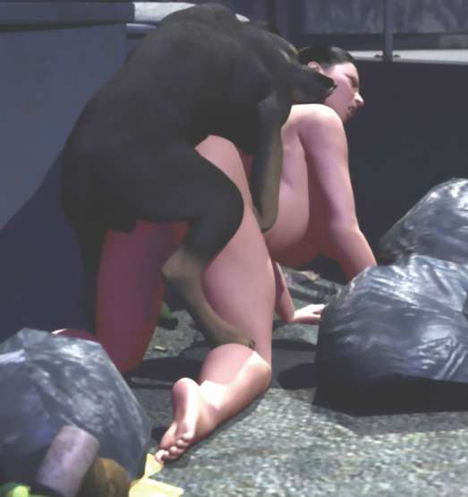

Soon Tom was in his room again. From his window he saw the dog standing above the woman. It pushed its cock deeper into her a few times. Her breasts swayed back-and-forth. But she had lost her strength. Without her pussy locked around his cock and her neck tightly in his jaws, she would have collapsed.

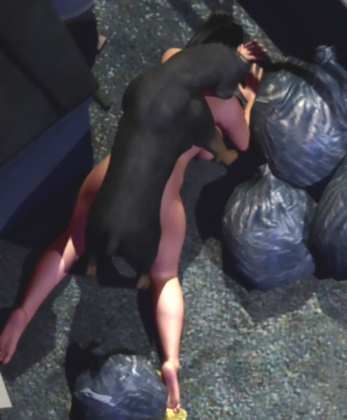

When the dog had filled his bitch completely with its sperm, it released her neck. Her head and tits fell on the ground and she passed out. Her hip was still high in the air suspended by the dog's cock.

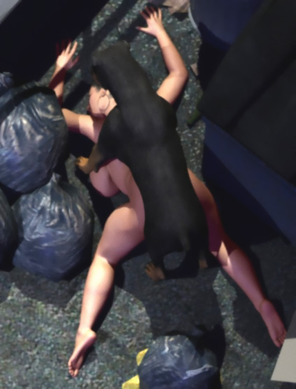

The dog was now done with its human bitch. He lifted his hind leg and turned around so that they were as- to-ass. Then the dog started walking dragging his limp cum-filled slut-bitch behind her. Her big breasts were like pillows under her. Luckily the dog dragged her over her nightgown saving the skin of her tits.

Then another dog came to study the unconscious woman suspended by her pussy. He was a huge black dog. Maybe a mixed breed of a lab and a Great Dane. Tom had never seen a dog larger than this one. People called him Goliath. When he walked, all dogs and men gave him way. He was the king of the block.

Now Goliath studied the small woman suspended by her pussy and being dragged on the ground.

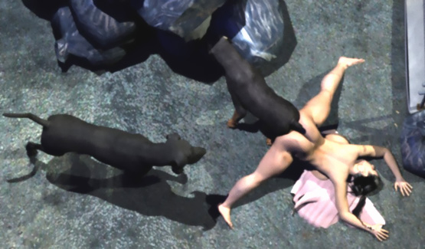

The rotty stopped at the next garbage heap and started searching something to eat, ignoring the woman locked around his cock. Goliath sniffed the woman's pussy. But he stepped quickly back when with a loud popping! sound, the cock slipped out of her pussy and she fell on the ground. Doggy cum flowed from her gaping pussy which the black dog licked enthusiastically.

Pete's mom was now regaining consciousness. Tom saw her opening her eyes and looking around. She felt pain. But Tom saw a glimpse of hope in her face when she saw her doggy rapist digging trash.

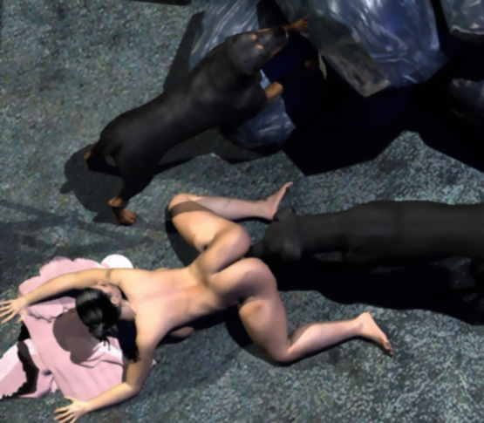

Then she looked back and with horror saw a huge black dog licking her aching pussy. What she saw but Tom couldn't see was a giant penis under the dog's belly. With shaking hands and feet, she got up and tried to run towards the door. But with a single leap, the huge dog grabbed her ponytail in his jaws. Her head was fiercely pulled back. For a split-second her breasts stretched forward ... then jumped up and bounced down.

Tom saw her fearful face. She was dirty and tears had spread makeup all over her face. Then she fell.

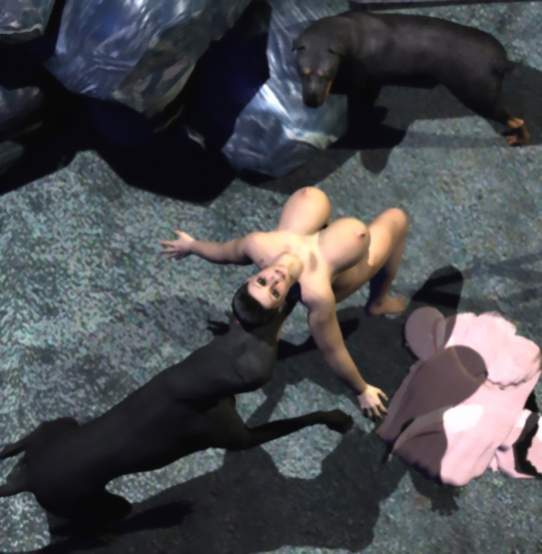

She tried to kick and hit the dog. But he only growled at her. When the woman didn't stop fighting, the dog shook his head until she stopped fighting. Her body was almost limp as he jerked her like a rag doll. With her hands and feet she tried to ease the pain as the dog pulled her on heap of trash.

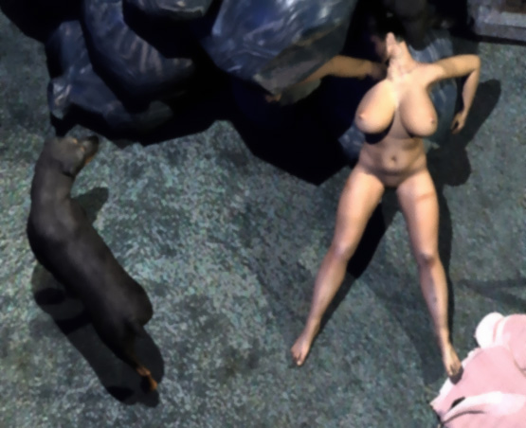

She was lying there on her back with her legs spread and her gaping pussy still leaking semen from her previous doggy rape. The black dog put his head between her legs and licked her pussy. She shook her head and upper body trying to deny what she knew was coming. Tom saw her big tits flopping from side-to-side while the dog licked her pussy. Tom was about to cum again.

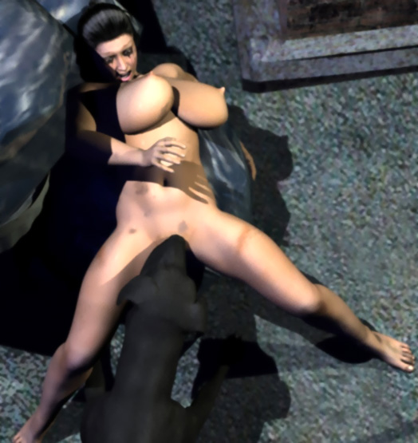

The woman tried to crawl backwards over the trash heap. But the dog stepped on her side and closed his jaws around her throat and growled at her. The woman kicked a few times but stopped when the dog grabbed her throat deeper in his jaws and lifted her head up a few inches.

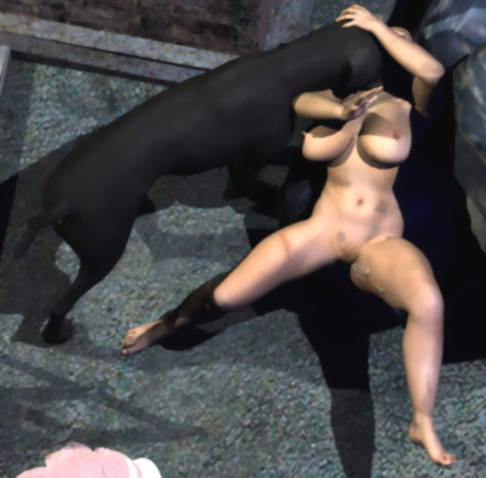

After a few seconds he released her throat but stood beside her growling. When she moved a little, he <nipped> her left breast with his teeth and pulled her nipple up. Soon Tom saw hisher friend's mom lying naked and spread on a trash heap. She had surrendered to the dog. And she knew that she was going to be raped by a dog again and nobody could help her.

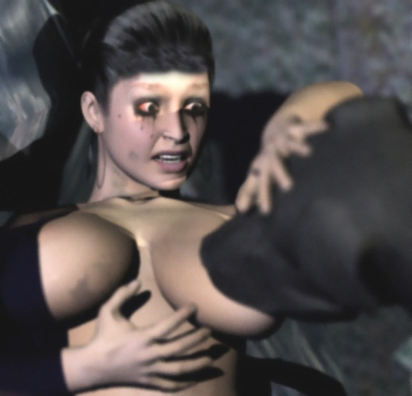

The dog laid his forepaws on her both sides. He had never bred bitches in a missionary position. But soon his penis found her gaping hole. In her desperation she was relieved that the cock was smaller that the cock of the first dog. However, she soon felt that the cock kept growing.

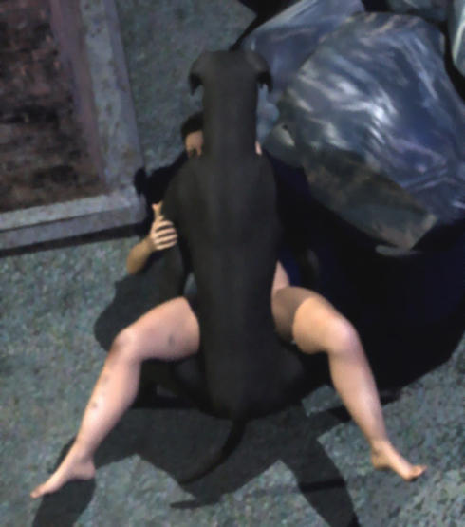

After a few minutes of powerful fucking, the cock filled hervagina completely. His cock was no longer sliding in her vagina but dragged her whole body back-and-forth.

The dog was not happy with the situation. The pussy was too tight for his huge cock. He laid his forepaws on her shoulders to keep her in place. Now that he could hold his bitch in place, his cock could again move inside her.

Tom saw the pain in her face as the huge cock stretched her vagina and hit her cervix. With each push, her hip sinked into the trash. And each pull of the cock raised her hip in the air. She had to spread as wide as she could.

Her big tits spread out lying on the dogs paws. When the dog pushed his huge cock deeper into her, his shoulders pressed her tits making them swell out and violently pumping milk from them in his fucking rhythm.

Her nipples grew longer and harder. It looked like her tits would burst from the savage treatment. From his window Tom couldn't see the dog's cock. But from the woman's face, he could read that the cock must have been huge.

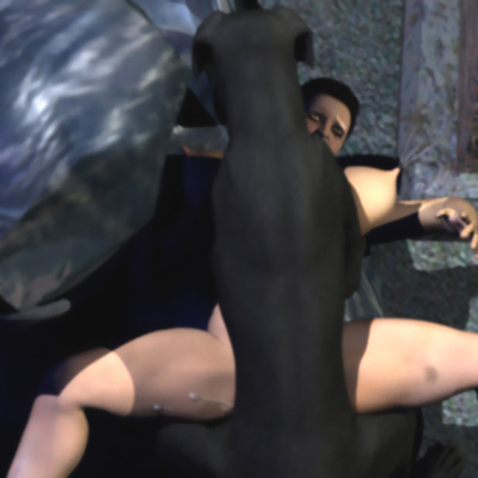

But the worst was yet to come. The knot was hitting her pussy. Luckily she had given birth to a baby a few months ago because the knot was almost as large as a baby's head. With brute force the huge dog pushed it inside the helpless woman. Tears ran down her face and she covered her mouth with her hand to muffle her scream.

"What-the-hell is that noise?" Tom heard somebody saying.

It was Pete's neighbor. His head was out of the window as he looked at the huge dog fiercely raping his neighbor. But without his glasses he couldn't see the small woman under the giant animal.

"There's a huge dog digging trash. Somebody should shoot those dogs," he said and closed the window.

Tom watched the huge beast pumping his seed into Pete's mom.

"Damn it. She will get her entire womb filled to the limit," he thought.

Tom saw that the woman was breathing heavily again. He knew that they were locked because the dog was now standing on his feet and her hip was suspended in the air by her pussy. The huge knot sealed her pussy effectively. Bt a small stream of sperm was flying with high pressure from her pussy.

First Tom thought she was peeing. But then he noticed that it had to be doggy semen. It formed a small pool on the ground a few feet away from her. The pressure must be intolerable, Tom thought.

The dog turned around and walked to the corner behind the trash dragging the exhausted woman with him and lied down with her "tied" around his cock and lying between his paws. People started to walk on the alley. But the dog and the woman were hidden from their eyes.

She was conscious but extremely exhausted. She could only lie between the paws of the huge dog and wait for his cock to subside. Only Tom could see them from his window. He noticed a puddle on the ground growing as doggy sperm flowed down from the woman's pussy.

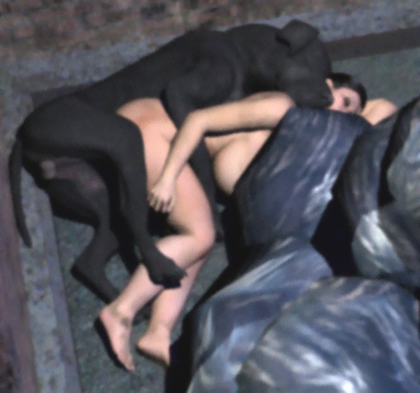

Other dogs soon came to dig the trash. They started to lick her face, breasts, and the sperm leaking from her pussy.
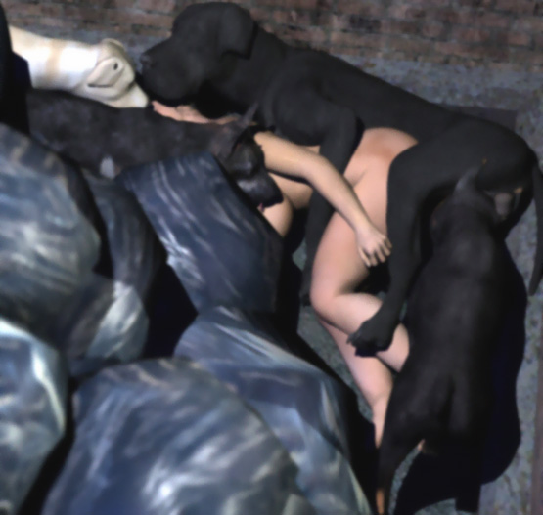

Finally the black dog started to get up and he pulled his huge cock off the woman's pussy. She tried to get up ...

... but was immediately mounted by a German Shepherd. In a second he penetrated her sloppy pussy and fucked her fiercely. Tom saw her body spasming from orgasms. Her pussy was too sloppy for his knot to lock in.

When the Shepherd was finished with her, she tried to escape but was too weak to get on her feet. She collapsed under the next dog. He fucked her like a jack hammer and she had her second orgasm.

People walked by as several dogs entered the site and fucked her. She orgasmed at least 5 times. She was lying with her belly on a trash bag when she passed out. Her body shook like a rag doll as more dogs raped her unconscious body. Tom came again.

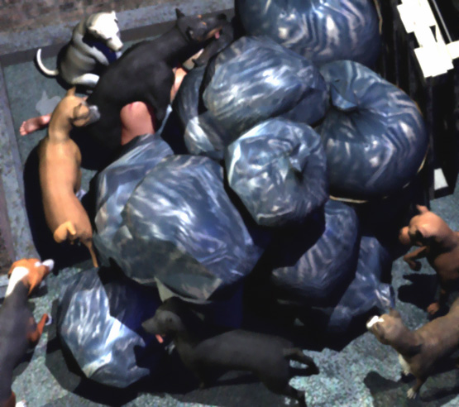

People wondered the number of dogs on the alley and the noise they made. But only Tom saw what was happening. All the male dogs in the neighborhood claimed the mom of his friend as their bitch. She was raped by more than a dozen dogs. Smaller dogs couldn't reach her pussy. But they humped her head, her arms, and anything they could reach.

Finally she was lying unconscious behind the trash. She was covered with dirt, claw marks, and doggy semen. A thick flow of sperm was running from her gaping cunt.

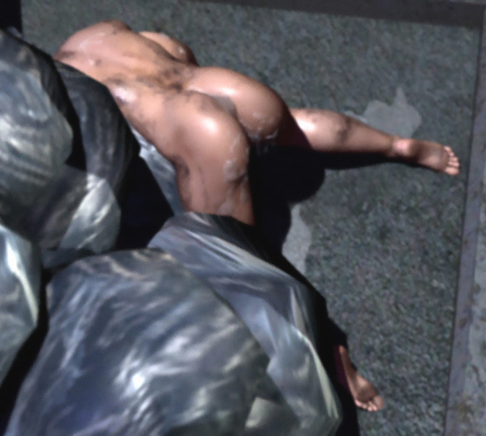

Slowly she got up and sat down on the ground weeping.

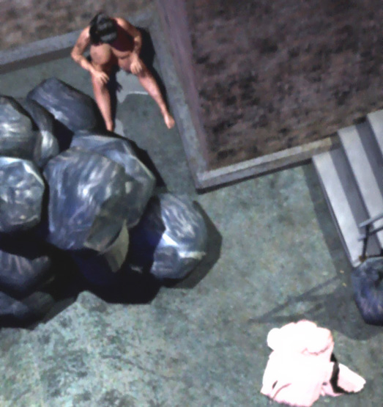

Next day Tom visited Pete again. His mother looked sad. But she at hi, friendly. She knew that Tom hadn't told anyone about that horrible morning. She never again teased Tom with her breasts. But she didn't hide them either from his hungry eyes.

Then one day Tom went to again visit Pete. Her mother opened the door and asked him in.

"Pete is not home. But come in anyway. I want to say you one thing," she said. "Come here."

She took Tom by the hand, closed the door, leaned on the wall, lowered her glasses, and looked over them at his eyes.

"Tom," she said, "you are the only person who know what happened to me that horrible morning. I know that you haven't told anyone. And I want to keep it that way. Do you understand?"

"Yes, maam. I ain't gonna tell anyone," Tom answered.

When he had said that, his eyes turned down and he saw her big tits in front of her. She wore a different nightgown. But Tom could clearly see her boobs throught the thin fabric. She looked at his eyes and smiled.

Then she opened the nightgown so that Tom could see her naked breasts right in front of him. He tried to turn around. But she took his right arm in her left hand and guided his hand on her left breast. She put her left hand on his hand and made him squeeze. Her breast felt bigger and softer than Tom could have imagined. Carefully he spread his fingers and tried to close the breast in his hand. But it was too big. He could only feel huge softness and a hard nipple between his fingers.

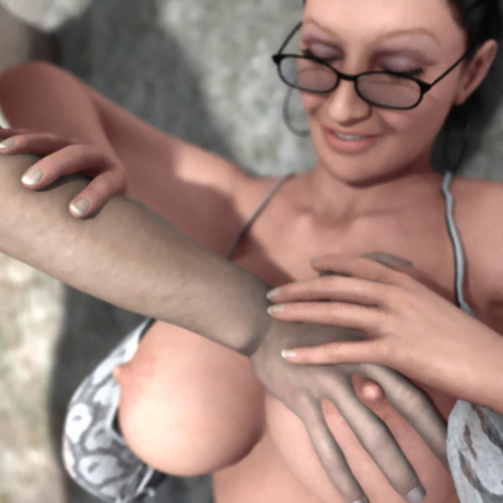

"Do you like it?" she asked.

"Yes, maam."

"This is what you want isn't it?" she asked.

But the boy couldn't get a word off his mouth.

"If you keep our secret, I will be thankful to you. Do you understand?" she said and made him squeeze her breast again. "Now go!"

"Yes, Maam. ... Goodnight, Maam" was all that Tom could say when he walked out.

A few days later late in the evening, Tom was walking home with Pete and his mom.

"Go ahead. I'll come later," Pete said when he saw a beautiful girl he had met a few days ago.

Tom and Pete's mom walked on their alley when a big dog stepped forward from the shadows. Soon it was standing in front of Pete's mom. They both knew the dog. It was the dog that first raped her.

"Run!" Tom yelled and ran to his door.

He looked back and saw Goliath, the huge black dog behind Pete's mom. She tried to run away. But Goliath grabbed her from the neck and started to drag her to the gate of the fenced area between 3 houses. The other dog grabbed her skirt in his teeth and with a swift movement pulled it off her.

When Tom took a few steps towards her, the dog rushed towards him and snarled at him ferociously. Goliath lowered the woman on the ground and swiftly grabbed her neck again in his jaws snarling at Tom. The woman couldn't say a word. But Tom understood the message.

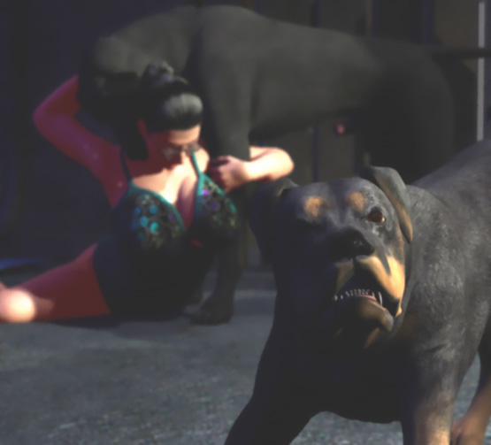

He picked up her skirt and walked home while Goliath dragged the woman behind the fence. From his window he saw several other dogs walking and running to the fenced area. He opened the window and heard growling and snarling mixed with some muffled cries.

Goliath had stopped. But it still held the woman by the neck. The Rotweiler tore the chest of her skirt open so that her breasts were squeezed out. When the dog had 2 huge tits neatly on display, he started to lick them so that soon her nipples were big, hard, and leaking milk.

A German Shepherd licked her pussy and butt. He< nipped her butt> if she didn't keep her legs wide open. The boxer ripped her skirt off tearing it into shreds.

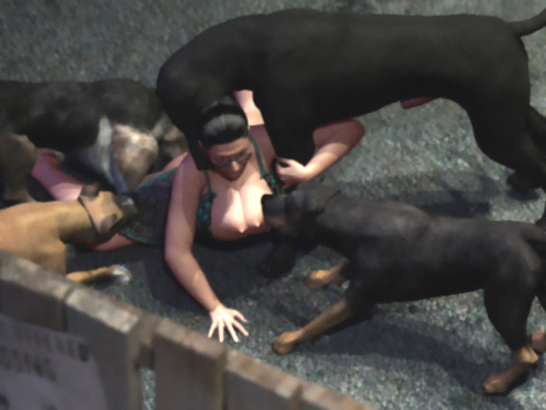

Goliath's huge jaws clamped around her neck lifted her chest up with her tits pointing forward. With their forepaws, Goliath and the Shepherd pinned her hip on the ground so that her back was painfully arched. She was now naked and totally helpless for the dogs to play with her as they wanted.

The Shepherd licked her pussy until it was soaking wet. The pussy was still wide open from the previous doggy gang-rape so that the shepherd could lick deep inside her vagina. The rotty and the boxer licked and <nipped> her tits and were rewarded by a stream of milk on her tits which they happily lapped away. She was sweating and was moaning.

Finally Tom could see her body spasming from a powerful orgasm. Her pussy was filled with her love juices and her breasts milked even more to which the dogs answered by more licking, lapping, and nipping.

The Boxer <nipped> her right nipple in his teeth and pulled stretching her breast and causing her shivers. The Rotty grabbed her right tit deep into his jaws. When he bit his jaws almost together, he received a solid stream of milk in his mouth. He milked her huge soft breast trying to get it as deep in his mouth as possible. She covered her mouth so that neighbors couldn't hear hear cries of passion.

After a while her moans turned into sobs. She was totally humiliated. The dogs licked her, milked her, and made her cum. With her neck in Giant's jaws, her body was now totally limp. She didn't care what the dogs did to her. They had stolen her orgasm. She didn't know that up in the window Tom was cumming also. For the dogs, this was only the beginning.

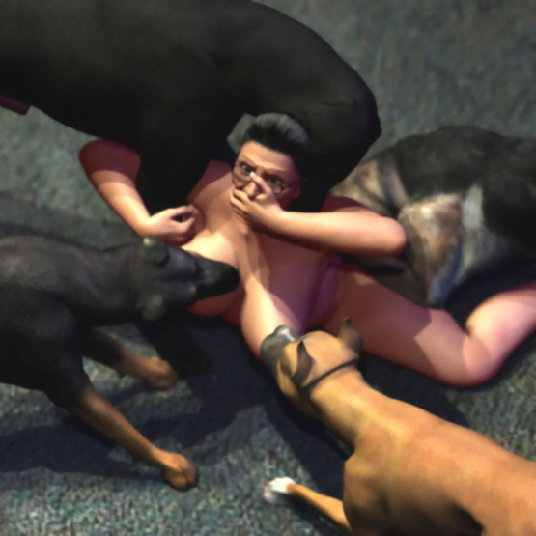

He could see behind the fence where the dogs played with their human bitch hidden from other eyes. Goliath was the alpha male of the pack and he was the first one to fuck her.

He walked around her and licked her face and pussy a few times before he mounted her. She was on her hands-and-knees hoping that the dogs would fuck her quickly without biting her and then leave her alone.

Tom saw fear in her eyes as Goliath mounted her. Inch-by-inch he pushed his huge cock into her wet pussy that was absolutely too small for his huge tool. He shifted the angle lifting her hip and pushing his cock more up-down. Finally Goliath could use all his strength to force his massive tool inside her. For Tom it looked like the dog was forcing a baseball bat into her pussy.

When the cock finally sank to the hilt into her, the dog started a fierce fucking. Her weight rested almost totally on her neck. Her head was bent against her chest and her tits flopped wildly hitting her face. She bit her lip not to cry.

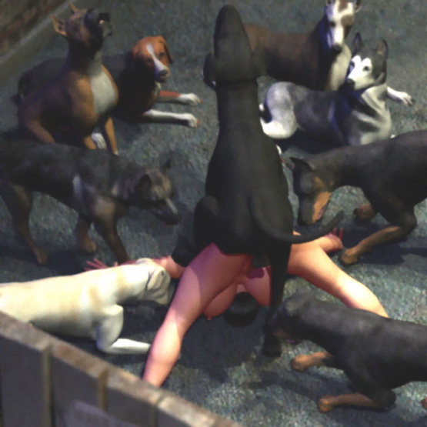

Then Tom saw a big bulge forming at the the base of Giant's cock. It was growing all the time until it was the size of a grapefruit. The dog banged furiously to force the knot into her pussy. Slowly her hole grew bigger-and-bigger until the knot sank inside her and locked.

Tom saw the beast's cock throbbing as he filled her vagina and womb with his puppy-making sperm. The woman's body was spasming as she was having her second orgasm. Goliath was just standing as his cock sent load-after-load of doggy semen into the spasming woman suspended by her pussy.

Having this doggy rape in front of his eyes, Tom saw Pete walking down the alley. He noticed Tom at the window.

"Hi, Tom. Is my mom home?" Pete asked.

"I think she went to visit some friend of hers," Tom lied.

"Damn those dogs. Why are they so noisy?" Pete remarked as he walked home.

Tom didn't want to show his friend that her mother was orgasming on a huge doggy cock locked inside her fertile womb.

The dog waited for 5 minutes and during this time the woman suspended by his cock had several waves of spasms. Gravity was pulling her down. But her pussy was high up in the air tied around the dog's cock until it has subsided a little and her pussy began to give way. Then the knot slipped out of her pussy which slided down along the huge dog penis. She was lying on the ground with huge amounts of doggy sperm flowing from her gaping pussy.

But she had no rest. In a second she herad growling and felt a <bite< in her thighs. She rose to her hands-and-knees and the second doggy cock immediately sunk into her pussy.

At least 10 dogs raped her. The biggest ones knotted her and dragged her on the dirty ground. Sometimes 2 dogs wanted to fuck her at the same time. After a short but fierce fight, the winner fucked her first.

After 2 hours the last dogs walked away. Pete grasped her skirt, a towel, and one of his own t-shirts and went out. He opened the gate in the fence and saw Pete's mom lying on her stomach on the ground. She was dirty all over. Her gaping pussy was still leaking doggy sperm.

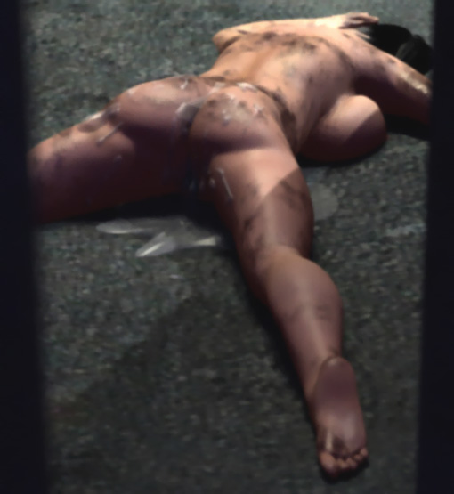

Tom used the towel to clean her up. She was now moaning. She lifted her head and saw Tom and gave him an exhausted smile.

When Tom stopped cleaning her, she turned on her back. Tom cleaned her face, then her stomach and her legs.

"Don't be shy, Tom. Clean my tits also," she whispered him.

Carefully Tom wiped her big breasts.

"Do it properly, Tom. They are dirty as hell."

Tom laid the towel on her chest and massaged her tits first. After a savage doggy gang-rape, his gentle-but-firm breast massage was very relaxing.

"Now my pussy, Tom. Please clean my pussy also," she pleaded.

Tom rubbed her pussy and thighs clean. She opened her legs to give Tom good access to her pussy.

"Wait until I get up," she said and with Tom's help managed to get on her feet.

She held her feet spread so that Tom could wipe off all semen leaking from her cunt. Then she put on her skirt and Tom's t-shirt.

"Thank you, Tom," she said and walked home.

A month later on one evening, Tom saw Pete and his mom walking home. He looked at her big bouncing tits and saw a collar on her neck. She saw Tom at the window and smiled but didn't flirt at him.

Suddenly several dogs circled Pete and his mom!

"Go home, Pete. I have to visit a friend of mine," his mom said.

Tom saw Pete walking home while his mom walked through the gate to the fenced area followed by the dogs. Tom opened the window and unzipped his pants. He saw the woman taking off her clothes. Soon she stood naked against the wall. Dogs gathered around her.

First they sniffed her and found the familiar smell of her pussy. Soon she was licked by the whole pack. Smaller dogs humped her legs. Bigger dogs licked her pussy and milked her by jewing her big breasts.

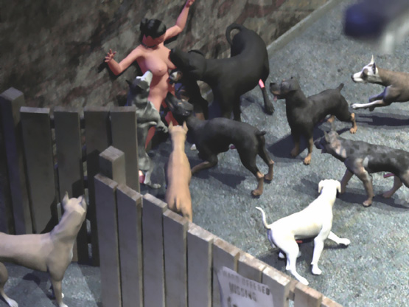

Tom saw that she had a collar around her neck and soon he found out the reason. Goliath grabbed her collar in his teeth and dragged the woman a few feet away from the wall and raped her.

The woman didn't try to escape any more. The dogs <bit> her only occasionally and dragged her by the collar. They didn't garb her neck in their jaws anymore. She stayed in a doggy position while they fucked her. The largest dogs knotted her and dragged her. When she was passing out and collapsing on the ground, the dogs <nipped> her thighs or dragged her by her ponytail until she regained her doggy position.

When the dogs left, the woman put on her skirt and with shaking legs walked home. She took a shower and put on a new nightgown that covered all teeth and claw marks in her body. Tom saw her weeping in the bed before she switched off the light.

She was the bitch for the entire pack of local stray dogs. And they bred her anytime they wanted.

Tom wiped his dick clean. He had ejaculated 4 times.

Then he went to bed and had the same dream again. But this time with a different end.

