http://abcnews.go.com/blogs/business/2012/03/sci-fi-inspired-brothel-near-area-51-is-out-of-this-world/
SciFi-Inspired Brothel Near Area-51 Is Out of This World
ABC News’ David Wright, Bonnie McLean, and Lauren Effron report:

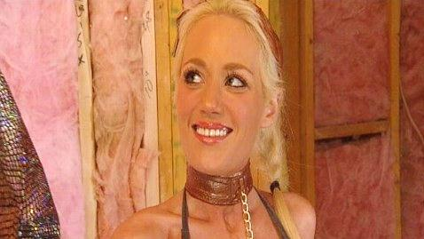

Just down the road from Area-51 (the infamous U.S. military base in Nevada where top-secret alien autopsies were supposedly conducted) is a new business.

It’s a galactic-themed brothel that brings to life sci-fi geeks’ wildest fantasies incorporating sex into an array of settings from famous sci-fi films and TV shows. It’s what you might call the XXX-Files. And it’s legal!

“The Trekkers are going to line up for miles,” said owner Dennis Hof.

Hof is already the most successful brothel entrepreneur in the state where prostitution is legal. His Moonlite Bunny Ranch in Carson City, NV is the most profitable brothel in the country and is featured on HBO’s “Cathouse.”

Hof believes he has a new Nevada gold mine in this alien-esqe “Cathouse” idea. He imagines his new brothel will be something like the bar from “Star Wars.”

And for the right price, any “Star Wars” enthusiast can spend a steamy moment with Princess Leia dressed in chains and her iconic gold bikini. If they prefer, clients can also dress up as Darth Vada and have their way with a lady in a Storm Trooper costume.

In a landscape that already looks a bit like the Star Wars planet Tatooino, it is truly the middle of nowhere. The brothel property also houses a gas station, a truck stop, and a convenience store.

While the place is still under construction, Hof said he has big plans. He wants to build a “Captain Kirk” room that would have the actual chair from the Starship Enterprise used in the TV series “Star Trek.”

Hof’s muse and partner in this particular enterprise is his old friend Heidi Fleiss, the former Hollywood Madame who was arrested in the ’90s for running a high-price prostitution ring. Now she fashions herself as the alien Madame right down to designing and ordering skimpy spacesuit costumes and props for the employees. She draws some of her inspiration from an unusual film choice: “Avatar.”

“You want sexy, ‘Avatar’ sexy aliens,” she said. “Sexy aliens -- that’s the way we are going.”

While some critics might say the brothel exploits women or that some things like “Star Trek” are just too sacred to be messed with, Hof and Fleiss aren’t fazed.

“In a way it’s always fun to have those people against you,” Fleiss said. “It does make you rise up a little bit and grow to a higher level in way.”

And Hof is convinced he will have plenty of customers such as guys like on the hit TV show “Big Bang Theory” whose sexual fantasies run towards “Battlestar Galactica.”

“A lot of our business at the Bunny Ranch is gamers,” Hof said. “Because of the computers and because of games, men sometimes don’t develop the social skills that they used to.”

And those guys might well need the confidence boost that comes from a costume.

“The biggest sex organ is right here -- it’s all in our head,” Hof said. “It’s not as much physical as it is mental. And the fact that you can try living out fantasies, it doesn’t hurt anybody. You just have a little fun and then you go home.”

